CSR Add-Ons and Outpatient test cancellations
The following is a brief summary of the add-on and outpatient test cancellations. Please use the following link to watch the LMS Video which is approximately 15 minutes long. Please print transcript and give to your manager when complete.
LMS: Epic Beaker Add-Ons Holds and CSR Tasks

Customer Service will print out a label for the specimen with the Add-On to the designated Add-On Label printer
When you receive the label
- Find the sample and determine if it meets all requirements
- In specimen Inquiry Click on the action button and find holds (you can add the holds and Add follow up task to your tool bar using the personalize option at the bottom of the drop down)
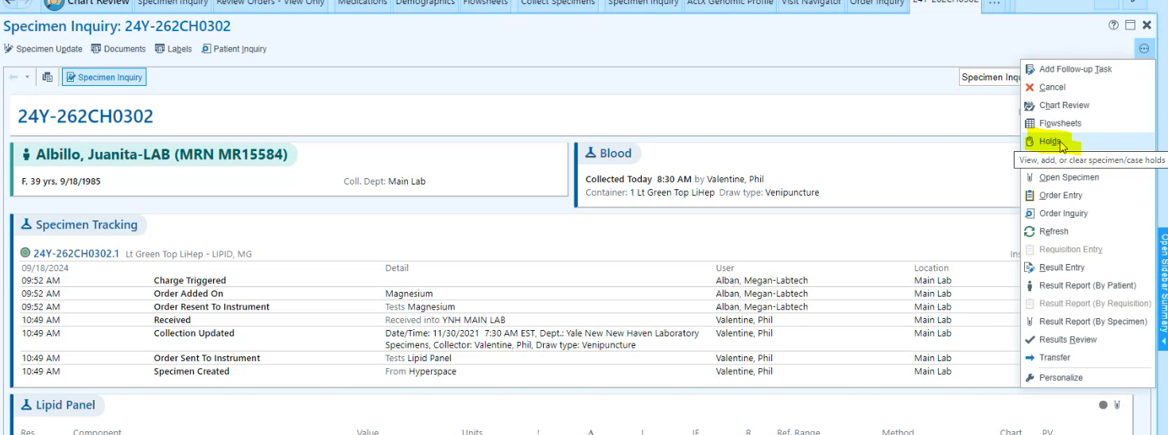
- When you click on holds, you will get a pop-up with the specimen that has a hold. If the specimen meets all criteria for the Add-on, Click “Clear”
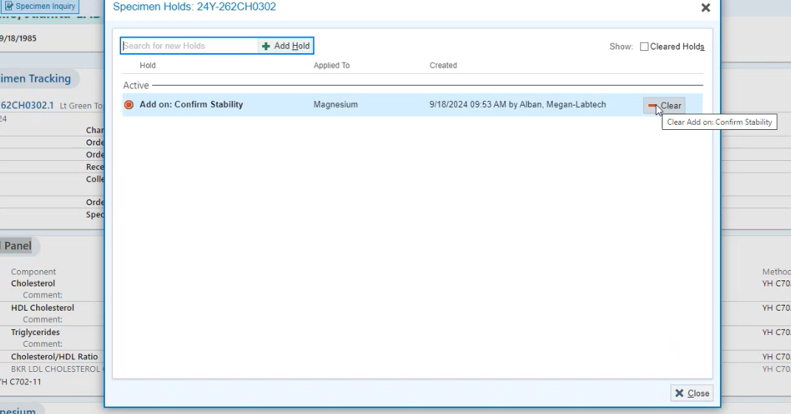
- After clicking on Clear, you will need to enter a Clear reason: Use “Stability Confirmed”
And click accept. Perform the testing
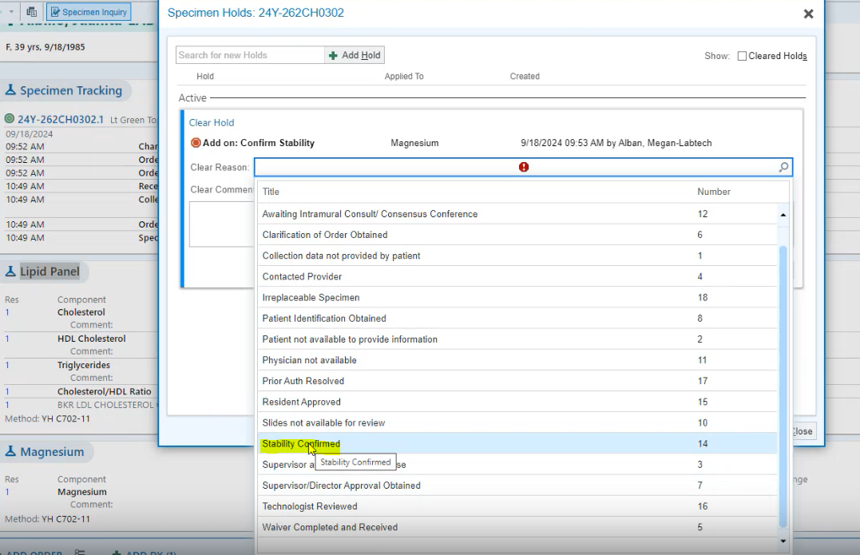
(Follow these instructions for all outpatient specimens that require a redraw)
- If you are unable to run the add-on, cancel the add-on test ( put the reason for the cancellation)and add a Follow-up task. Use this process for any Outpatient tests that need to be re-drawn(Tests should be cancelled not sent for a redraw)
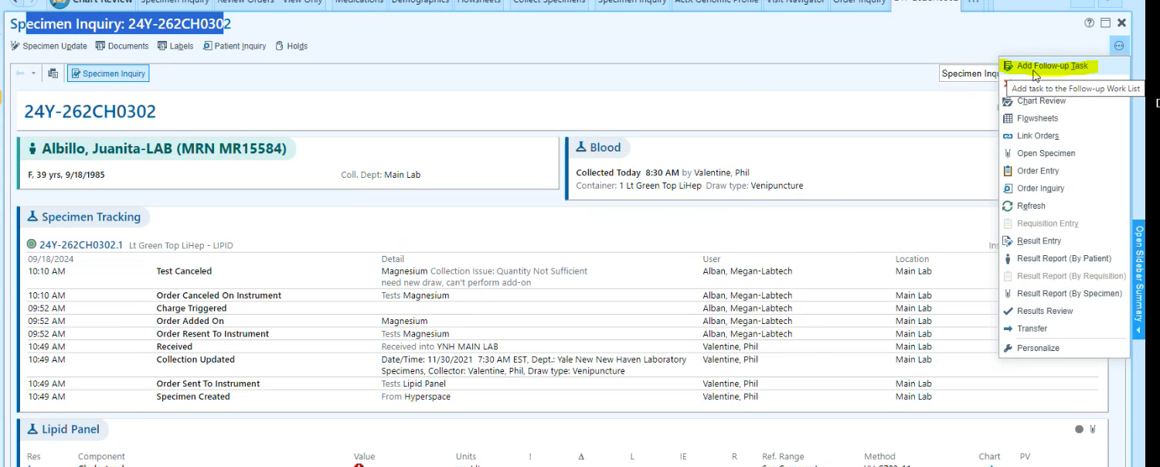

- Use (CSR) Call Physician for test cancellation
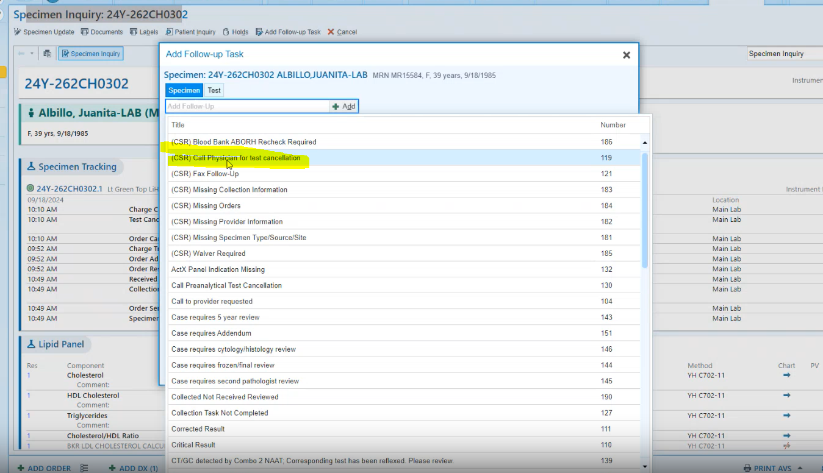
- The only section that needs to be filled out on the following pop-up is the comment section. Please be detailed as to why the test cannot be performed. When complete, click on Accept.( When cancelling the Add-on only, please notate in the comments)
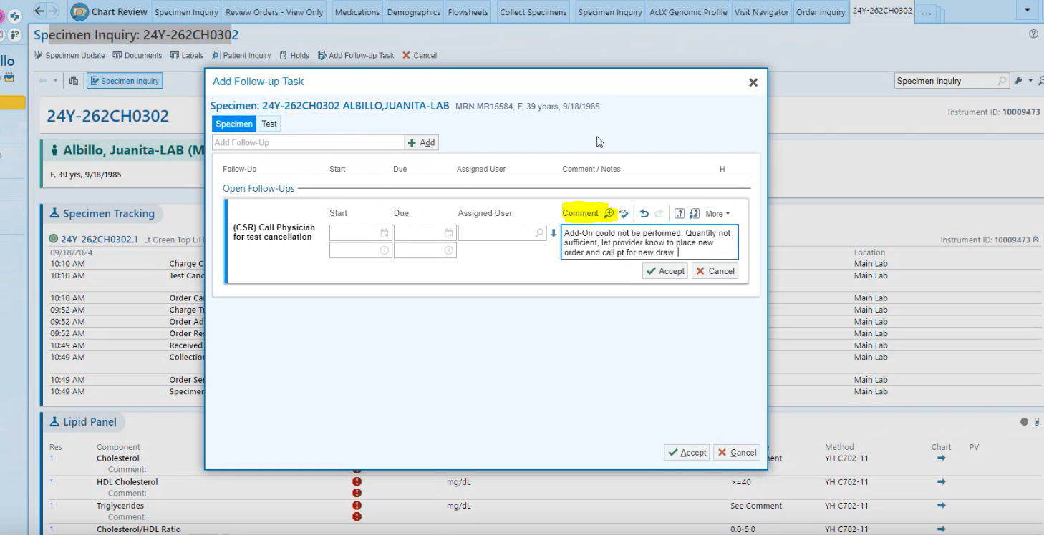
- Click on Accept

