ONE CALL/ QGENDA

Accessing The Pathology on-call schedule:
To access
- YNNH Resources ONeCall/QGenda Click on Bridgeport Hospital

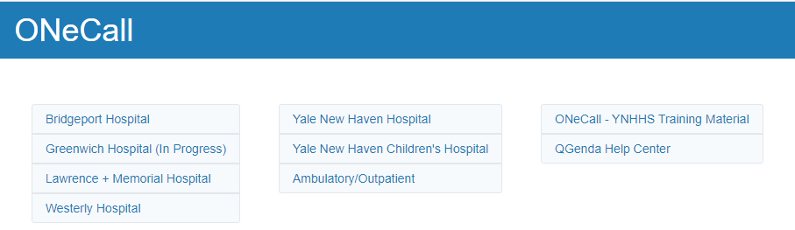
- Click on Pathology
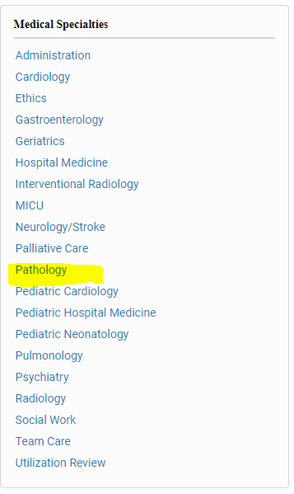

- Find the BH Clinical Laboratory Call Physician. The call List comes up for the current date and time. You change the date and time using the calendar and the time dropdown at the top of the list,
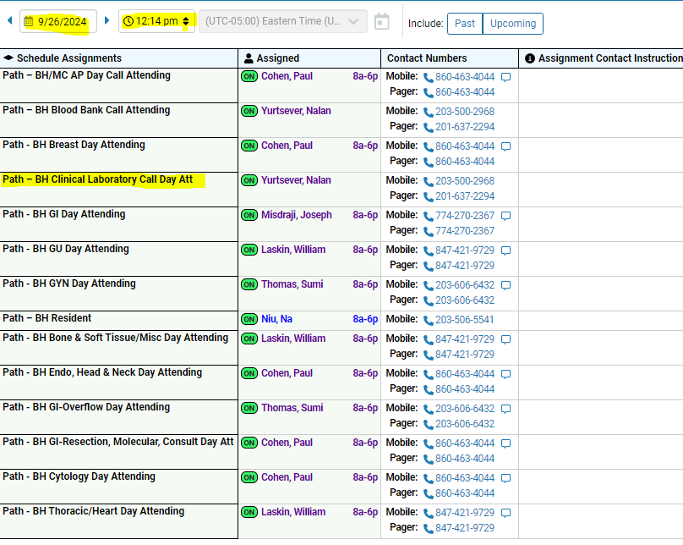

OR

Use the following link (can be found on the p-drive : P:\Laboratory\Links)
https://intranet.yalepath.org
- This will bring you to the Pathology Clinical intranet: Under Practice Toolbox, scroll down to the Directories, Schedules, Calendar and WebMail section and click on Anatomic Pathology schedules

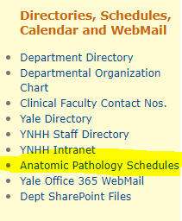
- Click on Qgenda which will open up the YNHHS path schedule.
- Using the task filter, click on the drop down arrow and choose Delivery network-BH under task tags
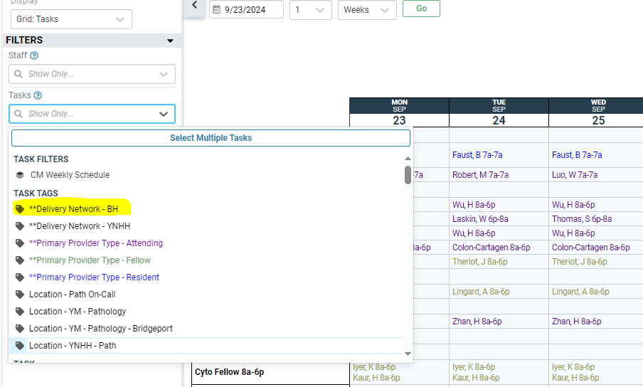
- The BH Pathology Call schedule for the current week will come up.

