HEMATOLOGY
MINUTES
November 2024
DATE: 11/6/2024
PRESENT:
Day Shift: Louise, Dan, Susan, Hiram, Emma, Faye, Dr. Yurtsever
Evening Shift: Kwame, Duc , Fei, Lisa

- Dates to Remember

- 11/17/2024: - Performance reviews must be completed.
- If you have not done so, please complete self-evaluations ASAP
- HealthStream’s must be up to date for review to be accepted
- Merit increases will be determined between 11/17 and 12/1
- Increase will be in the 12/19/2024 check

- 11/10/2024: Beaker upgrade
- 12/2/2024: Kronos update
- Information on the P drive: P:\Laboratory\Hematology - BH 38020\LINKS and useful info\KRONOS INFO
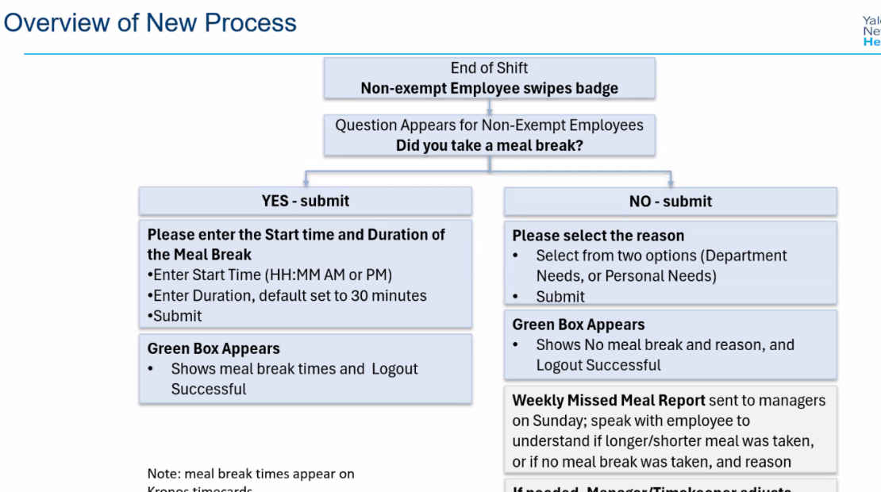

- General Info
- FIT testing will now be required for all core lab Techs.
- Testing can be scheduled using Infor – Click on Employee health-more links: Respiratory FIT testing- schedule appointment.
- The following times during the Flu Clinics are available for walk-in testing and the location is in the same hallway as the Flu clinic on Marsh 1
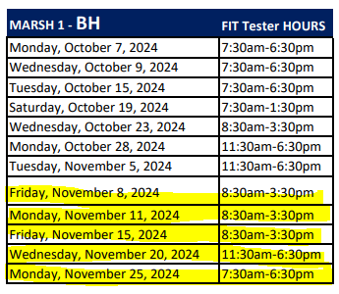
- Everyone will be required to complete a course on Category A and B Shipping
- Everyone will be trained in the Donning and Doffing of PPE.

- Reminders:

- If you have done so, please complete the BSC and Centrifuge training ASAP

BSC
- https://www.train.org/connecticut/course/1041976/

Centrifuge
- https://www.train.org/connecticut/course/1073746/

- Please check your follow-up worklist at the end of your shift. If there are critical results to call and you are leaving, you must communicate that to the next shift.
- All outstanding lists should be checked at the end (or near the end) of your shift and make sure all pending specimens are accounted for. This includes the BH Microbiology list.
- Please be at your workstation at your scheduled time
- We are modifying the daily clean on the XN’s. Starting Sunday Night (11/10), Night shift will perform the cell clean on XN1 and Day shift will perform the cell clean on XN3. This will help with workflow in the mornings.

