December lab meeting

1. Follow all directions when running CAP PT samples.
2. Kronos exception log on P drive-any deviation from scheduled hours need to be entered. Please don’t swipe in before your scheduled time or after your scheduled time unless it is warranted. Incremental overtime is being monitored very closely. Enter any extra minutes/hours into kronos exception log.
3. Kronos-when swiping out at end of day, staff will have to answer if they had a 30 minute meal break. Remember this is meal break not the 15 minute breaks taken. There will also be the option to swipe in and out at the computer . if you do not get a meal break, enter in kronos exception log
4. Started 12/1-Friday and Saturday 3rd shift hours changing from 11-730 to 1130-730, call changing to 12-630 on Friday and Saturday night also.
5. As we go into the winter months, watch the weather forecasts and give yourself extra time to get in if the weather is bad. The lab must be covered 24/7. Staff cannot leave until adequate replacement staff arrive. There is an air mattress, sheets, blankets and pillows should someone be held over to cover during storms.
6. Weekend huddle coverage is not an option. It is required that when it is Milford’s turn to cover the 8:15 huddle, staff is present and reports any concerns that the lab may have. Attendance is taken.
7. Still short staffed, only 1 person can be scheduled PTO at a time. Be aware of your PTO balances and manage accordingly.
8. PPE, cell phones, ear buds -Some staff are still not following this-please do or warnings will be issued.
9. New QC rules and frequency-CMP analytes 3X/day, 10X for Ca, TP, more to follow, Troponin 1 4S rule in effect.
10. Also starting increasing hemolysis tolerance levels on the EXL’s-now only certain tests will be rejected based on instrument hemolysis settings.
11. Shared specimen policy in effect for samples that are shared among the DN’s. This is for non-blood samples. I think mainly fluids (like CSF) for Milford. If there are multiple tubes and you are not sharing the same tube then you don’t have to fill out the form just send the unentered tubes as usual to BH. The forms are in the central processing notebook at the desk.
12. Milford lab is not doing well with the YNHHS quality metric for calling critical results. ALL CRITICAL RESULTS NEED TO BE COMMUNICATED WITHIN 30 MINUTES FOR INPATIENTS AND 60 MINUTES FOR OUTPATIENTS. Document attempts to call and always follow up per policy every 15 minutes. We are the worst performing lab in the system and I have to account for this at the YNHHS quality meetings. Investigating floors, techs etc. it is the feeling of our leadership that there is nothing more important than reporting/receiving critical results. If you cannot give a critical report fill out a SAFER. This has to get better.

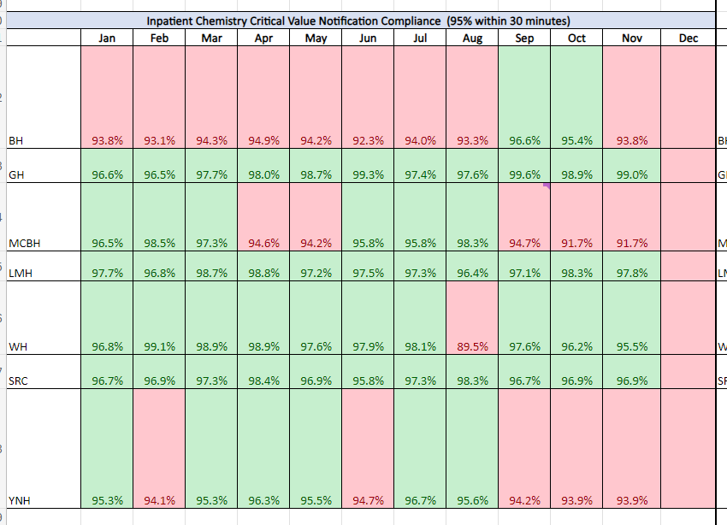

1. Please check the sendout bench for sendouts that need to go to BH-we are missing sendouts. Thank you to Kirsta for checking the sendout bench to catch these. There is also a report that printouts behind the processing desk of collected not received-this is a report that should be checked to be sure we have “received” all samples.
2. Let’s review bench assignments as we enter the busy respiratory system- on the Cepheid

* Hematology does heme, coag & Cepheid
* Chemistry does EXL, e411, Blood gas, UA
* Blood bank-BB and then helps core lab

As always, this is an agenda for subjects that need to be covered, if you have anything else to add or any comments or suggestions, please let me know. Thank you all and have a wonderful Christmas/ Hannukah & New Years to you and your families--Laura