HEMATOLOGY
MINUTES
October 7, 2025
Attendance:
Day- Susan, Dan , Hiram, Dan R, Emma, Sharon
Eve- Kwame, Fei, Bril

Dates to remember:
- 10/7/2025 Flu shot clinics begin (see schedule at end of notes)
- Use Infor to schedule flu shots
- 10/14/2025 (3-4PM); 10/15/2025 (7-8am) and 10/16/2025 (7-8pm) – Open enrollment webinars.
- 10/14 System Laboratory Town Hall
- 7-8am
- 1-2pm
- 5-6pm
- 10/20/2025 – Micah starts training in Hematology
- 10/23/2025: Caresphere update 4pm downtime is approximately 1 hour.
- 10/27/2025-11/7/2025- Open enrollment begins
- 10/28/2025-1/26/2026: CAP inspection window . New this year, inspectors can give up to 2 weeks’ notice for inspection date.
- 10/28/2025- UB Student (George) starts Hematology Rotation
- 11/3/2025- Emma starts training in Chemistry.
- 11/9/2025- Epic upgrade
- 1/1/2026: DPH inspection window opens
- 12/1/2025- Deadline for Flu vaccine compliance
- 12/16/2025: PLEX go-live

General Information and Reminders

- Please work on your self-evaluations for the performance reviews. Managers need to have the performance reviews completed by 11/16/2025
- LMS training and CEU’s must be up -to- date
- Document CEU’s on P-drive (P:\Laboratory\Hematology - BH 38039\! CEU\2025)
- Reminder: If you get a Positive sickledex on a patient, please have CP add on a Hemoglobin electrophoresis and send to Yale.
- If you use the last bottle/cartridge/vial of reagent or QC in a box, please look at the lot number of the next box. For Teg/ cepheid/verigene- If the next box is a new lot, please QC the next box so that when we get a patient, we do not have delays due to running QC. For Plt mapping on off shifts- please leave a note that QC needs to be performed. For New lots of QC, please leave a note so that we can begin lot to lot testing
- CAOG RFP will be going out to Vendors (Sysmex, Siemens, Werfen, and Stago) on Friday 10/10/2025.
- Please check Follow-up worklists periodically throughout your shift , and at the end of your shift, there have been missed criticals in the FUWL on every shift.
- Gram stain TAT 90% ≤ 60 minutes was 75% for August up from 35% the previous month- Great Job!!
- We have been working with Roche to develop a lay-out plan for Chemistry. The Sysmex and 2 new Roche lines will be attached to a new 8100. The goal is to eventually covert the chemistry side to a core lab and have all instrumentation placed in chemistry.

CRITICAL CALL TAT FOR INPATIENT CBC
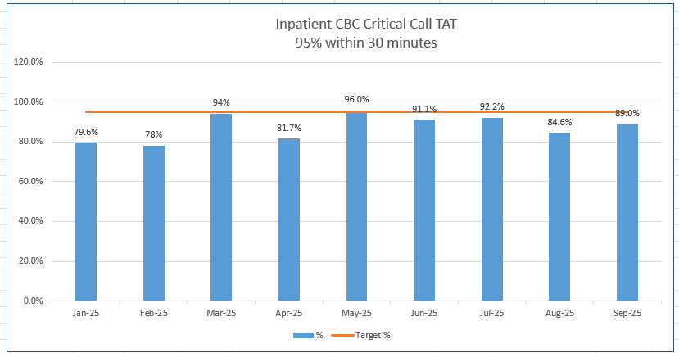

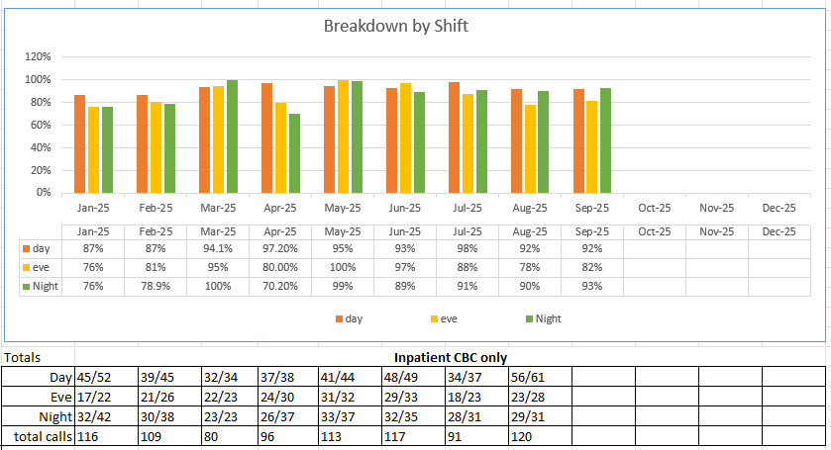
TENTATIVE ROCHE PLANS

