HEMATOLOGY
MINUTES
February 4, 2026
Attendance:
Day- Susan, Dan , Hiram, Emma, Sharon
Eve- Lisa, Kwame, Abril, Duc, Souman, Sharon

Dates to remember:
- Now- 3/3/2026: JCAHO window
- 2/9/2026 : Start Training/Retraining on the PLEX
- 2/17/2026: PLEX Go-live
- 2/17/2026; KFST discontinued
- 2/18/2026: CWS update(4 PM)
- 3/30/2026: DPH Hospital Licensing due
- 3/30 – 5/1/2026: Epic upgrade testing ( Let me know if you are interested in upgrade testing)
- 5/17/2026: Next epic upgrade.

General Information and Reminders

- JR is looking for volunteers to be on a Laboratory Counsel. The purpose of the counsel is to bring forth issues and ideas to improve workflow and morale as well as discuss employee engagement. Please let me know if you are interested.
- LMS training-Please complete the LMS training on time. This is a regulatory requirement.
- Reminder to document CEU’s on the P-drive.
- When working OT on different shifts, please be sure to perform the maintenance required for the shift you are working. Look at the maintenance charts and ask for help if you’re not sure how to perform the maintenance.
- Please clean your workstations at the end of your shift: wash the benches, throw away used gauze etc. and clean the microscopes.
- Be sure to check the Micro outstanding list, we are finding missed specimens 2 or more shifts later.
- Check the micro specimens in beaker before tube tracking to ensure tests were run and verified.

YNHHS System news:
- COAG RFP- The system is in the process of looking at new coagulation analyzers. The 2 vendors under consideration are Stago and Werfen. The specific instruments for MC and BH are Stago Compact Max 3 and Werfen ACT TOP 350. Next step is to schedule site visits to see the instruments in person.
- Project workforce Connect: The Health system is upgrading workforce management (Kronos) to UKG Pro Workforce Management (WFM)- tentatively scheduled for mid to late 2026
- One system- all scheduling and time keeping move from Kronos and spreadsheets to UKG
- Mobile access to view schedules, approve timecards and manage requests
- Self-service tools Employees submit time-off requests, report absences, update availability, and correct timecards in UKG
- Automated attendance tracking- tracks absences, tardiness, missed punches and OT thresholds
- Standardized scheduling

CRITICAL CALL TAT FOR INPATIENT CBC

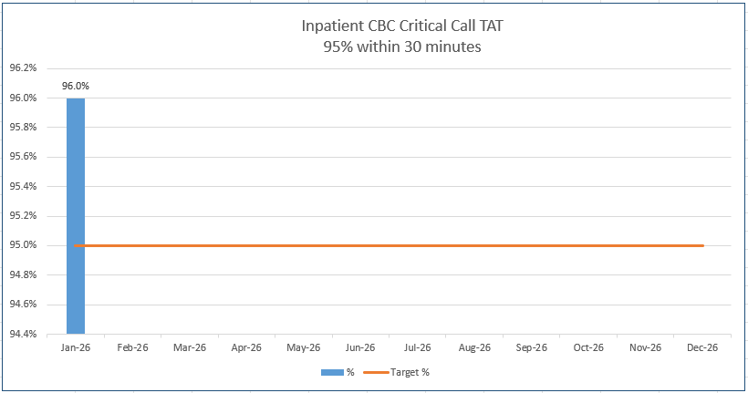

GREAT JOB EVERYONE!!!

FREE CEU: can also be found on the p-Drive P:\Laboratory\Hematology - BH 38039\! CEU\Free CEU's

