HEMATOLOGY
MINUTES
April 22, 2026
Attendance:
Day- Dan , Hiram, Emma, Fei
Eve- Lisa, Kwame, Abril, Duc,

Dates to remember:
- 5/17/2026: Next epic upgrade.
Position updates:
- Day-Shift:
- Krystal Rivera and Daylin Alarcon start 5/17/2026
- Evening Shift:
- Offer not accepted.
General Information and Reminders
- JR is still looking for volunteers to be on a Laboratory Counsel. The purpose of the counsel is to bring forth issues and ideas to improve workflow and morale as well as discuss employee engagement. Please let me know if you are interested.

YNHHS System news:
- COAG RFP- The system is in the process of looking at new coagulation analyzers. The 2 vendors under consideration are Stago and Werfen. The specific instruments for MC and BH are Stago Compact Max 3 and Werfen ACT TOP 370 - No updates

Miscellaneous:
- Please Track CSF cell counts and CSF cultures(for Gram stains) into Hematology when dropped off from CP. Hoping that this helps with our TAT’s.
- Adding microscope maintenance to the daily maintenance charts for the Benches that have Microscopes. Please clean the microscopes at the end of EACH shift. Replacement lens’ cost about $1,000.
- If you leave a fluid diff for review, please validate the diff in caresphere. Fluid differentials do not auto verify in beaker. Also, in lab comments, please leave a notation that you left a slide for review.
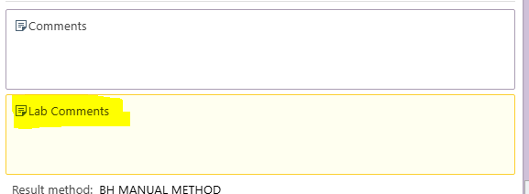
- Please check to see if the Fluid MD interp has been performed, if it has been done, validate the fluid diff. This can be done on any shift
- Please check your follow-up worklist frequently throughout your shift to ensure that critical Values are called/followed up on in a timely manner.
- Work order has been placed to purchase a couple large monitors for the wall that will have the follow-up worklists open 24/7
- Please be sure to follow the critical call policy when you are unable to reach the caregiver to communicate a critical result. If, after 3 hours, you have been unsuccessful, escalate to the pathologist on-call
- PLEASE clean your work areas at the end of your shift: put away any supplies used, throw away trash and wipe down/disinfect the benches.

CRITICAL CALL TAT FOR INPATIENT CBC

