

**Employee Health Consult Diagnostics**

**Clinic Influenza A &B Test**

|  |  |
| --- | --- |
| Effective Date: December 2021 | Department: Laboratory |
| Date of Review: December 2023 | Created/Maintained by: Laboratory Management |

A rapid qualitative test that detects Influenza type A and type B antigens directly from nasal swab, nasopharyngeal swab, and nasopharyngeal aspirate/wash specimens. For professional and laboratory use only. For in vitro diagnostic use only. Rx Only. For use with MFR # 181-36025.

CLIA Complexity: Moderate Complexity when Used with Nasopharyngeal Wash/Aspirate Samples. (not applicable)

CLIA Waived when Used with Nasal and Nasopharyngeal Swabs.

INTENDED USE

McKesson Consult® Influenza A&B Test is an in vitro rapid qualitative test that detects influenza type A and type B nucleoprotein antigens directly from nasal swab, nasopharyngeal swab, and nasopharyngeal aspirate/wash specimens obtained from patients with signs and symptoms of respiratory infection. It is intended to aid in the rapid differential diagnosis of influenza A and B viral infections.

Negative test results are presumptive and it is recommended that these results be confirmed by viral culture or an FDA-cleared influenza A and B molecular assay. Negative results do not preclude influenza virus infection and should not be used as the sole basis for treatment or other management decisions.

The test is intended for professional and laboratory use.

Performance characteristics for influenza A and B were established during the 2007-2009 and the 2014-2016 influenza seasons when influenza A/H1N1, A/H1N1 pandemic, A/H3N2, influenza B/Victoria lineage, and B/Yamagata lineage were the predominant influenza viruses in circulation according to the Flu Activity & Surveillance reports from the CDC. When other influenza viruses are emerging, performance characteristics may vary.

If infection with a novel influenza virus is suspected based on current clinical and epidemiological screening criteria recommended by public health authorities, specimens should be collected with appropriate infection control precautions for novel virulent influenza viruses and sent to state or local health department for testing. Viral culture should not be attempted in these cases unless a BSL 3+ facility is available to receive and culture specimens.

SUMMARY AND EXPLANATION

Influenza is a highly contagious acute viral infection of the respiratory tract. It is a communicable disease easily transmitted from person to person through aerosol droplets excreted when sneezing and coughing. Common symptoms include high fever, chills, headache, cough, sore throat and malaise. The type A influenza virus is more prevalent and is the primary pathogen associated with serious epidemics. The type B virus causes a disease that is generally not as severe as that caused by the type A virus.

An accurate diagnosis of influenza based on clinical symptoms is difficult because the initial symptoms of influenza are similar to those of numerous other illnesses. Therefore, it can be confirmed only by laboratory diagnostic testing.1 Early differential diagnosis of influenza type A or type B can allow for proper treatment with appropriate antiviral therapy while reducing the incidence of inappropriate treatment with antibiotics. Early diagnosis and treatment is of particular value in a clinical setting where accurate diagnosis can assist the healthcare professional with management of influenza patients who are at risk for complications.2 McKesson Consult Influenza A&B Tests are a rapid immunoassay to be used as an aid for the differential diagnosis of influenza type A and type B.

PRINCIPLE OF PROCEDURE

McKesson Consult Influenza A&B Tests utilize the chemical extraction of viral antigens followed by solid-phase immunoassay technology for the detection of extracted antigen, influenza A and/or B. In the test procedure, a specimen is collected and placed for one minute into the Extraction Well of the test device containing extraction solution, during which time antigen is extracted from disrupted virus particles. The test device is then raised, tapped and laid back down onto a level surface to allow the solution in the Extraction Well to migrate through the pads containing detector antibodies conjugated to gold dye and then through the test membrane. If influenza antigens are present in the specimen, they will react with anti-influenza antibody coupled to gold dye particles, migrate through the membrane as antigen-antibody-dye complexes, bind to the immobilized anti-influenza antibody on the membrane, and generate a colored line in the test line position (A and/or B). The rest of the sample and unbound/bound dye complexes continue to migrate to the control line position (C), where antibody to the anti-influenza antibody is immobilized, and forms the control line. Formation of the control line serves as an internal control to demonstrate that antibodies in the dye pad have been hydrated and that sufficient sample has been applied to allow for migration to the test line and beyond. If the control line does not appear within the designated incubation time, the result is invalid and the test should be repeated.

McKesson Consult Influenza A&B Tests have two test lines, one for influenza A and one for influenza B. The two test lines allow for the separate and differential identification of influenza A and/or B from the same specimen. If either test line appears in the test result window, together with the control line, the test result is positive for influenza.

REAGENTS

Materials Provided

Each McKesson Consult Influenza A&B Test kit contains enough reagents and materials for 25 tests. The following components are included in a kit.

* McKesson Consult Influenza A&B test devices (25): The test strip in each device contains mouse monoclonal antibodies to nucleoprotein (NP) of influenza A and influenza B. The device is individually pouched.
* Extraction Reagent in capsules (25): For use with swab samples, 300 µL of Phosphate buffer with detergents and preservative
* Sterile Swabs (25): For swab samples • Positive Control Swab (1): Influenza A and B antigens (non-infective recombinant nucleoprotein)
* Negative Control Swab (1): Inactivated Group B Streptococcus antigen (noninfective)
* Package Insert /Instructions for use (1) • Procedure Card (1)

Materials Required, But Not Provided

For Aspirate Samples only (available separately: MFR # 181-36026)

* Extraction Reagent in a bottle (5 mL): Phosphate buffer with detergents and 0.09% sodium azide
* Disposable Transfer Pipettes (50): Buffer and sample transfer
* Procedure card for aspirate samples

For All Sample types:

* Timer
* Latex gloves

PRECAUTIONS/WARNINGS

* For in vitro diagnostic use only.
* Do not use after the expiration date.
* Use only the swabs provided for collecting swab samples. Other swabs may not work properly. • Two forms of Extraction Reagent are available. Use Extraction Reagent in capsules to test swab samples, and Extraction Reagent in a bottle to test nasopharyngeal wash/aspirate samples.
* Do not smoke, eat or drink in areas in which specimens or kit reagents are handled. • Extraction Reagent is slightly caustic. Avoid contact with eyes, sensitive mucous membranes, cuts, abrasions, etc. If the reagent comes in contact with skin or eyes, flush with a large volume of water.
* Wear disposable gloves while handling kit reagents or specimens and thoroughly wash hands afterwards.
* All specimens should be handled as if they are capable of transmitting disease. Observe established precautions against microbiological hazards throughout all procedures and follow the standard procedures for proper disposal of specimens and test devices.
* The McKesson Consult Influenza A&B test device should remain in its original sealed pouch until ready for use. Do not use the test if the seal is broken or the pouch is damaged.
* Performance characteristics for influenza A were established when influenza A/H3 and A/H1 were the predominant influenza A viruses in circulation. When other influenza A viruses emerge, performance characteristics may vary.
* If infection with a novel influenza A virus is suspected based on current clinical and epidemiological screening criteria recommended by public health authorities, specimen should be collected with appropriate infection control precautions for novel virulent influenza viruses and sent to state or local health departments for testing. Viral culture should not be attempted in these cases unless a BSL 3+ facility is available to receive and culture specimens.

STORAGE AND STABILITY

The McKesson Consult Influenza A&B Test may be stored at 35-86ºF (2-30°C) in the original sealed pouch, away from direct sunlight. Kit contents are stable until the expiration date printed on the pouch or box.

SPECIMEN COLLECTION AND PREPARATION

* Inadequate or inappropriate specimen collection, storage, and transport are likely to yield false negative test results. Training in specimen collection is highly recommended because of the importance of specimen quality.
* To collect nasopharyngeal or nasal swab specimens, the swab provided in the McKesson Consult Influenza A&B test kit should only be used.
* Using 2.5 mL of sterile saline solution is recommended to collect wash/aspirate specimens.
* Use fresh samples for best performance. Freshly collected specimens should be tested immediately. If necessary, aspirate specimens may be stored for up to 8 hrs at room temperature or up to 24 hrs at 2-8°C, and swab samples for up to 4 hrs at room temperature or up to 8 hrs at 2-8°C. Aspirate samples can be frozen for up to 7 days.
* If transport of the samples is required, the following transport media have been tested and shown not to interfere with the performance of the test.

|  |  |
| --- | --- |
| BD™ Universal Viral Transport medium | Bartel ViraTrans™ medium |
| Saline Solution | Puritan Amies Transport medium |
| Puritan UTM medium | Veal Infusion Broth |
| Copan UTM-RT medium | Hank’s Balanced Salt Solution |
| Tryptose Phosphate Broth | M4 medium |
| M5 medium | M6 medium |
| PBS | PBS + 0.5% BSA |
| BD™ Eswab collection kit (Buffer only) |  |

NOTE: Using one milliliter (1 mL) or less of transport media is recommended for optimal test performance, as dilution of the sample may result in decreased test sensitivity.

Flu A&B Specimen Collection Procedures Good sample collection is the most important first step for an accurate test result. Therefore, follow below instruction carefully to obtain as much secretion as possible.

Nasal Swab Specimen: Using a flocked swab provided in the McKesson Consult Influenza A&B Test Kit, gently insert the swab approximately 1/4” into the anterior nares (just inside the nasal orifice). Rotate the swab a few times, and repeat in the second nostril, using the same swab.

Nasopharyngeal Swab Specimen: Using a flocked swab provided in the McKesson Consult Influenza A&B Test kit, insert the swab into the nostril, gently rotating the swab inward until resistance is met at the level of the turbinates. Rotate the swab a few times against the nasopharyngeal wall and then withdraw the swab.

Nasopharyngeal Aspirate Specimen: With the patient’s head slightly hyper-extended, instill 2.5 mL or less (the minimal volume of saline required per patient’s size and age) of sterile saline into the patient’s nostril. Gently thread the tube through the external nostril, into the nasopharynx. Aspirate wash solution by gentle suction with rotating movement.

NOTE: Catheter should remain in nasopharynx no longer than 10 seconds. Repeat the procedure until adequate sample volume (2.5ml) is obtained.

Nasopharyngeal Wash Specimen: (not applicable)

Adults and Older Children:

Position the patient comfortably in a sitting position, with the neck slightly hyper-extended. Prior to the procedure, have the patient blow their nose.

Using a sterile syringe, introduce 2.5 ml of sterile saline into one nostril. If possible, have the patient retain the saline for a few seconds. Place specimen container directly under the nose with slight pressure on the upper lip. Tilt the head forward and allow the fluid to flow into the specimen container. Repeat the procedure on other nostril, collecting fluid into the same container.

Infants and Younger Children:

The parent should wrap one arm around the child in a manner that will restrain the child’s body and arms. Fill a bulb syringe with 2.5 ml of sterile saline, depending on the size of the patient, and instill saline into one nostril, while the head is tilted back. Release the pressure on the bulb to aspirate the specimen back into the bulb. Transfer the specimen into specimen container. Repeat the procedure on other nostril, transferring the second specimen into the same specimen container.

TEST PROCEDURE

Procedural Notes

• The test procedure below must be followed to obtain accurate and reproducible results.

• Reagents, specimens, and device must be at room temperature (18-30°C) for testing.

• Do not open the foil pouch until you are ready to perform the test.

• Several tests may be run at one time.

• Label the device with the patient identification or control to be tested.

• Place test device on a level surface.

Swab Sample Procedure

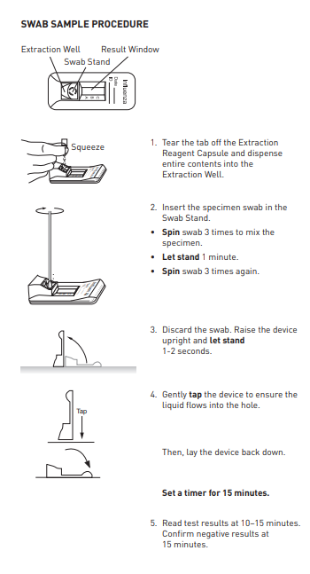1. Tear the tab off the Extraction Reagent capsule.

2. Squeeze the Extraction Reagent capsule to dispense all of the solution into the Extraction Well of the test device.

3. Insert the specimen swab on the Swab Stand in the Extraction Well. Spin swab 3 times to mix the specimen.

4. Incubate 1 minute with the swab in Extraction Well.

5. Spin swab 3 times to mix the specimen. Remove and discard the swab.

6. Raise the device upright (see picture).

7. Let it stand for 1-2 seconds. Gently tap the device to ensure that the liquid flows into the hole. 8. Lay the device back down onto the flat surface. Set a timer for 15 minutes.

9. Read test results at 10-15 minutes. Confirm negative results at 15 minutes.

INTERPRETATION OF RESULTS

Positive: A reddish-purple control line (C position) and a reddish-purple test line (A or B position) indicate that Influenza A or B antigen has been detected. Lines at the A and C positions indicate the presence of Influenza type A viral antigen, and lines at the B and C positions indicate the presence of Influenza type B viral antigen in the specimen. A positive result does not rule out co-infections with other pathogens or identify any specific influenza A virus subtype. Determination of a positive result can be made as soon as both a visible test line (either A or B) and control line appear.

Note: The test line (reddish-purple line) may vary in shade and intensity (light or dark, weak or strong) depending on the concentration of antigen detected. The intensity of the control line should not be compared to that of the test line for the interpretation of the test result. Even a light or faint test line must be interpreted as a positive result.

Negative: Only a reddish-purple control line (C position), with no test line at the A or B position, indicates that Influenza A or B antigen has not been detected. A negative result does not exclude influenza viral infection. Determination of negative results should not be made before 15 min.

Invalid: A reddish-purple line should always appear at the control line position (C). If a line does not form at the control line position in 15 minutes, the test result is invalid and the test should be repeated with a new McKesson Consult Influenza A&B Test device.

NOTE: Co-infection with Influenza A and B is rare. McKesson Consult Influenza A&B “dual positive” clinical specimens (Influenza A and Influenza B positive) should be re-tested. Repeatable influenza A and B “dual positive” results should be confirmed by cell culture or PCR testing before reporting results.

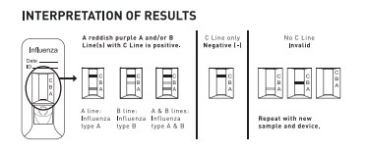

LIMITATIONS

* A negative test result does not exclude infection with influenza A or B. Therefore, the results obtained with the McKesson Consult Influenza A&B Test should be used in conjunction with clinical findings to make an accurate diagnosis. Additional testing is required to differentiate any specific influenza A and B subtypes or strains, in consultation with state or local public health departments.
* This test detects both viable (live) and non-viable influenza A and B. Test performance depends on the amount of virus (antigen) in the specimen and may or may not correlate with cell culture results performed on the same specimen.
* McKesson Consult Influenza A&B Test uses highly target specific monoclonal antibodies. As in most immunoassays, it may fail to detect, or detect with less sensitivity, influenza A viruses that have undergone minor amino acid changes in the target epitope region.
* Performance of the McKesson Consult Influenza A&B Test has not been established for monitoring antiviral treatment of influenza.
* Children tend to shed virus more abundantly and for longer periods of time than adults. Therefore, testing specimens from adults will result in lower sensitivity than testing specimens from children.
* Positive and negative predictive values are highly dependent on prevalence. False negative test results are more likely during peak activity when prevalence of disease is high. False positive test results are more likely during periods of low influenza activity when prevalence is moderate to low.
* Individuals who received nasally administered influenza A vaccine may produce positive test results for up to three days after vaccination. • The performance of this assay has not been evaluated for use in patients without signs and symptoms of respiratory infection.
* This test cannot rule out diseases caused by other bacterial or viral pathogens.
* The performance of this test has not been evaluated for sample types other than those specified in the Intended Use.
* The performance of this test has not been evaluated for immunocompromised individuals.
* The McKesson Consult Influenza A&B Test can distinguish between influenza A and B viruses, but it cannot differentiate influenza subtypes.

USER QUALITY CONTROL

Internal Quality Control:

Each McKesson Consult Influenza A&B Test device has built-in controls. The control line at the C position can be considered as an internal positive procedural control; i.e., a proper amount of sample was used, sample was properly added to the Extraction Well, sample migrated properly, and the reagent system worked properly. A distinct reddish-purple control line should always appear if the test has been performed correctly. If the control line does not appear, the test result is invalid and a new test should be performed. If the problem persists, contact Technical Support at 1-800-526-2125. A clear background in the test result window is considered an internal negative procedural control. If the test is performed correctly and the McKesson Consult Influenza A&B Test device is working properly, the background in the test result window will be clear, providing a distinct result.

External Quality Control:

Good laboratory practice includes the use of external controls to ensure proper kit performance. It is recommended that external control testing be performed with each new operator and before using a new lot or shipment of McKesson Consult Influenza A&B Test kits to confirm the expected Q.C. results, using the external controls provided in the kit. The frequency of additional Q.C. tests should be determined according to your laboratory’s standard Q.C. procedures and local, State and Federal regulations or accreditation requirements. Upon confirmation of the expected results, the kit is ready for use with patient specimens. If external controls do not perform as expected, do not use the test results. Repeat the tests or contact Technical Support at 1-800-526-2125. The built-in reddish-purple control line indicates only the integrity of the test device and proper fluid flow.

The McKesson Consult Influenza A&B Test kit contains two control swabs. Test the control swabs in the same manner as patient specimens. When the positive control is tested, reddish-purple lines appear at the C, A and B positions. When the negative control is tested, a reddish-purple line appears at the C position only.

If the controls do not perform as expected, do not report patient results.

The use of positive and negative controls from other commercial kits has not been established with McKesson Consult Influenza A&B Test.

EXPECTED VALUES

The prevalence of influenza varies every year and the rate of positives in influenza testing varies depending on many factors, including the specimen collection method, the test method used, the disease prevalence, and the geographic location. The expected values based on McKesson Consult Influenza A&B results were 30.3% for influenza A and 13.8% for influenza B during the 2007-2009 prospective clinical study, and were 33.6% for influenza A and 9.8% for influenza B during the 2014- 2016 prospective clinical study.

PERFORMANCE CHARACTERISTICS

Clinical Performance Prospective Clinical Study from 2007 to 2009

A prospective clinical study was conducted from January 2007 to March 2008 and during March and April 2009 to determine the performance of McKesson Consult Influenza A&B for nasopharyngeal aspirate, nasopharyngeal swab, and nasal swab specimens.

The samples were collected at 5 sites in the USA from patients who visited physicians’ offices and clinics with signs and symptoms of respiratory infection during the study period. All collected samples were tested with McKesson Consult Influenza A&B, and were cultured. The culture was initially used as the comparator method. The samples that produced discrepant results between McKesson Consult Influenza A&B and viral culture were further analyzed with an FDA-cleared real time RTPCR Flu A and B assay (PCR comparator assay hereafter).

The total number of patients tested was 862, of which 30% were 5 and younger, 38% were 6-21 years old, and the rest were older than 21. Forty-eight (48) percent were male and 52% were female. A total of 253 nasopharyngeal aspirate specimens and 609 nasopharyngeal swab or nasal swab specimens were included in the performance analyses below. (see package insert)

Reproducibility

The reproducibility study for McKesson Consult Influenza A&B Test was conducted at two physicians’ offices and one laboratory using a panel of 90 coded specimens for each site. Testing was performed by two personnel for five days at each site. The panel consists of coded samples of high negative, low positive and moderate positive specimens for each of influenza A and B. For influenza A and B positive samples, A/PR/8/34 (H1N1) and B/Maryland/1/59 were used. The low positive was the LOD level of each strain. Each specimen level was tested in triplicate every day per operator. Each operator conducted the tests using the coded samples following the test protocol given in the package insert as if they are testing patient sample including the sample extraction step.

The results obtained at each site agreed 100% with the expected results. No differences were observed within run (15 replicates), between runs (five different days), or between sites (two POL sites and one lab) (see package insert)

Analytical Sensitivity

Limit of Detection (LOD)

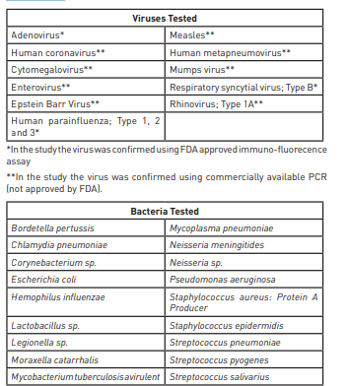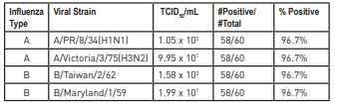The LODs were determined for each of the two strains selected from the influenza type A and type B strains listed in the analytical inclusivity (sensitivity) section below. The sensitivity level of each selected viral strain established in the analytical inclusivity (sensitivity) study was tested 60 times to confirm the sensitivity level as LOD level, which gives 95% detection rate. All four viral strains tested were detected 96.7% of the time in 60 replicates.(see package insert)

ANALYTICAL SPECIFICITY

Cross-Reactivity The potential cross-reactivity of the non-influenza respiratory pathogens and other microorganisms with which the majority of the population may be infected was tested using the McKesson Consult Influenza A&B Test at medically relevant levels, 106 cfu/mL for bacteria and 105 pfu/mL for nonflu viruses. None of the organisms or viruses listed in the table below gave a positive result with McKesson Consult Influenza A&B Tests at the tested concentration🡺

Interference

The interference study was conducted using medically relevant concentrations of the potentially interfering substances listed below with two strains each of influenza type A and type B to assess the potential interference of the substances on the performance of the McKesson Consult Influenza A&B Test. The test was conducted by spiking each substance into samples containing the lowest detectable virus level of influenza Type A or Type B for the positive interference testing and into samples 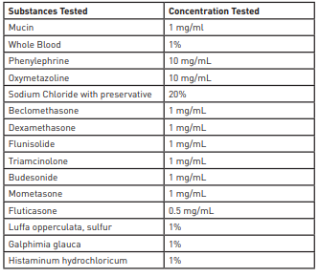without influenza virus for the negative interference testing. Each substance had no inhibitory effect on the McKesson Consult Influenza A&B Test at the concentration listed in the table.🡺

CLIA WAIVER STUDY

Clinical Study at CLIA Waived Sites

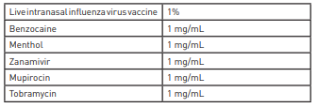To evaluate the expected performance of the McKesson Consult Influenza A&B Test when used by operators at CLIA-waived sites, a prospective clinical study was performed using nasopharyngeal and nasal swab specimens at seven CLIA waived sites (non-laboratory study sites) from December 2014 to May 2016. A total of sixteen operators from seven intended user sites in the USA were involved in the study. All collected samples were tested with both McKesson Consult Influenza A&B Tests and an FDA-cleared NAAT. The total number of samples tested was 455, of which 148 samples were archived samples which were confirmed by PCR as Influenza A or Influenza B.

The combined data from all sites of the prospective study and archived samples are presented.

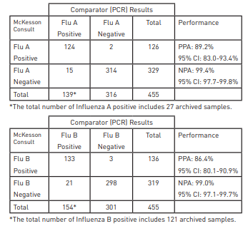

Performance with Near Cutoff Concentrations at CLIA Waived Sites

To determine the performance of operators at CLIA waived sites with the McKesson Consult Influenza A&B Test when tested with samples near the cutoff, this study was conducted using a sample panel consisting of high negative (C5 ), weak positive (C95) and moderate positive (3 x C95) samples for influenza type A and B, and samples negative for both flu A and B (true negative). For influenza A and B positive samples, A/Denver/1/57 (H1N1) and B/Maryland/1/59 were used. The testing was performed over a period of 10 days using 90 coded samples for each of 6 operators (True negative: 50, High Negative: 15, Low Positive; 15, Moderate Positive; 10 samples respectively). The results are summarized in below table

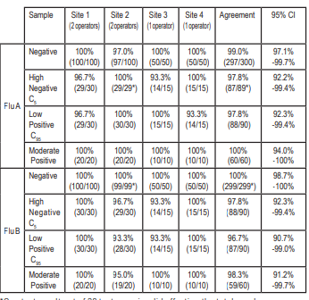*One test result out of 30 tests was invalid affecting the total number. Annual analytical reactivity testing results with CDC influenza panel and other information can be found on our web site at mms.mckesson.com

REFERENCES

1. Shaw MW, Arden NH and Massab HF. New aspects of influenza viruses. Clin. Microbiol. Rev. 5: 74-92 (1992)
2. WHO recommendations on the use of rapid testing for influenza diagnosis, July 2005.
3. Design Considerations for Pivotal Clinical Investigations for Medical Devices: Guidance for Industry, Clinical Investigators, Institutional Review Boards and Food and Drug Administration Staff, November 7, 2013 (Page 45)