
ETSU Physicians and Associates

ETSUHealth
MEAC POL

Policy Title: UScreen Drug Test Cup

Date Effective/Author: 1/19/2023 CEF

Reviewed by: | Date: | Revision Number: (i.e. A,B,C)

APPROVED BY:

Signature: ____________________________________________________
Administrative Director, ETSU Clinical Labs Date
Medical Director, MEAC POL

Signature: _____________________________________________________

Lab Manager, ETSU Clinical Labs Date

Principle / Purpose:

UScreen Drug Test Cup is a competitive immunoassay used to screen for the presence of multiple drugs of abuse in urine.

Reagents & Equipment:

- UScreen Drug Test Cup
- Adulteration color comparison chart
- Timer
- Gloves

Specimen Collection and Testing:

- Urine should be collected after the minimum detection time following suspected drug use. Each drug is cleared by the body and detectable at different times. Refer to the chart bellow for minimum and maximum detection times.

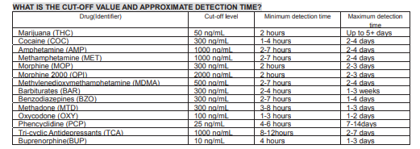

- Remove test cup from the foil package and uses as soon as possible.

- Remove the test cup lid and void directly into the test cup until urine reaches the minimum level mark on the cup.

- A minimum volume of 30 mL of urine is required for testing.

- Wipe any urine from the exterior of the collection cup and replace the lid.

- Observe the temperature strip on the test cup between 2 and 4 minutes. If the temperature is within acceptable limits of 32°C to 38°C (90°F to 100°F) testing can continue. If the specimen is not within the acceptable limits, the specimen is to be recollected in a new test cup and the temperature must be within acceptable before testing can continue.

- Place test cup on a flat surface.

- Peel off the label on the cup to reveal the test region.

- Read the adulteration strips as follows:

  - pH- Immediately
  - Creatinine (CR), and Specific Gravity (SG)- 45 seconds

Use the Adulteration Color Comparison Chart to verify the pad color is within acceptable range. If the results are not within the normal range, do not continue testing. If the specimen is not within the acceptable limits, the specimen is to be recollected in a new test cup.

- Once the specimen is verified as being acceptable for testing, read the test result for the drugs of abuse at 5 minutes.

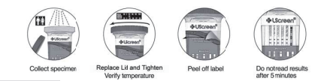

Quality Control:

- Internal Quality Control: A colored line in the control line region (C) of each test strip is considered an internal procedural control. This confirms sufficient specimen volume, adequate membrane wicking, and correct procedural technique.

- External Quality Control: Separately purchased external positive and negative quality control materials are to be ran with each new lot and new shipment of test cups or every 30 days of use. QC must be documented after it is complete. If the QC results are not acceptable, patient testing cannot be performed. All QC must be acceptable and documented prior to patient testing.

Reporting Results:

All results obtained are preliminary and are used as a screening method.

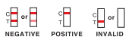

Limitations:

Adulterants, such as bleach and/or alum, in urine specimens may produce erroneous results regardless of the analytical method. If adulteration is suspected, the test must be repeated with a different specimen.

A positive result does not indicate a level of intoxication.

A negative result can be obtained when the drug is present in levels that are below the threshold of the test.

This test does not differentiate between drugs of abuse and certain medications, foods, or food supplements.

Troubleshooting / Corrective Actions:

For assistance with troubleshooting the Drugs of Abuse Test Cup, please call

Technical Support: 1-888-669-4337 or

ETREL 423-439-8031

Warnings and Precautions:

Following the Universal Precautions, handle all blood and body fluids with caution. All specimens and containers are to be disposed of in the biohazard containers. Wear gloves at all times and disinfect work area before and after each patient.

References:

Abbott. (2020). UScreen Drugs of Abuse Cup. Package Insert.

UScreen Drugs of Abuse Test Cups
Patient Worksheet
Name: _____________________ Tech: _____

DOB: ______________________

Collection Date :_____________

Collection Time:_____________

Start Time: _________________

Specimen Validity Results: Use the Color Chart Card for Results

 | Acceptable Range | Pass | Fail
pH  read immediately | 4.5-9.0
Specific Gravity (S.G.)  read at 45 seconds | 1.003-1.025
Creatinine (CR)  read at 45 seconds | <20 mg/dL
Temperature  read at 2 minutes | 90°F-100°F
***If the Specimen Validity results are not within the normal range, do not continue testing. Another specimen must be collected.

Drugs of Abuse Results: See Expected Results Below for Interpretation

Read at 5 Min | Cut-off (ng/mL) | Positive | Negative
THC | 50
COC | 300
MOP | 300
AMP | 1000
MET | 1000
BAR | 300
BZO | 300
MDMA | 500
MTD | 300
OXY | 100
PCP | 25
BUP | 10

