
ETSU Physicians and Associates

ETSUHealth
MEAC POL

Policy Title: True Metrix Pro
Date Effective/Author: 5/18/2023- CEF

Reviewed by: | Date: | Revision Number: (i.e. A,B,C)

APPROVED BY:

Signature: ____________________________________________________
Administrative Director, ETSU Clinical Labs Date
Medical Director, MEAC POL

Signature: _____________________________________________________

Lab Manager, ETSU Clinical Labs Date

Principle / Purpose:

The TRUE METRIX® PRO Blood Glucose Monitoring System is intended for the quantitative determination of glucose in human whole blood taken from the fingertip or forearm (capillary) or from the vein (venous). The system is not to be used for neonates less than 30 days old. The system is intended for multiple-patient use in professional healthcare settings.

Specimen Collection and Requirements:

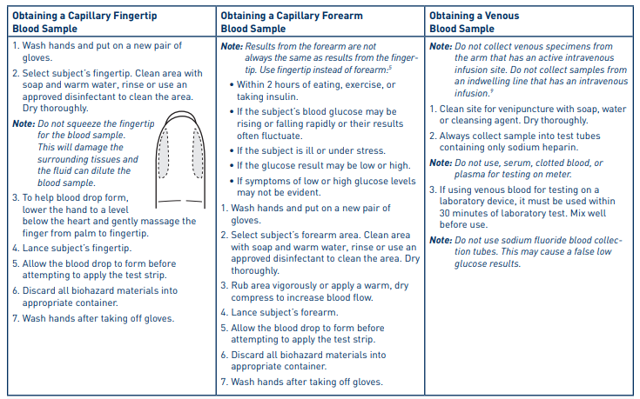

Reagents & Equipment:

- True Metrix Pro Meter
- True Metrix Pro Strips
- Lancet
- True Metric Control Solution, level 1 and level 3
- Gloves

Quality Control:

Internal Control: An automatic self-test is performed by the meter each time a test strip is inserted into the test port. If the self-test fails, an error message appears on the display and it will not perform a test. Follow the troubleshooting guide in the operator’s manual or call technical support 1-800-803-6025 for further assistance.

External Quality Control: Only True Metrix Control Solution is acceptable for use with the True Metrix Pro Meter. Level 1(low) and Level 3 (high) control material are to be uses prior to patient testing:

- With each new lot of strips
- Every 30 days
- To perform competency training for new employees
- To troubleshoot the analyzer

The acceptable ranges for the control material are located on the test strip bottle. These ranges may very between lots of test strips.

If the external quality control is not within the acceptable range, patient testing cannot be performed. Repeat the testing and call technical support 1-800-803-6025 for further assistance.

Testing Procedure / Operating instructions:

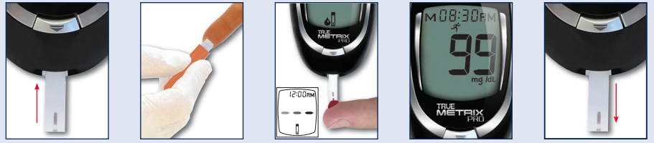
1. Insert test 2. Lance finger 3. Once drop 4. Glucose 5. Remove
Strip and allow appears on results will strip and
blood drop the display, appear in disinfect
to from allow the 4 seconds the meter
blood to be
drawn into
the strip

Reporting Results:

All results must be manually entered into the EHR.

The linear range of the True Metrix Pro is 20-600 mg/dL. Any results that are outside of the linear range must be verified by a different methodology.

Limitations:

The system is not to be used for neonates less than 30 days old.

Do not use for the diagnosis or screening for diabetes mellitus.

This device has not been validated for use with critically ill patients.

Alternative site (forearm) testing should not be used to calibrate continuous glucose monitors or for insulin dose calculations.

Do not us if blood concentrations of ascorbic acid is > 2 mg/dL.

Do not use if blood concentrations of uric acid is > 5 mg/dL.

Troubleshooting / Corrective Actions:

Follow the troubleshooting guide in the operator’s manual or call technical support 1-800-803-6025 for further assistance.

Warnings and Precautions:

Universal Precautions are to be followed while handling all blood and body fluids. All specimens and containers are to be disposed of in the biohazard containers. Wear gloves at all times and disinfect work area before and after each patient.

References:

TRUE METRIX® PRO System Comprehensive Resource Guide (GDH-FAD Enzyme), 2014

