This Procedural Bulletin is intended to provide a ready outline reference for performance of the assay. These abbreviated directions for use are not intended to replace the complete package insert. It is the obligation of every manufacturer of medical devices labeled FOR *IN VITRO* DIAGNOSTIC USE to provide a complete package insert in accordance with FDA labeling regulation (21 CFR 809.10).

**Quidel Corporation provides CLSI procedures for your use. The procedures are required to include the same information as listed in the package insert. Any modifications to this document are the sole responsibility of the Laboratory.**

\_\_\_\_\_\_\_\_\_\_\_\_\_\_\_\_\_\_\_\_\_\_\_\_\_\_\_\_\_\_\_\_\_\_\_\_\_\_\_\_\_\_\_\_\_\_\_\_\_\_\_\_\_\_\_\_\_\_\_\_\_\_\_\_\_\_\_\_\_\_\_\_\_\_\_\_\_\_\_\_\_\_\_\_\_\_\_\_\_

**QuickVue Influenza A+B**

**CLIA Complexity: Waived**

For *in vitro* use only 

# **INTENDED USE**

The QuickVue Influenza A+B Test allows for the rapid, qualitative detection of influenza type A and type B antigens directly in nasal swab and nasopharyngeal swab specimens from symptomatic patients. The test is intended for use as an aid in the rapid differential diagnosis of acute influenza type A and type B viral infections. The test is not intended to detect influenza C antigens. A negative test is presumptive, and it is recommended these results be confirmed by viral culture or an FDA-cleared influenza A and B molecular assay. Negative results do not preclude influenza virus infections and should not be used as the sole basis for treatment or other patient management decisions. The test is intended for professional and laboratory use.

Performance characteristics for influenza A were established during the 2017/2018 influenza seasons when influenza A/H3N2 and A/H1N1 pandemic were the predominant influenza A viruses in circulation. When other influenza A viruses are emerging, performance characteristics may vary.

If infection with a novel influenza A virus is suspected based on current clinical and epidemiological screening criteria recommended by public health authorities, specimens should be collected with appropriate infection control precautions for novel virulent influenza viruses and sent to state or local health department for testing. Viral culture should not be attempted in these cases unless a BSL 3+ facility is available to receive and culture specimens.

# **SUMMARY AND EXPLANATION**

Influenza is a highly contagious, acute, viral infection of the respiratory tract. The causative agents of the disease are immunologically diverse, single-strand RNA viruses known as influenza viruses. There are three types of influenza viruses: A, B, and C. Type A viruses are the most prevalent and are associated with most serious epidemics. Type B viruses produce a disease that is generally milder than that caused by type A. Type C viruses have never been associated with a large epidemic of human disease. Both type A and B viruses can circulate simultaneously, but usually one type is dominant during a given season.1

Influenza antigens may be detected in clinical specimens by immunoassay. The QuickVue Influenza A+B Test is a lateral-flow immunoassay using highly sensitive monoclonal antibodies that are specific for influenza antigens. The test is specific to influenza types A and B antigens with no known cross-reactivity to normal flora or other known respiratory pathogens.

**PRINCIPLE OF THE TEST**

The QuickVue Influenza A+B Test involves the extraction of influenza A and B viral antigens. The patient specimen is placed in the Reagent Tube, during which time the virus particles in the specimen are disrupted, exposing internal viral nucleoproteins. After extraction, the Test Strip is placed in the Reagent Tube where nucleoproteins in the specimen will react with the reagents in the Test Strip.

If the extracted specimen contains influenza A or B antigens, a pink-to-red Test Line along with a blue procedural Control Line will appear on the Test Strip indicating a positive result. The Test Line for influenza A or B will develop at separate specified locations on the same Test Strip. If influenza A or B antigens are not present, or are present at very low levels, only the blue procedural Control Line will appear.

# **REAGENTS AND MATERIALS SUPPLIED**

*25-Test Kit: Catalog Number 20183*

* Shelf box containing:
* Individually Packaged Test Strips (25): Mouse monoclonal anti-influenza A and anti-influenza B antibodies
* Reagent Solution (25): Vials with 340 µL of salt solution
* Reagent Tubes (25): Lyophilized buffer with detergents and reducing agents
* Disposable Pipettes (25)
* Sterile Nasal Swabs (25)
* Positive Influenza Type A Control Swab (1): Swab is coated with non-infectious recombinant influenza A antigen
* Positive Influenza Type B Control Swab (1): Swab is coated with non-infectious recombinant influenza B antigen
* Negative Control Swab (1): Swab is coated with heat-inactivated, non-infectious Streptococcus C antigen
* Package Insert (1)
* Procedure Card (1)

# **MATERIALS NOT SUPPLIED**

* Specimen containers
* Timer or watch

# **WARNINGS AND PRECAUTIONS**

* For *in vitro* diagnostic use
* Do not use the kit contents beyond the expiration date printed on the outside of the box.
* Use appropriate precautions in the collection, handling, storage, and disposal of patient samples and used kit contents.2
* Use of Nitrile or Latex gloves is recommended when handling patient samples.2
* The Test Strip must remain sealed in the protective foil pouch until use.
* The Reagent Solution contains a salt solution. If the solution contacts the skin or eye, flush with copious amounts of water.
* To obtain accurate results, you must follow the Package Insert.
* Inadequate or inappropriate specimen collection, storage, and transport may yield false negative test results.
* Seek specific training or guidance if you are not experienced with specimen collection and handling procedures.3,4
* Use the Transport Media recommended in the Package Insert.
* If infection with a novel influenza A virus is suspected based on current clinical and epidemiological screening criteria recommended by public health authorities, specimens should be collected with appropriate infection control precautions for novel virulent influenza viruses and sent to state or local health departments for testing. Viral culture should not be attempted in these cases unless a BSL 3+ facility is available to receive and culture specimens.
* Although this test has been shown to detect cultured avian influenza viruses, including avian influenza A subtype H5N1 virus, the performance characteristics of this test with specimens from humans infected with H5N1 or other avian influenza viruses are unknown.
* Testing should be performed in an area with adequate ventilation.
* Dispose of containers and unused contents in accordance with Federal, State and Local regulatory requirements.
* Wear suitable protective clothing, gloves, and eye/face protection when handling the contents of this kit.
* Wash hands thoroughly after handling.
* For additional information on hazard symbols, safety, handling and disposal of the components within this kit, please refer to the Safety Data Sheet (SDS) located at quidel.com.

# **KIT STORAGE AND STABILITY**

Store the kit at room temperature, 59°F to 86°F (15°C to 30°C), out of direct sunlight. Kit contents are stable until the expiration date printed on the outer box. Do not freeze.

# **SPECIMEN COLLECTION AND HANDLING**

**Proper specimen collection, storage, and transport are critical to the performance of this Test.3,4**

## **Specimen Collection**

***Nasal Swab Sample:***

**For optimal test performance with a Nasal Swab specimen, use the Swabs supplied in the kit.**

It is important to obtain as much secretion as possible. Therefore, to collect a Nasal Swab sample, insert the sterile Swab into the nostril that presents the most secretion under visual inspection. Using gentle rotation, push the Swab until resistance is met at the level of the turbinates (less than one inch into the nostril). Rotate the Swab a few times against the nasal wall.

***Nasopharyngeal Swab Sample:***

It is important to obtain as much secretion as possible. Therefore, to collect a Nasopharyngeal Swab sample, carefully insert the sterile Swab into the nostril that presents the most secretions under visual inspection. Keep the Swab near the septum floor of the nose while gently pushing the Swab into the posterior nasopharynx. Rotate the Swab several times.

## **SPECIMEN TRANSPORT AND STORAGE**

Specimens should be tested as soon as possible after collection. However, if transport of Swab samples is required, minimal dilution of the sample is recommended, as this may result in decreased test sensitivity. One (1) milliliter or less is suggested for optimal rapid test performance. The following transport media are compatible with the QuickVueInfluenza A+B Test:

|  |  |  |  |
| --- | --- | --- | --- |
| **Transport Media** | **Recommended Storage Condition** | | |
| 2°C to 25°C  8 hours | 2°C to 25°C  24 hours | 2°C to 8°C  48 hours |
| BD Universal Viral Transport Media | Yes | Yes | Yes |
| Bartels Flextrans Media | Yes | No | No |
| Copan Universal Transport Media | Yes | Yes | Yes |
| Hank’s Balanced Salt Solution | Yes | No | No |
| M5 Media | Yes | No | No |
| Saline | Yes | No | No |
| Storage of sample in a clean, dry, closed container | Yes | No | No |

The M4, M4-RT, Liquid Amies-D, Amies Clear, Modified Stuart’s and Ramel M6 transport media are not compatible with this device.

**NOTE: QuickVueInfluenza A+B Test performance testing Swab samples diluted in transport media has not been evaluated and established in clinical studies.**

# **QUALITY CONTROL**

## **Built-in Control Features**

The QuickVue Influenza A+B Test contains built-in procedural control features. The manufacturer’s recommendation for daily control is to document these built-in procedural controls for the first sample tested each day.

The two-color result format provides a simple interpretation for positive and negative results. The appearance of a blue procedural Control Line provides several forms of positive control by demonstrating sufficient flow has occurred and the functional integrity of the Test Strip was maintained. **If the blue procedural Control Line does not develop at 10 minutes, the test result is considered invalid.**

A built-in negative control is provided by the clearing of red background color, verifying that the test has been performed correctly. Within 10 minutes, the result area should be white to light pink and allow the clear interpretation of the test result. **If background color appears and interferes with interpretation of the test result, the result is considered invalid.** Should this occur, review the procedure and repeat the test with a new Test Strip.

## **External Quality Control**

External controls may also be used to demonstrate that the reagents and assay procedure perform properly.

Quidel recommends that positive and negative controls be run once for each untrained operator, once for each new shipment of kits – provided that each different lot received in the shipment is tested – and as deemed additionally necessary by your internal quality control procedures, and in accordance with Local, State, and Federal regulations or accreditation requirements.

If the controls do not perform as expected, repeat the test or contact Quidel Technical Support before testing patient specimens.

External Positive and Negative Control Swabs are supplied in the kit and should be tested using the Nasal/Nasopharyngeal Swab Test Procedure provided in this Package Insert or in the Procedure Card.

# **TEST PROCEDURE**

**All clinical specimens must be at room temperature before beginning the assay.**

**Expiration date:** Check expiration on each individual test package or outer box before using. *Do not use any test past the expiration date on the label.*

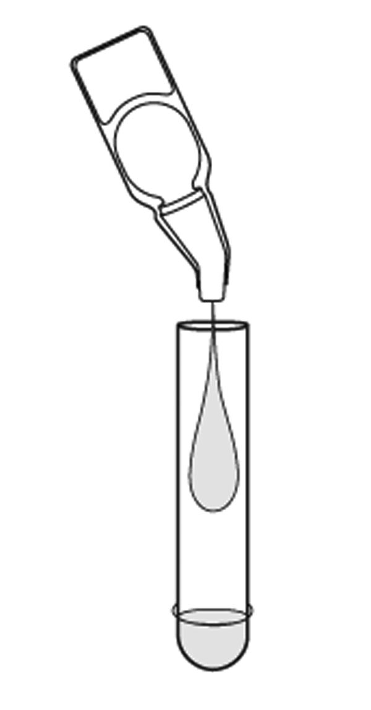

## **Nasal/Nasopharyngeal Swab Procedure**

1. Dispense all of the Reagent Solution into the Reagent Tube. Gently swirl the Tube to dissolve its contents.
2. 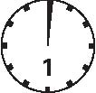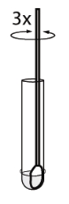Place the patient Swab with sample into the Reagent Tube. Roll the Swab at least 3 times while pressing the head against the bottom and side of the Reagent Tube.

**Leave the Swab in the Reagent Tube for 1 minute.**

**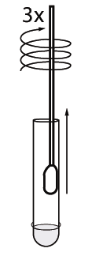**

1. Roll the Swab head against the inside of the Reagent Tube as you remove it. Dispose of the used Swab in accordance with your biohazard waste disposal protocol.



1. Place the Test Strip into the Reagent Tube with the arrows on the Test Strip pointing down. Do not handle or move the Test Strip until the test is complete and ready for reading.

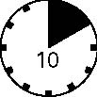

1. Read result at 10 minutes. Some positive results may appear sooner. Do not read result after 10 minutes.

# **INTERPRETATION OF RESULTS**

***Positive Result\*:***

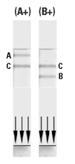At 10 minutes, the appearance of **ANY** shade of a pink-to-red Test Line, either above or below the blue Control Line, **AND** the appearance of a blue procedural Control Line indicates a positive result for the presence of influenza A and/or B viral antigen.

Hold the test strip with the **arrows pointed down**.

* If the red line is **above** the Control Line, the test results are positive for type A. See image to the immediate right (A+).
* If the red line is **below** the Control Line, the test results are positive for type B. See image to the far right (B+).

*\*A positive result does not rule out co-infections with other pathogens or identify any specific influenza A virus subtype.*

***Negative Result\*\*:***

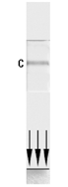At 10 minutes, the appearance of **ONLY** the blue procedural Control Line indicates influenza A and B viral antigen were not detected. A negative result should be reported as a presumptive negative for the presence of influenza antigen.

*\*\*A negative result does not exclude influenza viral infection. Negative results should be confirmed by cell culture.*

*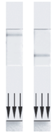****Invalid Result:***

**If at 10 minutes, the blue procedural Control Line does not appear**, even if any shade of a pink-to-red Test Line appears, **the result is considered invalid**. If at 10 minutes, the background color does not clear and it interferes with the reading of the test, the result is considered invalid. If the test is invalid, a new test should be performed with a new patient sample and a new Test Strip.

**NOTE: Co-infection with influenza A and B is rare. QuickVue Influenza A+B Test “dual positive” clinical specimens (influenza A and influenza B positive) should be re-tested. Repeatable influenza A and B “dual positive” results should be confirmed by viral culture or an FDA-cleared influenza A and B molecular assay before reporting results.**

\_\_\_\_\_\_\_\_\_\_\_\_\_\_\_\_\_\_\_\_\_\_\_\_\_\_\_\_\_\_\_\_\_\_\_\_\_\_\_\_\_\_\_\_\_\_\_\_\_\_\_\_\_\_\_\_\_\_\_\_\_\_\_\_\_\_\_\_\_\_\_\_\_\_

# **LIMITATIONS**

* The contents of this kit are to be used for the qualitative detection of influenza A and B antigen from nasal swab and nasopharyngeal swab specimens.
* A negative test result may occur if the level of antigen in a sample is below the detection limit of the test.
* Failure to follow the Test Procedure and Interpretations of Test Results may adversely affect test performance and/or invalidate the Test Result.
* Test Results must be evaluated in conjunction with other clinical data available to the physician.
* Negative test results do not rule-out possible other non-influenza viral infections.
* Positive test results do not rule out co-infections with other pathogens.
* Positive test results do not identify specific influenza A virus subtypes.
* Children tend to shed virus more abundantly and for longer periods of time than adults. Therefore, testing specimens from adults will often yield lower sensitivity than testing specimens from children.
* Positive and negative predictive values are highly dependent on prevalence. False negative test results are more likely during peak activity when prevalence of disease is high. False positive test results are more likely during periods of low influenza activity when prevalence is moderate to low.
* Individuals who received nasally administered influenza A vaccine may have positive test results for up to 3 days after vaccination.
* Monoclonal antibodies may fail to detect, or detect with less sensitivity, influenza A viruses that have undergone minor amino acid changes in the target epitope region.
* If differentiation of specific influenza A subtypes and strains is needed, additional testing, in consultation with the State or Local public health department, is required.

# **EXPECTED VALUES**

Seasonal outbreaks of influenza occur worldwide in both the northern and southern hemispheres causing widespread illness each winter. The average attack rate of influenza is 26-33 cases per 100 people per year. The risk of hospitalization is roughly 1/300 of those infected among the very young and elderly. Approximately 36,000 deaths in the U.S. are attributed to influenza or its complications each year. Ninety percent (90%) of deaths occur in those 65 years of age and older. During each of three major epidemics occurring in 1957 and 1968, more than 40,000 people died of influenza in the U.S. alone. In the 1918 pandemic, an estimated 50 million deaths resulted worldwide. In the multi-center clinical study conducted by Quidel during an influenza season in North America, an illness prevalence of 25% for type A and 15% for type B influenza was observed.

# **PERFORMANCE CHARACTERISTICS**

## QuickVue Influenza A+B Test Performance vs. An FDA-Cleared Influenza A and B Molecular Assay

***2017/2018 Clinical Study in the United States***

The performance of the QuickVue Influenza A+B Test was evaluated in a prospective multi-center field clinical study during two distinct influenza seasons in the United States, February through May 2017 and October 2017 through January 2018.

In this clinical study, the performance of the QuickVue Influenza A+B Test was compared to an FDA-cleared influenza A and B molecular assay. This study was conducted at five (5) clinical sites, which were CLIA waived test environments comprised of Urgent Care, Pediatric and General Practice offices. A total of forty-eight (48) operators from the five intended user sites participated in the study. The results are shown in Tables 1 and 2.

In this multi-center, point-of-care (POC) field trial, two (2) nasal or two (2) nasopharyngeal swab specimens were collected from each of a total of one thousand one hundred and eighty-three (1183) patients. All clinical samples were collected from symptomatic patients meeting the inclusion and exclusion criteria. Thirty-nine percent (39%) of the patients tested were <5 years of age, forty-one percent (41%) 5-<18 years of age, and twenty percent (20%) ≥18 years of age. Forty-eight percent (48%) were male and fifty-two percent (52%) were female.

On-site testing of one nasal swab or nasopharyngeal swab specimen in the QuickVue Influenza A+B Test was performed by CLIA waived test operators within one (1) hour of collection. This swab was incubated for one (1) minute with the Extraction Reagent Solution before addition of the dipstick. The other swab was placed in viral transport media and stored at 2°C to 8°C prior to testing with the FDA-cleared influenza A and B molecular assay.

**Table 1**

**QuickVue Influenza A+B Nasal/Nasopharyngeal Swab Performance versus the FDA-cleared Influenza A and B Molecular Assay (All Age Groups)**

|  |  |  |  |
| --- | --- | --- | --- |
| **TYPE A** | | **TYPE B** | |
| |  |  |  | | --- | --- | --- | |  | Molecular | | |  | + | - | | QV Pos | 190 | 21 | | QV Neg | 43 | 924 | | PPA = 190/233= 81.5%  (95% C.I. 76.1%-86.0%)  NPA = 924/945= 97.8%  (95% C.I. 96.6%-98.5%) | |  |  |  | | --- | --- | --- | |  | Molecular | | |  | + | - | | QV Pos | 89 | 10 | | QV Neg | 21 | 1058 | | PPA = 89/110 = 80.9%  (95% C.I. 72.6%-87.2%)  NPA= 1058/1068 = 99.1%  (95% C.I. 98.3%-99.5%) |

**Table 2**

**QuickVue Influenza A+B Nasal/Nasopharyngeal Swab Performance versus the FDA-cleared Influenza A and B Molecular Assay (by Age Group)**

|  |  |  |  |  |  |  |
| --- | --- | --- | --- | --- | --- | --- |
|  | **<5 years of age** | | **5-<18 years of age** | | **≥18 years of age** | |
| **N=458** | | **N=480** | | **N=240** | |
| **PPA** | **NPA** | **PPA** | **NPA** | **PPA** | **NPA** |
| **Type A** | 90.0% (63/70) | 98.2% (381/388) | 80.4% (90/112) | 97.8% (360/368) | 72.5% (37/51) | 96.8% (183/189) |
| **Type B** | 84.2% (16/19) | 99.3% (436/439) | 80.3% (61/76) | 98.8% (399/404) | 80.0% (12/15) | 99.1% (223/225) |

# **ANALYTICAL SPECIFICITY AND CROSS-REACTIVITY**

The QuickVue Influenza A+B Test was evaluated with a total of 62 bacterial and viral isolates. Bacterial isolates were evaluated at a concentration between 107 and 109 org/mL. Viral isolates were evaluated at a concentration of at least 104–108 TCID50/mL Adenovirus 18 and Parainfluenza virus 3 were tested at 102 TCID50/mL. None of the organisms or viruses listed below in Table 3 gave a positive result in the QuickVue Influenza A+B Test.

**Table 3**

**Analytical Specificity and Cross-Reactivity**

|  |  |
| --- | --- |
| **Bacterial Panel:** | **Viral Panel:** |
| *Acinetobacter calcoaceticus* | Adenovirus 5 (Ad. 75) |
| *Bacteroides fragilis* | Adenovirus 7 (Gomen) |
| *Bordetella pertussis* | Adenovirus 10 (J.J.) |
| *Branhamella catarrhalis* | Adenovirus 18 (D.C.) |
| *Candida albicans* | Coronavirus OC43 |
| *Corynebacterium diphtheriae* | Coxsackievirus A9 (Bozek) |
| *Enterococcus faecalis* | Coxsackievirus B5 (Faulkner) |
| *Escherichia coli* | Cytomegalovirus (Towne) |
| *Gardnerella vaginalis* | Echovirus 2 (Cornelis) |
| *Haemophilus influenzae* | Echovirus 3 (Morrisey) |
| *Klebsiella pneumoniae* | Echovirus 6 (D’Amori) |
| *Lactobacillus casei* | Herpes simplex virus 1 |
| *Lactobacillus plantarum* | Herpes simplex virus 2 |
| *Legionella pneumophila* | Human Rhinovirus 2 (HGP) |
| *Listeria monocytogenes* | Human Rhinovirus 14 (1059) |
| *Mycobacterium avium* | Human Rhinovirus 16 (11757) |
| *Mycobacterium intracellulare* | Measles (Edmonston) |
| *Mycobacterium tuberculosis* | Mumps (Enders) |
| *Mycoplasma orale* | Parainfluenza virus 1 (Sendai) |
| *Mycoplasma pneumoniae* | Parainfluenza virus 2 (CA/Greer) |
| *Neisseria gonorrhoeae* | Parainfluenza virus 3 (C243) |
| *Neisseria meningitidis* | Respiratory Syncytial virus (A-2) |
| *Neisseria sicca* | Respiratory Syncytial virus |
| *Neisseria subflava* | (Subgroup A, Long chain) |
| *Proteus vulgaris* | Rubella (RA 27/3) |
| *Pseudomonas aeruginosa* | Varicella-Zoster (Ellen) |
| *Serratia marcescens* |  |
| *Staphylococcus aureus* |  |
| *Staphylococcus epidermidis* |  |
| *Streptococcus mutans* |  |
| *Streptococcus pneumoniae* |  |
| *Streptococcus pyogenes* |  |
| *Streptococcus sanguis* |  |
| Streptococcus sp. Gp. B |  |
| Streptococcus sp. Gp. C |  |
| Streptococcus sp. Gp. F |  |
| Streptococcus sp. Gp. G |  |

# **ANALYTICAL SENSITIVITY**

Limit of detection was determined using a total of forty-eight (48) strains of human influenza viruses: thirty-five (35) influenza A and thirteen (13) influenza B (Table 4).

**Table 4**

**Limit of Detection with Human Isolates of Influenza A and B**

|  |  |  |  |  |  |  |  |
| --- | --- | --- | --- | --- | --- | --- | --- |
| **Viral Strain** | **Viral Type** | **Sub-Type** | **Minimum Detectable Level** | **Viral Strain** | **Viral Type** | **Sub-Type** | **Minimum Detectable Level** |
|  |  |  | **TCID50/mL** |  |  |  | **pfu/mL\*\*** |
| New Caledonia/20/99 | A | H1N1 | 1.63 x 103 | Fort Monmouth/1/47 | A | H1N1 | 6.70 x 103 |
| California/04/09\* | A | H1N1 | 4.4 x 103 | Aichi | A | H3N2 | 3.20 x 103 |
|  |  |  |  | Shangdong | A | H3N2 | 8.40 x 103 |
|  |  |  | **EID50/mL** | Maryland/91 | A | H1N1 | 1.00 x 104 |
| A/Anhui/1/2013\* | A | H7N9 | 7.90 x 106 | Japan/305/57 | A | H2N2 | 1.30 x 104 |
|  |  |  |  | Johannesburg/94 | A | H3N2 | 1.44 x 104 |
|  |  |  | **pfu/mL\*\*** | Brazil | A | H1N1 | 1.70 x 104 |
| Hong Kong | A | H3N2 | 6.60 x 10-1 | Sydney | A | H3N2 | 2.00 x 104 |
| Beijing/32/92 | A | H3N2 | 3.30 x 100 | Bangkok | A | H3N2 | 3.30 x 104 |
| Shanghai/11 | A | H3N2 | 6.70 x 100 | Wuhan | A | H3N2 | 3.30 x 104 |
| Shanghai/16 | A | H3N2 | 1.00 x 101 | Beijing/353/89 | A | H3N2 | 3.30 x 105 |
| Victoria | A | H3N2 | 3.30 x 101 | Singapore/86 | A | H1N1 | 6.60 x 105 |
| Singapore/1/57 | A | H2N2 | 6.70 x 101 | Texas/91 | A | H1N1 | 1.60 x 107 |
| Port Chalmers | A | H3N2 | 1.24 x 102 | Victoria | B |  | 1.40 x 104 |
| USSR | A | H1N1 | 2.00 x 102 | Taiwan | B |  | 1.10 x 102 |
| Puerto Rico/8/34 | A | H1N1 | 2.60 x 102 | Panama | B |  | 1.00 x 100 |
| New Jersey | A | H1N1 | 2.70 x 102 | Ann Arbor | B |  | 3.30 x 102 |
| Taiwan | A | H1N1 | 3.30 x 102 | Singapore | B |  | 3.30 x 102 |
| Tokyo/3/67 | A | H2N2 | 3.40 x 102 | Lee | B |  | 6.60 x 102 |
| Bayern | A | H1N1 | 6.60 x 102 | Hong Kong | B |  | 7.00 x 102 |
| Sichuan | A | H3N2 | 6.60 x 102 | Beijing/184/93 | B |  | 1.66 x 103 |
| Beijing/352/89 | A | H3N2 | 7.70 x 102 | California | B |  | 3.30 x 103 |
| NWS/33 | A | H1N1 | 1.00 x 103 | Maryland | B |  | 6.60 x 103 |
| Fort Warren/1/50 | A | H1N1 | 1.70 x 103 | Yamagata/16/88 | B |  | 6.70 x 103 |
| Mississippi | A | H3N2 | 1.70 x 103 | Harbin | B |  | 1.40 x 104 |
| Texas/77 | A | H1N1 | 3.30 x 103 | Stockholm | B |  | 3.30 x 105 |
| TCID50/mL = 50% tissue culture infectious dose ; EID50/mL = 50% egg infective dose; pfu/mL = plaque-forming unit per milliliter.  \*Although this test has been shown to detect the 2009 H1N1 and H7N9 viruses cultured from a positive human respiratory specimens, the performance characteristics of this device with clinical specimens that are positive for the 2009 H1N1 or H7N9 infuenza viruses have not been established. The QuickVue Influenza A+B Test can distinguish between influenza A and B viruses, but it cannot differentiate influenza subtypes.  \*\*These viral strains were obtained from American Type Culture Collection (ATCC) with titer information, and the titers were not verified by Quidel. The performance characteristics for influenza A virus subtypes emerging as human pathogens have not been established. | | | | | | | |

Analytical reactivity was further evaluated using a total of twenty-four (24) influenza A viruses isolated from birds and mammals. The QuickVue Influenza A+B Test detected all of the strains examined (Table 5).

**Table 5**

**Analytical Reactivity with Bird and Mammal Isolates of Influenza A**

|  |  |  |
| --- | --- | --- |
| **Viral Strain\*** | **Viral**  **Type** | **Viral Subtype** |
| Duck/Tottori/723/80 | A | H1N1 |
| Duck/Alberta | A | H1N1 |
| Duck/Hokkaido/17/01 | A | H2N2 |
| Duck/Mongolia/4/03 | A | H3N8 |
| Duck/Ukraine/1/63 | A | H3N8 |
| Equine/Miami/1/63 | A | H3N8 |
| Duck/Czech/56 | A | H4N6 |
| Hong Kong/483/97 | A | H5N1 |
| Hong Kong/156/97 | A | H5N1 |
| Chicken/Yamaguchi/7/04 | A | H5N1 |
| A/Chicken/Vietnam/33/04 | A | H5N1 |
| A/Vietnam/3028/04 | A | H5N1 |
| A/Thailand/MK2/04 | A | H5N1 |
| Duck/Pennsylvania/10128/84 | A | H5N2 |
| Turkey/Massachusetts/3740/65 | A | H6N2 |
| Seal/Massachusetts/1/80 | A | H7N7 |
| Turkey/Ontario/67 | A | H8N4 |
| Turkey/Wisconsin/66 | A | H9N2 |
| Chicken/Germany/N/49 | A | H10N7 |
| Duck/England/56 | A | H11N6 |
| Duck/Alberta/60/76 | A | H12N5 |
| Gull/Maryland/704/77 | A | H13N6 |
| Mallard/Astrakhan/263/82 | A | H14N5 |
| Duck/Australia/341/83 | A | H15N8 |
| \*Performance characteristics for detecting influenza A virus from human specimens when these or other influenza A virus subtypes are emerging as human pathogens have not been established. | | |

# **INTERFERING SUBSTANCES**

Whole blood, and several over-the-counter (OTC) products and common chemicals were evaluated and did not interfere with the QuickVue Influenza A+B Test at the levels tested: whole blood (2%); three OTC mouthwashes (25%); three OTC throat drops (25%); three OTC nasal sprays (10%); 4-Acetamidophenol (10 mg/mL); Acetylsalicylic Acid (20 mg/mL); Chlorpheniramine (5 mg/mL); Dextromethorphan (10 mg/mL); Diphenhydramine (5 mg/mL); Ephedrine (20 mg/mL); Guaiacol glyceryl ether (20 mg/mL); Oxymetazoline (10 mg/mL); Phenylephrine (100 mg/mL); and Phenylpropanolamine (20 mg/mL).

# **PRECISION STUDIES**

The total, within-run, and between-run performance of the QuickVue Influenza A+B Test was evaluated for precision. A panel consisting of two different levels of influenza A antigen (Johannesburg/82/96; weak positive and strong positive) and two different levels of influenza B antigen (Harbin/7/94; weak positive and strong positive) were repeated five times with a single lot of QuickVue Influenza A+B Test on three different days. One hundred percent (100%) accuracy was obtained for all specimens tested.

# **Physician’s Office Laboratory (POL) Studies**

An evaluation of the QuickVue Influenza A+B Test was conducted at three Physicians’ Offices using a panel of 180 coded specimens. Testing was performed by physician office personnel with diverse educational backgrounds and work experiences at three different locations. The proficiency panel contained negative, low positive and moderate positive specimens. Each specimen level was tested at each site in replicates of at least six over a period of 3 days.

The results obtained at each site agreed >99% with the expected results. No significant differences were observed within run (six replicates), between runs (three different days) or between sites (three POL sites).

# **ASSISTANCE**

If you have any questions regarding the use of this product, please call Quidel’s Technical Support Number 800.874.1517 (in the U.S.) or 858.552.1100, Monday through Friday, from 7:00 a.m. to 5:00 p.m., Pacific Time. If outside the U.S., contact your local distributor or [technicalsupport@quidel.com](mailto:technicalsupport@quidel.com).

# **REFERENCES**

1. Murphy, B.R., and R.G. Webster. Orthomyxoviruses, In: Fields Virology, 3rd edition, B.N. Fields, D.M. Knipe, P.M. Howley, et al. (eds.), Lippincott-Raven, Philadelphia. 1996, pp. 1397–1445.
2. Biosafety in Microbiological and Biomedical Laboratories, 5th Edition. U.S. Department of Health and Human Services, CDC, NIH, Washington, DC (2007).
3. Henretig F.M. MD, King C. MD. Textbook of Pediatric Procedures, Chapter 123 – Obtaining Biologic Specimens Williams and Williams (April 1997).
4. The Clinical Virology Laboratory, Department of Laboratory Medicine at Yale: <http://info.med.yale.edu/labmed/virology/booklet.html>.

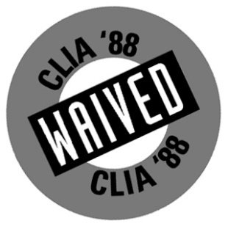

|  |  |  |
| --- | --- | --- |
|  | 20183 – QuickVue Influenza A+B 25 Test Kit | |
|  | |  |

|  |  |  |
| --- | --- | --- |
|  |  | **Quidel Corporation**  10165 McKellar Court  San Diego, CA 92121 USA  **quidel.com** |
| MDSS GmBH  Schiffgraben 41  30175 Hannover,  Germany |
| **Swab** |  |  |
| MDD 93/42/EEC |  | Puritan Medical Products Company LLC  31 School Street  Guilford, Maine 04443-0149 |
| Emergo Europe  The Hague  The Netherlands |
|  |  |  |

**CL1350313EN00 (02/18)**

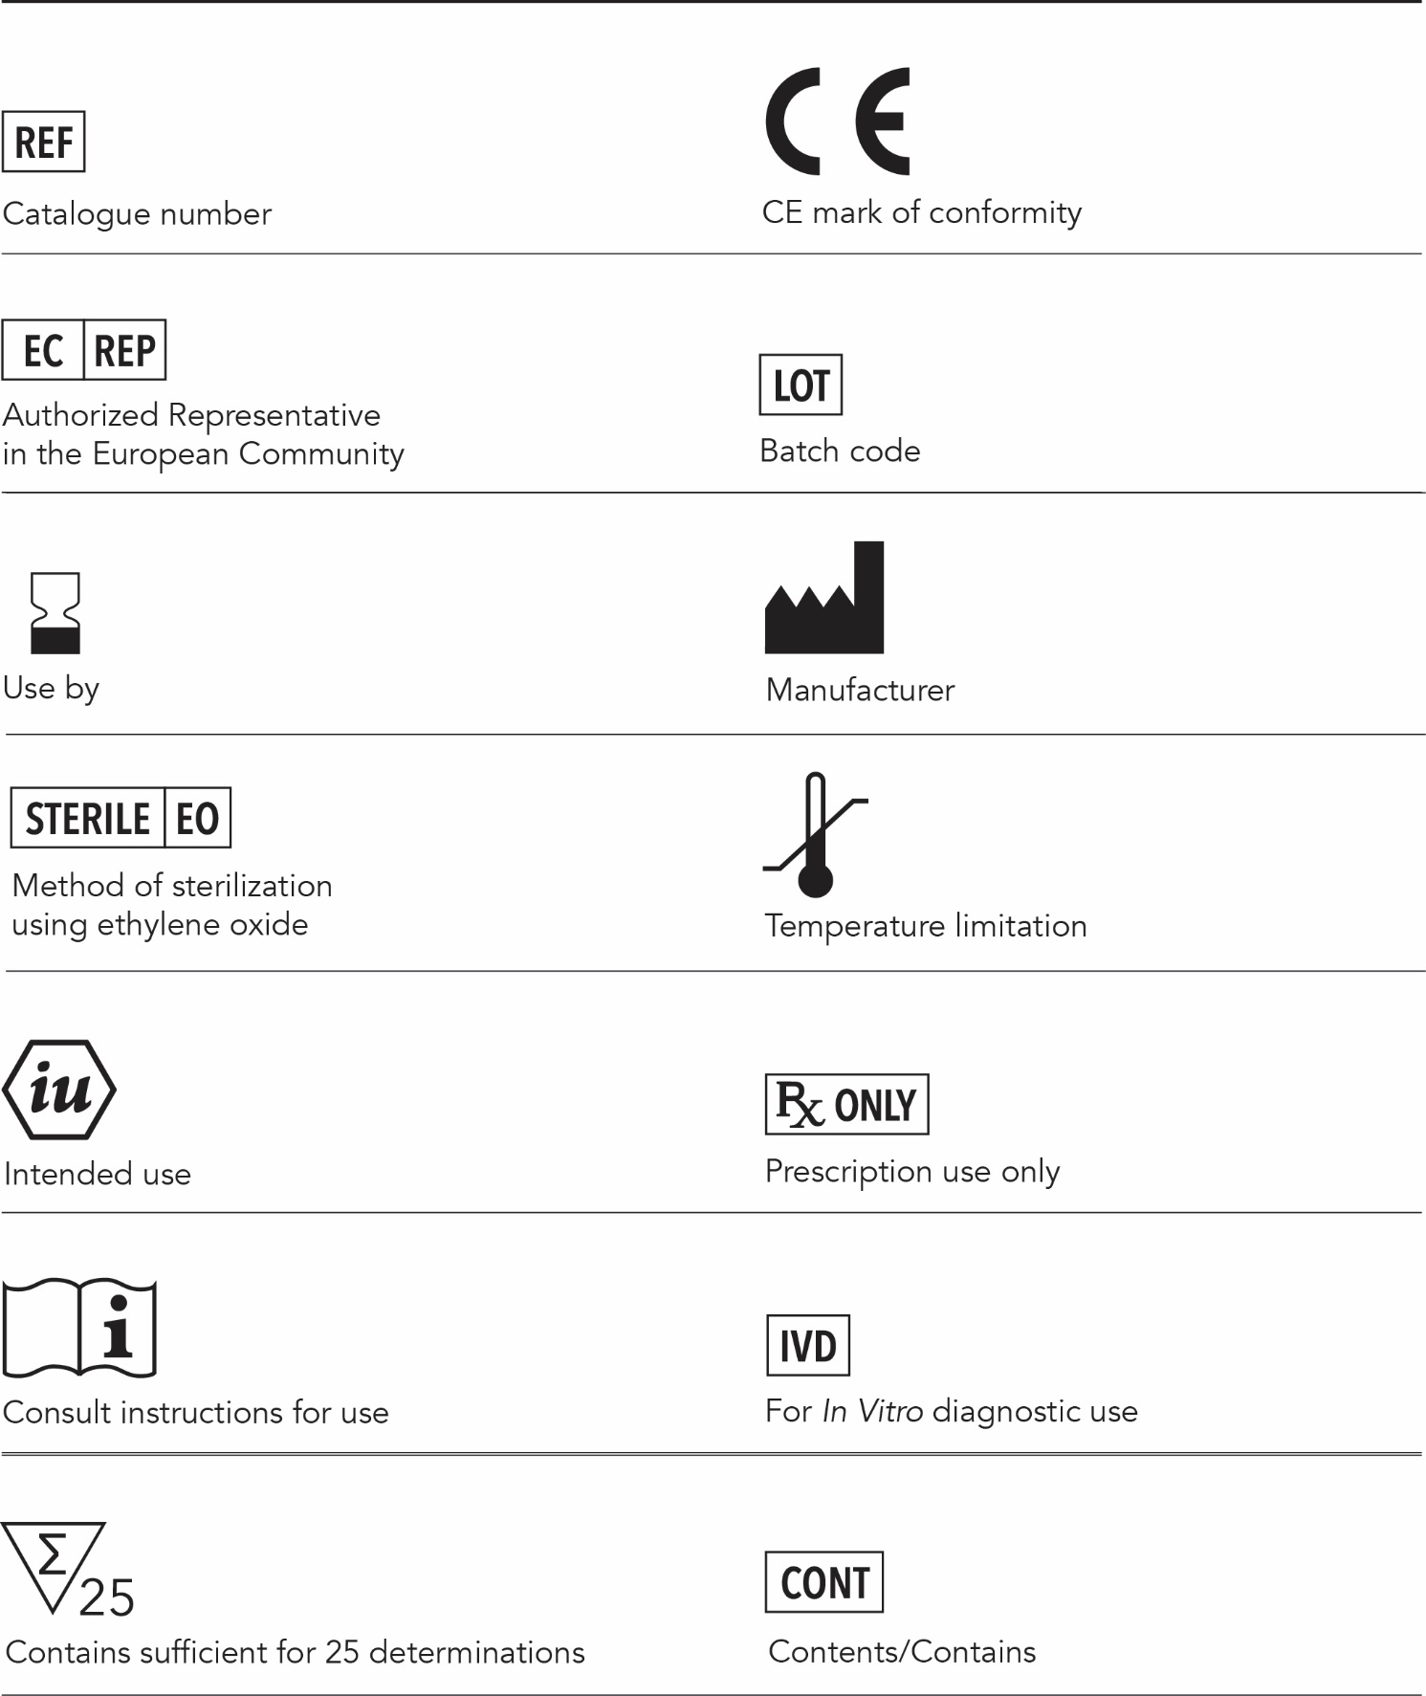

**Lab Name:**

|  |  |  |  |  |  |  |  |  |  |
| --- | --- | --- | --- | --- | --- | --- | --- | --- | --- |
| LOG SHEET | | | | | | | |  | |
| **QVInfluenzaA+B_lg**  *Record Built-in Procedural Controls on the first patient tested each day.* | | | | | | | | | |
|  |  | **Date**  MM/DD/YY | **Patient Name** | **Positive**  **Procedural**  **Control**  (Blue Line) | **Negative**  **Procedural**  **Control**  (White to light pink background) | **Test Results**  **At 10 minutes** | **Lot Number and Expiration Date** | | **Technician Initials** |
| **1** |  |  |  |  |  |  |  | |  |
| **2** |  |  |  |  |  |  |  | |  |
| **3** |  |  |  |  |  |  |  | |  |
| **4** |  |  |  |  |  |  |  | |  |
| **5** |  |  |  |  |  |  |  | |  |
| **6** |  |  |  |  |  |  |  | |  |
| **7** |  |  |  |  |  |  |  | |  |
| **8** |  |  |  |  |  |  |  | |  |
| **9** |  |  |  |  |  |  |  | |  |
| **10** |  |  |  |  |  |  |  | |  |
| **11** |  |  |  |  |  |  |  | |  |
| **12** |  |  |  |  |  |  |  | |  |
| **13** |  |  |  |  |  |  |  | |  |
| **14** |  |  |  |  |  |  |  | |  |
| **15** |  |  |  |  |  |  |  | |  |

|  |  |  |  |  |  |  |  |
| --- | --- | --- | --- | --- | --- | --- | --- |
| QC LOG SHEET | | | | | | | |
| |  | | --- | | **Facility Name:** |   **QVInfluenzaA+B_lg**  *Quidel recommends that positive and negative controls be run once for each untrained operator, once for each new shipment of kits — provided that each different lot received in the shipment is tested — and as deemed additionally necessary by your internal quality control procedures, and in accordance with Local, State, and Federal regulations or accreditation requirements. If you have any questions or concerns, please contact Quidel Technical Support at 800.874.1517 or at* [*technicalsupport@quidel.com*](mailto:technicalsupport@quidel.com)*.* | | | | | | | |
|  | **Date**  MM/DD/YY | **Kit Lot #** | **Influenza A Positive Control OK?** | **Influenza B Positive Control OK?** | **Influenza Negative Control OK?** | **Comments** | **Technician**  **Initials** |
| **1** |  |  |  |  |  |  |  |
| **2** |  |  |  |  |  |  |  |
| **3** |  |  |  |  |  |  |  |
| **4** |  |  |  |  |  |  |  |
| **5** |  |  |  |  |  |  |  |
| **6** |  |  |  |  |  |  |  |
| **7** |  |  |  |  |  |  |  |
| **8** |  |  |  |  |  |  |  |
| **9** |  |  |  |  |  |  |  |
| **10** |  |  |  |  |  |  |  |
| **11** |  |  |  |  |  |  |  |
| **12** |  |  |  |  |  |  |  |
| **13** |  |  |  |  |  |  |  |
| **14** |  |  |  |  |  |  |  |
| **15** |  |  |  |  |  |  |  |
| **16** |  |  |  |  |  |  |  |
| **17** |  |  |  |  |  |  |  |
| **18** |  |  |  |  |  |  |  |
| **19** |  |  |  |  |  |  |  |
| **20** |  |  |  |  |  |  |  |