Lab Name: Procedure #:

Procedure: CLIA Complexity: Moderate

Prepared By | Date Adopted | Supersedes Procedure #

Review Date | Revision Date | Signature

Distributed to | # of Copies | Distributed to | # of Copies

This Procedural Bulletin is intended to provide a ready outline reference for performance of the assay. These abbreviated directions for use are not intended to replace the complete package insert. It is the obligation of every manufacturer of medical devices labeled FOR IN VITRO DIAGNOSTIC USE to provide a complete package insert in accordance with FDA labeling regulation (21 CFR 809.10). Prepared in accordance with the guidelines recommended by the Clinical and Laboratory Standards Institute, Wayne, PA 19087; CLSI Document GP2-A2.

Quidel Corporation provides CLSI procedures for your use. The procedures are required to include the same information as listed in the package insert. Any modifications to this document are the sole responsibility of the Laboratory.

Lab Name:



CLIA Complexity: Moderate

INTENDED USE
The QuickVue RSV test is a dipstick immunoassay which allows for the rapid, qualitative detection of respiratory syncytial virus (RSV) antigen (viral fusion protein) directly from nasopharyngeal swab, nasopharyngeal aspirate, or nasal/nasopharyngeal wash specimens for symptomatic pediatric patients (eighteen years of age and younger). The test is intended for use as an aid in the diagnosis of acute respiratory syncytial viral infections. It is recommended that negative test results be confirmed by cell culture. Negative results do not preclude RSV infection and it is recommended that they not be used as the sole basis for treatment or other management decisions. The test is intended for professional and laboratory use.

SUMMARY AND EXPLANATION
Respiratory syncytial virus is a single-stranded (negative strand) RNA virus of the Paramyxoviridae family.¹ It is the causative agent of a highly contagious, acute, viral infection of the respiratory tract. Nearly half of all children become infected by their first year of life. It is also the major viral cause of nosocomial illness in children already hospitalized for other reasons.² In the United States, RSV is estimated to be responsible for 73,400 to 126,300 hospitalizations annually for bronchiolitis and pneumonia alone among children younger than 1 year.³ In children hospitalized with RSV infection, it is believed to be the most common viral cause of death in children younger than 5 years, particularly in children younger than one year.⁴ Among children hospitalized with RSV infection, the mortality rate is estimated to be as low as 0.3% to 1.0%^{3,5,6,7} and in the range of 2.5% to 4.0% for children with underlying cardiac or pulmonary disease.^{3,5,8}

PRINCIPLE OF THE TEST
The QuickVue RSV test is a dipstick immunoassay that allows the capture and visual detection of RSV antigen (viral fusion protein). The patient specimen is placed in the Extraction Tube containing the Extraction Reagent, enhancing the exposure of the viral fusion protein antigen. After extraction, the Test Strip is placed in the Extraction Tube where the RSV fusion proteins in the specimen will react with the reagents in the Test Strip.

Lab Name:

If the extracted specimen contains RSV antigens, a pink-to-red Test Line, along with a blue procedural Control Line, will appear on the Test Strip indicating a positive result. If RSV type antigens are not present, or are present at very low levels, only a blue procedural Control Line will appear.

REAGENTS AND MATERIALS SUPPLIED
20-Test Kit:
- Shelf box containing:
- Individually Packaged Test Strips (20): Mouse monoclonal anti-RSV viral fusion protein and control line protein

- Extraction Reagent Bottle (1): With detergents and 0.2% sodium azide

- Extraction Tubes (20)

- Disposable Droppers (20)

- Nasopharyngeal Swabs (20)

- Positive RSV Control Swab (1): Swab is coated with non-infectious RSV antigen

- Negative Control Swab (1): Swab is coated with formalin-inactivated, non-infectious Streptococcus C antigen

- Package Insert (1)

- Quick Reference Instructions (1)

MATERIALS NOT SUPPLIED
- Timer or watch

- Specimen containers

WARNINGS AND PRECAUTIONS
- For in vitro diagnostic use.
- Performance characteristics have not been established for use with adult or immunocompromised patients.

- Do not use the kit contents beyond the expiration date printed on the outside of the box.

Lab Name:

- Use appropriate precautions in the collection, handling, storage, and disposal of patient samples and used kit contents.⁹

- Use of Nitrile or Latex gloves is recommended when handling patient samples.⁹
- Dispose of containers and used contents in accordance with Federal, State and Local requirements.
- The Test Strip must remain sealed in the protective foil pouch until use.

- The Extraction Reagent contains sodium azide. Sodium azide may react with lead or copper plumbing to form potentially explosive metal azides. Copious quantities of water should be used to flush the Extraction Reagent down a sink. If the solution contacts the skin or eye, flush with copious amounts of water.

- To obtain accurate results, you must follow the Package Insert instructions.

- To obtain accurate results, you must use the proper volume of the Extraction Reagent.

- To avoid erroneous results, you must rotate the swab a minimum of five (5) times as indicated in the Test Procedure.

- Proper specimen collection, storage, and transport are critical to the performance of this test.

- Seek specific training or guidance if you are not experienced with specimen collection and handling procedures.^{10,11,12,13}

- M4-3 and Amies transport media are not compatible with this device. To obtain optimal results, use the transport media recommended in the Package Insert.
- For proper test performance, use the nasopharyngeal swabs supplied in the kit.

- Individuals with color-impaired vision may not be able to adequately interpret test results.

KIT STORAGE AND STABILITY
Store the kit at room temperature, 15–30°C, out of direct sunlight. Kit contents are stable until the expiration date printed on the outer box. Do not freeze.

Lab Name:

SPECIMEN COLLECTION AND HANDLING
Proper specimen collection and handling is critical to the performance of this Test. ^{10,11,12,13}

SPECIMEN COLLECTION
Use of the nasopharyngeal swab supplied in the kit and the transport media recommended in the Package Insert are recommended for optimal test performance. The performance with other nasopharyngeal swabs has not been established with the QuickVue RSV test.

Nasopharyngeal Swab Method:
To collect a nasopharyngeal swab sample, carefully insert the swab into the nostril and using gentle rotation, push the swab into the posterior nasopharynx. Gently rotate the swab three times, then remove it from the nasopharynx.

Nasopharyngeal Aspirate Method:
Instill a few drops of sterile saline into the nostril to be suctioned. Insert the flexible plastic tubing along the nostril floor, parallel to the palate. After entering the nasopharynx, aspirate the secretions while removing the tubing. The procedure should be repeated for the other nostril if inadequate secretions were obtained from the first nostril.

Nasal/Nasopharyngeal Wash Method:
Follow your Institution’s Protocol for obtaining wash specimens. Use the minimal amount of saline that your procedure allows, as excess volume will dilute the amount of antigen in the specimen. The following are examples of procedures used by clinicians:

The child should sit in the parent’s lap facing forward, with the child’s head against the parent’s chest. Fill the syringe or aspiration bulb with the minimal volume of saline required per the subject’s size and age. Instill the saline into one nostril while the head is tilted back. Aspirate the wash specimen back into the syringe or bulb. The aspirated wash sample will likely be at least 1 cc in volume.

Alternatively, following instillation of the saline, tilt the child’s head forward and
let the saline drain out into a clean collection cup.

SPECIMEN TRANSPORT AND STORAGE
Specimens should be tested as soon as possible after collection. If transport of the specimens is required, the following transport media are recommended when specimens are stored at 2-30ºC for up to eight (8) hours prior to testing: Hank’s Balanced Salt Solution, M4 – RT or M5 Media, Multitrans Media, Stuart’s, UTM, Bartels Viratrans or saline. For longer storage at 2-8ºC for up to forty-eight (48) hours, only Bartels Viratrans,

Lab Name:

M4 – RT and Multitrans Media are recommended. Alternatively, samples may be
stored at 2-30°C, in a clean, dry, closed container for up to eight (8) hours prior to testing.

Note: M4-3 and Amies transport media are not compatible with this device.

QUALITY CONTROL
There are two primary types of Quality Control for this device: the built-in control features defined below and the external controls.

Built-in Control Features
The QuickVue RSV test contains built-in procedural control features. The manufacturer's recommendation for daily control is to document these built-in procedural controls for the first sample tested each day.

The two-color result format provides a simple interpretation for positive and negative results. The appearance of a blue procedural Control Line provides several forms of positive control by demonstrating sufficient flow has occurred and the functional integrity of the Test Strip was maintained. If the blue procedural Control Line does not develop within 15 minutes, the test result is considered invalid.

A built-in negative control is provided by the clearing of red background color, verifying that the test has been performed correctly. Within 15 minutes, the result area should be white to light pink and allow the clear interpretation of the test result. If background color remains and interferes with interpretation of the test result, the result is considered invalid. Should this occur, review the procedure and repeat the test with a new Test Strip.

External Quality Control
External controls may also be used to demonstrate that the reagents and assay procedure perform properly.

Quidel recommends that positive and negative controls be run once for each untrained operator, once for each shipment of kits – provided that each different lot received in the shipment is tested – and as deemed additionally necessary by your internal quality control procedures, and in accordance with local, state, and federal regulations or accreditation requirements.

The Nasopharyngeal Swab Test Procedure described in this Package Insert should be used when testing the external controls.

Lab Name:

If the controls do not perform as expected, repeat the test or contact Quidel Technical Support before testing patient specimens. Note that the External Positive Control Swab provided in the kit is a moderately high positive sample which may not represent the performance of a low positive RSV specimen in the QuickVue RSV test.

Additional Control Swabs may be obtained separately by contacting Quidel’s Customer Support Services at (800) 874-1517 (toll-free in the U.S.A.) or 858-552-1100.

CLIA WAIVER CONSIDERATIONS
A certificate of CLIA waiver is required to perform the QuickVue RSV test in a waived setting. Waived laboratories must follow the manufacturer’s instructions in this Package Insert for performing the test. For information on how to obtain a CLIA certificate, go to the Centers for Medicare & Medicaid Services (CMS) website (http://www.cms.hhs.gov/
CLIA/06_How_to_Apply_for_a_CLIA_Certificate,_Including_Foreign_Laboratories.asp).

TEST PROCEDURE
All clinical specimens must be at room temperature before beginning the assay.

Performing the assay outside the time and temperature ranges provided may produce invalid results. Assays not performed within the established time and temperature ranges must be repeated.

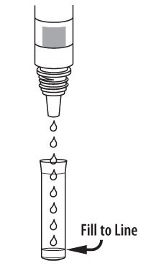
Expiration date: Check expiration on each individual test package or outer box before using. Do not use any test past the expiration date on the label.

Nasopharyngeal Swab Test Procedure
- Just before testing, add Extraction Reagent to the test tube
up to the fill line (250 µL).
Note: Too little or too much of the Extraction Reagent may cause
erroneous results.
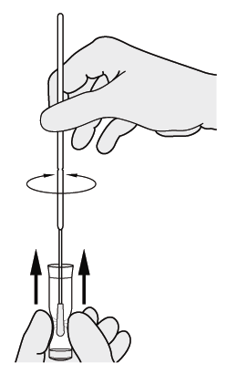

- Immediately add the patient swab sample to the tube.
Squeeze the bottom of the tube so the swab head is
compressed. Rotate the swab a minimum of five (5) times
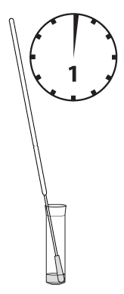
to obtain optimal results.
Keep swab in the tube for one (1) to two (2) minutes.
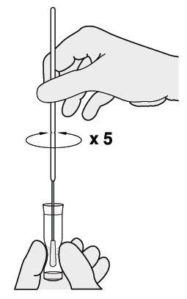
Lab Name:

- Express all liquid from the swab head by squeezing the tube
as the swab is removed. Discard the swab.

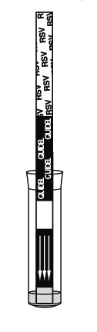

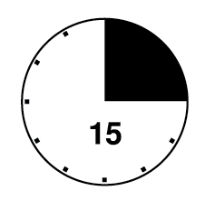
- Place the Test Strip into the tube with the arrows pointing down.
Do not handle or move the Test Strip for fifteen (15) minutes.
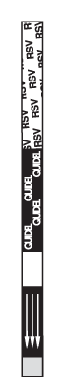
- Remove the Test Strip, and read result according to the
Interpretation of Results section. Some positive results
may appear sooner than 15 minutes.

Nasopharyngeal Aspirate or Nasal/Nasopharyngeal Wash Test Procedure
1. Just before testing, add Extraction Reagent to the test tube
up to the fill line (250 µL).

Note: Too little or too much of the Extraction Reagent may cause
erroneous results.

2. To fill the pipette with the sample*:
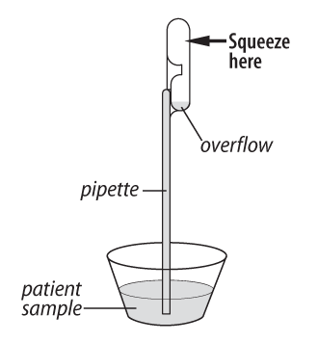
a) FIRMLY squeeze the top bulb.
b) Still squeezing, place the pipette tip into the liquid sample.
c) With the pipette tip still in the liquid sample, release pressure on
bulb to fill the pipette (extra liquid in the overflow bulb is OK).
*NOTE: The pipette is designed to collect and dispense the correct
amount of liquid sample.

Lab Name:
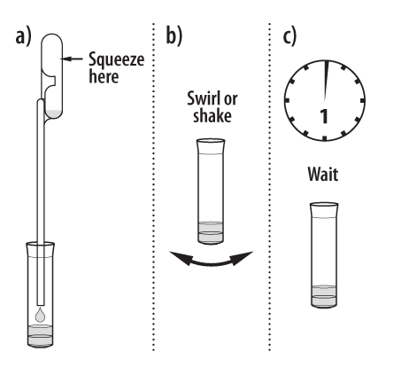
3. To add the sample to the test tube:
a) Firmly squeeze the top bulb to add the sample in the pipette to
the test tube with the reagent. The correct amount will be added,
even though the overflow bulb will not empty. Discard the pipette.
b) Swirl or shake the tube to mix.
c) Wait one (1) to two (2) minutes to allow the mixture to react.
- Place the Test Strip into the tube with the arrows pointing down.
Do not handle or remove the Test Strip for fifteen (15) minutes.
- Remove the Test Strip, and read result according to the
Interpretation of Results section. Some positive results
may appear sooner than 15 minutes.

INTERPRETATION OF RESULTS

SEE Quick Reference Instructions for larger images of test results in COLOR.

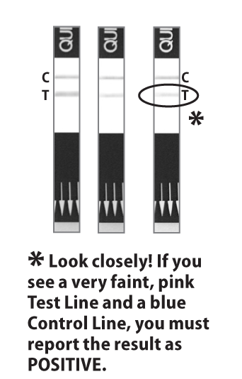
POSITIVE Result*:
At fifteen (15) minutes, the appearance of ANY shade of a pink-to-red Test Line AND a blue procedural Control Line indicates a positive result for the presence of RSV viral antigen. Results will remain stable for five (5) minutes after the recommended read time.

*A positive result does not rule out co-infections with other pathogens.

C = Control Line
T = Test Line

Negative Result**:
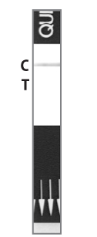
At fifteen (15) minutes, the appearance of ONLY the blue procedural Control Line indicates the sample is negative for RSV viral antigen. Results will remain stable for five (5) minutes after the recommended read time.

Lab Name:

**A negative result does not exclude RSV infection. It is recommended that negative results be confirmed by cell culture.

Invalid Result:
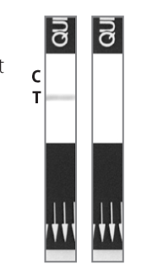
If at fifteen (15) minutes, the blue procedural Control Line does not appear, even if any shade of a pink-to-red Test Line appears, the result is invalid.

If at fifteen (15) minutes, the background color does not clear and it interferes with the reading of the test, the result is also invalid.

If the test is invalid, a new test should be performed.

LIMITATIONS
- This test is suitable for the pediatric population (eighteen years of age and younger) only and should not be used in an adult population.
- The contents of this kit are to be used for the qualitative detection of RSV fusion protein antigen from nasopharyngeal swab, nasopharyngeal aspirate, or nasal/nasopharyngeal wash specimens.
- Analytical testing has demonstrated the test is slightly more sensitive for RSV B than for RSV A (refer to the Analytical Sensitivity and Limit of Detection section of this Package Insert).

- A negative test result may occur if the level of antigen in a sample is below the detection limit of the test, or if the sample was collected improperly.

- Failure to follow the Test Procedure and Interpretation of Results may adversely affect test performance and/or invalidate the Test Result.

- Test Results must be evaluated in conjunction with other clinical data available to the physician.

- Negative test results are not intended to rule in other non-RSV viral or bacterial infections.

- Positive test results do not rule out co-infections with other pathogens.

Lab Name:

- Positive and negative predictive values are highly dependent on prevalence. False negative test results are more likely during peak activity when prevalence of disease is high. False positive test results are more likely during periods of low RSV activity when prevalence is moderate to low.

EXPECTED RESULTS

The rate of positivity observed in RSV testing will vary depending on the method of specimen collection, handling/transport system employed, detection method utilized, time of year, age of the patient, and most importantly, disease prevalence. The prevalence observed with culture during the clinical study (December 2005 – February 2006) was 18.6% (95/512). The prevalence observed with culture during the clinical study (December 2006 – February 2007) was 41.9% (121/289).

PERFORMANCE CHARACTERISTICS
QuickVue RSV Test Performance

Background on the 2005/2006 Clinical Studies
In the 2005/2006 clinical studies, the performance of the QuickVue RSV test was compared to viral cell culture methods and DFA in a multi-center clinical study during the RSV season in the United States. This study was performed by professional health care personnel at two general practice clinics, one hospital emergency department and one pediatric clinic in the southwestern United States. In this multi-center, point-of-care (POC) field trial, nasopharyngeal aspirate specimens were collected from two hundred thirty-seven (237) patients. Two nasopharyngeal swab specimens were collected from each of two hundred seventy-five (275) patients. All clinical samples were collected from symptomatic patients eighteen (18) years of age and younger. 55% were male and 45% were female.

On-site testing of one nasopharyngeal swab specimen, or a portion of nasopharyngeal aspirate, was performed by physician office personnel with the QuickVue RSV test. All samples were freshly collected and tested within one hour which demonstrates optimal performance. No samples were frozen prior to testing. The remaining sample was placed in viral transport media and stored at 2–8°C for up to 18 hours prior to culture.

Cells were inoculated with the specimen, incubated at 36°C for 48 hours, and then removed from culture and tested for RSV by direct fluorescent antibody (DFA) staining at a designated reference laboratory.

Lab Name:

Results with Fresh Nasopharyngeal Aspirate Specimens
Nasopharyngeal aspirate specimens from two hundred thirty-seven (237) patients were tested in QuickVue RSV and in cell culture. The QuickVue RSV test correctly identified 99% (68/69) RSV culture-positive specimens and 92% (155/168) RSV culture-negative specimens. These results are shown in Table 1.

Table 1
QuickVue RSV Nasopharyngeal Aspirate Results versus Culture
(≤ 18 years of age)
 | RSV Culture |  | Sensitivity = | 68/69 = 99%
 | + | - |  | (95% C.I. 91-100%)
QV Pos | 68 | 13 | Specificity = | 155/168 = 92%  (95% C.I. 87-96%)
QV Neg | 1 | 155 | PPV = | 68/81 = 84%
 |  |  | NPV = | 155/156 = 99%

Results with Fresh Nasopharyngeal Swab Specimens
Nasopharyngeal swab specimens from two hundred seventy-five (275) patients were tested in QuickVue RSV and in cell culture. The QuickVue RSV test correctly identified 92% (24/26) RSV culture-positive specimens and 92% (230/249) RSV culture-negative specimens. These results are shown in Table 2.

Table 2
QuickVue RSV Nasopharyngeal Swab Results versus Culture
(≤ 18 years of age)
 | RSV Culture |  | Sensitivity = | 24/26 = 92%
 | + | - |  | (95% C.I. 75-99%)
QV Pos | 24 | 19 | Specificity = | 230/249 = 92%  (95% C.I. 88-95%)
QV Neg | 2 | 230 | PPV = | 24/43 = 56%
 |  |  | NPV = | 230/232 = 99%

Lab Name:

Background on the 2006/2007 Clinical Studies
In the 2006/2007 clinical studies, the performance of the QuickVue RSV test was compared to viral cell culture methods and DFA in a multi-center clinical study during the RSV season in the United States. This study was performed by professional health care personnel at two pediatric clinics and two hospital emergency departments in various geographical regions within the United States. In this multi-center, point-of-care (POC) field trial, nasal/nasopharyngeal wash specimens were collected from two hundred eighty-nine (289) patients. All clinical samples were collected from symptomatic patients less than six years of age. 60% were male and 40% were female.

On-site testing of a portion of nasal/nasopharyngeal wash was performed by physician office personnel with the QuickVue RSV test. All samples were freshly collected and tested within one hour. No samples were frozen prior to testing. The remaining sample was placed in viral transport media and transported to a reference laboratory for culture, where cells were inoculated with the specimen, incubated at 36°C for 48 hours, and then removed from culture and tested for RSV by direct fluorescent antibody (DFA) staining.

Results with Fresh Nasal/Nasopharyngeal Wash Specimens
Nasal/nasopharyngeal wash specimens from two hundred eighty-nine (289) patients were tested in QuickVue RSV and in cell culture. The QuickVue RSV test correctly identified 83% (100/121) RSV culture-positive specimens and 90% (152/168) RSV culture-negative specimens. These results are shown in Table 3.

Table 3
QuickVue RSV Nasal/Nasopharyngeal Wash Results versus Culture
(<6 years of age)
 | RSV Culture |  | Sensitivity = | 100/121 = 83%
 | + | - |  | (95% C.I. 75-88%)
QV Pos | 100 | 16 | Specificity = | 152/168 = 90%  (95% C.I. 85-94%)
QV Neg | 21 | 152 | PPV = | 100/116 = 86%
 |  |  | NPV = | 152/173 = 88%

Lab Name:

REPRODUCIBILITY STUDIES
The reproducibility of the QuickVue RSV test was evaluated at three different laboratories, one of which was Quidel. Three different operators at each site tested a series of coded, contrived samples, ranging from low negative to high positive. Each had been carefully seeded with graded doses of RSV. The inter-laboratory agreement (Table 4) for negative samples was 99.4% and 98.3 to 100% for positive samples. The intra-laboratory agreement (Table 5) for all samples ranged from 99.0 to 99.7%.

Table 4
QuickVue RSV Reproducibility Study
Inter-laboratory Agreement
Site | Low Negative Samples | Low Positive Samples | Intermediate Positive Samples |  | High Positive Samples
Site | 1.5 x 10⁴ vp/mL* | 1.4 x 10⁶ vp/mL | 1.8 x 10⁶ vp/mL | 2.2 x 10⁶ vp/mL | 6.3 x 10⁶ vp/mL
1 | 59/59 | 60/60 | 59/60 | 60/60 | 60/60
2 | 59/60 | 59/60 | 60/60 | 58/59 | 60/60
3 | 60/60 | 58/60 | 59/59 | 60/60 | 60/60
Total | 178/179 | 177/180 | 178/179 | 178/179 | 180/180
% Overall Agreement  (95% C.I.) | 99.4%  (96.9 – 100%) | 98.3%  (95.2 – 99.7%) | 99.4%  (96.9 - 100%) | 99.4%  (96.9 - 100%) | 100%  (98 - 100%)
*The concentration of virus particles (vp/mL) was determined by electron microscopic techniques.

Lab Name:

Table 5
QuickVue RSV Reproducibility Study
Intra-laboratory Agreement

Site | Low Negative Samples | Low Positive Samples | Intermediate Positive Samples |  | High Positive Samples | % Overall Agreement  (95% C.I.)
Site | 1.5 x 10⁴ vp/mL* | 1.4 x 10⁶ vp/mL | 1.8 x 10⁶ vp/mL | 2.2 x 10⁶ vp/mL | 6.3 x 10⁶ vp/mL | % Overall Agreement  (95% C.I.)
1 | 59/59 | 60/60 | 59/60 | 60/60 | 60/60 | 99.7% (298/299)  (98.2 -100%)
2 | 59/60 | 59/60 | 60/60 | 58/59 | 60/60 | 99% (296/299)  (97.1 – 99.8%)
3 | 60/60 | 58/60 | 59/59 | 60/60 | 60/60 | 99.3% (297/299)  (97.6 – 99.9%)
*The concentration of virus particles (vp/mL) was determined by electron microscopic techniques.

ANALYTICAL SENSITIVITY AND LIMIT OF DETECTION
The analytical sensitivity of the QuickVue RSV test was evaluated with four different isolates of RSV A and four different isolates of RSV B. Viral lysates from each were titered in immunoperoxidase plaque assays using established methodology and tested in the QuickVue RSV test. All eight isolates of RSV were readily detected. The analytical sensitivity was shown to be somewhat greater for RSV B than for RSV A. The limit of detection was determined by enumeration of viral plaques after serial two-fold dilutions of viral lysates on LLC-MK2 cells and comparison of the visually read QuickVue RSV results to the calculated plaque forming units (pfu) per mL of the diluted lysates. For RSV A the average limit of detection (taking the mean value obtained with all four RSV A isolates) was 394 pfu/mL. For the four RSV B isolates, the average limit of detection observed was 142 pfu/mL. Therefore, the assay has a slightly higher analytical sensitivity for RSV B than for RSV A.

Lab Name:

ANALYTICAL SPECIFICITY – CROSS REACTIVITY

A total of thirty-three (33) bacterial and twenty-four (24) viral isolates were tested in duplicate in the QuickVue RSV test. None (i.e., 0/66 bacterial and 0/48 viral isolates) of the microorganisms tested at the levels indicated showed any sign of cross-reactivity in the assay. Flow of the sample and appearance of the Control Line were also not affected. These results confirm high immunological specificity of the QuickVue RSV Test.

Bacterial Panel*
Organism | Concentration tested
Bordetella pertussis | 1.0 x 10⁸ org/mL
Candida albicans | 1.0 x 10⁸ org/mL
Corynebacterium diphtheriae | 1.0 x 10⁸ org/mL
Enterococcus faecalis | 1.0 x 10⁸ org/mL
Escherichia coli | 1.0 x 10⁸ org/mL
Gardnerella vaginalis | 1.0 x 10⁸ org/mL
Hemophilus influenzae | 1.0 x 10⁸ org/mL
Klebsiella pneumoniae | 1.0 x 10⁸ org/mL
Lactobacillus casei | 1.0 x 10⁸ org/mL
Lactobacillus plantarum | 1.0 x 10⁸ org/mL
Legionella pneumophila | 1.0 x 10⁸ org/mL
Listeria monocytogenes | 1.0 x 10⁸ org/mL
Moraxella catarrhalis | 1.0 x 10⁸ org/mL
Mycobacterium avium | 1.0 x 10⁸ org/mL
Mycobacterium tuberculosis | 1.0 x 10⁶ org/mL
Mycoplasma pneumoniae | 1.0 x 10⁸ org/mL
Neisseria gonorrhoeae | 1.0 x 10⁸ org/mL
Neisseria meningiditis | 1.0 x 10⁸ org/mL
Neisseria sicca | 1.0 x 10⁸ org/mL
Neisseria subflava | 1.0 x 10⁶ org/mL
Proteus vulgaris | 1.0 x 10⁸ org/mL
Pseudomonas aeruginosa | 1.0 x 10⁸ org/mL
Staphylococcus aureus (Cowan) | 2.5 x 10⁷ org/mL
Staphylococcus epidermidis | 1.0 x 10⁸ org/mL
Serratia marcescens | 1.0 x 10⁸ org/mL
Streptococcus mutans | 1.0 x 10⁸ org/mL
Streptococcus pneumoniae | 1.0 x 10⁸ org/mL
Streptococcus pyogenes (Grp A) | 1.0 x 10⁸ org/mL
Streptococcus Grp B | 1.0 x 10⁸ org/mL
Streptococcus Grp C | 1.0 x 10⁸ org/mL
Streptococcus Grp F  Streptococcus Grp G  Streptococcus sanguis | - x 10⁸ org/mL  - x 10⁸ org/mL  1.0 x 10⁸ org/mL

Lab Name:

Viral Panel*
Organism Concentration tested
Adenovirus 5 TCID₅₀ 1.0 x 10⁵
Adenovirus 7 TCID₅₀ 1.0 x 10⁴
Adenovirus 10 TCID₅₀ 1.0 x 10⁵
Adenovirus 18 TCID₅₀ 1.0 x 10⁵
Cytomegalovirus TCID₅₀ 1.0 x 10⁵
Echovirus 2 TCID₅₀ 1.0 x 10⁵
Echovirus 3 TCID₅₀ 1.0 x 10⁵
Echovirus 6 TCID₅₀ 1.0 x 10⁵
Mumps (Enders) TCID₅₀ 1.0 x 10⁵
Parainfluenza virus type 1 TCID₅₀ 1.0 x 10⁵
Parainfluenza virus type 3 TCID₅₀ 1.0 x 10⁵
Coronavirus (OC43) 1.0 x 10⁶ pfu/mL
Herpes simplex type 1 1.0 x 10⁶ pfu/mL
Herpes simplex type 2 1.0 x 10⁶ pfu/mL
Influenza A (H1N1) A/New Jersey/8/76 1.0 x 10⁸ pfu/mL
Influenza A (H1N1) Fort Monmouth A/1/47 1.0 x 10⁸ pfu/mL
Influenza A (H3N2) A/Beijing/32/92 1.0 x 10⁶ pfu/mL
Influenza B (Hong Kong) 1.0 x 10⁶ pfu/mL
Influenza B (Allen) 1.0 x 10⁸ pfu/mL
Influenza B (Lee) 1.0 x 10⁸ pfu/mL
Rhinovirus 18 1.0 x 10⁶ pfu/mL
Rhinovirus 2 1.0 x 10⁶ pfu/mL
Rhinovirus 14 1.0 x 10⁸ pfu/mL
Rhinovirus 16 1.0 x 10⁶ pfu/mL

*The bacteria, viruses and titer information were obtained directly from the American Type Culture Collection (ATCC). The titers were not independently confirmed by Quidel.

INTERFERING SUBSTANCES
Several over-the-counter (OTC) products and common chemicals were evaluated and did not interfere with the QuickVue RSV test at the levels tested. These included the following: three OTC mouthwashes (25%); three OTC cough drops (25%); three nasal sprays/gel (10%); Acetamidophenol (10 mg/mL); Acetylsalicylic Acid (20 mg/mL); Chlorpheniramine (5 mg/mL); Dextromethorphan (10 mg/mL); Diphenhydramine (5 mg/mL); Mucin (4 mg/mL); Guaiacol (20 mg/mL); Phenylephrine (50 mg/mL); Rimantadine (50 ug/mL); and Albuterol (20 mg/mL).

Lab Name:

PRECISION STUDIES
The total within-run and between-run performance of the QuickVue RSV test was evaluated for precision. A panel consisting of two positives (3.0 x 10⁶ vp/mL and 5.9 x 10⁶ vp/mL) of inactivated RSV virus was tested in replicates of 50 on 2 different days
with each of 3 validation lots. One hundred percent (100%) accuracy was obtained for all specimens tested.

CONSUMER PRECISION STUDY
Lay Users vs. Trained Laboratorians
The QuickVue RSV test was evaluated by seventy-one (71) operators with no professional laboratory experience (lay users) at three different sites. Each operator at each site tested four concentration levels of RSV, comprising a coded panel of negative, weak positive, low positive, and positive samples. In order to demonstrate equivalent performance among lay users and trained laboratorians, six (6) trained laboratorians at two laboratory sites ran the panel of blind coded samples containing the same negative, weak positive, low positive, and positive samples described above.

As indicated by the overlapping 95% confidence intervals in Tables 6 and 7 below, no significant differences were observed between the performance of the lay users and the trained laboratorians. These results demonstrate that users with no formal laboratory training can read the package insert and perform the QuickVue test with the same precision as trained laboratorians. No significant differences were observed between the untrained users at the three different lay user sites.

Table 6
Lay Users vs. Trained Laboratorians – Overall Results

ParticipantType | Negative  % Negative  (95%CI) | Weak Positive  % Detection  (95% CI) | Low Positive  % Detection  (95% CI) | Positive  % Detection  (95% CI)
Lay User | 100% (71/71)  (93.9-100) | 89% (63/71)  (79.1-94.4) | 97% (69/71)  (89.7-99.8) | 100% (71/71)  (93.9-100)
TrainedLaboratorian | 98% (59/60)  (90.3->99.9) | 95% (57/60)  (85.8-98.8) | 100% (60/60  (92.8-100) | 100% (60/60)  (92.8-100)

Lab Name:

Table 7
Sample Testing by Site – Lay Users and Trained Laboratorians

 |  | Negative  % Negative (95%CI) | Weak Positive  % Detection (95% CI) | Low Positive  % Detection (95% CI) | Positive  % Detection (95% CI)
Lay User Results | 1 | 100% (21/21)  (81.8-100) | 95% (20/21)  (75.6->99.9%) | 100% (21/21)  (81.8-100) | 100% (21/21)  (81.8-100)
 | 2 | 100% (26/26)  (84.8-100) | 81% (21/26)  (61.7-92.0) | 96% (25/26)  (79.6-99.9) | 100% (26/26)  (84.8-100)
 | 3 | 100% (24/24)  (83.7-100) | 92% (22/24)  (73.0-98.8) | 96% (23/24)  (78.1-99.9) | 100% (24/24)  (83.7-100)
Trained  Laboratorian  Results | 1 | 97% (29/30)  (81.9->99.9) | 97% (29/30)  (81.9->99.9) | 100% (30/30)  (86.5-100) | 100% (30/30)  (86.5-100)
 | 2 | 100% (30/30)  (86.5-100) | 93% (28/30)  (77.6-99.2) | 100% (30/30)  (86.5-100) | 100% (30/30)  (86.5-100)

ASSISTANCE
If you have any questions regarding the use of this product or if you want to report a test system problem, please call Quidel’s Technical Support Number (800) 874.1517 (toll-free in the U.S.A.) or (858) 552.1100, Monday through Friday, between 7:00 a.m. and 5:00 p.m., Pacific Time, U.S.A. If outside the United States contact your local distributor or technicalsupport@quidel.com. Test system problems may also be reported to FDA (http://www.fda.gov/medwatch) or CMS (http://www.cms.hhs.gov/clia/ro-map.asp).

REFERENCES
- Course BS3035: Virology, University of Leicester,
http://www-micro.msb.le.ac.uk/3035/Paramyxoviruses.html.

- Macartney K. et al. Nosocomial Respiratory Syncytial Virus Infections: The Cost-Effectiveness and Cost-Benefit of Infection Control. Pediatrics Vol. 106 No. 3 Sept 2000, pp. 520-526. http://pediatrics.aappublications.org/cgi/content/full/106/3/520.

- Collins P., Chanock R., Murphy B. Fields Virology. Fourth Edition. Volume 1. Chapter 45 – Respiratory Syncytial Virus. Lippincot Williams and Wilkins. (2001)

- Thompson W. et al. Mortality Associated With Influenza and Respiratory Syncytial Virus in the United States. JAMA, January 8, 2003 – Vol 289, No. 2.

- Navas L., Wang E. et al. Improved outcome of respiratory syncytial virus infection in a high-risk hospitalized population of Canadian children. Pediatric Investigators Collaborative Network on Infections in Canada. J Pediatr. 1992 Sep; 121(3) 348-54.

Lab Name:

- American Academy of Pediatrics. http://www.aap.org/pubed/ZZZSO05MASD.htm?&sub_cat=107.

- Purcell P., Fergie J. Effect of an educational program on the treatment of RSV lower respiratory tract infection. Am J Health-Syst Pharm. 2003; 60(8):759-767. http://www.medscape.com/viewarticle/452573.

- Moler F.W. et al. Respiratory syncytial virus morbidity and mortality estimates in congential heart disease patients: a recent experience. Crit Care Med. 1992 Oct; 20(10):1406-13.
- Biosafety in Microbiological and Biomedical Laboratories, 4th Edition. U.S. Department of Health and Human Services, CDC, NIH, Washington, DC (1999).
- Henretig F.M. MD, King C. MD. Textbook of Pediatric Procedures, Chapter 123 – Obtaining Biologic Specimens Williams and Williams (April 1997).
- The Clinical Virology Laboratory, Department of Laboratory Medicine at Yale: http://info.med.yale.edu/labmed/virology/booklet.html.
- Australian Management Plan for Pandemic Influenza – Section 5 Annex 5: Laboratory Guidelines.
- Murray P.R. et al. Manual of Clinical Microbiology, 8th Edition, American Society for Microbiology (2003).
Covered by U.S. Patent No. 4,943,522; European Patent No. 0 296 724; other patents pending.


20193 – QuickVue RSV 20 Test Kit





Lab Name:


MDSS GmbH
Schiffgraben 41
30175 Hannover,
Germany



Quidel Corporation
Worldwide Headquarters
10165 McKellar Court
San Diego, CA 92121 USA
www.quidel.com

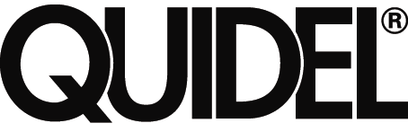 1358ID0908D (09/08)

Authorized Representative For In Vitro diagnostic use

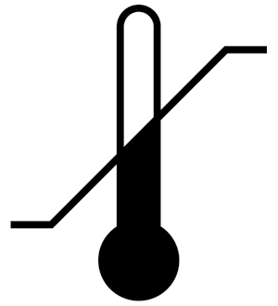

Manufacturer Temperature Limit

Lab Name:

LOG SHEET

Record Built-in Procedural Controls on the first patient tested each day.
 | Date | Patient Name | Positive  Procedural  Control  (Blue Line) | Negative Procedural Control (White to Light Pink Background) | Test Results at 15 minutes | Lot Number and Expiration Date | Technician
1
2
3
4
5
6
7
8
9
10
11
12
13
14
15

Lab Name:

LOG SHEET
 | Date | External Positive Control  Result | External Negative Control  Result | Lot Number and Exp. Date | Technician
1
2
3
4
5
6
7
8
9
10
11
12
13
14
15

0146RA0908D (09/08)

