PROCEDURE TITLE: | Alinity i Anti-Hepatitis C Virus (Anti-HCV) | DEPARTMENT: | Main Laboratory

EFFECTIVE DATE: | 05/23/2025 | APPROVAL: | 05/22/25
APPROVED BY: | Patrice Y. Ohouo, PhD  Main Laboratory Director | PROCEDURE NO.: | IMM.01009

- PURPOSE
  - To provide instructions for use of the Alinity i Anti-HCV assay. The Alinity i Anti-HCV assay is used to detect the presence of immunoglobulin G (IgG) and immunoglobulin M (IgM) antibodies to hepatitis C virus (anti-HCV) in human serum and plasma on the Abbott Alinity i analyzer.
- SUMMARY AND EXPLANATION OF THE TEST
  - The Alinity i Anti-HCV assay is a chemiluminescent microparticle immunoassay (CMIA) used for the qualitative detection of immunoglobulin G (IgG) and immunoglobulin M (IgM) antibodies to hepatitis C virus (anti-HCV) in human adult serum and plasma (potassium EDTA, lithium heparin, and sodium heparin) on the Alinity i analyzer.
  - Chemiluminescent immunoassays are a variation of the enzyme immunoassay (EIA) principle. Solid phase EIAs, first described in the early 1970s, use antigens and/or antibodies coated on a surface to bind complementary analytes. The bound analyte is detected by a series of antigen-antibody reactions. EIAs are available to identify antigens and antibodies related to viral hepatitis infection. In the Alinity i Anti-HCV final reaction, bound acridinylated conjugates are used to generate a chemiluminescent signal.
  - HCV is a bloodborne virus. Serological studies employing EIAs for detection of antibodies to recombinant antigens of HCV have established HCV as the cause of most bloodborne as well as community-acquired non-A, non-B hepatitis. The presence of anti-HCV indicates that an individual may have been infected with HCV, may harbor infectious HCV, and/or may be capable of transmitting HCV infection.
  - Although the majority of infected individuals may be asymptomatic, HCV infection may develop into chronic hepatitis, cirrhosis, and/or increased risk of hepatocellular carcinoma. The implementation of blood donation screening for anti-HCV by EIAs has led to a marked decline in the risk of transfusion-transmitted hepatitis.
  - Alinity i Anti-HCV has been designed to detect antibodies to putative structural and nonstructural proteins of the HCV genome.
- BIOLOGICAL PRINCIPLES OF THE PROCEDURE
  - This assay is a two-step immunoassay for the qualitative detection of anti-HCV in human serum and plasma using chemiluminescent microparticle immunoassay (CMIA) technology.
  - Sample, recombinant HCV antigen coated paramagnetic microparticles, and assay diluent are combined and incubated. The anti-HCV present in the sample binds to the HCV coated microparticles. The mixture is washed. Anti-human IgG/IgM acridinium-labeled conjugate is added to create a reaction mixture and incubated. Following a wash cycle, Pre-Trigger and Trigger Solutions are added.
  - The resulting chemiluminescent reaction is measured as relative light units (RLUs). There is a relationship between the amount of anti-HCV in the sample and the RLUs detected by the system optics.
  - The presence or absence of anti-HCV in the sample is determined by comparing the chemiluminescent RLU in the reaction to the cutoff RLU determined from an active calibration.
  - If the chemiluminescent signal of the sample is greater than or equal to the cutoff signal, the sample is considered reactive for anti-HCV.
  - For additional information on system and assay technology, refer to the Alinity ci-series Operations Manual, Section 3.
- INTENDED USE
  - The Alinity i Anti-HCV assay is a chemiluminescent microparticle immunoassay (CMIA) used for the qualitative detection of immunoglobulin G (IgG) and immunoglobulin M (IgM) antibodies to hepatitis C virus (anti-HCV) in human adult serum and plasma (potassium EDTA, lithium heparin, and sodium heparin) on the Alinity i analyzer.
  - Assay results, in conjunction with other laboratory results and clinical information, may be used to provide presumptive evidence of infection with HCV (state of infection or associated disease not determined) in persons with signs and symptoms of hepatitis and in persons at risk for hepatitis C infection.
  - This assay has not been cleared for use in screening blood, plasma, or tissue donors.
- Definitions
  - N/A
- Responsibilities
  - Only trained personnel are authorized to perform this procedure. Qualified personnel are responsible for the proper execution of this procedure. Under the guidance of the Laboratory Director, it is the responsibility of the Technical Supervisor to ensure the competency of laboratory personnel performing this test.
  - Training is documented in the training file of each qualified staff member.
  - All patient information is handled in a manner that is compliant with HIPAA guidelines. Refer to http://www.hhs.gov/ocr.hipaa/ and also to CleanSlate’s HIPAA Policy, https://cleanslatecenters.training.reliaslearning.com or equivalent.
  - Under the direction of the Laboratory Director, the Technical Supervisor is responsible for the direct review of all quality control, equipment maintenance and reporting of patient results.
- SAFETY
  - Standard Precautions
    - CAUTION: This product contains human-sourced and/or potentially infectious components. Refer to the REAGENTS section of assay insert for more details.
    - It is recommended that these reagents, human specimens, and all consumables contaminated with potentially infectious materials be handled in accordance with the OSHA Standard on Bloodborne Pathogens. Biosafety Level 2 or other appropriate regional, national, and institutional biosafety practices should be used for materials that contain, are suspected of containing, or are contaminated with infectious agents.
    - Care should be taken, and personal protective equipment is required when handling material of human origin. All biological specimens should be considered potentially infectious.
    - For up-to-date recommendations on handling biological specimens refer to the CDC website: http://cdc.gov/ncidod/dhqp/pdf/guidelines/Isolation2007.pdf or CLSI document M29-A3, Protection of Laboratory Workers from Occupationally Acquired Infections. Clinical and Laboratory Standards Institute; Approved Guidelines and or Refer to Clean Slate’s safety policy, https://cleanslatecenters.training.reliaslearning.com or equivalent.
  - Safety
    - For the most current hazard information, see the product Safety Data Sheet also available at www.corelaboratory.abbott.
    - The tables below list warnings and precautions that apply to listed kit components:

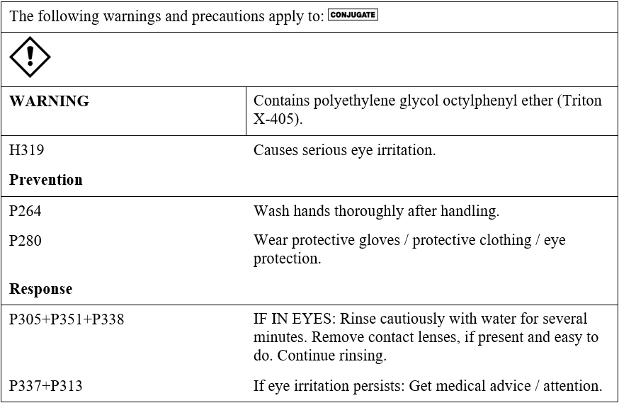
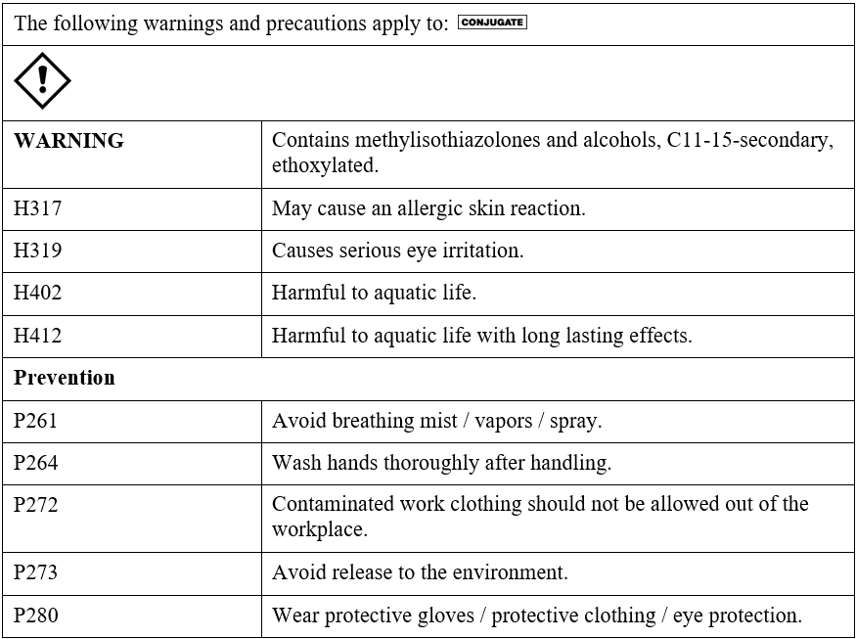

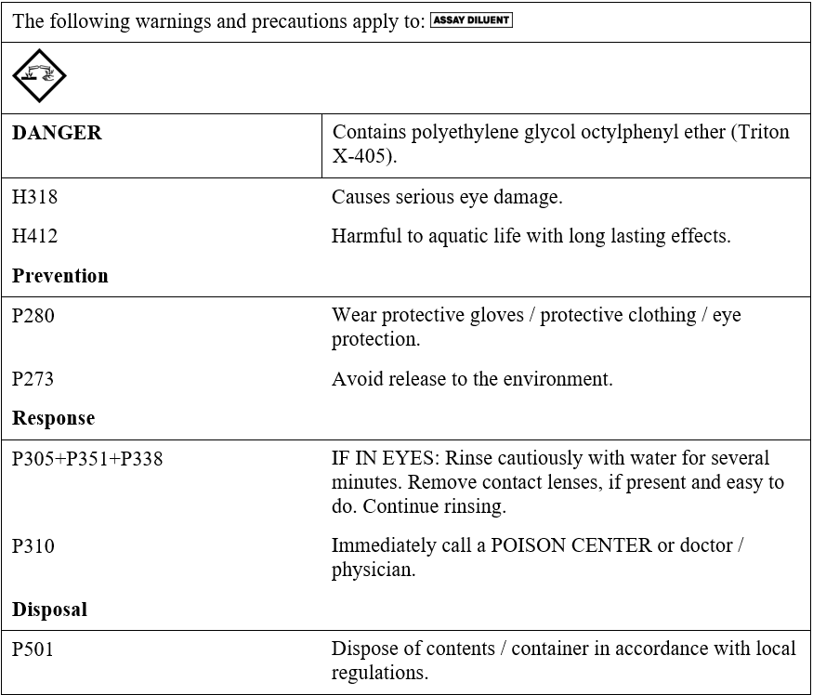

    - For a detailed discussion of safety precautions during system operation, refer to the Alinity ci-series Operations Manual, Section 8.
  - Computer and Web Portal
    - Passwords must be assigned only to authorized personnel.

    - To ensure HIPAA compliance, it is recommended that the computer, printer and printouts be located away from the visibility and access of unauthorized individuals.
- SPECIMEN REQUIREMENTS, COLLECTION AND PREPARATION FOR ANALYSIS
  - Specimen types:
    - The specimen types described in the table below were verified by the manufacturer for use with this assay.
    - The instrument does not provide the capability to verify specimen types. It is the responsibility of the operator to verify that the correct specimen types are used in the assay.
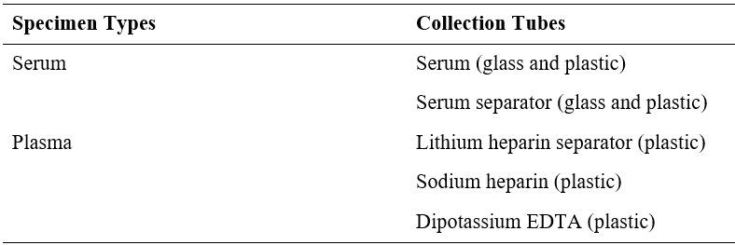
  - Specimen conditions:
    - Do not use:
      - heat-inactivated specimens
      - pooled specimens
      - grossly hemolyzed specimens
      - specimens with obvious microbial contamination
      - For accurate results, serum and plasma specimens should be free of fibrin, red blood cells, and other particulate matter.
      - Serum specimens from patients receiving anticoagulant or thrombolytic therapy may contain fibrin due to incomplete clot formation.
      - To prevent cross contamination, use of disposable pipettes or pipette tips is recommended.
      - Unlabeled specimens: there must be an ID link between the test order and the specimen container. Unlabeled specimens cannot be accepted.
      - All specimens are examined for correct identification when accessioned and processed and are rejected if it does not have two matching patient identifiers.
      - Leaking/improperly closed tubes cannot be accepted.
      - Specimen with insufficient quantity or specimen containers that are “empty” or have improper storage cannot be accepted.
  - Preparation for analysis:
    - Follow the tube manufacturer’s processing instructions for collection tubes. Gravity separation is not sufficient for specimen preparation.
    - Specimens should be free of bubbles. Remove bubbles with an applicator stick before analysis. Use a new applicator stick for each specimen to prevent cross contamination.
    - To ensure consistency in results, recentrifuge specimens prior to testing if
they contain fibrin, red blood cells, or other particulate matter.
    - NOTE: If fibrin, red blood cells, or other particulate matter are observed, mix by low-speed vortex or by inverting 10 times prior to recentrifugation.
    - Prepare frozen specimens as follows: (Avoid more than 3 freeze/thaw cycles).
      - Frozen specimens must be completely thawed before mixing.
      - Mix thawed specimens thoroughly by low speed vortex or by inverting 10 times.
      - Visually inspect the specimens. If layering or stratification is observed, mix until specimens are visibly homogeneous.
      - If specimens are not mixed thoroughly, inconsistent results may be obtained.
      - Recentrifuge specimens.
    - Recentrifugation of Specimens:
      - Transfer specimens to a centrifuge tube and centrifuge at > 10,000 RCF (Relative Centrifugal Force) for 10 minutes.
      - Transfer clarified specimen to a sample cup or secondary tube for testing. For centrifuged specimens with a lipid layer, transfer only the clarified specimen and not the lipemic material.
  - Specimen Storage:
    - Specimen storage is as described in the table below or according to stability studies performed by the Cleanslate Centers’ Main Laboratory, where indicated.
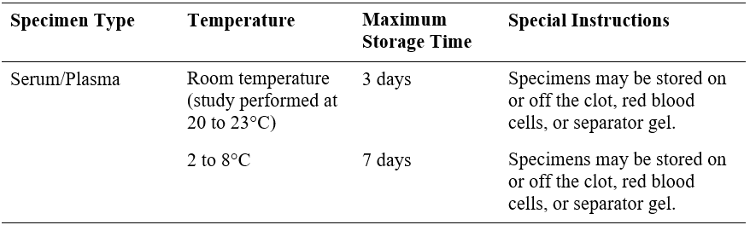
    - If testing will be delayed longer than the maximum storage time, remove serum or plasma from the clot, red blood cells, or separator gel and store frozen (-20°C or colder).
    - Avoid more than 3 freeze/thaw cycles.
  - Specimen Shipping:
    - Package and label specimens in compliance with applicable state, federal, and international regulations covering the transport of clinical specimens and infectious substances.
    - Do not exceed the storage limitations listed above or as determined based on stability studies performed by the Cleanslate Centers’ Main Laboratory, where indicated.
- MATERIALS & EQUIPMENT
  - Abbott Alinity i analyzer.
  - Alinity i Anti-HCV Reagent Kit 08P05. See table below for details. Volumes (mL) listed in the table below indicate the volume per cartridge.
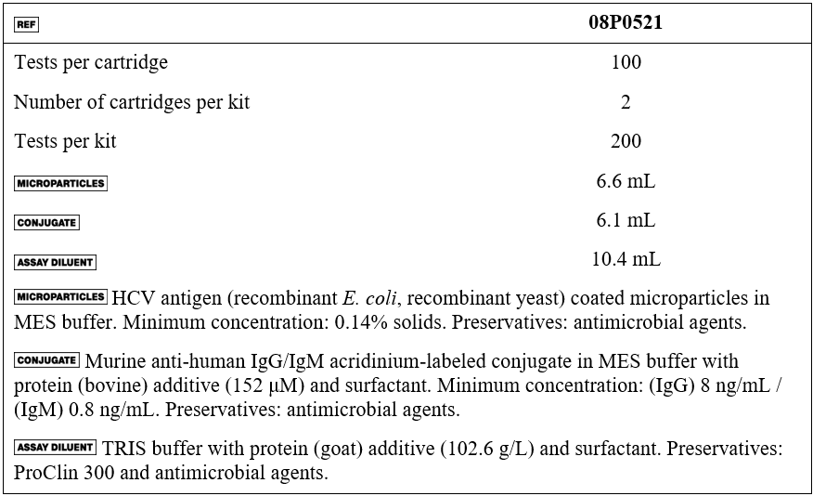
  - Alinity i Anti-HCV Calibrator (Part# 08P0501)
  - Alinity i Anti-HCV Controls (Part# 08P0510)
  - Alinity Trigger Solution (Part# 06P1160)
  - Alinity Pre-Trigger Solution (Part# 06P1265)
  - Alinity i-series Concentrated Wash Buffer (Part# 06P1368)
  - Alinity i Reaction Vessels (Part# 06P1401)
  - Alinity i Replacement Caps (Part# 04R4701)
  - Alinity i Sample Cups (Part# 01R3801)
  - For information on materials required for operation of the instrument, refer to the Alinity ci-series Operations Manual, Section 1.
  - For information on materials required for maintenance procedures, refer to the Alinity ci-series Operations Manual, Section 9.
- REAGENTS HANDLING
  - Upon receipt, gently invert the unopened reagent kit by rotating it over and back for a full 180 degrees, 5 times with green label stripe facing up and then 5 times with green label stripe facing down. This ensures that liquid covers all sides of the bottles within the cartridges. During reagent shipment, microparticles can settle on the reagent septum.
  - Place a check in the square on the reagent kit to indicate to others that the inversions have been completed.
  - After mixing, place reagent cartridges in an upright position for 1 hour before use to allow bubbles that may have formed to dissipate.
  - If a reagent cartridge is dropped, place in an upright position for 1 hour before use to allow bubbles that may have formed to dissipate.
  - Note:
    - Prior to loading on the analyzer for the first time, gently invert cartridges 30 times.
    - Reagent cartridges cannot be inverted after the septum has been pierced by the analyzer.
  - Reagents are susceptible to the formation of foam and bubbles. Bubbles may interfere with the detection of the reagent level in the cartridge and cause insufficient reagent aspiration that may adversely affect results.
  - For a detailed discussion of reagent handling precautions during system operation, refer to the Alinity ci-series Operations Manual, Section 7.

- REAGENTS STORAGE:
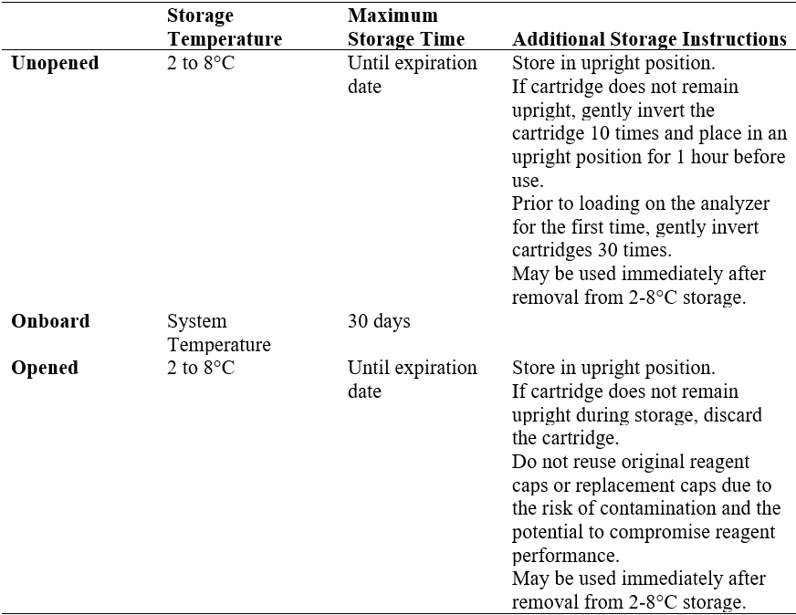

  - Reagents may be stored on or off the system. If removed from the system, store reagents with new replacement caps in an upright position at 2 to 8°C. For reagents stored off the system, it is recommended that they be stored in their original trays or boxes to ensure they remain upright.
  - For information on unloading reagents, refer to the Alinity ci-series Operations Manual,
Section 5.
  - Indications of Reagent Deterioration
    - Deterioration of the reagents may be indicated when a calibration error occurs or a control value is out of the specified range. Associated test results are invalid, and samples must be retested. Assay recalibration may be necessary.
    - For troubleshooting information, refer to the Alinity ci-series Operations Manual, Section 10.
- CALIBRATIONS & CONTROL PROCEDURES
  - Calibration
    - Cal 1 contains recalcified heat-inactivated anti-HCV positive human plasma in recalcified anti-HCV negative human plasma. Preservatives: ProClin 950 and sodium azide.
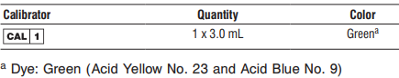

    - This product is liquid ready-to-use and may be used immediately after removal from 2 to 8°C storage.
    - Prior to each use, mix by gentle inversion.
    - The calibrator vial is placed directly on the instrument and automatically processed using the barcode on the calibrator vial. Alternatively, the calibrator can be pipetted into a sample cup. If the calibrator is pipetted into a sample cup, the calibration must be manually ordered.
    - Calibrator 1 is tested in triplicate. The Alinity i analyzer calculates the cutoff Relative Light Units (RLU) from the mean RLU of the three replicates.
    - Traceability was performed on the ARCHITECT i System. Calibrator 1 is traceable to an Abbott internal reference standard. This internal reference standard is manufactured by diluting anti-HCV reactive recalcified human plasma with anti-HCV nonreactive recalcified human plasma.
    - The acceptability of the calibration is assessed against a parameter. If the calibration is acceptable, the cutoff RLU is calculated as follows:
Cutoff RLU = Calibrator 1 Mean RLU x 0.074
    - The acceptable calibration is stored by the Alinity i analyzer for use with any reagent kit of that lot.
    - The calibration should be used in conjunction with control ranges to determine the validity of the calibration
    - The frequency of calibration is as follows:
      - A reagent kit with a new lot number is used.
      - Daily quality control results are outside of statistically-based quality control limits used to monitor and control system performance.
      - If statistically-based quality control limits are not available then the calibration should not exceed a 30-day limit for recalibration frequency.
      - This assay may also need to be recalibrated after specified service procedures have been performed or maintenance to critical part or subsystems that might influence the performance of the assay.
    - Assay control must be tested to evaluate the assay calibration.
    - Once a calibration is accepted and stored, all subsequent samples may be tested.
    - For additional instructions on performing a calibration, refer to the Alinity ci-series Operations Manual, Section 5.
    - Storage and Stability of Calibrators:
      - The analyzer will track In-use Stability, which is the time the calibrator is outside of refrigerated storage while on the analyzer.
      - The analyzer will not allow the use of the calibrator if the In-use Stability has been exceeded. Maximum In-use Stability can be found in the Assay Parameter Report. For additional information on calibrator In-use Stability, refer to the Alinity ci-series Operations Manual, Section 5.
      - Do not use past expiration date.
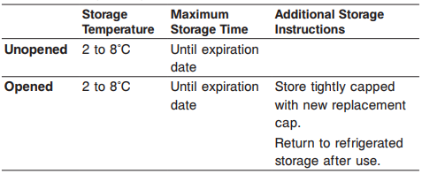

  - Quality Control Procedures
    - The Control (-) contains recalcified human plasma.
    - The Control (+) contains recalcified, heat-inactivated anti-HCV positive human plasma in recalcified anti-HCV negative human plasma.
    - Both controls also contain preservatives (sodium azide).
    - The controls are at the following ranges and target concentrations:
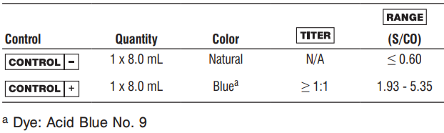
    - This product is liquid ready-to-use and may be used immediately after removal from 2 to 8°C storage.
    - Prior to each use, mix by gentle inversion.
    - During operation of the Alinity i analyzer, at least two levels of quality control material (one Non-reactive (Negative QC) and one Reactive (Positive QC)) will be tested at a minimum of once a day.
    - The frequency of Quality Control Procedures is as follows:
      - Once every 24 hours each day of use
      - After performing calibration
      - After instrument service procedures or maintenance that may affect assay performance have been performed.
    - Control ranges determined during method validation at the CleanSlate Centers’ Main Laboratory are used to establish basis to monitor the acceptable performance of the assay. If a control is out of its specified range, the associated sample results are invalid and the samples must be retested. Recalibration may be indicated.
    - Note: The insert ranges for the controls are not lot specific and represent the total range of values which may be generated throughout the life of the product. Means and acceptable ranges that fall within the package insert ranges were defined during validation and will be monitored and updated by the CleanSlate Centers’ Main Laboratory.
    - Once a calibration is accepted and stored, all subsequent samples may be tested.
    - To troubleshoot control values that fall outside the control range, refer to the Alinity ci-series Operations Manual, Section 10, Observed Problems.
    - Storage and Stability of QC materials:
      - Do not use past expiration date.
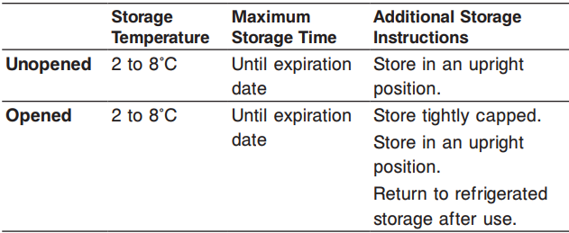
13 PROCEDURE(S)
  - Specimen Receipt: The test(s) have been previously ordered at the point of collection through the EMR and populated into the laboratory information system (LIS), here LabDaq or equivalent. Specimens are received into the main lab already labeled.
    - Specimens are scanned into LabDaq and received.
    - Specimens are placed into sample racks.
  - Analysis: performed as described in the “biological principles of the procedure” section above.
  - For a detailed description of how to run an assay, refer to the Alinity ci-series Operations Manual, Section 5.
  - If using primary or aliquot tubes, refer to the Alinity ci-series Operations Manual, Section 4 to ensure sufficient specimen is present.
  - To minimize the effects of evaporation, verify adequate sample cup volume is present prior to running the test.
  - Maximum number of replicates sampled from the same sample cup: 10
    - Priority:
      - Sample volume for first test: 70 µL
      - Sample volume for each additional test from same sample cup: 20 µL
    - ≤ 3 hours on the reagent and sample manager:
      - Sample volume for first test: 150 µL
      - Sample volume for each additional test from same sample cup: 20 µL
    - > 3 hours on the reagent and sample manager:
      - Replace with a fresh aliquot of sample.
  - Refer to the Anti-HCV calibrator package insert and/or Anti-HCV control package insert for preparation and usage.

  - For general operating procedures, refer to the Alinity ci-series Operations Manual, Section 5.
  - For optimal performance, it is important to perform routine maintenance as described in the Alinity ci-series Operations Manual, Section 9. Perform maintenance more frequently when required by laboratory procedures.
  - Sample Dilution Procedures
    - Samples cannot be diluted for the Alinity i Anti-HCV assay.
- REFERENCE INTERVAL OF PATIENT RESULTS
  - Linearity
    - N/A
  - Critical Values
    - N/A
- ESTABLISH QC TARGET MEANS AND ACCEPTANCE CRITERIA UPON ARRIVAL OF NEW LOT
  - Evaluate new lot against manufacturer range for updates compared to current.
  - Report any update found to laboratory leadership for approval and implementation.
  - Analyze each level in 5 replicates to evaluate:
    - Need for a new mean.
    - SD range:
      - Reactive QC: 1SD set at 10% of mean.
      - Non-reactive: set according to manufacture range.
    - Mean adjustments will also be performed relative to performance trends.
    - To establish statistically-based control limits, each laboratory should establish its own concentration target and ranges for new control lots at each clinically relevant control level. This can be accomplished by assaying a minimum of 20 replicates over several (3-5) days and using the reported results to establish the expected average (target) and variability about this average (range) for the laboratory.
- CALCULATIONS
  - The Alinity i analyzer calculates results for the Alinity i Anti-HCV assay using the ratio of the sample RLU to the cutoff RLU (S/CO) for each specimen and control.
  - Cutoff RLU = Calibrator 1 Mean RLU x 0.074
  - The cutoff RLU is stored for each reagent lot calibration.
  - S/CO = Sample RLU/Cutoff RLU.
- INTREPTATION OF RESULTS
  - The cutoff is 1.00 S/CO.
  - As with all analyte determinations, assay results, in conjunction with other laboratory results and clinical information, may be used to provide presumptive evidence of infection with HCV (state of infection or associated disease not determined) in persons with signs and symptoms of hepatitis and in persons at risk for hepatitis C infection.
  - See Table Below For Interpretation of Results:

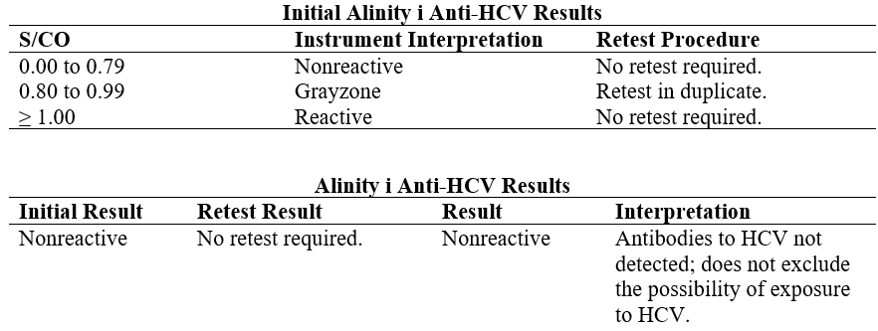
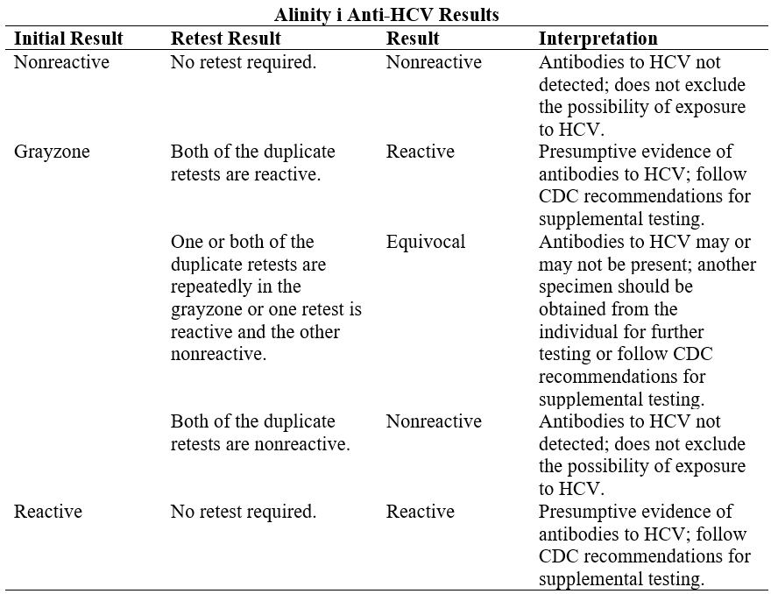
  - Flags
    - Some results may contain information in the Flags field. For a description of the flags that may appear in this field, refer to the Alinity ci-series Operations Manual, Section 5.
- REPORTING
  - Report Transmission
    - Patient test results uploaded into LABDAQ are reviewed by designated personnel and released for transmission into EMR chart via interface; results within the normal are transmitted to EMR via Auto-verification.
- LIMITATIONS
  - For diagnostic purposes, results should be used in conjunction with patient history and other hepatitis markers for diagnosis of acute and chronic infection.
  - Current methods for the detection of antibodies to HCV may not detect all infected individuals. A nonreactive test result does not exclude the possibility of exposure to HCV.
  - Nonreactive test results in individuals with prior exposure to HCV may be due to antibody levels being below the detection limit of this assay or to lack of antibody reactivity to the recombinant antigens used in this assay.
  - Immunocompromised patients who have HCV may produce levels of antibody below the sensitivity of this assay and may not be detected as positive.
  - The affinity or avidity differences of anti-human IgG/IgM for anti-HCV have not been determined with this assay. Therefore, there may not be a demonstration of a significant increase in antibody level between acute and convalescent specimens for a patient in the late acute stage of infection when IgM antibodies are decreasing.
  - Results obtained with the Alinity i Anti-HCV assay may not be used interchangeably with values obtained with different manufacturers’ assay methods.
  - Assay performance characteristics have not been established for newborns, infants, children, or populations of immunocompromised or immunosuppressed patients.
  - Heterophilic antibodies in human serum can react with reagent immunoglobulins, interfering with in vitro immunoassays. Patients routinely exposed to animals or to animal serum products can be prone to this interference and anomalous values may be observed. Additional information may be required for diagnosis.
  - A reactive anti-HCV result does not exclude co-infection by another hepatitis virus.
  - The magnitude of an Alinity i Anti-HCV assay result cannot be correlated to an end point titer.
  - Refer to the SPECIMEN COLLECTION AND PREPARATION FOR ANALYSIS section of this package insert for specimen limitations.
- TROUBLESHOOTING
  - Notify laboratory leadership or designated staff.
  - See the Abbott Alinity ci-series Operations Manual available onboard the instrument or CleanSlate Centers OneDrive.
  - Call Technical Support 1-877-422-2688, and SN # SCM28296.
- PERFORMANCE CHARACTERISTICS
  - Refer to the Alinity i Anti-HCV assay insert for performance characteristics and validation studies completed by the CleanSlate Centers’ Main Laboratory.
REFERENCES: | - Abbott Alinity ci-series Operations Manual  - Alinity i Anti-HCV Reagent Kit insert  - Alinity i Anti-HCV calibrator insert  - Alinity i Anti-HCV quality control insert  - Clean Slate’s HIPAA Policy  - Clean Slate’s Safety Policy  - CAP Laboratory General Checklist.
REVISION HISTORY: | N/A

____________________________ _________________
Patrice Y. Ohouo, PhD Date
Main Laboratory Director

