PROCEDURE TITLE: | Alinity i Hepatitis B surface antigen Qualitative II (HBsAg Qual II) | DEPARTMENT: | Main Laboratory

EFFECTIVE DATE: | 05/23/2025 | APPROVAL: | 05/22/25
APPROVED BY: | Patrice Y. Ohouo, PhD  Main Laboratory Director | PROCEDURE NO.: | IMM.01010

- PURPOSE
  - To provide instructions for use of the Alinity i HBsAg Qual II assay. The Alinity i HBsAg Qual II assay is used for the qualitative detection of hepatitis B surface antigen (HBsAg) in human serum and plasma on the Abbott Alinity i analyzer.
- SUMMARY AND EXPLANATION OF THE TEST
  - The Alinity i HBsAg Qualitative II assay is a chemiluminescent microparticle immunoassay (CMIA) used for the qualitative detection of hepatitis B surface antigen (HBsAg) in human adult and pediatric serum and plasma and neonate serum on the Alinity i analyzer.
  - The causative agent of serum hepatitis is HBV which is an enveloped DNA virus. During infection, HBV produces an excess of HBsAg, also known as Australia antigen, which can be detected in the blood of infected individuals. It is responsible for binding the virus to the liver cell and is the target structure of neutralizing antibodies. HBsAg is the first serological marker after infection with HBV, appearing 1 to 10 weeks after exposure and 2 to 8 weeks before the onset of clinical symptoms. HBsAg persists during this acute phase and clears late in the convalescence period. Failure to clear HBsAg within 6 months indicates a chronic HBsAg carrier state.
  - HBsAg assays are used to identify persons infected with HBV and to monitor the status of infected individuals in combination with other hepatitis B serological markers. In most countries, testing for HBsAg is part of the antenatal screening program to identify HBV infected mothers and to prevent perinatal HBV infection by subsequent immunization.
  - Specimens nonreactive by Alinity i HBsAg Qualitative II are considered negative for HBsAg. A reactive specimen must be retested in duplicate by Alinity i HBsAg Qualitative II to determine whether it is repeatedly reactive. Specimens found to be repeatedly reactive by the Alinity i HBsAg Qualitative II assay should be confirmed using the Alinity i HBsAg Qualitative II Confirmatory (08P11) assay, a neutralization procedure utilizing human anti-HBs. If the specimen is neutralized, the specimen is considered confirmed positive for HBsAg. It is recommended that confirmatory testing be performed before disclosing HBsAg status.
- BIOLOGICAL PRINCIPLES OF THE PROCEDURE
  - This assay is a one-step immunoassay for the qualitative detection of HBsAg in human serum and plasma using chemiluminescent microparticle immunoassay (CMIA) technology.
  - (Note: Ancillary Wash Buffer is added in a second incubation step, so the assay file performs a two-step assay protocol).
  - Sample, anti-HBs coated paramagnetic microparticles, and anti-HBs acridinium-labeled conjugate are combined to create a reaction mixture and incubated. The HBsAg present in the sample binds to the anti-HBs coated microparticles and to the anti-HBs acridinium-labeled conjugate. Following a wash cycle, Pre-Trigger and Trigger Solutions are added.
  - The resulting chemiluminescent reaction is measured as relative light units (RLUs). There is a direct relationship between the amount of HBsAg in the sample and the RLUs detected by the system optics.
  - The presence or absence of HBsAg in the sample is determined by comparing the chemiluminescent RLU in the reaction to the cutoff RLU determined from an active calibration.
  - If the chemiluminescent signal in the specimen is greater than or equal to the cutoff signal, the sample is considered reactive for HBsAg.
  - For additional information on system and assay technology, refer to the Alinity ci-series Operations Manual, Section 3.
- INTENDED USE
  - The Alinity i HBsAg Qualitative II assay is a chemiluminescent microparticle immunoassay (CMIA) used for the qualitative detection of hepatitis B surface antigen (HBsAg) in human adult and pediatric serum and plasma and neonate serum on the Alinity i analyzer.
  - The assay may also be used to screen for HBV infection in pregnant women to identify neonates who are at risk for acquiring hepatitis B during the perinatal period. Assay results, in conjunction with other laboratory results and clinical information, may be used to provide presumptive evidence of infection with the hepatitis B virus (HBV) (state of infection or associated disease not determined) in persons with signs and symptoms of hepatitis and in persons at risk for hepatitis B infection.
  - This assay has not been cleared for use in screening blood, plasma, or tissue donors.
- Definitions
  - N/A
- Responsibilities
  - Only trained personnel are authorized to perform this procedure. Qualified personnel are responsible for the proper execution of this procedure. Under the guidance of the Laboratory Director, it is the responsibility of the Technical Supervisor to ensure the competency of laboratory personnel performing this test.
  - Training is documented in the training file of each qualified staff member.
  - All patient information is handled in a manner that is compliant with HIPAA guidelines. Refer to http://www.hhs.gov/ocr.hipaa/ and also to CleanSlate’s HIPAA Policy, https://cleanslatecenters.training.reliaslearning.com or equivalent.
  - Under the direction of the Laboratory Director, the Technical Supervisor is responsible for the direct review of all quality control, equipment maintenance and reporting of patient results.
- SAFETY
  - Standard Precautions
    - CAUTION: This product contains human-sourced and/or potentially infectious components. Refer to the REAGENTS section of assay insert for more details.
    - It is recommended that these reagents, human specimens, and all consumables contaminated with potentially infectious materials be handled in accordance with the OSHA Standard on Bloodborne Pathogens. Biosafety Level 2 or other appropriate regional, national, and institutional biosafety practices should be used for materials that contain, are suspected of containing, or are contaminated with infectious agents.
    - Care should be taken, and personal protective equipment is required when handling material of human origin. All biological specimens should be considered potentially infectious.
    - For up-to-date recommendations on handling biological specimens refer to the CDC website: http://cdc.gov/ncidod/dhqp/pdf/guidelines/Isolation2007.pdf or CLSI document M29-A3, Protection of Laboratory Workers from Occupationally Acquired Infections. Clinical and Laboratory Standards Institute; Approved Guidelines and or Refer to Clean Slate’s safety policy, https://cleanslatecenters.training.reliaslearning.com or equivalent.
  - Safety
    - For the most current hazard information, see the product Safety Data Sheet also available at www.corelaboratory.abbott.
    - The tables below list warnings and precautions that apply to listed kit components:
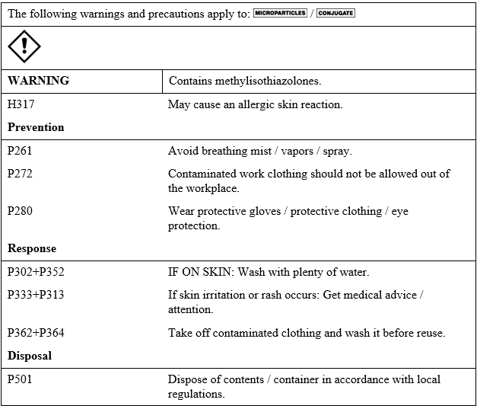

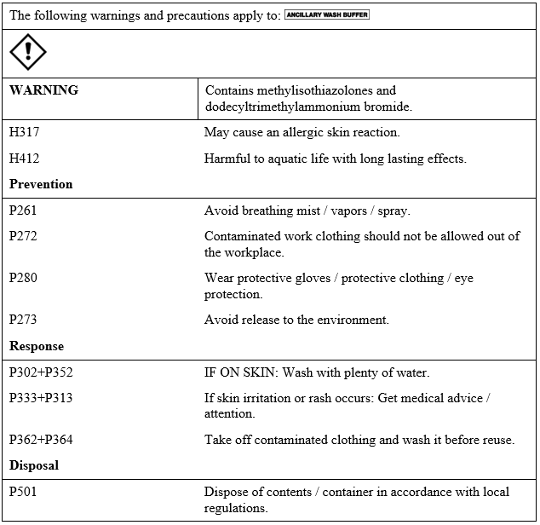
    - For a detailed discussion of safety precautions during system operation, refer to the Alinity ci-series Operations Manual, Section 8.
  - Computer and Web Portal
    - Passwords must be assigned only to authorized personnel.

    - To ensure HIPAA compliance, it is recommended that the computer, printer and printouts be located away from the visibility and access of unauthorized individuals.
- SPECIMEN REQUIREMENTS, COLLECTION AND PREPARATION FOR ANALYSIS
  - Specimen types:
    - The specimen types described in the table below were verified by the manufacturer for use with this assay.
    - The instrument does not provide the capability to verify specimen types. It is the responsibility of the operator to verify that the correct specimen types are used in the assay.
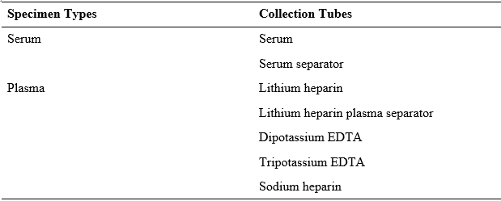
  - Specimen conditions:
    - Do not use:
      - heat-inactivated specimens
      - pooled specimens
      - grossly hemolyzed specimens
      - specimens with obvious microbial contamination
    - For accurate results, serum and plasma specimens should be free of fibrin, red blood cells, and other particulate matter. Serum specimens from patients receiving anticoagulant or thrombolytic therapy may contain fibrin due to incomplete clot formation.
    - Draw specimens from heparinized patients prior to heparin therapy. Specimens may be partially coagulated and erroneous results could occur due to the presence of fibrin.
    - Ensure that complete clot formation in serum specimens has taken place prior to centrifugation. If the specimen is centrifuged before a complete clot forms, the presence of fibrin may cause erroneous results.
    - To prevent cross contamination, use of disposable pipettes or pipette tips is recommended.
      - Unlabeled specimens: there must be an ID link between the test order and the specimen container. Unlabeled specimens cannot be accepted.
      - All specimens are examined for correct identification when accessioned and processed and are rejected if it does not have two matching patient identifiers.
      - Leaking/improperly closed tubes cannot be accepted.
      - Specimen with insufficient quantity or specimen containers that are “empty” or have improper storage cannot be accepted.
  - Preparation for analysis:
    - Follow the tube manufacturer’s processing instructions for collection tubes. Gravity separation is not sufficient for specimen preparation.
    - Specimens should be free of bubbles. Remove bubbles with an applicator stick before analysis. Use a new applicator stick for each specimen to prevent cross contamination.
    - Prepare frozen specimens as follows: (Avoid more than 3 freeze/thaw cycles).
      - Frozen specimens must be completely thawed before mixing.
      - Mix thawed specimens thoroughly by low speed vortex or by inverting 10 times.
      - Visually inspect the specimens. If layering or stratification is observed, mix until specimens are visibly homogeneous.
      - If specimens are not mixed thoroughly, inconsistent results may be obtained.
      - Centrifuge mixed specimens as described below.

    - Recentrifugation of Specimens:
      - To ensure consistency in results, specimens must be centrifuged using an appropriate tube at a minimum 2500 RCF to obtain ≥ 100 000 g-minutes before testing if:
        - they contain fibrin, red blood cells, or other particulate matter or
        - they were frozen and thawed.

      - g-minutes = relative centrifugal force (RCF) (g) X centrifugation time (minutes). For Example:
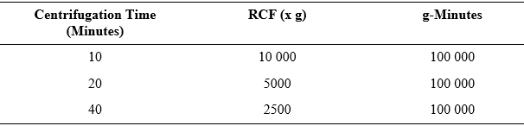
      - Transfer clarified specimen to a sample cup or secondary tube for testing. For centrifuged specimens with a lipid layer, transfer only the clarified specimen and not the lipemic material.
  - Specimen Storage:
    - Specimen storage is as described in the table below or according to stability studies performed by the Cleanslate Centers’ Main Laboratory, where indicated.
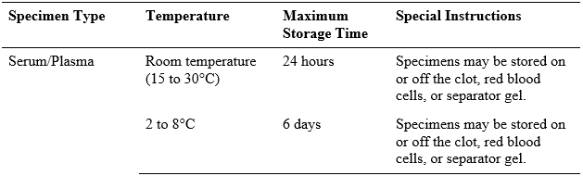
    - If testing will be delayed longer than the maximum storage time, remove serum or plasma from the clot, red blood cells, or separator gel and store frozen (-20°C or colder).
    - Avoid more than 3 freeze/thaw cycles.
  - Specimen Shipping:
    - Package and label specimens in compliance with applicable state, federal, and international regulations covering the transport of clinical specimens and infectious substances.
    - Do not exceed the storage limitations listed above or as determined based on stability studies performed by the Cleanslate Centers’ Main Laboratory, where indicated.
- MATERIALS & EQUIPMENT
  - Abbott Alinity i analyzer.
  - Alinity i HBsAg Qualitative II Reagent Kit 08P10. See table below for details. Volumes (mL) listed in the table below indicate the volume per cartridge.
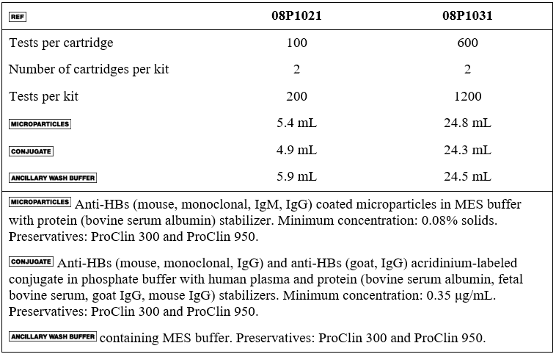
  - Alinity i HBsAg Qualitative II Calibrators (Part# 08P1002)
  - Alinity i HBsAg Qualitative II Controls (Part# 08P1012)
  - Alinity Trigger Solution (Part# 06P1160)
  - Alinity Pre-Trigger Solution (Part# 06P1265)
  - Alinity i-series Concentrated Wash Buffer (Part# 06P1368)
  - Alinity i Reaction Vessels (Part# 06P1401)
  - Alinity i Replacement Caps (Part# 04R4701)
  - Alinity i Sample Cups (Part# 01R3801)
  - For information on materials required for operation of the instrument, refer to the Alinity ci-series Operations Manual, Section 1.
  - For information on materials required for maintenance procedures, refer to the Alinity ci-series Operations Manual, Section 9.
- REAGENTS HANDLING
  - Upon receipt, gently invert the unopened reagent kit by rotating it over and back for a full 180 degrees, 5 times with green label stripe facing up and then 5 times with green label stripe facing down. This ensures that liquid covers all sides of the bottles within the cartridges. During reagent shipment, microparticles can settle on the reagent septum.
  - Place a check in the square on the reagent kit to indicate to others that the inversions have been completed.
  - After mixing, place reagent cartridges in an upright position for 1 hour before use to allow bubbles that may have formed to dissipate.
  - If a reagent cartridge is dropped, place in an upright position for 1 hour before use to allow bubbles that may have formed to dissipate.
  - Reagents are susceptible to the formation of foam and bubbles. Bubbles may interfere with the detection of the reagent level in the cartridge and cause insufficient reagent aspiration that may adversely affect results.
  - For a detailed discussion of reagent handling precautions during system operation, refer to the Alinity ci-series Operations Manual, Section 7.
- REAGENTS STORAGE:
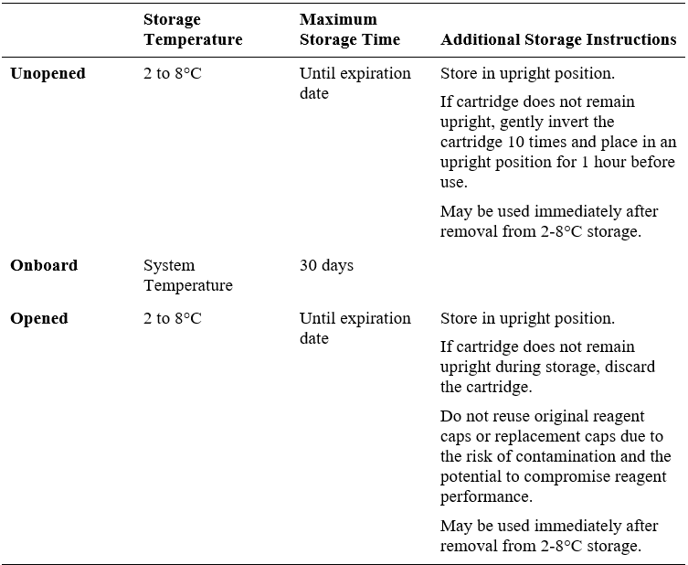

  - Reagents may be stored on or off the system. If removed from the system, store reagents with new replacement caps in an upright position at 2 to 8°C. For reagents stored off the system, it is recommended that they be stored in their original trays or boxes to ensure they remain upright.
  - For information on unloading reagents, refer to the Alinity ci-series Operations Manual,
Section 5.
  - Indications of Reagent Deterioration
    - Deterioration of the reagents may be indicated when a calibration error occurs or a control value is out of the specified range. Associated test results are invalid, and samples must be retested. Assay recalibration may be necessary.
    - For troubleshooting information, refer to the Alinity ci-series Operations Manual, Section 10.
- CALIBRATIONS & CONTROL PROCEDURES
  - Calibration
    - Cal 1 contains inactivated purified human HBsAg (subtype ad) in phosphate buffer with human plasma and protein (bovine serum albumin) stabilizers. Preservatives: ProClin 300 and ProClin 950.
    - Cal 2 contains recalcified human plasma. Preservatives: ProClin 950 and sodium azide.
    - The calibrators are at the following concentrations:
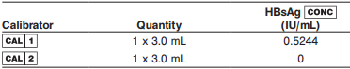
    - This product is liquid ready-to-use and may be used immediately after removal from 2 to 8°C storage.
    - Prior to each use, mix by gentle inversion.
    - The calibrator vials are placed directly on the instrument and automatically processed using the barcode on the calibrator vial. Alternatively, the calibrators can be pipetted into a sample cup. If the calibrators are pipetted into sample cups, the calibration must be manually ordered.
    - Calibrators are tested in triplicate. The Alinity i analyzer calculates the cutoff Relative Light Units (RLU) from the mean RLU of the three replicates for each calibrator.
    - The cutoff RLU is calculated using the following equation:
Cutoff RLU = (Cal 1 Mean RLU x 0.0575) + (Cal 2 Mean RLU x 0.8)
    - The Alinity i HBsAg Qualitative II Calibrator 1 is referenced to the World Health Organization (WHO) Second International Standard for HBsAg (subtype adw2, genotype A, NIBSC Code 00/588) using the ARCHITECT i System.
    - The calibration should be used in conjunction with control ranges to determine the validity of the calibration
    - The acceptable calibration is stored by the Alinity i analyzer for use with any reagent kit of that lot.
    - The frequency of calibration is as follows:
      - A reagent kit with a new lot number is used.
      - Daily quality control results are outside of statistically-based quality control limits used to monitor and control system performance.
      - If statistically-based quality control limits are not available then the calibration should not exceed a 30-day limit for recalibration frequency.
      - This assay may also need to be recalibrated after specified service procedures have been performed or maintenance to critical part or subsystems that might influence the performance of the assay.
    - Assay control must be tested to evaluate the assay calibration.
    - Once a calibration is accepted and stored, all subsequent samples may be tested.
    - For additional instructions on performing a calibration, refer to the Alinity ci-series Operations Manual, Section 5.
    - Storage and Stability of Calibrators:
      - The analyzer will track In-use Stability, which is the time the calibrator is outside of refrigerated storage while on the analyzer.
      - The analyzer will not allow the use of the calibrator if the In-use Stability has been exceeded. Maximum In-use Stability can be found in the Assay Parameter Report. For additional information on calibrator In-use Stability, refer to the Alinity ci-series Operations Manual, Section 5.
      - Do not use past expiration date.
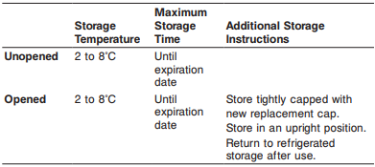
  - Quality Control Procedures
    - The Control (-) contains recalcified human plasma. Preservatives: ProClin 950 and sodium azide.
    - The Control (+) contains inactivated purified human HBsAg (subtype ad/ay) in phosphate buffer with human plasma and protein (bovine serum albumin) stabilizers. Preservatives: ProClin 300 and ProClin 950.contains inactivated purified human HBsAg (subtype ad/ay) in phosphate buffer with human plasma and protein (bovine serum albumin) stabilizers. Preservatives: ProClin 300 and ProClin 950.
    - The controls are at the following ranges and target concentrations:
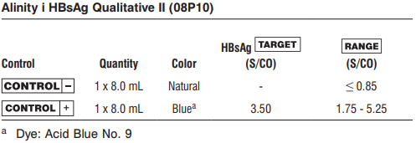
    - This product is liquid ready-to-use and may be used immediately after removal from 2 to 8°C storage.
    - Prior to each use, mix by gentle inversion.
    - During operation of the Alinity i analyzer, at least two levels of quality control material (one Non-reactive (Negative QC) and one Reactive (Positive QC)) will be tested at a minimum of once a day.
    - The frequency of Quality Control Procedures is as follows:
      - Once every 24 hours each day of use
      - After performing calibration
      - After instrument service procedures or maintenance that may affect assay performance have been performed.
    - Control ranges determined during method validation at the CleanSlate Centers’ Main Laboratory are used to establish basis to monitor the acceptable performance of the assay. If a control is out of its specified range, the associated sample results are invalid and the samples must be retested. Recalibration may be indicated.
    - Note: The insert ranges for the controls are not lot specific and represent the total range of values which may be generated throughout the life of the product. Means and acceptable ranges that fall within the package insert ranges were defined during validation and will be monitored and updated by the CleanSlate Centers’ Main Laboratory.
    - Once a calibration is accepted and stored, all subsequent samples may be tested.
    - To troubleshoot control values that fall outside the control range, refer to the Alinity ci-series Operations Manual, Section 10, Observed Problems.
    - Storage and Stability of QC materials:
      - Do not use past expiration date.
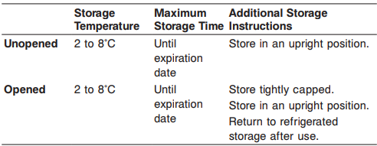
13 PROCEDURE(S)
  - Specimen Receipt: The test(s) have been previously ordered at the point of collection through the EMR and populated into the laboratory information system (LIS), here LabDaq or equivalent. Specimens are received into the main lab already labeled.
    - Specimens are scanned into LabDaq and received.
    - Specimens are placed into sample racks.
  - Analysis: performed as described in the “biological principles of the procedure” section above.
  - For a detailed description of how to run an assay, refer to the Alinity ci-series Operations Manual, Section 5.
  - If using primary or aliquot tubes, refer to the Alinity ci-series Operations Manual, Section 4 to ensure sufficient specimen is present.
  - To minimize the effects of evaporation, verify adequate sample cup volume is present prior to running the test.
  - Maximum number of replicates sampled from the same sample cup: 10
    - Priority:
      - Sample volume for first test: 106 µL
      - Sample volume for each additional test from same sample cup: 56 µL
    - ≤ 3 hours on the reagent and sample manager:
      - Sample volume for first test: 150 µL
      - Sample volume for each additional test from same sample cup: 56 µL
    - > 3 hours on the reagent and sample manager:
      - Replace with a fresh aliquot of sample.
  - Refer to the HBsAg Qualitative II calibrator and/or control package insert for preparation and usage.
  - For general operating procedures, refer to the Alinity ci-series Operations Manual, Section 5.
  - For optimal performance, it is important to perform routine maintenance as described in the Alinity ci-series Operations Manual, Section 9. Perform maintenance more frequently when required by laboratory procedures.
  - Sample Dilution Procedures
    - Samples cannot be diluted for the Alinity i HBsAg Qualitative II assay.
- REFERENCE INTERVAL OF PATIENT RESULTS
  - Linearity
    - N/A
  - Critical Values
    - N/A
- ESTABLISH QC TARGET MEANS AND ACCEPTANCE CRITERIA UPON ARRIVAL OF NEW LOT
  - Evaluate new lot against manufacturer range for updates compared to current.
  - Report any update found to laboratory leadership for approval and implementation.
  - Analyze each level in 5 replicates to evaluate:
    - Need for a new mean.
    - SD range:
      - Reactive QC: 1SD set at 10% of mean.
      - Non-reactive: set according to manufacture range.
    - Mean adjustments will also be performed relative to performance trends.
    - To establish statistically-based control limits, each laboratory should establish its own concentration target and ranges for new control lots at each clinically relevant control level. This can be accomplished by assaying a minimum of 20 replicates over several (3-5) days and using the reported results to establish the expected average (target) and variability about this average (range) for the laboratory.
- CALCULATIONS
  - The Alinity i analyzer calculates results for the Alinity i HBsAg Qualitative II assay using the ratio of the sample RLU to the cutoff RLU (S/CO) for each specimen and control.
  - Cutoff RLU = (Calibrator 1 mean RLU x 0.0575) + (Calibrator 2 mean RLU x 0.8)
  - The cutoff RLU is stored for each reagent lot calibration.
  - S/CO = Sample RLU/Cutoff RLU.
- INTREPTATION OF RESULTS
  - The cutoff is 1.00 S/CO.
  - As with all analyte determinations, Assay results, in conjunction with other laboratory results and clinical information, may be used to provide presumptive evidence of infection with the hepatitis B virus (HBV) (state of infection or associated disease not determined) in persons with signs and symptoms of hepatitis and in persons at risk for hepatitis B infection.
  - See Table Below For Interpretation of Results:

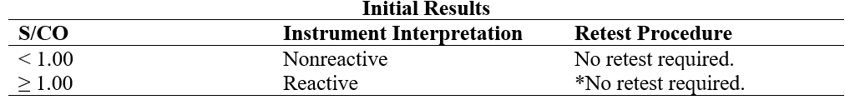
* It is CleanSlate Centers policy to reflex reactive HBsAg screen results for confirmatory testing.

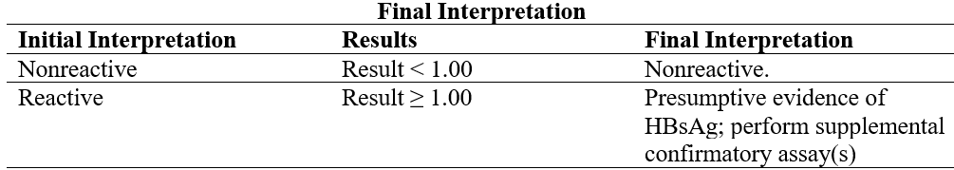
  - Flags
    - Some results may contain information in the Flags field. For a description of the flags that may appear in this field, refer to the Alinity ci-series Operations Manual, Section 5.
- REPORTING
  - Report Transmission
    - Patient test results uploaded into LABDAQ are reviewed by designated personnel and released for transmission into EMR chart via interface; results within the normal are transmitted to EMR via Auto-verification.
- LIMITATIONS
  - The effectiveness of the Alinity i HBsAg Qualitative II assay for use in screening blood, plasma, or tissue donors has not been established.
  - Assay performance characteristics have not been established when the Alinity i HBsAg Qualitative II assay is used in conjunction with other manufacturers’ assays for specific HBV markers. Users are responsible for establishing their own performance characteristics.
  - Current methods for the detection of hepatitis B surface antigen may not detect all potentially infected individuals. A nonreactive test result does not exclude the possibility of exposure to or infection with hepatitis B virus. A nonreactive test result in individuals with prior exposure to hepatitis B may be due to antigen levels below the detection limit of this assay or lack of antigen reactivity to the antibodies in this assay.
  - If the Alinity i HBsAg Qualitative II results are inconsistent with clinical evidence, additional testing is recommended.
  - For diagnostic purposes, results should be used in conjunction with patient history and other hepatitis markers for diagnosis of acute and chronic infection.
  - Results obtained with the Alinity i HBsAg Qualitative II assay may not be used interchangeably with values obtained with different manufacturers’ assay methods.
  - Heterophilic antibodies in human serum can react with reagent immunoglobulins, interfering with in vitro immunoassays. Patients routinely exposed to animals or to animal serum products can be prone to this interference and anomalous results may be observed. Additional information may be required for diagnosis.
  - Specimens from patients who have received preparations of mouse monoclonal antibodies for diagnosis or therapy may contain human anti-mouse antibodies (HAMA). Specimens containing HAMA may produce anomalous values when tested with assay kits such as Alinity i HBsAg Qualitative II that employ mouse monoclonal antibodies.
  - A reactive HBsAg result does not exclude co-infection by another hepatitis virus.
  - Refer to the SPECIMEN COLLECTION AND PREPARATION FOR ANALYSIS section of this package insert for specimen limitations.
- TROUBLESHOOTING
  - Notify laboratory leadership or designated staff.
  - See the Abbott Alinity ci-series Operations Manual available onboard the instrument or CleanSlate Centers OneDrive.
  - Call Technical Support 1-877-422-2688, and SN # SCM28296.
- PERFORMANCE CHARACTERISTICS
  - Refer to the Alinity i HBsAg Qualitative II assay insert for performance characteristics and validation studies completed by the CleanSlate Centers’ Main Laboratory.
REFERENCES: | - Abbott Alinity ci-series Operations Manual  - Alinity i HBsAg Qualitative II Reagent Kit insert  - Alinity i HBsAg Qualitative II calibrator insert  - Alinity i HBsAg Qualitative II quality control insert  - Clean Slate’s HIPAA Policy  - Clean Slate’s Safety Policy  - CAP Laboratory General Checklist.
REVISION HISTORY: | N/A

____________________________ _________________
Patrice Y. Ohouo, PhD Date
Main Laboratory Director

