PROCEDURE TITLE: | Alinity i HIV Ag/Ab Combo (HIV Ag/Ab Combo) | DEPARTMENT: | Main Laboratory

EFFECTIVE DATE: | 05/24/2025 | APPROVAL: | 05/23/25
APPROVED BY: | Patrice Y. Ohouo, PhD  Main Laboratory Director | PROCEDURE NO.: | IMM.01011

- PURPOSE
  - To provide instructions for the use of the Alinity i HIV Ag/Ab Combo assay. The Alinity i HIV Ag/Ab Combo assay is used for the simultaneous qualitative detection of human immunodeficiency virus (HIV) p24 antigen and antibodies to HIV type 1 (HIV-1 group M and group O) and/or type 2 (HIV-2) in human serum and plasma on the Alinity i analyzer.
- SUMMARY AND EXPLANATION OF THE TEST
  - Acquired immunodeficiency syndrome (AIDS) is caused by two types of human immunodeficiency viruses, collectively designated HIV. HIV is transmitted by sexual contact, exposure to blood or blood products, and prenatal or perinatal infection of a fetus or newborn. Antibodies against HIV are nearly always detected in AIDS patients and HIV-infected asymptomatic individuals.
  - Phylogenetic analysis classifies HIV type 1 (HIV-1) into groups M (major), N (non-M, non-O), O (outlier), and P. HIV-1 group M is composed of genetic subtypes (A-D, F-H, J, and K) and circulating recombinant forms (CRFs). Group M viruses have spread throughout the world to cause the global AIDS pandemic. However, the geographic distribution and regional predominance of HIV-1 subtypes and CRFs vary. HIV-1 subtype B is the predominant subtype in North America, South America, Europe, Japan, and Australia, although other subtypes and CRFs are present in these regions as well. A significant percentage of new HIV-1 infections in Europe are caused by non-B subtype strains. All subtypes and many recombinant strains exist in Africa. In Asia, subtypes B and C, and CRF01_AE (formerly called subtype E) are found. HIV-1 groups N, O, and P are endemic to west central Africa and are relatively rare. However, group O infections have been identified in Europe and the USA.
  - HIV type 2 (HIV-2) is similar to HIV-1 in its structural morphology, genomic organization, cell tropism, in vitro cytopathogenicity, transmission routes, and ability to cause AIDS. HIV-2 is endemic to West Africa, but HIV-2 infections have been identified in North America and Europe at a low frequency compared to HIV-1.
  - Early after infection with HIV-1, but prior to seroconversion, HIV-1 core protein, p24 antigen, may be detected in HIV-1-infected individuals. Alinity i HIV Ag/Ab Combo uses anti-HIV-1 p24 antibodies as reagents to detect HIV-1 p24 antigen, thereby decreasing the window period and improving early detection of HIV infection.
  - The key immunogenic protein for serodetection of HIV infection is the viral transmembrane protein (TMP). Antibodies against the TMP are consistently among the first to appear during seroconversion of HIV-infected individuals and remain relatively strong throughout the asymptomatic and symptomatic stages of HIV infection. Alinity i HIV Ag/Ab Combo detects antibodies to HIV-1 groups M and O, and HIV-2 through the use of five recombinant proteins and two synthetic peptides derived from native TMP sequences of HIV-1 groups M and O, and HIV-2.
- BIOLOGICAL PRINCIPLES OF THE PROCEDURE
  - This assay is a two-step immunoassay for the qualitative detection of HIV-1 p24 antigen and antibodies to HIV-1 (group M and group O), and HIV-2 in human serum or plasma using chemiluminescent microparticle immunoassay (CMIA) technology.
  - Sample, paramagnetic microparticles, assay diluent, and wash buffer are combined and incubated. The HIV-1 p24 antigen and HIV-1/HIV-2 antibodies present in the sample bind to the HIV-1/HIV-2 antigen and HIV-1 p24 monoclonal (mouse) antibody coated microparticles. The mixture is washed. Acridinium-labeled conjugate is added to create a reaction mixture and incubated. The bound HIV-1 p24 antigen and HIV-1/HIV-2 antibodies bind to the acridinium-labeled conjugates. Following another wash cycle, Pre-Trigger and Trigger solutions are added.
  - The resulting chemiluminescent reaction is measured as relative light units (RLUs). There is a relationship between the amount of HIV antigen and antibodies in the sample and the RLUs detected by the system optics.
  - The presence or absence of HIV-1 p24 antigen or HIV-1/HIV-2 antibodies in the sample is determined by comparing the chemiluminescent RLU in the reaction to the cutoff RLU determined from an active calibration.
  - Specimens with signal to cutoff (S/CO) values greater than or equal to 1.00 are considered reactive for HIV-1 p24 antigen or HIV-1/ HIV-2 antibodies. Specimens with S/CO values less than 1.00 are considered nonreactive for HIV-1 p24 antigen and HIV-1/ HIV-2 antibodies.
  - Specimens that are initially reactive in the Alinity i HIV Ag/Ab Combo assay should be retested in duplicate. Repeat reactivity is highly predictive of the presence of HIV-1 p24 antigen and/or HIV-1/HIV-2 antibodies. However, as with all immunoassays, the Alinity i HIV Ag/Ab Combo assay may yield nonspecific reactions due to other causes, particularly when testing in low prevalence populations. A repeatedly reactive specimen should be investigated further with supplemental confirmatory HIV-specific tests, such as immunoblots, antigen tests, and HIV nucleic acid tests. Supplemental testing of repeatedly reactive specimens obtained from individuals with HIV infection usually confirms the presence of HIV antibodies, HIV antigen, or HIV nucleic acid. A full differential diagnostic work-up for the diagnosis of AIDS and AIDS-related conditions includes an examination of the patient’s immune status and a clinical history.
  - For additional information on system and assay technology, refer to the Alinity ci-series Operations Manual, Section 3.
- INTENDED USE
  - The Alinity i HIV Ag/Ab Combo assay is a chemiluminescent microparticle immunoassay (CMIA) used for the simultaneous qualitative detection of human immunodeficiency virus (HIV) p24 antigen and antibodies to HIV type 1 (HIV-1 group M and group O) and/or type 2 (HIV-2) in human serum and plasma (EDTA and heparin) on the Alinity i analyzer.
  - The Alinity i HIV Ag/Ab Combo assay is intended to be used as an aid in the diagnosis of HIV-1/HIV-2 infection, including acute or primary HIV-1 infection. The assay may also be used as an aid in the diagnosis of HIV-1/HIV-2 infection in pediatric subjects (i.e., children as young as two years of age) and in pregnant women.
  - An Alinity i HIV Ag/Ab Combo reactive result does not distinguish between the detection of HIV-1 p24 antigen, HIV-1 antibody, or HIV-2 antibody.
  - This assay is not intended for use in screening blood, plasma, or tissue donors.
- Definitions
  - N/A
- Responsibilities
  - Only trained personnel are authorized to perform this procedure. Qualified personnel are responsible for the proper execution of this procedure. Under the guidance of the Laboratory Director, it is the responsibility of the Technical Supervisor to ensure the competency of laboratory personnel performing this test.
  - Training is documented in the training file of each qualified staff member.
  - All patient information is handled in a manner that is compliant with HIPAA guidelines. Refer to http://www.hhs.gov/ocr.hipaa/ and also to CleanSlate’s HIPAA Policy, https://cleanslatecenters.training.reliaslearning.com or equivalent.
  - Under the direction of the Laboratory Director, the Technical Supervisor is responsible for the direct review of all quality control, equipment maintenance and reporting of patient results.
- SAFETY
  - Standard Precautions
    - CAUTION: This product contains human-sourced and/or potentially infectious components. Refer to the REAGENTS section of assay insert for more details.
    - It is recommended that these reagents, human specimens, and all consumables contaminated with potentially infectious materials be handled in accordance with the OSHA Standard on Bloodborne Pathogens. Biosafety Level 2 or other appropriate regional, national, and institutional biosafety practices should be used for materials that contain, are suspected of containing, or are contaminated with infectious agents.
    - Care should be taken, and personal protective equipment is required when handling material of human origin. All biological specimens should be considered potentially infectious.
    - For up-to-date recommendations on handling biological specimens refer to the CDC website: http://cdc.gov/ncidod/dhqp/pdf/guidelines/Isolation2007.pdf or CLSI document M29-A3, Protection of Laboratory Workers from Occupationally Acquired Infections. Clinical and Laboratory Standards Institute; Approved Guidelines and or Refer to Clean Slate’s safety policy, https://cleanslatecenters.training.reliaslearning.com or equivalent.
  - Safety
    - For the most current hazard information, see the product Safety Data Sheet also available at www.corelaboratory.abbott.
    - The tables below list warnings and precautions that apply to listed kit components:
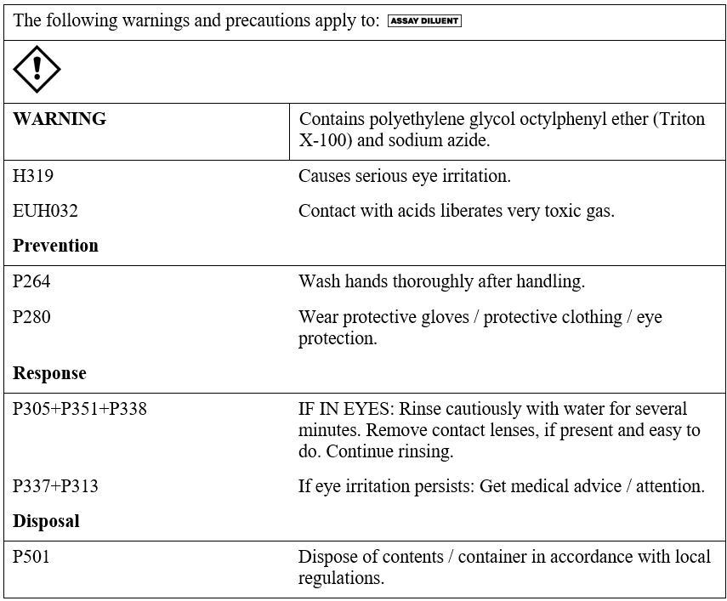

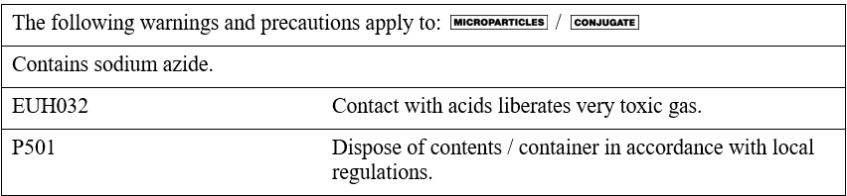
    - For a detailed discussion of safety precautions during system operation, refer to the Alinity ci-series Operations Manual, Section 8.
  - Computer and Web Portal
    - Passwords must be assigned only to authorized personnel.

    - To ensure HIPAA compliance, it is recommended that the computer, printer and printouts be located away from the visibility and access of unauthorized individuals.
- SPECIMEN REQUIREMENTS, COLLECTION AND PREPARATION FOR ANALYSIS
  - Specimen types:
    - The specimen types described in the table below were verified by the manufacturer for use with this assay.

    - The instrument does not provide the capability to verify specimen types. It is the responsibility of the operator to verify that the correct specimen types are used in the assay.

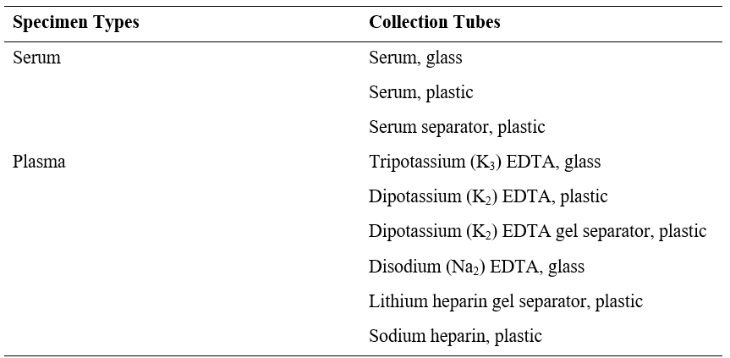
    - Although heparin tube types will demonstrate higher S/CO values than other tube types for specimens containing HIV antibody, there is no change to the interpretation of results. Specimens that do not contain HIV antibody do not demonstrate higher S/CO values in heparin tube types.
    - For blood screening in urgent situations, do not use samples collected directly from whole blood bags as they contain anticoagulants other than EDTA and heparin.
    - Liquid anticoagulants may have a dilution effect resulting in lower S/CO values for individual specimens.

  - Specimen conditions:
    - Do not use:
      - heat-inactivated specimens
      - pooled specimens
      - grossly hemolyzed specimens
      - specimens with obvious microbial contamination
    - For accurate results, serum and plasma specimens should be free of fibrin, red blood cells, and other particulate matter. Serum specimens from patients receiving anticoagulant or thrombolytic therapy may contain fibrin due to incomplete clot formation.
    - To prevent cross contamination, use of disposable pipettes or pipette tips is recommended.
    - Unlabeled specimens: there must be an ID link between the test order and the specimen container. Unlabeled specimens cannot be accepted.
    - All specimens are examined for correct identification when accessioned and processed and are rejected if it does not have two matching patient identifiers.
    - Leaking/improperly closed tubes cannot be accepted.
    - Specimen with insufficient quantity or specimen containers that are “empty” or have improper storage cannot be accepted.
  - Preparation for analysis:
    - Follow the tube manufacturer’s processing instructions for collection tubes. Gravity separation is not sufficient for specimen preparation.
    - Specimens should be free of bubbles. Remove bubbles with an applicator stick before analysis. Use a new applicator stick for each specimen to prevent cross contamination.
    - To ensure consistency in results, recentrifuge specimens prior to testing if they contain fibrin, red blood cells, or other particulate matter.
    - NOTE: If fibrin, red blood cells, or other particulate matter are observed, mix by low speed vortex or by inverting 10 times prior to recentrifugation.
    - Prepare frozen specimens as follows: (Avoid more than 5 freeze/thaw cycles).
      - Frozen specimens must be completely thawed before mixing.
      - Mix thawed specimens thoroughly by low speed vortex or by inverting 10 times.
      - Visually inspect the specimens. If layering or stratification is observed, mix until specimens are visibly homogeneous.
      - If specimens are not mixed thoroughly, inconsistent results may be obtained.
      - Recentrifuge specimens.
    - Recentrifugation of Specimens:
      - Transfer specimens to an appropriate tube and centrifuge at a minimum of 100 000 g-minutes.
      - Examples of acceptable time and force ranges that meet this criterion are listed in the table below.
      - Centrifugation time using alternate RCF values can be calculated using the following formula:
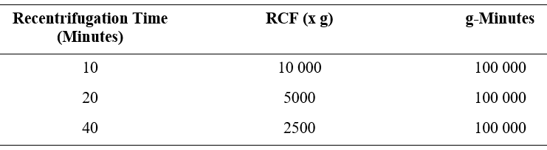
      - Transfer clarified specimen to a sample cup or secondary tube for testing. For centrifuged specimens with a lipid layer, transfer only the clarified specimen and not the lipemic material.
  - Specimen Storage:
    - Specimen storage is as described in the table below or according to stability studies performed by the Cleanslate Centers’ Main Laboratory, where indicated.
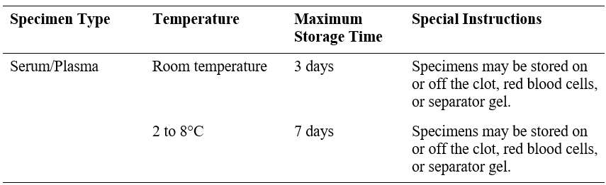
    - If testing will be delayed more than 7 days, the specimens should be removed from the clot, red blood cells, or separator gel, and the serum or plasma should be stored frozen (-20°C or colder).
    - Avoid more than 5 freeze/thaw cycles..
  - Specimen Shipping:
    - Package and label specimens in compliance with applicable state, federal, and international regulations covering the transport of clinical specimens and infectious substances.
    - Do not exceed the storage limitations listed above or as determined based on stability studies performed by the Cleanslate Centers’ Main Laboratory, where indicated.
- MATERIALS & EQUIPMENT
  - Abbott Alinity i analyzer.
  - Alinity i HIV Ag/Ab Combo Reagent Kit 08P07. See table below for details. Volumes (mL) listed in the table below indicate the volume per cartridge.
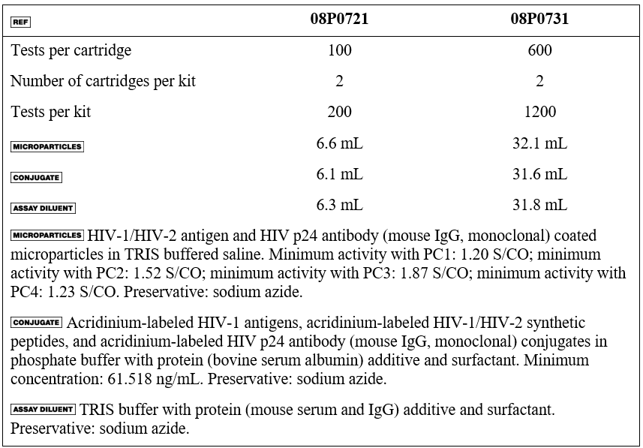
  - Alinity i HIV Ag/Ab Combo Calibrator (Part# 08P0702)
  - Alinity i HIV Ag/Ab Combo Controls (Part# 08P0712)
  - Alinity Trigger Solution (Part# 06P1160)
  - Alinity Pre-Trigger Solution (Part# 06P1265)
  - Alinity i-series Concentrated Wash Buffer (Part# 06P1368)
  - Alinity i Reaction Vessels (Part# 06P1401)
  - Alinity i Replacement Caps (Part# 04R4701)
  - Alinity i Sample Cups (Part# 01R3801)
  - For information on materials required for operation of the instrument, refer to the Alinity ci-series Operations Manual, Section 1.
  - For information on materials required for maintenance procedures, refer to the Alinity ci-series Operations Manual, Section 9.
- REAGENTS HANDLING
  - Upon receipt, gently invert the unopened reagent kit by rotating it over and back for a full 180 degrees, 5 times with green label stripe facing up and then 5 times with green label stripe facing down. This ensures that liquid covers all sides of the bottles within the cartridges. During reagent shipment, microparticles can settle on the reagent septum.
  - Place a check in the square on the reagent kit to indicate to others that the inversions have been completed.
  - After mixing, place reagent cartridges in an upright position for 1 hour before use to allow bubbles that may have formed to dissipate.
  - If a reagent cartridge is dropped, place in an upright position for 1 hour before use to allow bubbles that may have formed to dissipate.
  - Reagents are susceptible to the formation of foam and bubbles. Bubbles may interfere with the detection of the reagent level in the cartridge and cause insufficient reagent aspiration that may adversely affect results.
  - For a detailed discussion of reagent handling precautions during system operation, refer to the Alinity ci-series Operations Manual, Section 7.
- REAGENTS STORAGE:
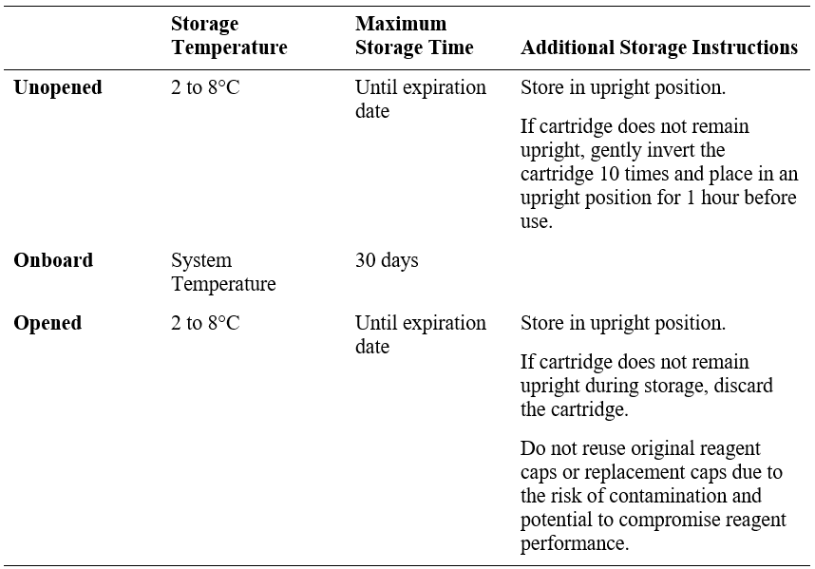

  - Reagents may be stored on or off the system. If removed from the system, store reagents with new replacement caps in an upright position at 2 to 8°C. For reagents stored off the system, it is recommended that they be stored in their original trays or boxes to ensure they remain upright.
  - For information on unloading reagents, refer to the Alinity ci-series Operations Manual,
Section 5.
  - Indications of Reagent Deterioration
    - Deterioration of the reagents may be indicated when a calibration error occurs or a control value is out of the specified range. Associated test results are invalid, and samples must be retested. Assay recalibration may be necessary.
    - For troubleshooting information, refer to the Alinity ci-series Operations Manual, Section 10.
- CALIBRATIONS & CONTROL PROCEDURES
  - Calibration
    - Cal 1 contains purified HIV-1 viral lysate prepared in TRIS buffered saline with protein (bovine serum albumin) additive. Preservative: sodium azide.
    - Cal 1 is at the following concentration:
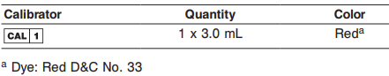
    - This product is liquid ready-to-use and may be used immediately after removal from 2 to 8°C storage.
    - Prior to each use, mix by gentle inversion.
    - The calibrator vial is placed directly on the instrument and automatically processed using the barcode on the calibrator vial. Alternatively, the calibrator can be pipetted into a sample cup. If the calibrator is pipetted into a sample cup, the calibration must be manually ordered.
    - The Alinity i analyzer utilizes the relative light units (RLU) from one calibrator. The acceptability of the calibration is assessed against an assay file parameter.
    - The Alinity i HIV Ag/Ab Combo Calibrator 1 is standardized to the Agence française de sécurité sanitaire des produits de santé (AFSSAPS) HIV-1 p24 antigen 50 pg/mL international standard.
    - The calibration should be used in conjunction with control ranges to determine the validity of the calibration
    - The acceptable calibration is stored by the Alinity i analyzer for use with any reagent kit of that lot.
    - The frequency of calibration is as follows:
      - A reagent kit with a new lot number is used.
      - Daily quality control results are outside of statistically-based quality control limits used to monitor and control system performance.
      - If statistically-based quality control limits are not available then the calibration should not exceed a 30-day limit for recalibration frequency.
      - This assay may also need to be recalibrated after specified service procedures have been performed or maintenance to critical part or subsystems that might influence the performance of the assay.
    - Assay control must be tested to evaluate the assay calibration.
    - Once a calibration is accepted and stored, all subsequent samples may be tested.
    - For additional instructions on performing a calibration, refer to the Alinity ci-series Operations Manual, Section 5.
    - Storage and Stability of Calibrators:
      - The analyzer will track In-use Stability, which is the time the calibrator is outside of refrigerated storage while on the analyzer.
      - The analyzer will not allow the use of the calibrator if the In-use Stability has been exceeded. Maximum In-use Stability can be found in the Assay Parameter Report. For additional information on calibrator In-use Stability, refer to the Alinity ci-series Operations Manual, Section 5.
      - Do not use past expiration date.
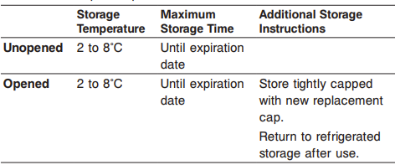
  - Quality Control Procedures
    - The Control (-) contains recalcified negative human plasma. Preservatives: sodium azide and antimicrobial agent.
    - The Control (+1) contains recalcified, inactivated human plasma reactive for anti-HIV-1 prepared in recalcified negative human plasma. Preservatives: sodium azide and antimicrobial agent.
    - The Control (+2) contains recalcified, inactivated human plasma reactive for anti-HIV-2 prepared in recalcified negative human plasma. Preservatives: sodium azide and antimicrobial agent.
    - The Control (+3) contains purified HIV-1 viral lysate prepared in TRIS buffered saline with protein (bovine serum albumin) additive. Preservative: sodium azide.
    - The Control (+4) contains purified HIV-1 group O monoclonal antibody prepared in recalcified negative human plasma. Preservatives: sodium azide and antimicrobial agent.
    - The controls are at the following ranges and target concentrations:
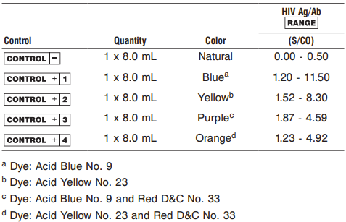
    - This product is liquid ready-to-use and may be used immediately after removal from 2 to 8°C storage.
    - Prior to each use, mix by gentle inversion.
    - During operation of the Alinity i analyzer, at least 5 levels of quality control material (one Non-reactive (Negative QC) and 4 Reactive (Positive QC)) will be tested at a minimum of once a day.
    - The frequency of Quality Control Procedures is as follows:
      - Once every 24 hours each day of use
      - After performing calibration
      - After instrument service procedures or maintenance that may affect assay performance have been performed.
    - Control ranges determined during method validation at the CleanSlate Centers’ Main Laboratory are used to establish basis to monitor the acceptable performance of the assay. If a control is out of its specified range, the associated sample results are invalid and the samples must be retested. Recalibration may be indicated.
    - Note: The insert ranges for the controls are not lot specific and represent the total range of values which may be generated throughout the life of the product. Means and acceptable ranges that fall within the package insert ranges were defined during validation and will be monitored and updated by the CleanSlate Centers’ Main Laboratory.
    - Once a calibration is accepted and stored, all subsequent samples may be tested.
    - To troubleshoot control values that fall outside the control range, refer to the Alinity ci-series Operations Manual, Section 10, Observed Problems.
    - Storage and Stability of QC materials:
      - Do not use past expiration date.
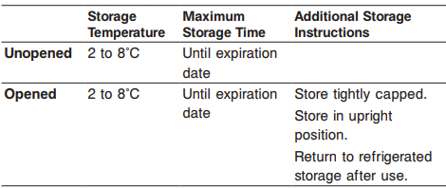
13 PROCEDURE(S)
  - Specimen Receipt: The test(s) have been previously ordered at the point of collection through the EMR and populated into the laboratory information system (LIS), here LabDaq or equivalent. Specimens are received into the main lab already labeled.
    - Specimens are scanned into LabDaq and received.
    - Specimens are placed into sample racks.
  - Analysis: performed as described in the “biological principles of the procedure” section above.
  - For a detailed description of how to run an assay, refer to the Alinity ci-series Operations Manual, Section 5.
  - If using primary or aliquot tubes, refer to the Alinity ci-series Operations Manual, Section 4 to ensure sufficient specimen is present.
  - To minimize the effects of evaporation, verify adequate sample cup volume is present prior to running the test.
  - Maximum number of replicates sampled from the same sample cup: 10
    - Priority:
      - Sample volume for first test: 150 µL
      - Sample volume for each additional test from same sample cup: 100 µL
    - ≤ 3 hours on the reagent and sample manager:
      - Sample volume for first test: 150 µL
      - Sample volume for each additional test from same sample cup: 100 µL
    - > 3 hours on the reagent and sample manager:
      - Replace with a fresh aliquot of sample.
  - Refer to the HIV Ag/Ab Combo calibrator and/or control package insert for preparation and usage.
  - For general operating procedures, refer to the Alinity ci-series Operations Manual, Section 5.
  - For optimal performance, it is important to perform routine maintenance as described in the Alinity ci-series Operations Manual, Section 9. Perform maintenance more frequently when required by laboratory procedures.
  - Sample Dilution Procedures
    - Samples cannot be diluted for the Alinity HIV Ag/Ab Combo assay.
- REFERENCE INTERVAL OF PATIENT RESULTS
  - Linearity
    - N/A
  - Critical Values
    - N/A
- ESTABLISH QC TARGET MEANS AND ACCEPTANCE CRITERIA UPON ARRIVAL OF NEW LOT
  - Evaluate new lot against manufacturer range for updates compared to current.
  - Report any update found to laboratory leadership for approval and implementation.
  - Analyze each level in 5 replicates to evaluate:
    - Need for a new mean.
    - SD range:
      - Reactive QC: 1SD set at 10% of mean.
      - Non-reactive: set according to manufacture range.
    - Mean adjustments will also be performed relative to performance trends.
    - To establish statistically-based control limits, each laboratory should establish its own concentration target and ranges for new control lots at each clinically relevant control level. This can be accomplished by assaying a minimum of 20 replicates over several (3-5) days and using the reported results to establish the expected average (target) and variability about this average (range) for the laboratory.
- CALCULATIONS
  - The Alinity i analyzer calculates results for the Alinity i HIV Ag/Ab Combo assay using the ratio of the sample RLU to the cutoff RLU (S/CO) for each specimen and control.
  - Cutoff RLU = Calibrator 1 Mean RLU x 0.40
  - The cutoff RLU is stored for each reagent lot calibration.
  - S/CO = Sample RLU/Cutoff RLU
- INTREPTATION OF RESULTS
  - The cutoff is 1.00 S/CO.
  - As with all analyte determinations, assay results, in conjunction with other laboratory results and clinical information, may be used to provide presumptive evidence of infection.
  - A specimen with a final result of reactive should be investigated further with supplemental confirmatory HIV-specific tests, such as immunoblots, antigen tests, and HIV nucleic acid tests.
  - See Table Below For Interpretation of Results:
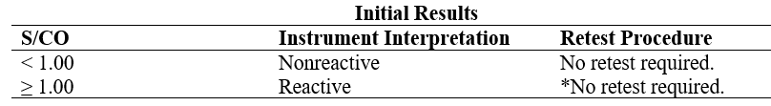
* It is CleanSlate Centers policy to reflex reactive HIV screen results for confirmatory testing.

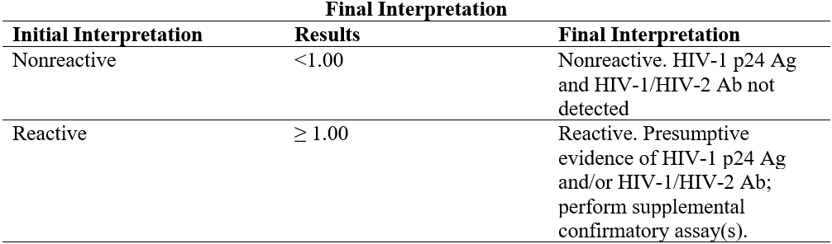

  - Flags
    - Some results may contain information in the Flags field. For a description of the flags that may appear in this field, refer to the Alinity ci-series Operations Manual, Section 5.
- REPORTING
  - Report Transmission
    - Patient test results uploaded into LABDAQ are reviewed by designated personnel and released for transmission into EMR chart via interface; results within the normal are transmitted to EMR via Auto-verification.
- LIMITATIONS
  - The interpretation of specimens with a final result of reactive by the Alinity i HIV Ag/Ab Combo assay and indeterminate by supplemental testing is not definitive; further clarification may be obtained by testing another specimen taken at least 1 month later.
  - The Alinity i HIV Ag/Ab Combo assay result and supplemental assay results should be interpreted in conjunction with the patient’s clinical presentation, history, and other laboratory results. If the results are inconsistent with clinical evidence, additional testing is suggested to confirm the result.
  - An individual who has antibodies to HIV is presumed to be infected with the virus; however, an individual who has participated in an HIV vaccine study may develop antibodies to the vaccine and may or may not be infected with HIV. Clinical correlation is indicated with appropriate counseling, medical evaluation, and possibly additional testing to determine whether a diagnosis of HIV infection is accurate.
  - A test result that is nonreactive does not exclude the possibility of exposure to or infection with HIV-1 and/or HIV-2. Nonreactive results in this assay for individuals with prior exposure to HIV-1 and/or HIV-2 may be due to antigen and antibody levels that are below the limit of detection of this assay.
  - The performance of this assay has not been established for individuals younger than 2 years of age. Nearly all infants born to HIV-infected mothers passively acquire maternal antibody and, in some cases, will test antibody positive until age 18 months regardless of whether they are infected. Definitive diagnosis of HIV infection in early infancy requires other assays, including HIV nucleic acid tests or viral culture.
  - Specimens from patients who have received preparations of mouse monoclonal antibodies for diagnosis or therapy may contain human anti-mouse antibodies (HAMA). Such specimens may show either falsely elevated or depressed results when tested with assay kits (such as Alinity i HIV Ag/Ab Combo) that employ mouse monoclonal antibodies. Alinity i HIV Ag/Ab Combo reagents contain a component that reduces the effect of HAMA reactive specimens.
  - Heterophilic antibodies in human serum can react with reagent immunoglobulins, interfering with in vitro immunoassays. Patients routinely exposed to animals or to animal serum products can be prone to this interference, and anomalous values may be observed. Additional information may be required for diagnosis.
  - Refer to the SPECIMEN COLLECTION AND PREPARATION FOR ANALYSIS section of this package insert for specimen limitations.
- TROUBLESHOOTING
  - Notify laboratory leadership or designated staff.
  - See the Abbott Alinity ci-series Operations Manual available onboard the instrument or CleanSlate Centers OneDrive.
  - Call Technical Support 1-877-422-2688, and SN # SCM28296.
- PERFORMANCE CHARACTERISTICS
  - Refer to the Alinity i HIV Ag/Ab Combo assay insert for performance characteristics and validation studies completed by the CleanSlate Centers’ Main Laboratory.
REFERENCES: | - Abbott Alinity ci-series Operations Manual  - Alinity i HIV Ag/Ab Combo Reagent Kit insert  - Alinity i HIV Ag/Ab Combo calibrator insert  - Alinity i HIV Ag/Ab Combo quality control insert  - Clean Slate’s HIPAA Policy  - Clean Slate’s Safety Policy  - CAP Laboratory General Checklist.
REVISION HISTORY: | N/A

____________________________ _________________
Patrice Y. Ohouo, PhD Date
Main Laboratory Director

