PROCEDURE TITLE: | Analytical Balance Operation Maintenance and Calibration Check | DEPARTMENT: | Main Laboratory

EFFECTIVE DATE: | 07/22/2024 | APPROVAL: | NEW
APPROVED BY: | Patrice Ohouo, PhD  Main Laboratory Director | PROCEDURE NO.: | COM.01019

- PROCEDURE
This procedure provides instructions for operation and maintenance of analytical balances, including instructions for quality control.

- PURPOSE
- The laboratory may rely on analytical balances for the preparation of quality control material, calibration material and other reagents directly or indirectly employed in the analytical testing process.

- SCOPE
- This document establishes the procedures for operation, preventative maintenance, and quality control that apply to analytical balances to ensure proper functioning of analytical balances within the CleanSlate Centers’ Main Laboratory.

- INTENDED USE
  - This procedure is intended for at the CleanSlate Centers’ Main Laboratory.

- DEFINITIONS
  - N/A

- RESPONSIBILITIES
  - Only trained personnel are authorized to perform this procedure. Qualified personnel are responsible for the proper execution of this procedure. Ultimately, it is the responsibility of the Laboratory Director to ensure the proficiency of laboratory personnel performing this test.
  - Training is documented in the training file of each qualified staff member.
  - All patient information is handled in a manner that is compliant with HIPAA guidelines. Refer to http://www.hhs.gov/ocr.hipaa/. And also to CleanSlate’s HIPAA Policy, https://cleanslatecenters.training.reliaslearning.com or equivalent.
  - The Laboratory Director is responsible for the direct review of all quality control, equipment maintenance and reporting of patient results.

- SAFETY
  - Standard Precautions
    - Care should be taken and personal protective equipment is required when handling material of human origin. All biological specimens should be considered potentially infectious.
    - For up-to-date recommendations on handling biological specimens refer to the CDC website: http://cdc.gov/ncidod/dhqp/pdf/guidelines/Isolation2007.pdf or CLSI document M29-A3, Protection of Laboratory Workers from Occupationally Acquired Infections. Clinical and Laboratory Standards Institute; Approved Guidelines and/or Refer to CleanSlate’s safety policy, https://cleanslatecenters.training.reliaslearning.com or equivalent.
  - Computer and Web Portal
    - Passwords must be assigned only to authorized personnel.
    - To ensure HIPAA compliance, it is recommended that the computer, printer and printouts be located away from the visibility and access of unauthorized individuals.
- MATERIALS
- Cleaning solvents, including distilled water, methanol or ethanol as indicated.
- Certified standard analytical weights
- Spatulas
- Weighing boats, dishes, paper.
- Lint free paper (ex: KIM wipes)
- Maintenance log

- PROCEDURE
- General procedure:
- Ensure balance is level
- Ensure balance is free of debris or contaminants (clean with ethanol and/or brush if necessary).
- Place weighing container (ex: weighing boat) as indicated
- Tare the balance, with all doors closed (if applicable).
- Using a clean spatula where indicated, place the item to be weighed in weighing container on the balance, close all doors (if applicable).
- Record weight when balance is stable.
- Clear and clean balance and surrounding area ensuring no debris or contaminants remain.
- Clean spatulas with appropriate cleaning solvent.

- PERFORMANCE CHECK
- Performance checks are conducted as needed (near time of use) once a day, at minimum, in addition to the yearly calibration check to ensure accuracy of the analytical balance.
- Performance checks involve the use of at least one certified standard analytical weight, closest to the targeted weight measure.
  - Ensure balance is level
  - Ensure balance is free of debris or contaminants (clean with ethanol and/or brush if necessary)
  - Tare the balance, with all doors closed (if applicable)
  - Place indicated certified standard analytical weight, close all doors.
  - Record weight in indicated maintenance log when balance is stable.
  - Evaluate recorded weight appropriateness by comparison to acceptable range.
  - Troubleshoot as needed or proceed with routine measurement based on findings.

- PREVENTIVE MAINTENANCE AND CALIBRATION CHECK
  - An external preventative maintenance must be performed annually at a minimum (i.e., once per calendar year), in line with manufacturer recommendations.
- CALCULATIONS
  - N/A
- INTREPRETATION OF RESULTS
  - N/A
- REPORTING
  - N/A

- LIMITATIONS
  - N/A

- TROUBLESHOOTING
  - Notify Laboratory Manager.
  - Remove analytical balance from service and reach out to service for repairs.

- DOCUMENTATION
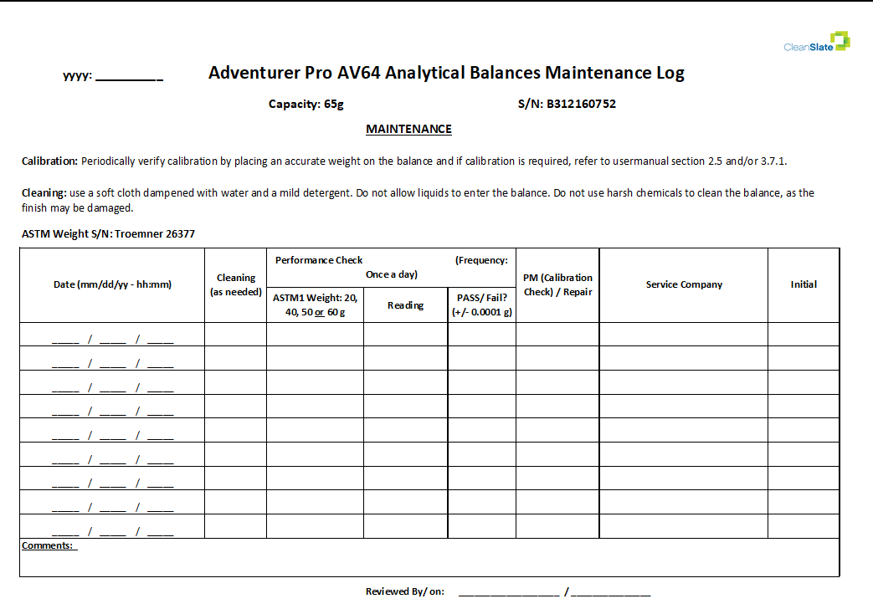

REFERENCES: | - CAP Laboratory General Checklist  - Adventurer Pro AV64 Analytical balance user manual  - Clean Slate’s HIPAA Policy  - Clean Slate’s, Safety Policy  - Service manual adventurer av and as model balances P/N 80250994
REVISION HISTORY: | Initial

____________________________ _________________
Patrice Ohouo, PhD Date
Laboratory Director

