PROCEDURE TITLE: | Fire Extinguisher Use and Maintenance | DEPARTMENT: | Main Laboratory

EFFECTIVE DATE: | 12/15/2025 | APPROVAL: | NEW
APPROVED BY: | Patrice Ohouo, PhD  Main Laboratory Director | PROCEDURE NO.: | GEN 01012

- PROCEDURE
This procedure provides instruction on the correct use, inspection, and maintenance of fire extinguishers at the CleanSlate Centers Main Laboratory.
- PURPOSE
To establish a standardized procedure for the correct use, inspection, and maintenance of fire extinguishers at the CleanSlate Centers Main Laboratory. This procedure in conjunction with yearly fire safety training provided by CleanSlate Centers will help ensure safety of personnel, protection of equipment, and compliance with regulatory standards.

- SCOPE
This document establishes the procedures for operation and maintenance of extinguishers at the CleanSlate Centers Main Laboratory.

- INTENDED USE
  - This procedure is intended for at the CleanSlate Centers’ Main Laboratory.

- DEFINITIONS
  - N/A

- RESPONSIBILITIES
  - All personnel must be instructed as to the location and operation of extinguishers in the CleanSlate Centers Main Laboratory facility.
  - Fire safety training is provided to all employees of CleanSlate Centers on a yearly basis. Refer to https://cleanslatecenters.training.reliaslearning.com or equivalent.
  - The Laboratory Director ensures compliance with fire safety regulations, training, and maintenance schedules.
  - Training is documented in the training file of each qualified staff member.
  - All patient information is handled in a manner that is compliant with HIPAA guidelines. Refer to http://www.hhs.gov/ocr.hipaa/. And also to CleanSlate’s HIPAA Policy, https://cleanslatecenters.training.reliaslearning.com or equivalent.
  - The Laboratory Director is responsible for the direct review of all quality control and equipment maintenance.

- SAFETY
  - Standard Precautions
    - Care should be taken and personal protective equipment is required when handling material of human origin. All biological specimens should be considered potentially infectious.
    - For up-to-date recommendations on handling biological specimens refer to the CDC website: http://cdc.gov/ncidod/dhqp/pdf/guidelines/Isolation2007.pdf or CLSI document M29-A3, Protection of Laboratory Workers from Occupationally Acquired Infections. Clinical and Laboratory Standards Institute; Approved Guidelines and/or Refer to CleanSlate’s safety policy, https://cleanslatecenters.training.reliaslearning.com or equivalent.
  - Computer and Web Portal
    - Passwords must be assigned only to authorized personnel.
    - To ensure HIPAA compliance, it is recommended that the computer, printer and printouts be located away from the visibility and access of unauthorized individuals.
- DEFINITIONS:
  - PASS Technique: Method used to operate a fire extinguisher — Pull, Aim, Squeeze, Sweep.
  - ABC Fire Extinguisher: Multi-purpose dry chemical extinguisher suitable for Class A, B, and C fires.
- OPERATION
  - In case of a fire, activate the fire alarm and notify emergency services.
  - Evacuate all non-essential personnel.
  - Only attempt to extinguish the fire if it is small and escape routes are clear.
  - Use the PASS technique: Pull, Aim, Squeeze, Sweep.
  - Evacuate immediately, if the fire cannot be readily controlled.

- MAINTENANCE
Frequency | Activity | Responsible Person | Documentation
Monthly | Visual inspection of pressure gauge, accessibility, damage, and seal integrity. | Safety Coordinator | Fire Extinguisher Inspection Log
Annually | Professional maintenance and tagging by certified fire protection service. | Service/ Vendor | Annual Service Record
After Each Use | Extinguisher must be recharged or replaced immediately. | Safety Coordinator. Performed by vendor. | Maintenance Record

- TROUBLESHOOTING
  - Notify Laboratory Manager.
  - Reach out to service/ vendor for repairs: Cintas at 860-747-2757.

- DOCUMENTATION
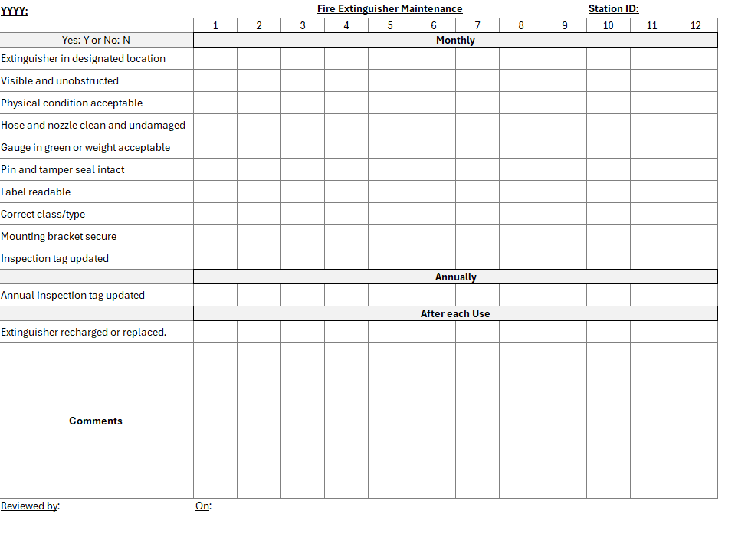

REFERENCES: | - CAP Laboratory General Checklist  - OSHA standard 29 CFR 1910.157 (Portable fire extinguishers)
REVISION HISTORY: N/A | Initial

___________________________ _________________
Patrice Ohouo, PhD
Laboratory Director

