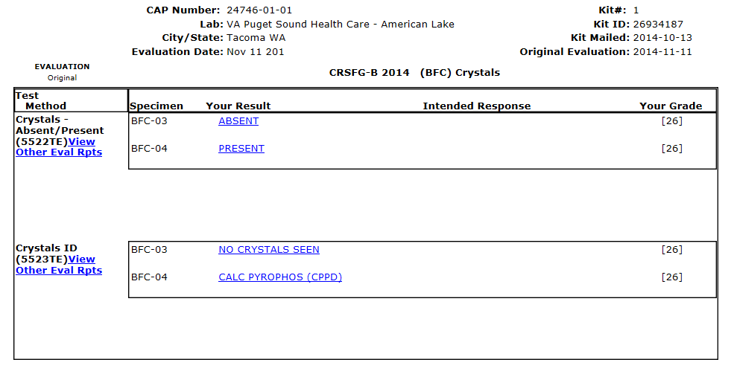

BFC-03 84.7% responded Calc Pyrophos (CPPD)

BFC-04 83.3% responded Cholesterol crystals

BFC-03 94.5% responded Present