Order Management

Order Management (OM) is an ordering system directly linked to the current Order Entry (OE) System; OM is OE with a different look. The best feature of OM is that orders can be entered by description rather than category and mnemonic. The instructions below explain how to place orders in OM.

- Select Order Management.
- Enter the patient’s name, account number, unit number, etc.
- Select the correct account.
- Select the Orders button located on the right.

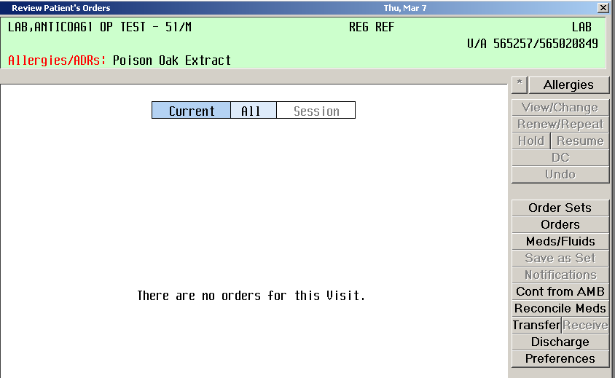

- Enter the Ordering Provider and Other Provider (if there is one).

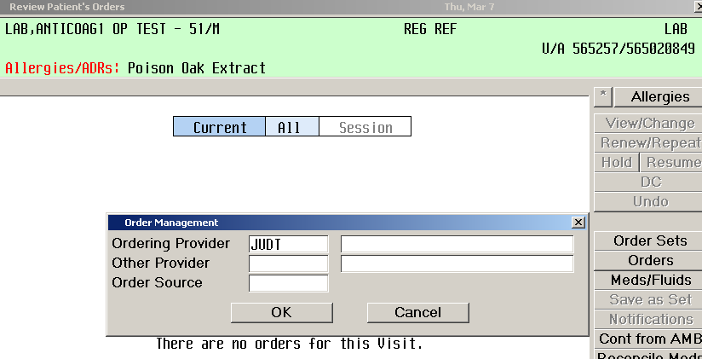

- Begin entering orders by description. Note that if the physician entered as the ordering provider has “favorite orders” his tests will appear, but Any Order must be selected from the right before ordering any tests.

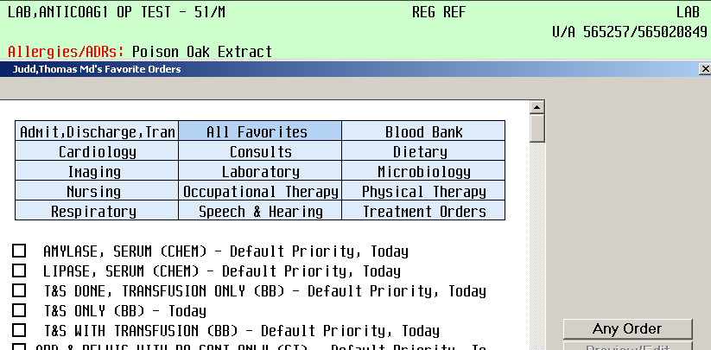

- Enter Select after each order (black bar must be on test to be chosen; move the black bar with the up and down arrows). Select Done when all orders have been entered. Note that the list of tests is not viewable to the user until after Done is selected.

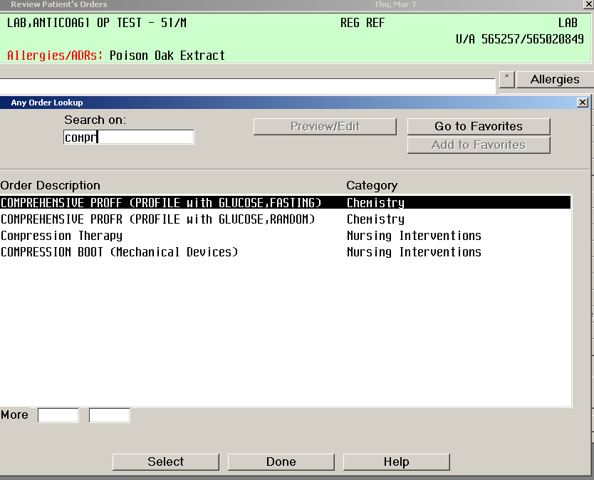
- Select Done once all orders are placed. Note: Cancel will get rid of the whole set of orders. Add More will go back to area for placing more orders. In order to remove one order placed incorrectly, uncheck the order.

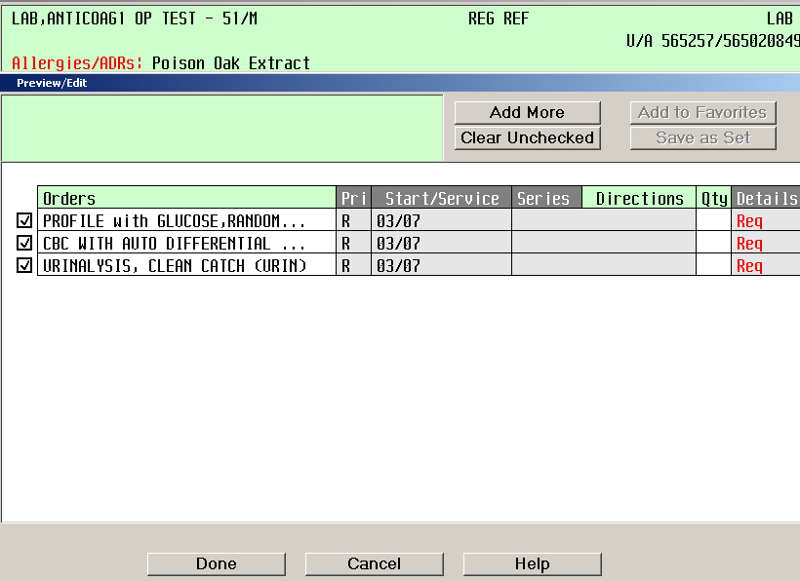

- Complete any fields necessary for the ordered tests.

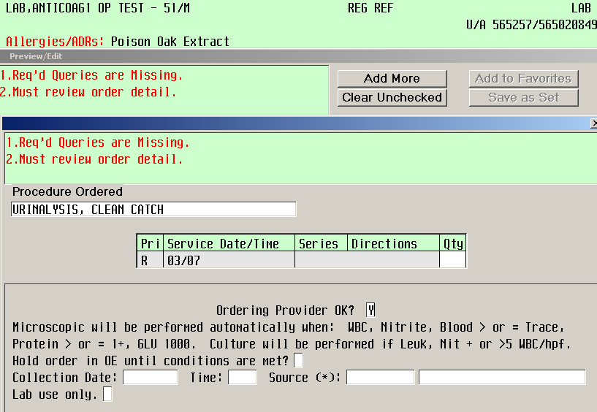

- Select Submit to place orders.

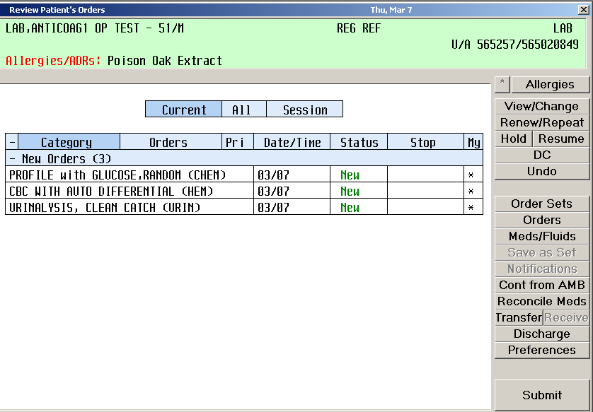

Notes:
- Shift F8 provides documentation for many functions in Meditech
- Order Sets need to be selected for RVC1 (Immune 1), RVC2 (Immune 2), PRENW (Lab Prenatal Workup).
- Orders for a future date can be entered via Order Management. If the Date/Time field is selected, a calendar will appear. Select the appropriate date and/or time.

