5.67 pp1 Collection Method

There is a change with the 5.67 pp1 upgrade. Meditech has added the ability to capture the collection method, collection method amount and the collection method unit. This was added in order to comply with ARRA rules and State Lab reporting. HMC currently does not use an interface with DPH which requires this information; so, this change will not be used yet; however, some of the specimen receipt screens will have a different appearance. Below are examples of how the screens appearance will change. Note that at this time, no information will be entered for the collection method.

Receive by Specimen

In the Receive by Specimen Routine, there are additional functions available. “E” can be used to edit the data and enter the collection method (found by performing a look-up at the Func prompt).

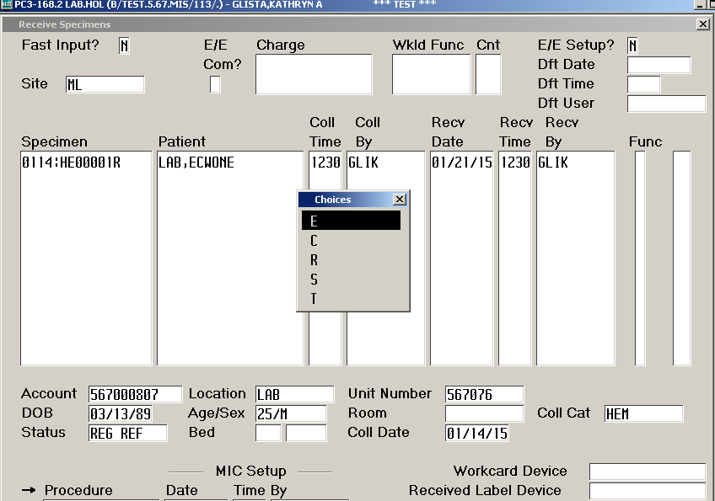

LAB and MIC result entry

If a specimen is not received before entering results, the Collection Method Screen will appear. This screen can be bypassed by selecting Enter through the prompts.

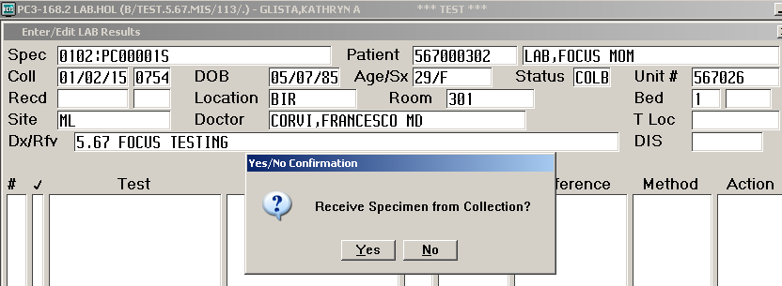

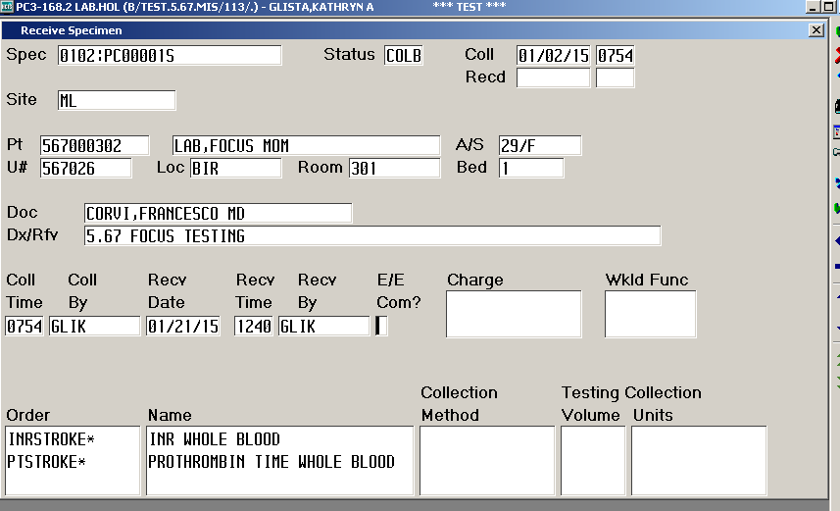

LAB and MIC test dictionary

The Collection Method is created in the e/e Collection Method Dictionary. In the LAB test dictionary or the MIC Procedure dictionary, the Coll Method Req, Coll Method, Testing Volume and Coll Unit prompts have been added to the dictionary.

