Policy: 401-LIS-2010

Category 3

Holyoke Medical Center
575 Beech Street
Holyoke, MA 01040

Laboratory Information Systems

LABORATORY COMPUTER DOWNTIME – Code C

PURPOSE:

The Laboratory Information System (LIS) in conjunction with the Meditech Admissions module and the Order Entry/Order Management module are used for the placement of physicians’ orders. The LAB, MIC and PTH modules are used to process patient results. When there are any interruptions in computer service, the Information Systems Department assesses the problem, and a code “C” announcement is made throughout the hospital. Typically, the announcement includes the downtime level and the servers involved. In the event of a computer downtime, it is critical that the laboratory continue to operate smoothly and with as little interruption of work flow as possible. Follow the steps below in the event of a “Code C” announcement.

PROCEDURE:

- Determine the application affected and downtime level.
- Proceed to step 2 if Admissions (ADM) and / or Order Entry/Order Mangement (OE/OM) are at downtime level 1.
- Proceed to step 3 if ADM and / or OE/OM are at downtime level 2 or 3.
- Proceed to step 4 if the Laboratory is at downtime level 1.
- Proceed to step 5 if the Laboratory is at downtime level 2 or 3.

- Admissions (ADM) and / or Order Entry/Order Management (OE/OM) are at level 1:
  - Enter stat orders, which are received on manual requisitions, in the lab system; refer to the Laboratory Enter / Edit Requisition Procedure, 401.LIS.0110 for details. Process the specimens as usual. Note: Nursing notifies the appropriate personnel of stat orders.
  - Call stat results if nursing does not have access to PCI. Faxing, printing and sending copies of results via the tube system can also be done; however, the floors need to be aware how the results will be delivered.
  - Process all routine (previously entered in OE/OM) orders as usual. Note: for in-house patients and drawing stations, new non-stat orders are held until the downtime is over or is increased to level 2 or 3; these orders are placed by the floors or phlebotomy. In the case of the hospital Outpatient department, the Admitting department registers the patient but does not enter the orders. In this case, each department is responsible for entering test orders.
  - Proceed to step 4 if the downtime level is extended to level 2 or 3; otherwise, return to normal operation.

- Admissions (ADM) and / or Order Entry (OE/OM) are at level 2 or 3:
- Enter all orders (received on manual requisitions) in the lab system. Manual requisitions are used for all orders until the downtime period is over. The floors, Admitting, etc. do not enter previous orders in OE when the system is available. Note: A downtime numbering system should be used in order to track specimens that were processed during downtime periods. In order to enter the downtime accession number, the prefix for each specific department will need to be edited. After entering the test mnemonics in E/E requisitions, enter the prefix (at Edit Px prompt). At the SPEC# prompt, delete “NEXT” and enter the number stamped on the requisition.
- Use generic downtime requisitions in place of OE requisitions such as Urinalysis result forms, Blood Bank forms, etc. – refer to department specific procedures for the correct forms.
- Return to normal operation when the downtime period is over.

- Laboratory is at level 1:
- Process stat specimens manually (instrument interfaces down – refer to the department specific procedures).
- Wait (if possible) to process routine specimens (ADM and OE will queue until the OE-LAB interface is available).
- Proceed to step 5 if the downtime is extended to level 2 or 3, otherwise return to normal operation.

- Laboratory is at level 2 or 3:
- Turn the module interface off in OE (access is restricted – Lab Manager, LIS Supervisor, designee and Information Systems). All new orders are directed to the OE printer in the laboratory (LAB3). Each requisition prints a listing of the tests for each patient for each category. The specimens are collected, labeled manually and entered into the LIS when the system is back on line.
- Print the List Interface Queue. This report lists what is waiting to come over the interface. The queue will back up when the LAB module is down or if there is a lock on the interface.
- Print Queued Interface Orders (Access is restricted – Lab Manager, LIS Supervisor, designee and Information Systems). This report is used when the interface is bypassed. This routine removes the orders from the queue and prints a paper requisition. The queued orders need to be entered manually in the lab system.
- Print the Daily Log. This report is a listing of all orders from OE for the day. Review future orders where the service time has not yet been reached.
- Review the Daily Log. Determine which orders have been previously sent to the LIS (labels are available but inaccessible). On the Daily Log, a separate listing will print for each category. Eliminate those orders which appeared on the Interface Queue report and those for which the service time has already been surpassed as requisitions have already been printed. Search for those service times yet to be attained and prepare manual requisitions. Collate and organize requisitions to prevent additional unnecessary venipunctures.
- Assign specimen numbers (manually) in each department beginning at a number so the number sequence will not coincide with the numbers assigned by the LIS. Use the assigned number in all manual entries of specimens for testing while the instrumentation is off-line. This will insure proper patient/specimen identification.
- Use the manual and OE requisitions as worksheets for testing. Record all test results on requisitions or utilize temporary reports (department specific).
- Use manual worksheets if necessary (department specific).
- Store results on interfaced instruments whenever possible. The results can be uploaded when the LIS is on-line.
- Proceed to step 6 when the LIS is available.

- When the LIS is available:
- Enter patient tests into Lab system. Numbers that were manually assigned during downtime should be recorded in the LIS using the Edit Prefix function on the Enter/Edit Requisition screen.
- Use requisition/worksheet to enter results into the LIS.
- Upload results from interfaced instruments whenever possible.
- Generate reports.
- Return to normal operation.

PROCEDURE NOTES:

- The LIS Supervisor and/or the Laboratory Manager will be in communication with the Information Systems department to keep everyone informed about the system status and problem resolution.
- In the event of prolonged downtime (level 3), the white copies of requisitions with the results recorded or attached (instrument printout copies) can be used as temporary copies of results. The Laboratory will call and or fax/print the results for all Stat tests (floor must be aware of how results will be received). Temporary copies of inpatient and Emergency Room results will be faxed or delivered by the Laboratory to the patient locations.
- When the Admissions module is down, new patients can be registered in the Laboratory Information System using the LIS backup Admission database; refer to the LIS Backup Admissions Systems procedure for details.
- Each department in the laboratory has its own department specific procedures for the downtime period.
- When both OE/OM and the LAB are unavailable, all those procedures that had been previously ordered through the order entry system for that day will not be accessible in the laboratory for collection. Nursing staff will check physicians’ orders and prepare manual requisitions for those specimens that need to be collected during downtime and notify the appropriate personnel.
- There are reports which are downloaded to the F drive. This report is only accessible if the user is logged on to the pc; lab station cannot be used. This report displays five days of results. The report can be viewed, cut/pasted and printed if necessary. A snap shot of the path is displayed below. Note that each module is separate and reports are separated by inpatient and outpatient.
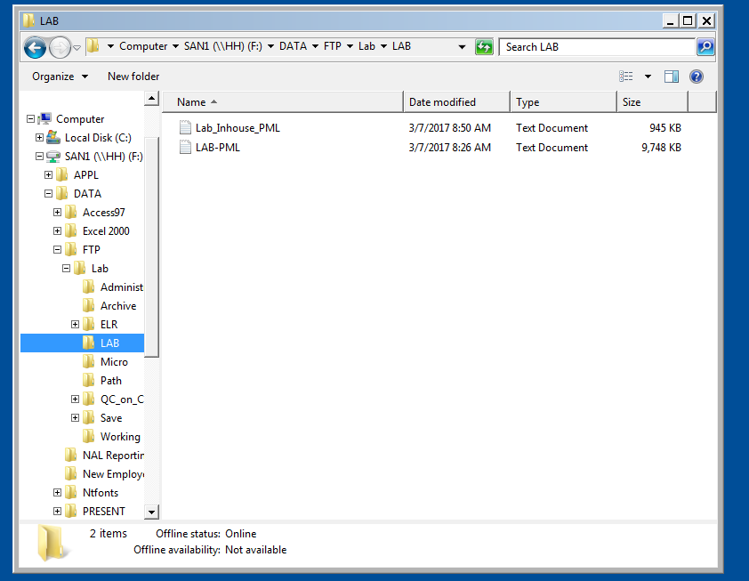
- All glucometer POC results are held in the individual testing devices. Results can be viewed in each device by accessing the patient’s account number.
- Although orders that were placed using manual requisitions are not supposed to be entered into OE after the system is available, this does occur. Check the Outstanding Specimen report to determine which (if any) orders are duplicates.
- There are times that Meditech may (is not always possible – depends on the problem) be accessed when the Network is “down”. If the server box appears, select the appropriate server in order to access Meditech. An alternate way of accessing Meditech is by selecting the Start key, Programs, Meditech and Meditech Nui.
- In the case of a prolonged scheduled downtime (upgrade), it may be useful to print Summary reports and distribute to the floors:
  - Select Patient Reports
  - Select Summary by Activity.
  - Select appropriate Summary report.
  - Enter desired date range and select if only new reports should print.
  - Print reports.
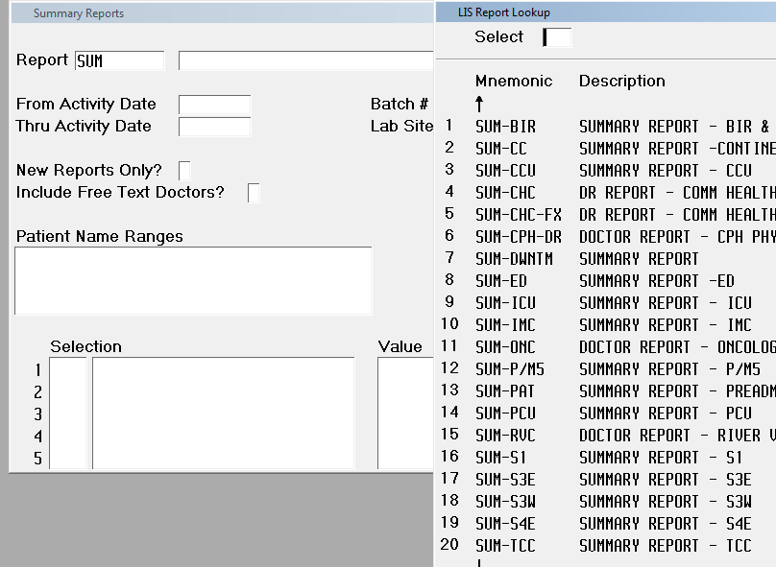

- In the case where there is an unscheduled downtime and data files need to be restored, Information Systems follows a disaster recovery procedure. In the Laboratory, all interfaces need to be verified to make sure information is crossing correctly; compare the instrument print out to the result which was transmitted via the interface. Reports containing results previous to the downtime should be called and reviewed for accurate information (verify against analyzer results, verify ranges, flagging, etc.). This verification must be saved as proof that the system has been restored and is working properly.

REFERENCES:

- Holyoke Hospital Information Systems Administrative manual.
- Product and Resource Home Page, Laboratory Information Systems. http://www.meditech.com/CustomerServiceHome.htm, 2006.
- Laboratory General Checklist. College of American Pathologists. Last Revised Date: April 06, 2006. GEN.43088, GEN 48750.
Approved By:
 | Kathryn Glista, MT (ASCP) |  | Date
Approved By:
 | Medical Director: Thomas Gould, M.D. |  | Date

Adopted or Date Initiated: January 1997, February 2001

Revised and Effective Date: January 2007, January 2011

Date | LIS Analyst/Designee | Date | LIS Analyst/Designee

Revision History
Version | Summary of Changes | Author | Date
5 | Updated oe to oe.om, updated 2c removed mednec, note 6 updated method to retrieve results from f drive, note 10 added detail for calling summary reports, note 11 added additional detail for unplanned downtime, added rev history box | glik | 3/7/17

