Category 3

LABORATORY COMPUTER DOWNTIME – Code C

PURPOSE:

The Meditech Laboratory Information System (LIS) in conjunction with the Admissions module, the Order Management module and Ambulatory module are used for the placement of physicians’ orders. The LAB, MIC, BBK and PTH modules are used to process patient results. When there are any interruptions in computer service, the Information Systems Department assesses the problem, and a code “C” announcement is made throughout the hospital. Typically, the announcement includes the downtime level and the servers involved. In the event of a computer downtime, it is critical that the laboratory continue to operate smoothly and with as little interruption of work flow as possible. Follow the steps below in the event of a “Code C” announcement.

PROCEDURE:

- Determine the application affected and downtime level (level 1: up to 1 hour, level 2:
1-4 hours, level 3: greater than 4 hours).
- Proceed to step 2 if Admissions (ADM) and / or Order Management (OM) are at downtime level 1.
- Proceed to step 3 if ADM and / or OM are at downtime level 2 or 3.
- Proceed to step 4 if the Laboratory is at downtime level 1.
- Proceed to step 5 if the Laboratory is at downtime level 2 or 3.

- ADM and / or OM are at level 1:
  - Enter stat and routine orders, which are received on manual requisitions, in the lab system for those patients who have an existing account number. Orders and results for patients without an existing account number will be entered after the downtime period.
  - Fax, print or send copies of results to the appropriate areas.
  - Process all routine (previously entered in OM) orders as usual. Note: the orders on manual requisitions are to be entered by Laboratory staff. In the case of the hospital Outpatient department, the Admitting department will register the patient once the system is back online then the laboratory can enter the orders and results.
  - Proceed to step 4 if the downtime level is extended to level 2 or 3; otherwise, return to normal operation.

- Admissions (ADM) and / or Order Entry (OE/OM) are at level 2 or 3:
- Enter all orders (received on manual requisitions) in the lab system (for those patients with an existing account number). Manual requisitions are used for all orders until the downtime period is over. The floors, Admitting, etc. do not enter previous orders in OE when the system is available.
- Refer to department specific procedures for the correct forms to use for temporary reports.
- Return to normal operation when the downtime period is over.

- Laboratory is at level 1:
- Process stat specimens manually (instrument interfaces down – refer to the department specific procedures).
- Wait (if possible) to process routine specimens (ADM and OM will queue until the OM-LAB interface is available).
- Proceed to step 5 if the downtime is extended to level 2 or 3, otherwise return to normal operation.

- Laboratory is at level 2 or 3:
- Utilize (print) the OM log for orders placed in OM. Manually write labels for tests to be collected.
- Use the manual requisitions as worksheets for testing if necessary (department specific). Record all test results on requisitions or utilize temporary reports (department specific).
- Use manual worksheets if necessary (department specific).
- Store results on interfaced instruments whenever possible. The results can be uploaded when the LIS is on-line.
- Proceed to step 6 when the LIS is available.

- When the LIS is available:
- Enter patient tests into Lab system.
- Use requisition/worksheet to enter results into the LIS.
- Upload results from interfaced instruments whenever possible.
- Generate reports if needed.
- Return to normal operation.

PROCEDURE NOTES:

- The LIS Analyst and/or the Laboratory Director/Manager will be in communication with the Information Systems department to keep everyone informed about the system status and problem resolution.
- During the downtime, the Laboratory will call and or fax/print the results for all stat tests (floor must be aware of how results will be received). Temporary copies of inpatient and Emergency Room results will be faxed or delivered by the Laboratory to the patient locations.
- Each department in the laboratory has its own department specific procedures for the downtime period.
- When both OM and the LAB are unavailable and the downtime is unplanned, those procedures that had been previously ordered through the order entry system for that day will not be accessible in the laboratory for collection. Reports that have been downloaded are available via m-print.

- A downtime menu has been added to Laboratory staff access (see snap shot below).
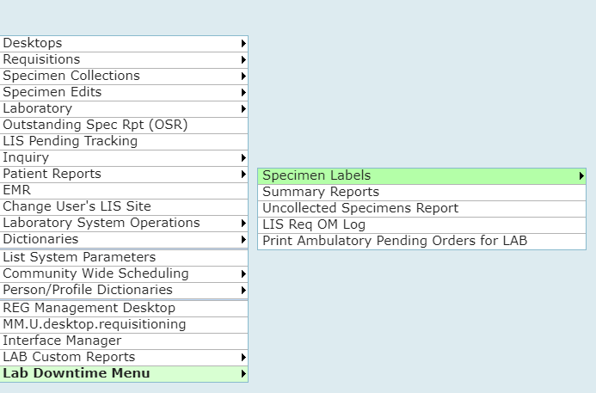
- A downtime LAB and MIC report is available via the C drive on specific pcs in the Laboratory. Five days of results are available. The PCs are 10.240.1.183 located in Serology, 10.240.2.84 located in Hematology/Chemistry, 10.240.3.209 located in Hematology/Chemistry, 10.240.4.82 located in Microbiology, 10.240.3.36 located in Hematology/Chemistry. Below is a snap shot of the pathway needed to access the report.
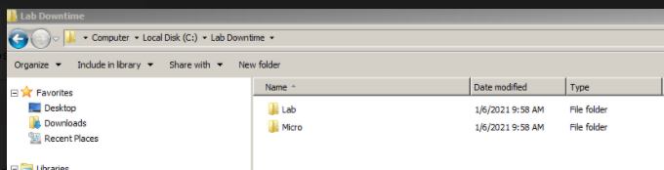

The reports which are separated into inpatient and outpatient are searchable and portions could be copied into a word document for faxing, etc. in the event of a prolonged downtime.
- All glucometer POC results are held in the individual testing devices. Results can be viewed in each device by accessing the patient’s account number or patient name.
- Although orders that were placed using manual requisitions are not supposed to be entered into OM after the system is available, this does occur. Check the Outstanding Specimen report to determine which (if any) orders are duplicates.
- In the case of a prolonged scheduled downtime (upgrade), print Summary reports, and distribute reports to the floors. Make a copy of the reports and keep the ED summary in the laboratory.
- In the case where there is an unscheduled downtime and data files need to be restored, Information Systems follows a disaster recovery procedure. In the Laboratory, all interfaces need to be verified to make sure information is crossing correctly. Compare the instrument print out to the result which was transmitted via the interface. Reports containing results before the downtime should be called and reviewed for accurate information (verify against analyzer results, verify ranges, flagging, etc.). Save the verification as proof that the system is restored and is working properly.

REFERENCES:

- Data Back-up and Protection, A10-217.
- Laboratory General Checklist. College of American Pathologists. Last Revised Date: 06.04.2020. GEN 48750.

APPROVAL:
 |  | Date
Approved By: | Thomas P. Buck, M.D.  Laboratory Medical Director | 12/05/2020
Author: | Kathryn Glista, MT (ASCP)  LIS Analyst | 12/05/2020

REVISION HISTORY:
Version | Summary of Changes | Author | Date | Lab Medical Director (for substantial changes)
5 | Updated oe to oe.om, updated 2c removed mednec, note 6 updated method to retrieve results from f drive, note 10 added detail for calling summary reports, note 11 added additional detail for unplanned downtime, added rev history box | glik | 3/7/17 | n/a
6 | Revised to reflect HIS/LIS change to Meditech Expanse; format updated | glik | 12/5/2020 | See approval box

Date | Reviewed by | Date | Reviewed by

