Policy: 408-I-002-4

RESPONSIBLE DEPARTMENT:  LABORATORY | POLICY #:  408-I-002-4 | PAGE: 1 of 4
SUBJECT: Home Draw Mileage Charge Addition | EFFECTIVE DATE: July 2010
REVIEWED/ REVISED: November 2018
DISTRIBUTION: PHLEBOTOMY

Purpose

All Home Draw Patients must have both a Venipuncture charge and a Mileage charge added to the account to correctly charge for the procedures. (The charge must be entered so Holyoke Medical Center will be reimbursed for the procedures.) There are two ways the charges can be added, through the Receive Specimens routine or the Enter Edit Requisition routine. Refer to the instructions below for both methods.

Procedure

  - The charge can be entered when receiving the specimens in the Edit Receive Date area, the Charge section (see example below).

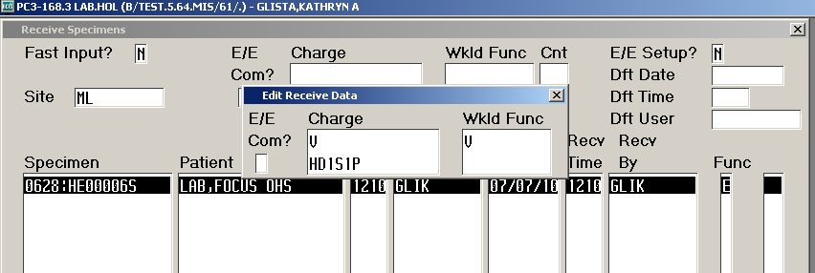

- Go to the Laboratory Module (LAB)
- Choose “SPECIMEN COLLECTION”
- Choose “RECEIVE”
- Choose “BY SPECIMEN”
- Enter both charges and workload function (See Mileage Chart below)
- Enter the Specimen(s) number
7. File by entering F12

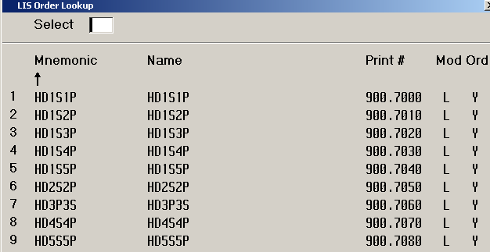

b. The charge can also be entered via the Enter/Edit Requisition routine. Refer to the example below.

- Go to the Laboratory Module (LAB)
- Choose “REQUISITIONS”
- Choose “ENTER/EDIT)
- Identify and enter the patient at the Patient prompt
- Look up (F9) the requisition
- Enter or Tab to the “Order section”
- Enter correct mileage mnemonic from the chart
- Enter the “Venipuncture” mnemonic
- Follow the appropriate steps
- File the additions (F12)
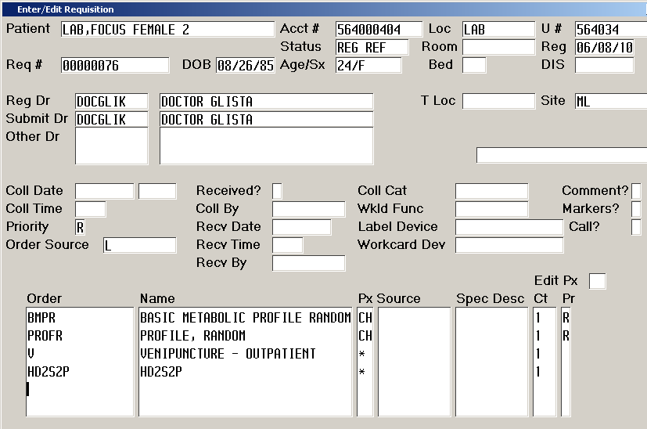

PROCEDURAL NOTE:

*Both the Venipuncture charge and the Mileage charge must be entered the same day the specimen is collected to insure proper billing.

Precautions
NORMAL ROUTINE INVOLVES NO EXPOSURE TO BLOOD AND THEREFORE REQUIRES NO PROTECTIVE EQUIPMENT.

References

Holyoke Medical Center, Laboratory Information Specialist

Prepared By: Kathryn Glista, Joan M. Poutré

Adopted/Initiated: July 2010

Revised Date: November 2018

Supercedes: July 2010
Approved By:
Date
Phlebotomy Supervisor
Phlebotomy Supervisor
Date
Medical Director

Reviewed:
DATE | REVIEWER | DATE | REVIEWER

Revision History
Version | Summary of Changes | Author | Date
V2 | Header added/revision history added/approval box/Reviewed boxes added | olearj | 11/30/18

