Policy: 408-I-003-7

RESPONSIBLE DEPARTMENT:  LABORATORY | POLICY #:  408-I-003-7 | PAGE: 1 of 7
SUBJECT: Pediatric Phlebotomy | EFFECTIVE DATE: January 1995
REVIEWED/ REVISED: October 2018
DISTRIBUTION: PHLEBOTOMY

Category 1

Purpose
Pediatric phlebotomy is a specialized process which should only be carried out by experienced phlebotomists. Special consideration must also be given to the providing of comfort to the patient to reduce the trauma of the event.

The success of blood collection from pediatric patients is dependent on patient identification and immobilization as well as on specimen collection and post care.

Techniques for collection of specimens vary according to the patient’s age, weight and the volume of specimen needed. The blood volume of young children, especially premature infants, may be very small. Injury to the patient from collecting too large of a sample volume must be avoided. The following guidelines should be followed to limit the volume of blood taken from children under fourteen (14) years of age:

Maximum Amount of Blood
Maximum Amount (Cumulative) During
To Be Drawn at a Given Hospital Stay Patients Weight Any One Time (1 Month or Under)

lb kg (mL) (mL)

6-8 2.7-3.6 2.5 23
8-10 3.6-4.5 3.5 30
10-15 4.5-6.8 5 40
16-20 7.3-9.1 10 60
21-25 9.5-11.4 10 70
26-30 11.8-13.6 10 80
31-35 14.1-15.9 10 100
36-40 16.4-18.2 10 130
41-45 18.6-20.5 20 140
46-50 20.9-22.7 20 160
51-55 23.2-25.0 20 180
56-60 25.5-27.3 20 200
61-65 27.7-29.5 25 220
66-70 30.0-31.8 30 240
71-75 32.3-34.1 30 250
76-80 34.5-36.4 30 270
81-85 36.8-38.6 30 290
86-90 39.1-40.9 30 310
91-95 41.4-43.2 30 330
96-100 43.6-45.5 30 350

Reprinted with permission from Becan-McBride K: Textbook of Clinical Laboratory Supervision. New York: Appleton-Century Crofts, 1982, as adapted in Garza Becan-McBride: Phlebotomy Handbook. 2nd ed. East Norwalk: Appleton-Century Crofts, 1989.

Equipment
Heelstick:
Cardinal Health, infant heel warmer, Heelstick device. (Refer to Insert manual for latest collection device) capillary blood collectors, sterile gauze, alcohol, and bandage

Fingerstick:
Safety Lancets (Refer to Insert manual for latest collection device) capillary blood collectors, sterile gauze, alcohol, and bandage

Venipuncture:
BD Vacutainer Safety-Lok Blood Collection set with Luer Adapter or BD Vacutainer Eclipse Blood Collection Needle, One Use Holder, and pediatric tubes.
70% Alcohol swab
Gauze

Precautions
HANDLING BLOOD SPECIMENS REQUIRES USE OF LAB COAT AND GLOVES, AND SAFETY SHIELD FACE PROTECTION IN DESIGNATED AREAS. WASH HANDS AFTER REMOVING GLOVES.

Procedure
1. Identify Patient:
Outpatient: Verbal identification from child or parent and ID band.
Inpatient: Hospital ID band and verification from parent and/or nursing staff.
2. Explain procedure briefly to child and parent if present. Be honest.
3. Determine site and method of collection*
**Site and method of collection is usually based on the age of the patient, and tests ordered.
Method | Heelstick | Fingerstick | Venipuncture
Site | Medial or lateral plantar surface; Do not perform on posterior curve of heel (see diagram) | Middle or ring finger | Antecubital area of arm
Age | Birth to 12 months | Over 12 months | Birth on depending on sample needed
Device | Heelstick Device  Refer to Insert manual for latest collection device. | Safety Lancets  Refer to Insert manual for latest collection device. | Butterfly (23 G)
Comments | **Method of choice until patient begins to walk  **Warm skin prior to collection  **Do not puncture through previous site which may be infected | Side of the ball of the finger, perpendicular to the lines of the fingerprint

Heelstick
The most medial or lateral sections of the plantar or bottom surface of the heel should be used. If areas outside this region are punctured the possibility of hitting bone is increased. If the bone is punctured it may become infected, resulting in osteomyelitis. Previously punctured sites should not be repunctured; the posterior curve of the heel should not be used; earlobes should not be used and the puncture should not be deeper than 2.4 mm to avoid hitting the bone.
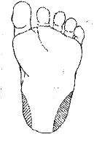
Heelstick site selection**
The distance for a 7 pound baby from outer skin surface to bone is: (diagram)
* Medial/lateral heel: 3.32 mm
* Posterior heel: 2.33 mm
* Toe: 2.19 mm

a. Position the patient and grasp the heel firmly but gently
with the index finger wrapped around the foot supporting
the arch, and the thumb wrapped around the ankle and
below the puncture site.
- Cleanse the site with an alcohol pre pad. Allow to air dry completely to eliminate alcohol residue
which can cause hemolysis, a stinging sensation on puncture and has been known to interfere with glucose testing.
c. Perform the puncture by placing the appropriate heel puncture device perpendicular to the lines of the footprint and depressing the plunger.
4. Applying firm pressure to the site, wipe away the first drop of blood with dry gauze. This is usually contaminated with residual alcohol and tissue fluid.
5. Position the site downward and continue to apply moderate pressure proximal to the puncture site. DO
NOT squeeze or massage the site vigorously because it causes hemolysis and contaminates the specimen
with tissue and intracellular fluids.
6. Collect the blood using appropriate collection devices for tests to be performed. (Follow Policy 408-I-
004-8 “Order of Draw for Multiple Tube Collections”.)
7. Apply pressure to site with a clean gauze until bleeding stops. Keep the site elevated.
8. Dispose of lancet in sharps container.
9. Label containers according to Specimen Labeling procedure at the patient bedside BEFORE you leave
the room.
10. Place collected specimen in sealed, leakproof transport container.
11. Remove gloves. Gloves, gauze, and alcohol wipe may be discarded in waste basket if gloves are removed wrong-side out with gauze and alcohol wipe inside. DO NOT discard in paper bag at patient’s
bedside.
12. Before leaving patient’s room be certain that the bed rails, lights, tray, etc. are in the same position you found them. Thank patient. If outpatient, verify that the patient feels well enough to leave on his/her own. Providing comfort by verbal or physical means shows the patient that you care.

NOTES: -A record should be kept of the amount of blood collected from each pediatric In-patient under 14 years of age if extensive testing is to be done. Pediatric and neonatal patient requiring extensive testing are usually transferred to another facility.
- Patient Immobilization: Ask the parent, if available, if he or she would like to help. If not available you must have the assistance of another phlebotomist or RN. Various techniques can be used dependent on if the patient is sitting or reclining. The purpose of immobilization is to prevent movement of the puncture site and other extremities thereby preventing injury to the patient and phlebotomist.
- Mothers may nurse their babies during the heelstick collection process.
- Caregivers may allow the baby to ingest sugar water, but phlebotomist can not assist. This helps with pain control during the collection process.
- Following hospital guidelines, the phlebotomist must immediately report to their supervisor all complications and incidents occurring during the draw. This includes any exposure to blood and other infectious materials.

Fingerstick
Follow Policy: 408-I-004-10 “Skin Puncture Procedure”
Fingerstick Site Selection**
Finger depth:
- Over 12 months: 2.0 mm

**Consider the effect of compression during the puncture. Too much may cause a deeper puncture than needed to get good flow

NOTE: Direct pressure must be applied to fingerstick puncture sites until bleeding ceases on children less than four years old. Bandaids are not recommended for children under the age of four due to the possibility of ingestion or choking.
Venipuncture precautions
Obtaining blood by venipuncture from infants may be difficult and potentially hazardous. Obtaining large quantities of blood, especially from premature infants, may result in anemia. Puncturing deep veins in children may cause:

A. Cardiac arrest
B. Hemorrhage
C. Venous thrombosis
D. Reflex arteriospasm and gangrene of an extremity
E. Damage to surrounding tissue or organs (e.g. puncturing the apex of the lung or piercing the trachea)
F. Infection
G. Injury from restraining the infant or child during the collection procedure.

Venipuncture: Refer to “Blood Collection by Venipuncture” procedure 401-PHLEB-004-6.
PKU
- Verify newborn name and DOB with Birthing Center staff, match labels with PKU slip.
- Verify that a patient sticker with information is placed on the reverse side of the PKU slip.
- Phlebotomist and Birthing Center staff will both initial the reverse side of the PKU slip.
- Verify that the information on the front part of PKU slip matches the information on the patient
labels before the procedure is started.
- Refer to Insert Manual for most current PKU slip.

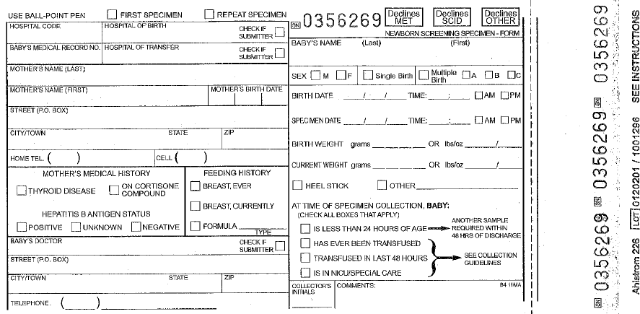

Pku Slip Sample (refer to Insert manual )

References
Procedures for the Collection of Diagnostic Blood Specimens by Venipuncture. NCCLS Document H3-A3. Third Edition. 1991.

Procedures and Devices for the Collection of Diagnostic Capillary Blood Specimens. NCCLS Document H4-A5. Fifth Edition. 2004.

"Implementing a Pediatric Phlebotomy Protocol". Kristen M. Buckbee, CPT,(ASCP). MLO, April 1994. pp. 32-35.

Phlebotomy Procedures: Skin Punctures. Department of Pathology. Dartmouth Hitchcock Medical Center. Copyright 2008. (accessed 7/29/08). HTTP://labhandbook.hitchcock.org/skinpuncture.html

Kotrla,Terry, MS, MT (ASCP) BB. Austin Community College. Age Specific Care and Phlebotomy. Copyright 2007. (accessed 7/29/08). www.austincc.edu/kotrla/phbagespecificcareand phlebotomy.ppt

CLSI. Collection of Diagnostic Venous Blood Specimens. 7th ed. CLSI standard GP41.
Wayne, PA: Clinical and Laboratory Standards Institute; 2017.

Prepared By: Frank Vasquez
Reviewed By:
 | Supervisor: |  | Date
Approved By:
 | Medical Director: |  | Date
Adopted or Date initiated: January, 1995

Revised and effective date: September 20, 2011, 10-2018

Supercedes:

Reviewed:
DATE | REVIEWER | DATE | REVIEWER

Revision History
Version | Summary of Changes | Author | Date
V2 | Updated equipment for heelstick and fingerstick.  Added revision box and header. PKU slip updates/Incident reporting added per CSLI guidelines | olearj | 10/04/18

