Policy: 408-I-003-12

RESPONSIBLE DEPARTMENT:  LABORATORY | POLICY #:  408-I-003-12 | PAGE: 1 of 4
SUBJECT: Skin Puncture Procedure | EFFECTIVE DATE: February 1996
REVIEWED/ REVISED: October 2018
DISTRIBUTION: ALL EMPLOYEES

Category 3

Principle
Skin punctures provide a quick and efficient method of obtaining a blood sample with minimum discomfort or risk to the patient. The blood obtained is a mixture of blood from arterioles, venules, and capillaries and contains interstitial and intracellular fluids.

Specimen
Finger or Heel stick

Equipment
Sterile blood lancet
Alcohol swab
Gauze
Bandage
Capillary tubes appropriate for requested tests
Puncture resistant sharps container

Precautions
HANDLING BLOOD SPECIMENS AND BODY FLUIDS REQUIRES USE OF LAB COAT AND GLOVES, AND SAFETY SHIELD FACE PROTECTION IN DESIGNATED AREAS. WASH HANDS AFTER REMOVING GLOVES.

Procedure
Fingerstick:
- Greet the patient and identify yourself, indicating that you are going to obtain a blood sample and explain the procedure. DO NOT argue with a patient if he/she refuses to have blood drawn. Report objections to nursing staff or physician.
- Positively Identify the patient, following Policy: 408-I-4-1 “Positive Patient Identification”.
- Check paperwork and verify test requirements.
- Verify any dietary restrictions.
- Assemble supplies.
- Position the patient.
- Put on a clean pair of gloves.
- Select the site. The palmar surface of the distal phalanx of the middle or ring finger is the site of choice. Try to choose a finger that is not cold, swollen, or cyanotic. DO NOT use the thumb or little finger.

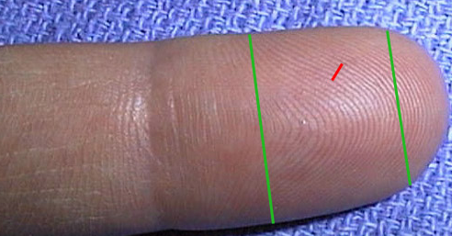

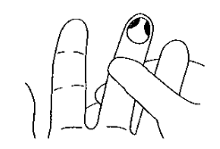
- The finger selected may be massaged to increase blood flow. A patient with cold hands may also be asked to rub them briskly together, run hands under warm water, or use heel warmer to increase blood flow to the site.
- Clean the ball of the finger with an alcohol swab. Allow to dry for 30 seconds.
- Remove protective cover on lancet.
- Grasp the patient's finger between the fingers and thumb of your other hand and squeeze gently for three seconds.
- Perform the puncture. The puncture should be made lateral to (just to the side of) the ball of the finger and across the lines of the finger print. Hold lancet on site with moderate pressure. Depress plunger with index finger to make puncture.
Immediately release plunger while holding lancet on site. Remove lancet.
- Wipe away the first drop of blood with clean gauze. It is usually contaminated with excess tissue fluid.
- Gently squeeze finger to obtain a drop of blood.

- Gently touch drop of blood to the lip of the capillary tube, allowing blood to run down into the tube. Make sure the tube is filled to the amount required, slightly tapping the tube to mix additive with blood (if there’s an additive).
- Place a clean, dry gauze pad over the site and ask the patient to press down with the thumb of the same hand until the bleeding stops.
- Gently invert the tube(s) to mix the additive with the blood.
- Bandage patient's finger.
- Place used lancet in sharps container and carefully dispose of contaminated gloves and equipment. Wash hands before proceeding to the next patient.
- Following hospital guidelines, the phlebotomist must immediately report to their supervisor all complications and incidents occurring during the draw. This includes any exposure to blood and other infectious materials.

Heelstick
Follow Policy: 408-I-004-5, “Pediatric Phlebotomy.”

References:
Diane Garza and Kathleen Becan-McBride, Phlebotomy Handbook, Appleton & Lange, 3rd edition, 1993.

Procedures for the Collection of Diagnostic Blood Specimens by Skin Puncture. NCCLS Document H4-A3. Third Edition. 1991.

Ruth E McCall and Cathee M Tankersley, Phlebotomy Essentials, J. B. Lippincott Company, 1993.

CLSI. Collection of Diagnostic Venous Blood Specimens. 7th ed. CLSI standard GP41.
Wayne, PA: Clinical and Laboratory Standards Institute; 2017.

Approved By:
Date
Phlebotomy Supervisor
Phlebotomy Supervisor
Date
Medical Director

Adopted or Date Initiated: February 29, 1996

Revised and Effective Date: May 2004, May 2008, October 2018

Reviewed:
DATE | REVIEWER | DATE | REVIEWER

Revision History
Version | Summary of Changes | Author | Date
4 | Updated approval box and added revision history box, updated illustrations | glik | 09/30/16
5 | Header added/Incident reporting added per CLSI guidelines | olearj | 10/09/18

