Laboratory Computer Manual and Emergency Mode Operations Manual

The Lab Computer Manual and the Emergency Mode Operations Manual have been updated to reflect the transition to Meditech Expanse.

* The Laboratory Computer Manual is now available on the intranet, and there is a paper copy located on the Chemistry/Hematology shelves near the break room. In order to access the procedures on the intranet:

1. Select the Policies and Procedures Site from the list on the left of the page.

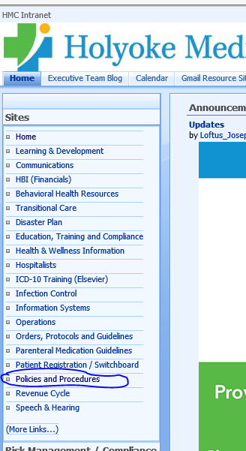

2. Select HERE.

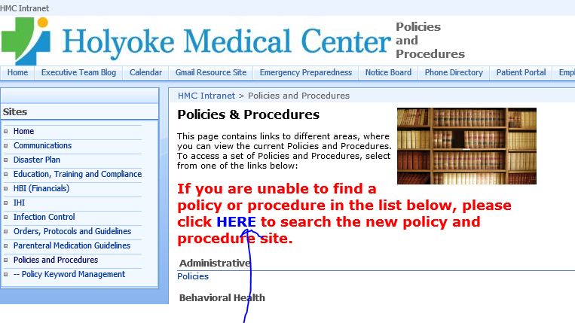

3. Select Laboratory.

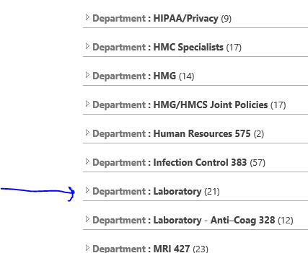

4. Select Procedure.

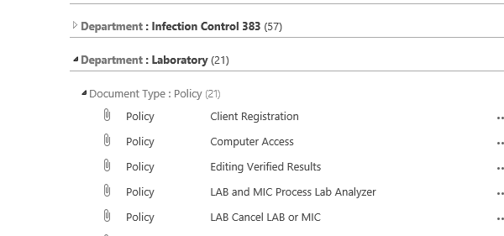

* The EMO (downtime) manual is located on the Chemistry/Hematology shelves near the break room.

Note: Each department may have department specific procedures for Expanse.