**MobiLab**

**Start of shift:**

1. Reset Handheld: “**Soft boot” -** Hold the Red key (A). This action would reset the Mobilab Handset. Tap on the MobiLab Icon to access the sign on page.

**A**

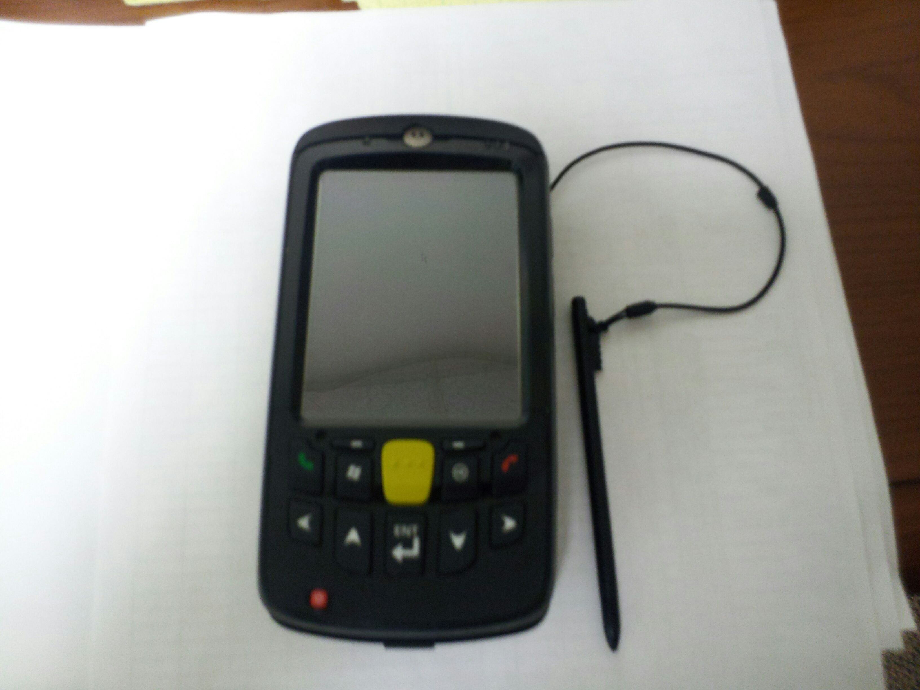

1. Signing on:

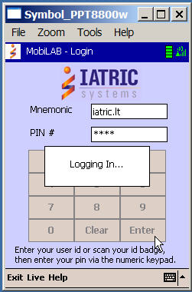

* At the Mnemonic field, scan your employee badge barcode by pressing the SCAN button on both sides of the handheld.
* At the PIN # field, enter your PIN # using the numeric keypad and press Enter

3. Assigning your printer

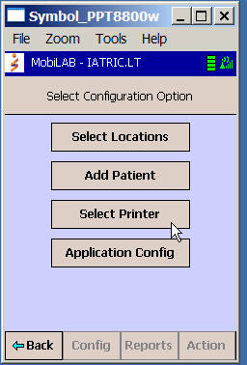

* Tap [Config] at the bottom of your screen
* Tap [Select Printer] to assign a printer to your handheld.
* Scan the barcode attached to the printer

**Note:** Check battery strength of printers if less than 5 bars replace with fully charged battery. Check supplies including extra labels.

4. Choosing your location:

* Tap [Select Locations] to display the list of patient locations
* Select or deselect patient locations based on your phlebotomy assignment by tapping the appropriate location on the screen.
* Tap [Action], then [Set] to set locations

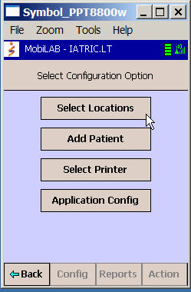

**THE DRAW LIST:**

Specimens are grouped by patient location. The column headers in the draw list are:

1. **PRI** – Specimen Priority
2. **Status** – Ordered (ORD), Collected (COLL), In-Lab (LAB)
3. **Rm-Bed** – Room/Bed
4. **Coll Tm/Dt** – Collection Tm/Dt

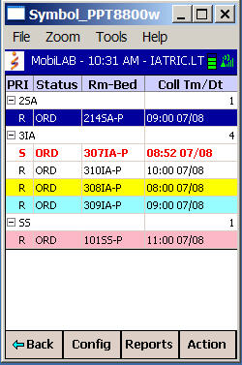

**The Colors of the Draw List:**

* Stat Priority: **Red** font
* Overdue Collection: **Yellow** background
* Not Drawn Reason applied: **Turquoise** background

**Screen Views: ALL vs. Pending**

The draw list display can be filtered by specimen status. **ALL** displays collected and uncollected specimens.  **Pending** excludes collected specimens.

**ALL Pending Orders Only**

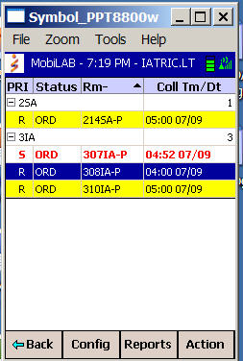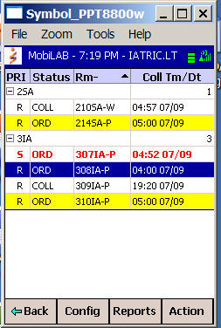

* Tap [Action] at the bottom of the screen then Tap [All] or [Pending] to select view.

**DRAWING THE PATIENT:**

1. Selecting patient

Tap the screen to select the patient you are about to draw.

**Combining Orders:**

The handheld displays specimens ordered for a future time along with the current specimen to be drawn.

If **all of the specimens are for the same collection time**, they will display as a single entry on the Draw List and the Combine Screen **will not** display.

If a patient has **specimens with multiple collection times**, they **will** be displayed on the Combine Screen.

**NOTE: A phlebotomist may combine the specimens into a single blood draw**

**ONLY when authorized by a nurse or physician.**

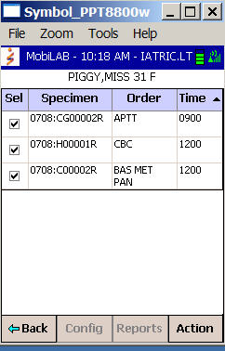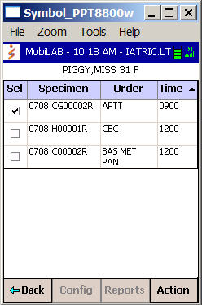

* Select or deselect the tests to be drawn by tapping on the individual specimens. Tap [Action] on the bottom of the screen and Select [Go] to advance to the Patient screen.

**Special Instructions:**

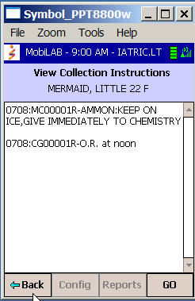

* Any special collection instructions will be displayed on your handheld prior to drawing the specimens.
* Obtain the necessary materials needed (i.e. ice, warm water bath)
* Tap [Go] to advance to the Patient Screen

1. Drawing the Patient

* The Patient Screen displays demographic information at the top of the screen, followed by the specimen numbers, test names and containers to be drawn.
* The containers display and specimen labels print in the preferred order of draw.
* The phlebotomist gathers the necessary supplies and enters the patient room.
* After greeting the patient, scan their wristband barcode by pressing either of the buttons on the side of the handheld device.

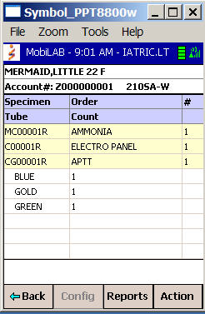

**NOTE:**

1. Patient MUST always have their wristband on.
2. Per Policy **Ask Patients Name and DOB.** Tap DOB on 2nd identifier screen to verify.
3. If patient is nonverbal, the caregiver must visually identify patient with verbal acknowledgement.
4. Verifying Patient and Specimen Collection

Unsuccessful Patient Verification (Patient’s name turns red)

Successful Patient Verification and Specimen Verification

(Green background)

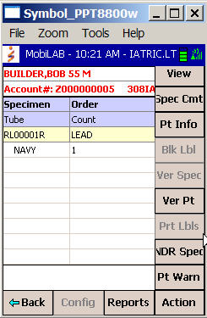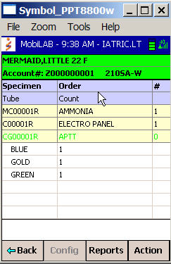

* Upon successful patient verification labels will automatically print.
* Draw the patient’s blood and affix the specimen labels to the collected tubes. Destroy any unused labels.
* Verify specimens: Scan each labeled specimen tube. Each successfully scanned specimen would be indicated by a green font.
* The specimen status will change from ORD to COLL on the Draw List screen.

Note: If the label does not match the patient, a warning message displays and the specimen remains in the ORD status

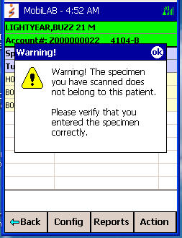

.

1. Specimen Comments

The user may add specimen comment(s) before or after patient verification.

* Tap [Action] and select [Spec Cmt]
* Select reason from drop down menu on the “Add Comments to Specimen” screen.
* Tap [Action] and select [Add]
* Tap the [Back] button to return to the draw list.

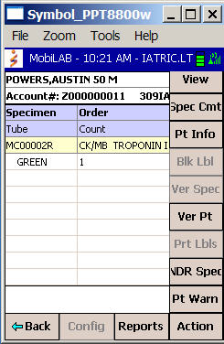

**The following are the Specimen Comments defined in the system:**

Patient receiving blood

@Extra tubes drawn

Patient Fasting

Finger Stick Collection

@OK to combine orders per RN

Drawn from PICC line

1. Specimen not drawn:

* If the user attempts to return to the Draw List by tapping the [Back] button before all specimen labels have been scanned to document collection, the Confirm Exit message displays.
* If the user taps the [Yes] button, they will be required to enter a Not Drawn Reason from the drop down list provided.
* If the user taps the [No] button, they will remain on the patient screen and continue to scan labels.

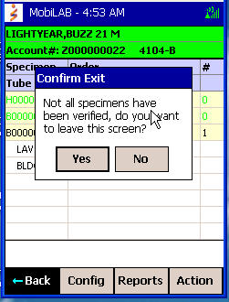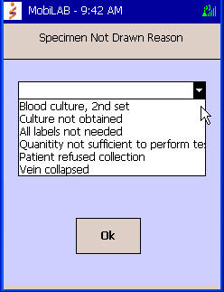

**Not Drawn Reasons (NDR):**

* When specimens are not drawn due to i.e. “difficult draw”, Tap [Back]
  + Select reason from the drop down menu.
  + **Destroy Labels**.
* When specimens are not drawn due to i.e. “patient unavailable” Tap [Action], then select [NDR Spec].
  + Select reason from drop down menu.

The following are the Specimen Not Drawn Reasons defined in the system:

@Test added to specimen in Lab

@To be Added to Specimen in Lab per RN

Blood Culture, 2nd set

Test(s) Cancelled by MD

Test(s) Cancelled by RN

@Difficult draw, 2nd phleb to try

@Patient discharged

Duplicate Order

@All labels not needed

Culture Not Obtained

@Patient in Radiology

Patient Refused to be drawn

@Nurse to Draw

Patient unavailable

**ADD-Ons:**

The MobiLAB handheld provides the ability to display specimens collected for a patient **within 2 hours of draw**.

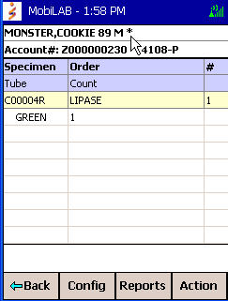

* An **asterisk** next to the patient’s name on the Patient screen is a visual indicator that specimens have been previously collected on the patient.
* The phlebotomist can then view this list of specimens in the laboratory by tapping on the patient name.

NOTE: A current test request can only be added on a previously collected specimen when authorized by the nurse or physician.

To add the test:

* Tap [IN LAB]
* Select “Test added to specimen in Lab” under the Specimen Not Drawn Reason
* The status of the current specimen will update from ORD to LAB and will be removed from the draw list screen after receipt by accessioning in the Meditech system.

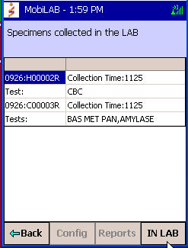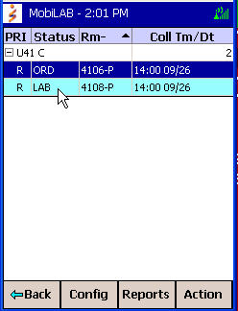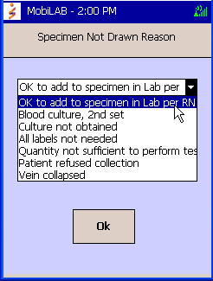

**STAT DRAWS:**

If you are assigned to STAT Draws:

Tap [Select Locations] on the Select Configuration Option Screen



* Tap the [Select Locations] to display the list of patient locations. Select **all patient locations** that we provide phlebotomy service to. Tap [Set] to set locations. Tap [Back] to update your draw list.

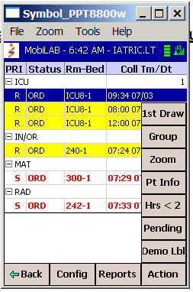

* To display specimens with

STAT priority only:

* Tap [Action] at the bottom

of your screen

* Tap [1st Draw]
* Tap [STAT Only]
  1. Assigned Stat Draws

Stat order - All handheld devices currently assigned to monitor a particular patient location will be alerted when a new stat order is added to their draw list.

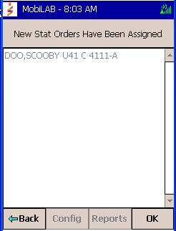

* The handheld device will beep and vibrate when new stat orders have been assigned.
* Tap [OK] or [Back] to return to the Draw List.
* The Draw List display will be updated with the stat order.
  1. Unassigned Stat Draws

If no handheld device is currently assigned to monitor a patient location and a stat order is entered for a patient admitted to that location, **ALL** active handheld devices will be alerted.

* The handheld device will beep and the Unassigned Stat Orders screen will be displayed

**Accepting the Stat Order:**

* Tap the [Back] button or [Action], then [Accept] button to accept the stat order.
* The first user to accept the order will receive the message “Assign IML Stat OK” when they return to their Draw List
* That user’s handheld will beep a second time and display the Assigned Stat screen, confirming acceptance. Tap [OK] to return to the draw list.
* All other users attempting to accept the unassigned stat will be notified that another user has already accepted the order.

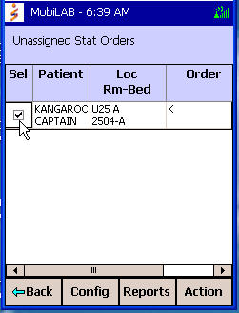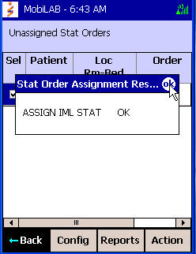

**Not Accepting Unassigned Stat Order:**

* If the phlebotomist de-selects the stat by removing the check mark in the *Sel* box and taps the [Back] button a warning message displays, “You are choosing to not accept these Stat Orders”
* **To confirm refusal of the stat order**: Tap [OK]. The Draw List will not be updated with the stat order.
* **To cancel refusal of the stat order**: Tap [Cancel]to clear the warning message and accept the stat order as described above.

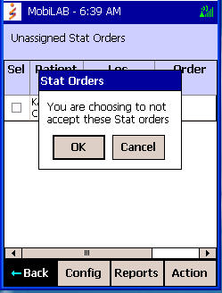

**PRINTERS**

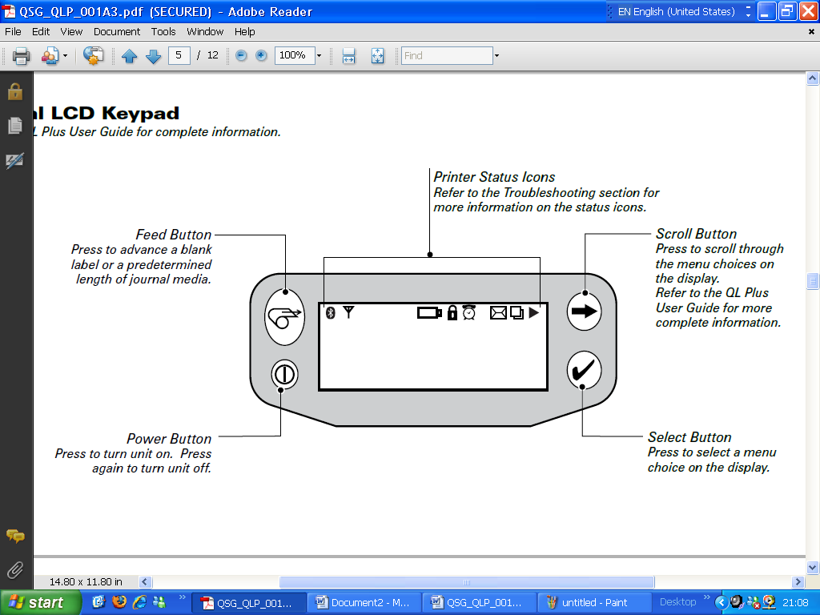

**A. Loading Labels**

1. Press the Latch button located on the side of the printer.
2. Latch will rise (2), pull back media cover (3)

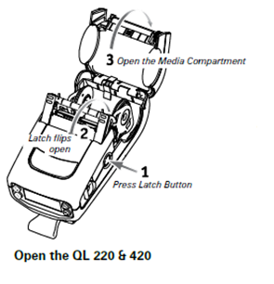

1. Pull the media supports apart.
2. Take out old roll of media and insert new roll

Note: Labels should face towards the front of the printer rolling upwards from

underneath.

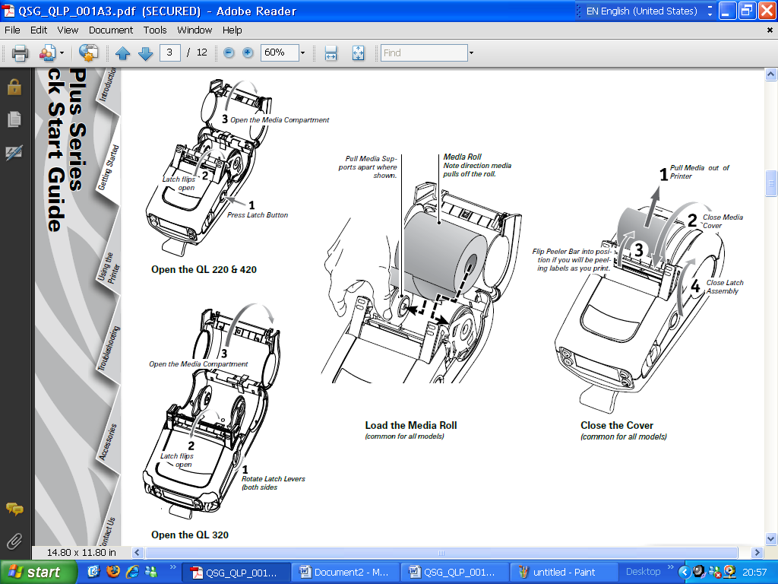

1. Close the cover.



1. **Changing the Battery**
   1. To remove the battery cover, turn the device over and rotate the belt clip out of the way of the battery.
   2. Take out the battery.
   3. Replace the battery pack with a newly charged battery pack.

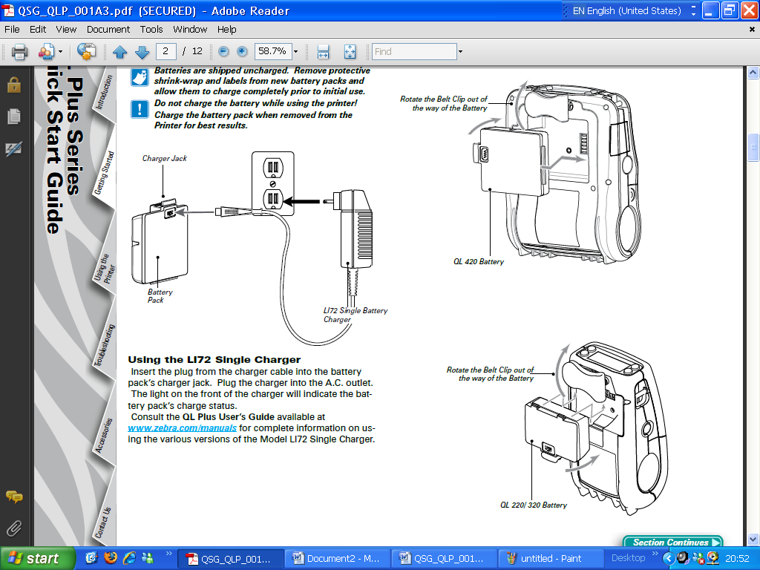

* 1. Take the uncharged or low charged battery pack and place it in the charger.

**Troubleshooting:**

**Handhelds:**

1. If your handheld **stops scanning** or is **Frozen** you need to do a **“Soft Boot”.**

**Printers:**

1. If Printer is not receiving a strong enough wireless signal in the patient’s room, phlebotomist may move closer to the door or in the hallway.
2. If Signal is OK but the printer won’t print, turn printer off and then back on.
3. If printer still will not print. Check battery level and change if < 3 bars.

**End of Shift:**

1. Log off MobiLab software.
   1. Make sure software is backed out all the way to the white screen with the MobiLab icon.
2. Dock handheld
3. Make sure printers are off. Plug printer to the adaptor for charging.