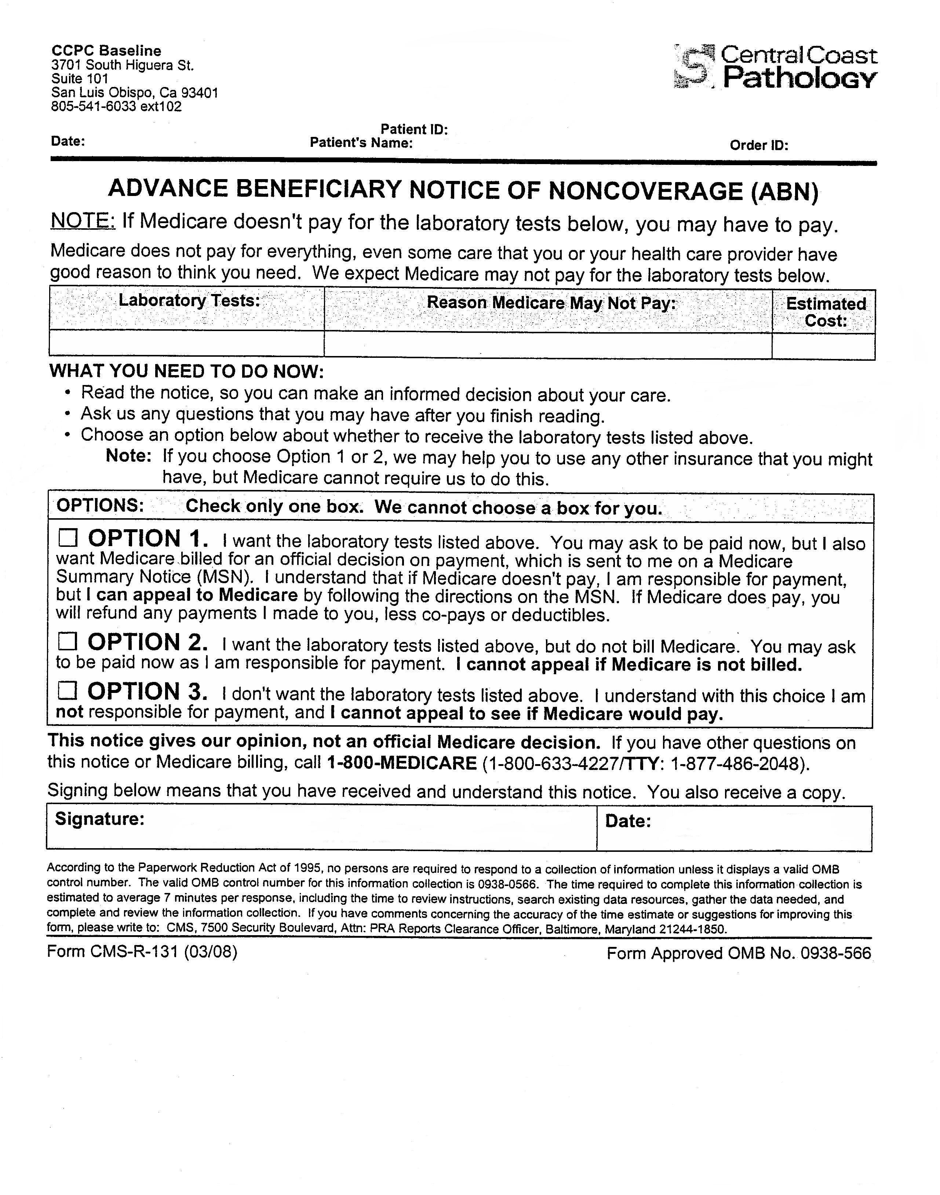
ABN Training Companion Sheet

Things to remember:
- Patients must receive a copy of the ABN once it is completed

- The ABN should be double-checked, especially if it is computer-generated

- If a PSA, HgbA1c, or Occult Blood is requested, indicate "frequency" and "condition" for the reason Medicare may not pay

Required Fields
- Name of Patient (both first and last)
- Test names (even if CPT code appears, the name of the test must be present too)
- The reason why Medicare may not pay
- The estimated cost (can be either individual amount or grouped together for total cost, if there are multiple tests)
- One option box is checked off (patient must do themselves without any influence)
- The patient must sign the ABN after everything else is done
- The date (which can be completed by lab staff, when requested by a patient. Please include day, month, and year.)

Things that could make an ABN invalid:
  - It is illegible or the font is small (less than 12 point) or hard to read.
  - The provider did not use the official CMS ABN form.
  - The ABN does not list the actual service rendered.
  - The form is more than one year old.
  - The form is signed after the date the service was provided.
  - The form is given to someone that cannot understand it.
  - The ABN is missing any of the seven required fields.

