Dignity Health  
Central Coast Service Area Procedure

|  |  |  |
| --- | --- | --- |
| **Central Coast Service Area North:** | | |
| Santa Maria Campus,  Marian Regional Medical Center | Arroyo Grande Campus,  Marian Regional Medical Center | French Hospital Medical Center |
| **Central Coast Service Area South:** | | |
| St. John’s Pleasant Valley Hospital | St. John’s Regional Medical Center |  |

**SUBJECT**: PRBC Requisition

**Lab Policy Number:** 7540.bb.cc.502

# Purpose: This procedure provides instructions for answering a PRBC requisition order.

# CLIA Complexity: High complexity

# Principle: PRBC requisition orders will generate any time a new request for red blood cell products are placed. Requisitions enable the ordering caregiver to communicate special transfusion requirements, number of units requested, and clinical indication for transfusion, date needed, and urgency of product availability. Verifying the requisition is used to track acknowledgement and fulfillment of the order.

# Procedure

|  |  |  |
| --- | --- | --- |
| **Step** | **Action** | |
| **1** | Using *Result Entry* application, open a new worksheet. Choose either <All procedures> or <PRBC Req> Test group. |  |
| **2** | Scan the specimen or if the order is an add on type in the accession number for the order. | |
| **3** | Some information is pulled in from the PowerPlan.  *Note: The Result Entry application was modified to view all information without scrolling when the window is expanded.* |  |
| **4** | **Special Requirements:**  Documentation of special requirements is specified by the ordering physician when ordering the blood transfusion PowerPlan. Special transfusion requirements include the following: CMV negative, Irradiated, Washed, Hgb S Neg, and Fresh.  *Note: The Special Requirements field is a free text field and can be edited in Result Entry.* |  |
| **5** | **File Check (Required field):**   * Prev History – If previous history is found * No Prev History – No history found. This will reflex an R ABORh. * Hist/Req checked – Do not use. * No Hx No RAB – used only if no history is found and patient has been discharged and will not be transfused but testing is being completed. * Err and See Comment must be accompanied by a comment |  |
| **6** | **Test Wanted:**  Should only use Not Indicated as tests should have already reflexed and don’t need ordering. A response is not required for order completion. |  |
| **7** | **Add to ACC#:**  Enter in Accession number if a previously collected specimen will be used for the crossmatch. |  |
| **8** | Quantity, Date needed, # Transfuse Now, and PRBC Indications are auto populated by the Blood Transfusion PowerPlan entered by the caregiver. |  |
| **9** | Result any required fields to verify the order prior to completing the crossmatch, in order to acknowledge that special transfusion requirements are met before selecting units for transfusion. | |
| **10** | Crossmatch red cell units as requested. | |

# Limitations of Procedure

* 1. Verifying the PRBC Requisition prior to selecting units for crossmatch will remove the PRBC order from the blood bank pending inquiry. The order can be observed on the blood bank section pending inquiry.

# Appendixes

* 1. Appendix A: PRBC Leukoreduced Requisition

**Appendix A: PRBC Leukoreduced Requisition**

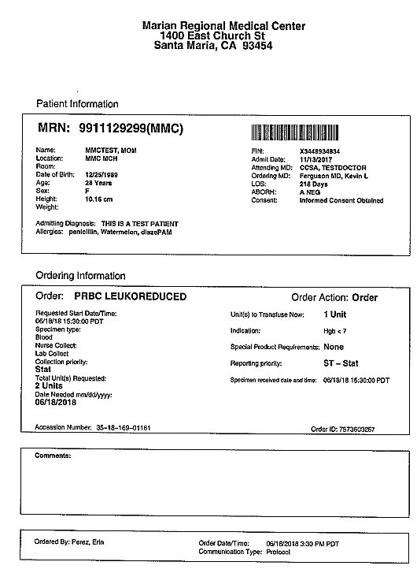

**Barcode readable medical record number**