Policy   
Dignity Health Central Coast Service Area

**SUBJECT**: Unit Status Report-Daily Short Dated Blood Product Review

**ORIGIN**: Laboratory - Transfusion Service

**NUMBER**: 7540.BB.CC.238

|  |  |  |
| --- | --- | --- |
| **Applies to:** | | |
| Santa Maria Campus,  Marian Regional Medical Center | Arroyo Grande Campus,  Marian Regional Medical Center | French Hospital Medical Center |
| St. John’s Pleasant Valley Hospital | St. John’s Regional Medical Center | |

# PURPOSE:

Provide instruction for the daily generation of and review of the Unit Status Report to assist in short dated product inventory management.

# DEFINITIONS:

## Short dated inventory- Blood products that will expire in less than or equal to five calendar days.

## Short Dated label-



## Unit Status Report- Tool utilized in the Cerner laboratory information system to generate a report detailing the blood products that expire in a defined time range.

# POLICY:

The blood bank will generate and review the Unit Status Report for blood products that will expire in less than or equal to five calendar days.

The blood products will be tagged with a short date sticker with the date of expiration written on it.

The Unit Status Report will be reviewed for unit expiration date, assigned and crossmatched units inventory management, and specimen expiration dates.

## Frequency: Daily

## Generation of the Unit Status Report

1. On the Cerner App Bar select the Explorer Menu 
2. On the Explorer Menu double click on the Main Menu folder.

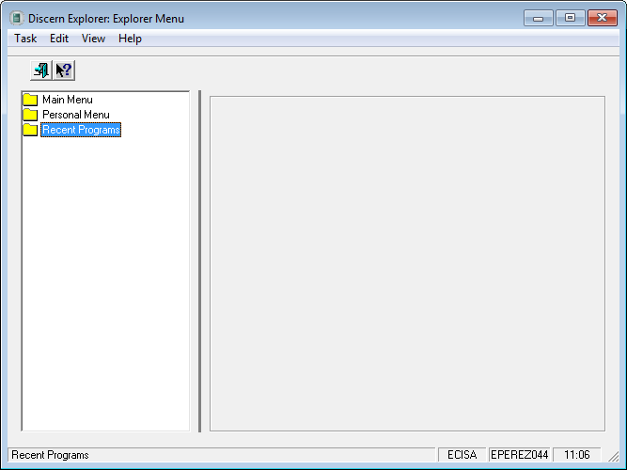

1. Scroll down to Laboratory – PathNet using the scroll bar and double click on the folder to expand the options.

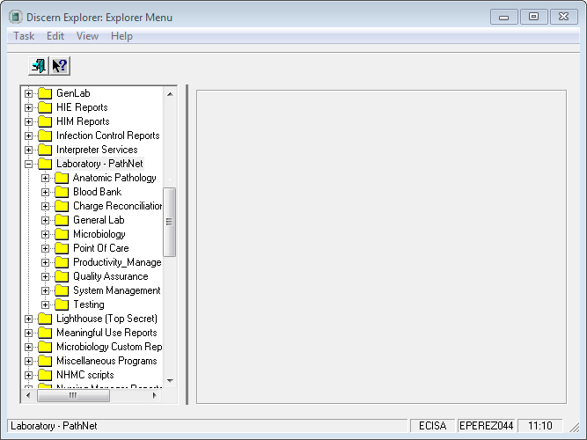

1. Double click on the Blood Bank folder and select the Unit Status Report-Date Sort option

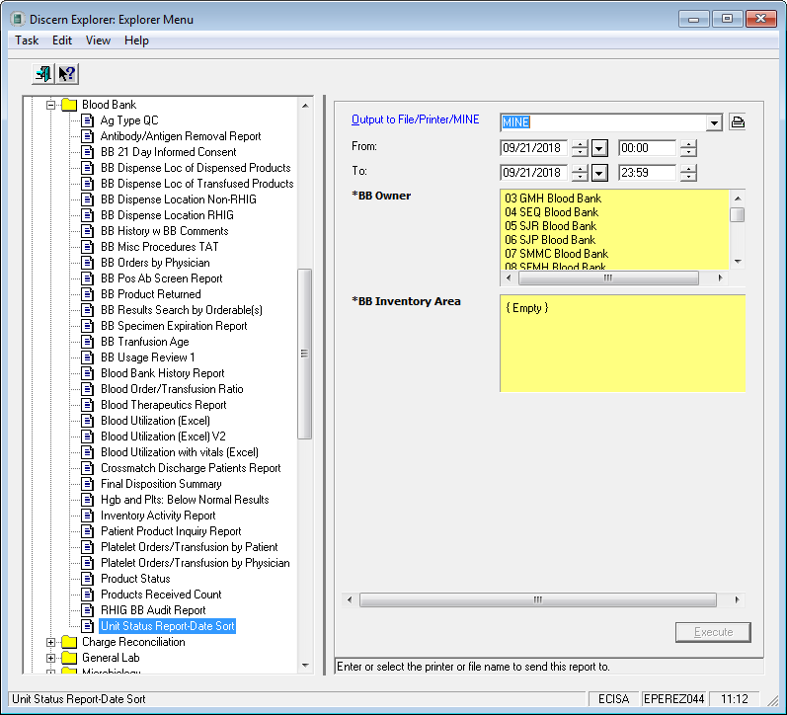

1. Change the following:

**To:** Change date to five days in the future

**BB Owner:** to 35 MMC Blood Bank

**BB Inventory Area:** Check the box

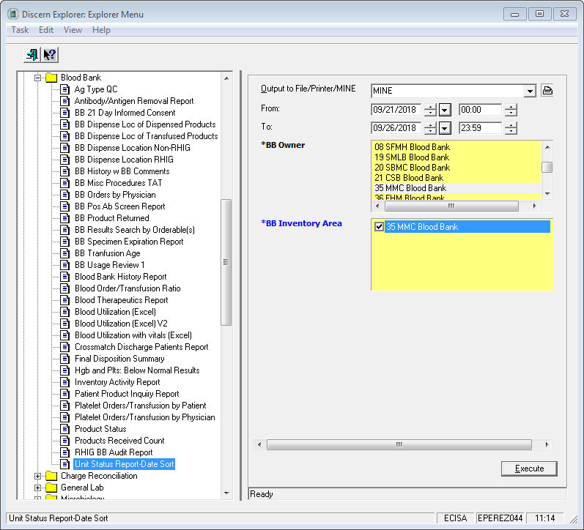

1. Select Execute
2. Print the Unit Status Report

## Report Review

1. The Unit Status Report will include all products that have been received into inventory and will be expiring during the selected date and time.
2. The Unit Status Report will include the Product Number (Donor Identification Number), Product Type, ABO/Rh, Quantity (derivatives), Expiration Date/Time, Status (Available, Assigned, Crossmatched, Dispensed, Quarantined), patient name and medical record number (if applicable).
3. The Unit Status Report is categorized by the product category (Fresh Frozen Plasma, Platelet Pheresis, Cryoprecipitate, Red Blood Cells, and Derivatives).
4. **Available product status**

|  |  |
| --- | --- |
| **Product Type** | **Action** |
| Fresh Frozen Plasma (FFP) | * Write the quantity, ABO type, and expiration date under the Plasma section on the white board in blood bank * If the FFP expires on the current day at 2359, then highlight the product number and the expiration date on the Unit Status Report and attach a Short Dated label to the unit. * After all FFP products have been addressed, then attach the Unit Status Report to the blood bank product refrigerator using the magnetic clip labeled Short Dated. |
| Platelet Pheresis (PLP) | * Write the expiration date under the Platelet section on the white board in blood bank * If the PLP expires on the current day at 2359, then highlight the product number and the expiration date on the Unit Status Report and attach a Short Dated label to the unit. * After all PLP products on the Unit Status Report have been addressed, then attach the PLP product report to the outside of the platelet agitator using the magnetic clip labeled Short Dated. |
| Cryoprecipitate (CRYO) | * Write the expiration date and time on the white board in blood bank. * Highlight the product number and the expiration date and attach the Unit Status Report to the white board in blood bank. |
| Red Blood Cells (RBC) | * Write the expiration date on the Short Dated label and attach the label to the product. Do not cover up the ISBT label attached to the unit. * Highlight the product number and the expiration date * After all RBC products have been addressed, then attach the Unit Status Report to the blood bank product refrigerator using the magnetic clip labeled Short Dated. |
| Derivatives  (Rh Immune Globulin) | * Confirm the available quantity with the quantity available in the derivative box. * Label the derivative box with a Short Dated label * Ensure the derivative box is placed in the front of the inventory. * Ensure there is at least one additional box of derivatives with a longer expiration date. If there is not, then notify the blood bank lead or transfusion service area supervisor or the laboratory manager that additional inventory needs to be ordered. * Place the derivative Unit Status Report in the Supervisor Review slot in blood bank. |

1. **Assigned/Dispensed and Crossmatched/Dispensed Status**

The product has been dispensed and does not need to be addressed during the report review.

1. **Assigned and Crossmatched Status**

Review the transfusion orders for products that are assigned and/or crossmatched to a patient.

* 1. On the Cerner App bar open the Order Result Viewer icon. 
  2. Enter the associated patients medical record number listed on the Unit Status Report and select the OK button.
  3. Review the product requisition order for the short dated product type (FFP, PLP, CRYO, RBC)
  4. Review the applicable lab values for the short dated product type

|  |  |
| --- | --- |
| **Product Type** | **Laboratory Test** |
| FFP | INR/PTT |
| PLP | Platelet count  Platelet Function Assay |
| CRYO | Fibrinogen |
| RBC | Hemoglobin |

* 1. Review the # Transfuse Now, Date Needed, and Indications result.

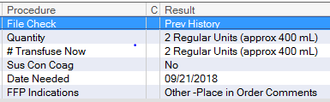

* 1. # Transfuse Now: None
     1. Notify the caregiver and clarify that blood products need to be available for use.

|  |  |
| --- | --- |
| **If units need to be available and there are** | **Then** |
| Orders to transfuse before the blood product or blood bank band expires | Do not release the short dated products. |
| No orders to transfuse | Release the short dated units and assign or crossmatch units with a longer expiration date. |

* 1. # Transfuse Now: Quantity Indicated
     1. On the Cerner App Bar select the Patient Product Inquiry icon 
     2. Enter the patient’s medical record number and press enter
     3. In the Product List grid select the Retrieve button

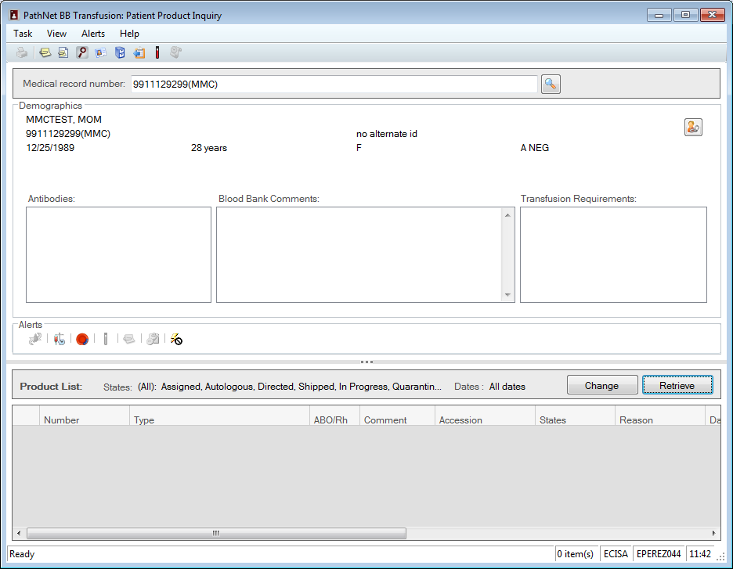

* + 1. Compare the number of products populated in the grid to the quantity in the # Transfuse Now result field on the product requisition order. If the number of products populated is equivalent to the # Transfuse Now, then call the caregiver with the applicable laboratory values, quantity and type of short dated product available, and clarify the need for the product type to be available. If the caregiver clarifies that the product can be released, then release the product into inventory.

|  |  |
| --- | --- |
| **If units need to be available and there are** | **Then** |
| Orders to transfuse before the product or blood bank band expires | Do not release the short dated products. |
| No orders to transfuse | Release the short dated units and assign or crossmatch units with a longer expiration date. |

* + 1. Review the available specimens in the Patient Product Inquiry window by selecting the Available Specimens icon on the Alerts bar.



* + 1. The Available Specimens icon will not be grayed out if there are specimens available. The available specimens pop up window will open. Locate the specimen with a Completed ABORH and ABSC (if indicated) and note the expiration date and time.

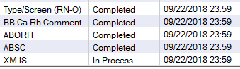

* + 1. If the available specimen will be expiring on the current date, then notify the caregiver that the blood bank band will be expiring at 2359, what products are short dated, and determine if the short dated products are to be transfused prior to the blood bank band or product expiration. If the short dated units will not be transfused before the blood bank band or product expires, then release the products into inventory.
  1. Review the Date Needed result in the product requisition order.

|  |  |
| --- | --- |
| **If the product is needed** | **Then** |
| After the product will expire | Release the product into inventory and assign or crossmatch a product that will be in date on the date needed. |
| Before the product will expire and there is an order to transfuse | Do not release the product into inventory. |
| Before the product will expire and there is not an order to transfuse | Notify the caregiver of the short dated products and the applicable lab values and determine if the product should be released into inventory or remain assigned to the patient. |

* 1. Review the product indications
     1. If the clinical indications are resulted as “Other,” then the patient may be undergoing an invasive procedure. Call the caregiver and clarify if the patient will be undergoing a procedure and when. Based on the date of the procedure, laboratory values, and expiration date of the product determine if the product needs to be released into inventory or remain assigned or crossmatched to the patient. If products are released, then ensure the same number and type of products are assigned or crossmatched with longer expiration dates. If additional red cells need to be crossmatched due to the expiration date, then credit the charges for the additional crossmatch testing performed.
  2. If the assigned or crossmatched blood product is expiring on the current day at 2359, then highlight the Product Expiration field on the product ID tag attached to the expiring blood product.

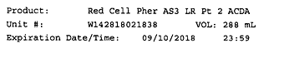

* 1. If the blood bank band is expiring on the current day at 2359, then highlight the Crossmatch Expired field on the product ID tag attached to the blood product.

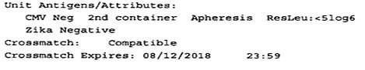

* 1. After all products are reviewed on the Unit Status Report then initial and date the printed report and attach the report to the appropriate product storage device.

|  |  |
| --- | --- |
| **Product Type** | **Attach Report to or place report in** |
| FFP | Blood product refrigerator |
| PLP | Platelet agitator/incubator |
| CRYO | White board in blood bank |
| RBC | Blood product refrigerator |
| Derivatives | Supervisor review slot in blood bank |

# REFERENCES:

A. Fung, M. K. (Current Edition). *Technical Manual.* Bethesda, MD: AABB.