Procedure   
Dignity Health Central Coast Service Area

**SUBJECT**: Issuing Blood Products – Single Person Check

**ORIGIN**: Laboratory – Transfusion Service

**NUMBER**: 7540.BB.CC.319

|  |  |  |
| --- | --- | --- |
| **Applies to:** | | |
| Santa Maria Campus,  Marian Regional Medical Center | Arroyo Grande Campus,  Marian Regional Medical Center | French Hospital Medical Center |
| St. John’s Pleasant Valley Hospital | St. John’s Regional Medical Center | |

# PURPOSE:

To provide guidance for the safe issue of blood products utilizing a single person check.

Note: In emergency situations the transfusion service staff members may dispense blood products prior to presentation of patient identification, however patient identification must be verified before blood products leave the transfusion service.

# clinical Complexity:

High Complexity

# Principle:

Transfusion safety relies on ensuring the correct recipient is transfused the correct blood product. Issuing blood products requires a visual inspection and a thorough check to be performed, that at minimum must include the following:

* Unique identification of the recipient including at least two independent identifiers
* Recipient’s ABO/Rh type
* Requested component type (red cells, plasma, platelets, cryoprecipitate)
* Donor Identification Number (DIN)
* Donor’s ABO/Rh type
* Compatibility testing interpretation, if applicable
* Special transfusion requirements, if applicable
* Donor unit expiration date and time, if applicable
* Date and time of issue
* Review of the original transfusion order

The performance of a check prior to the issue of a blood product allows a discrepancy to be detected and resolved prior to transfusion.

# Procedure:

|  |  |  |
| --- | --- | --- |
| Step | Action | Related Documents |
| 1 | On the Cerner app bar select the Dispense and Assign Products icon | 7540.BB.CC.511 Dispensing Blood Products in Cerner |
| 2 | Select the Dispense mode |  |
| 3 | Scan the M# (medical record number) barcode from the patient label. Select the current admission or place the cursor in the financial number (FIN NBR) box and barcode the FIN from the patient label and select OK. Note: If the barcode is not available then type in the patient’s medical record number and verify at least two independent patient identifiers are populated by the LIS with the patient information provided. |  |
| 4 | Click in the Product List grid and barcode the donor identification number of the type of blood product(s) requested. |  |
| 5 | Perform a clerical check verifying the following information:  |  |  |  |  |  | | --- | --- | --- | --- | --- | |  | Donor Unit | Product ID Tag | LIS | Patient ID | | Patient’s Name |  | X | X | X | | Medical Record Number |  | X | X | X | | Date of Birth |  | X | X | X | | Blood Bank Band Number |  | X |  | X | | Donor Identification Number (DIN) | X | X | X |  | | Blood Product Expiration Date and Time | X | X | X |  | | Standard Product Code and Container | X | X | X |  | | Blood Types, Patient and Donor Unit | X | X | X |  | | Specimen Expiration Date and Time |  | X | X |  | | Compatibility, if required |  | X | X |  | | Special Transfusion Requirements | X | X | X |  | | Original order for transfusion | X | X | X | X | | Appendixes: Request for Blood Products form |
| 6 | Verify that the blood product is not expired and is in date. Note: If the Expiration Date/Time is highlighted on the product ID tag, then compare the date and time on the product ID tag to the date and time on the computer. If the blood product is expired, then do not issue the blood product.    If the pathologist has approved the dispense of an expired blood product due to clinical necessity, then include a blood bank comment including the donor identification number, clinical reason for dispense, and approving pathologist. |  |
| 7 | To verify that the blood bank band specimen is current for red blood cells review the Crossmatch Expires date on the product ID tag. Note: If the Crossmatch Expires date is highlighted, then compare the date to the date on the computer. If the crossmatch is expired, then notify the caregiver that the blood bank band has expired. The patient must be re-banded before crossmatch compatible units may be issued.  cid:image006.jpg@01D44F3B.D8E61890  If it is an emergency, then refer to 7540.BB.CC.320 Emergency Release of Products and/or 7540.BB.CC.007 Code Crimson – Massive Hemorrhage Event. | 7540.BB.CC.320 Emergency Release of Products7540.BB.CC.007 Code Crimson – Massive Hemorrhage Event |
| 8 | To verify the blood bank band specimen is current for non crossmatched products select the Computer Crossmatch Eligibility icon.   The drawn date must be within the acceptable requirements for a current specimen. The draw date is day 0 and the blood bank band specimen will expire on day 3 at 2359.  For example:  Drawn Date: 01/01/2019 0700  Expiration Date: 01/04/19 2359 |  |
| 9 | To review the original order for an inpatient select the product requisition in Order Result Viewer or in Powerchart under Orders/Plans and Blood Bank. Review the order for special transfusion requirements, date needed, number of units, and indication for transfusion. |  |
| 10 | To review the original order for an outpatient obtain a copy of the original order from the outpatient transfusion service or review the scanned order (if available) in Cerner. Review the order for special transfusion requirements, date needed, number of units, and indication for transfusion.Note: To view the scanned order in Cerner select the Order Result Viewer application, select the Mode Menu and choose Flowsheet. The scanned order will be visible under Transcription or HIM Documents as a Physician Order or Orders Scanned. Verify the correct order is being viewed by reviewing the signature date. |  |
| 11 | If a discrepancy if found, then do not dispense the blood product until the discrepancy is resolved. Report significant discrepancies (i.e. ABO incompatibility, patient misidentification) to the transfusion service area supervisor or blood bank lead immediately. |  |
| 12 | Perform a visual inspection of the blood product. | 7540.BB.CC.312 Visual Inspection of Blood Components and RhIg |
| 13 | If no discrepancies were found and the visual inspection is acceptable, then select save. |  |
| 14 | Document the following:Physician ordering the transfusionReasonVisual inspection (defaulted to OK)CourierLocation (defaulted to current location)Cooler (if indicated)Blood bank ID (if indicated)  Select the OK button. |  |
| 15 | If the Dispense Packing List printed, then attach it to the product request form and compare to the transfusion log. Note: The transfusion log will be automatically printed each day at 0235. |  |

# Definitions:

## LIS: Laboratory information systems

# References:

## Fung, M. K. (Current Edition). *Technical manual*. Bethesda, MD: AABB.

## *Standards for Blood Banks and Transfusion Services* (Current Edition). Bethesda, MD: AABB.

# associated Documents:

## 7540.BB.CC.007 Code Crimson – Massive Hemorrhage Event

## 7540.BB.CC.312 Visual Inspection of Blood Components and RhIg

## 7540.BB.CC.320 Emergency Release of Products

## 7540.BB.CC.511 Dispensing Blood Products in Cerner

# Appendixes:

## 7500-205 MRMC Request for Blood Products form

## 5-7500-136 AGCH Request for Blood Products form

## 6-7500-68 FHMC Request for Blood Products form

Appendix A: 7500-205 MRMC Request for Blood Products form

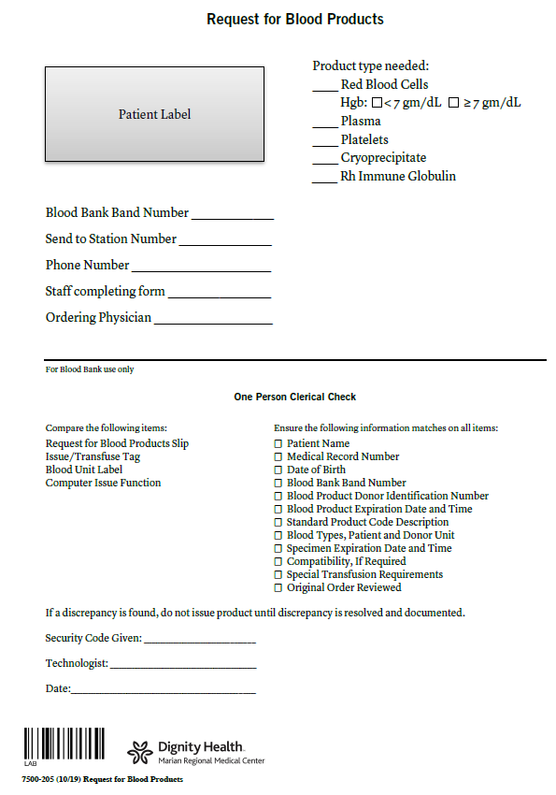

Appendix B: 5-7500-68 AGCH Request for Blood Products form

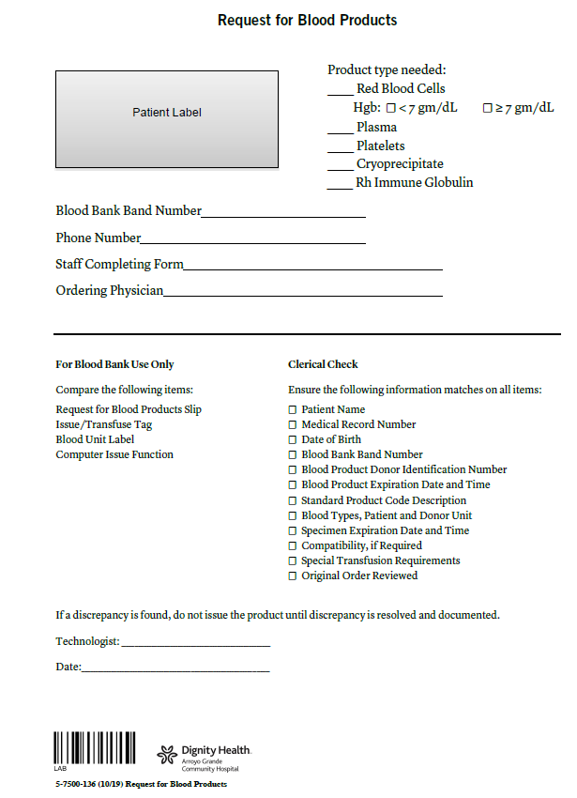

Appendix C: 6-7500-68 FHMC Request for Blood Products form

