Policy and Procedure
Dignity Health Central Coast Service Area

SUBJECT: Manual Gel Indirect Antiglobulin Testing Crossmatch Procedure
Laboratory Policy Number: 7540.BB.CC.146

Central Coast Service Area North:
☒ Santa Maria Campus,  Marian Regional Medical Center | ☒ Arroyo Grande Campus,  Marian Regional Medical Center | ☒ French Hospital Medical Center
Central Coast Service Area South:
☐ St. John’s Pleasant Valley Hospital | ☐ St. John’s Regional Medical Center

Purpose:
This procedure provides instruction for performing pre-transfusion compatibility testing.

Clinical Complexity
High complexity

Clinical Utility:
The Joint Commission Standard QSA 05.09.01 requires compatibility testing that includes an antiglobulin phase for recipients with current or a history of antibodies.

Principle:
The purpose of pre-transfusion testing is to select red blood cell components that when transfused, will have acceptable survival and will not cause clinically significant destruction of the recipient’s own red blood cells. If performed properly, pre-transfusion tests will establish ABO compatibility between the recipient and component and detect most clinically significant unexpected antibodies. Recipients with a history of or current unexpected antibodies must have compatibility testing performed that includes incubation at 37°C and the antihuman globulin test.

Specimen Collection:

Patient Identification and Labeling of Specimens

Proper patient identification is critical to the safe administration of blood products. Refer to the Blood Bank Identification and Collection of Blood Specimen.

Refer to 7540.BB.CC.121 Evaluating Patient Samples and Request Forms for evaluation of acceptability of patient samples and product requisitions.

Preoperative patients and patients undergoing outpatient transfusion must keep their wristband on between the times of specimen collection and the procedure or transfusion.

Sample Type
Sample Type | Container | Minimum Volume | Stability | Max Storage Temp
Whole blood | Pink top EDTA | 1.0 mL | 3 days at 2359 on the 3rd day | 2-8°C

Materials:
Reagents / Media | Supplies / Materials | Equipment
- Ortho MTS Anti-IgG cards  - MTS Diluent 2  - Donor RBC segment  - Isotonic saline | - Test tubes  - Pipette (10 µL, 25 µL, 50 µL)  - Disposable blood bank pipettes | - Ortho MTS incubator  - Ortho MTS centrifuge  - Serofuge  - Agglutination viewer

Maintenance:

Refer to equipment procedures for applicable maintenance schedules and instruction for performance.

Calibration:

Refer to equipment procedures for applicable maintenance schedules and instruction for performance.

Quality Control:

Quality control must be performed each calendar day of reagent use.

Refer to 7540.BB.CC.201 Reagent Quality Control- Daily for performance of daily quality control of reagents.

Procedure:

Refer to 7540.BB.CC.121 Evaluating Patient Samples and Request Forms and confirm the specimen is acceptable for use in compatibility testing.

Review the product requisition for special transfusion requirements, number of units requested, and date needed.

Refer to 7540.BB.CC.104 Evaluating Requests for Special Products – CMV Negative, Irradiated, or HGB S Negative.

If special transfusion requirements are needed and red blood cells are not available in the current inventory, then order the appropriate red blood cells from the donor center.

Verify that the Type and Screen has been completed on the current specimen prior to performing compatibility testing.

The immediate spin crossmatch (XMIS) is automatically reflexed by the laboratory information system (LIS) when a PRBC requisition is ordered. If the patient has a current or history of an antibody(ies) or a special transfusion requirement of Use AHG Crossmatch, then cancel the XMIS and add on a ALT XM (alternative crossmatch) to the Type and Screen specimen.

The indirect antiglobulin (IAT) crossmatch must be performed using the same methodology as the antibody screen test. Refer to 7540.BB.CC.142 Selection of Type of Crossmatch to verify which methodology must be performed.

Review the patient history for ABORh type, blood bank comments, previous and current antibodies and special transfusion requirements. Refer to 7540.BB.CC.103 Checking a Patient History.

If the patient does not have a historical ABORh type on file, then a second ABORh type must be performed on a specimen collected at a different time from the Type and Screen specimen. Refer to 7540.BB.CC.502 PRBC Requisition for resulting and generation of the BB Confirm ABORh Full orderable.

Review the most recent hemoglobin value to determine if a product with a short or long expiration date should be selected.

If the patient has current or a history of clinically significant antibodies, then the red blood cells must be lacking the relevant antigens.

Including, but not limited to: Anti-D, Anti-C, Anti-E, Anti-c, Anti-e, Anti-K, Anti-Fyª, Anti-Fy^{b}, Anti-Jkª, Anti-Jk^{b}, Anti-S, Anti-s. Refer to the AABB Technical Manual for other potentially clinically significant antibodies.

If the corresponding antiserum is unavailable at the facility or sufficient time is unavailable, then order antigen negative red blood cells from the donor center.

If the percentage of blood compatibility is greater than or equal to 30% and sufficient time is available, then screen ABO compatible red blood cells for the relevant antigen. Refer to 7540.BB.CC.119 Antigen Typing and the instructions for use for the corresponding antisera.

Examples: C, E, K, Fyª, S

If the patient has current or a history of clinically insignificant antibodies, then the red blood cells do not need to lack the antigen, but must be compatible at all phases of the IAT crossmatch testing.

Examples: Anti-Leª, Anti-Le^{b}, Anti-M, Anti-N, Anti-P₁, Anti-I, Anti-i

Note: If a patient has a warm reactive autoantibody in the presence of Anti-M, then M negative donor red blood cells are required.

Once the appropriate red blood cells are selected, verify the PRBC Requisition prior to performing compatibility testing. Refer to 7540.BB.CC.502 PRBC Requisition for resulting.

An immediate spin crossmatch is required for detecting ABO incompatibility in addition to the IAT crossmatch used to detect alloantibody incompatibility. Refer to 7540.BB.CC.144 Immediate Spin (IS) Crossmatch.

In Cerner, open the Result Entry application and scan the patient specimen



On the Alt XM procedure line, scan the donor identification number(s) (DIN) in the white box.

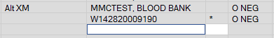

If more than one component is in inventory with the same DIN, then a Select Blood Product window will appear. Scan the standard product code (SPC) for product selection.

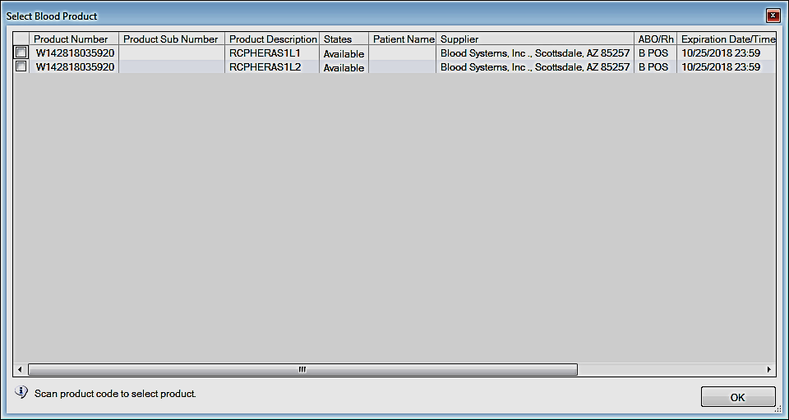

Enter the blood bank ID on the specimen in the BBID field.

Remove one segment from each red blood cell unit and place it in a glass test tube labeled with the DIN.

Dispense at least two drops of donor red blood cells from the segment into the labeled glass test tube.

Wash the donor red blood cells at least once in isotonic saline.

Prepare a 3%-5% and a 0.8% donor red blood cell suspension. Refer to 7540.BB.CC.101 3%-5% Red Cell Suspension Preparation and 7540.BB.CC.100 0.8% Cell Suspension Preparation.

Perform an immediate spin crossmatch using the 3%-5% donor red blood cell suspension and immediately record results. Refer to 7540.BB.CC.144 Immediate Spin Crossmatch.

Dispense 1 mL of MTS Diluent 2 into a glass test tube labeled with the DIN and the concentration (0.8%).

Visually inspect the Ortho MTS Diluent 2 for discoloration, turbidity, and signs of contamination prior to use.

Pipette 10 µL of donor red blood cells into the MTS Diluent 2 and rinse the tip in the diluent.

Visually compare the prepared donor red blood cells to a known 0.8% concentration prior to dispense into an Anti-IgG gel card.

Label the appropriate number of MTS Anti-IgG gel card wells with the patient identification including at a minimum:

Patient name

Accession number

CLS initials

Date

Last four digits of DIN

Note: A LIS accession label may be used.

Visually inspect the MTS Anti-IgG gel card for a clear liquid layer on top of the opaque gel and for signs of drying, discoloration, bubbles, crystals, and opened or damaged seals.

Remove the appropriate number of foil seals,

Foil should be removed within one hour prior to testing.

Dispense 50 µL of the 0.8% donor red blood cells in the appropriately labeled gel well ensuring not to touch the gel card.

Dispense 25 µL of the patient’s plasma into the corresponding wells ensuring not to touch the gel card.

Incubate the MTS Anti-IgG gel cards at 37 ± 2°C for 15 minutes. Incubation time can be extended up until 40 minutes.

Centrifuge the MTS Anti-IgG gel cards in the Ortho centrifuge for 10 minutes.

Ensure the centrifuge RPM’s are greater than 800 prior to walking away.

Remove the MTS Anti-IgG gel cards from the centrifuge and macroscopically read the front and back of each microtube and record the reactions in the Gel field in the LIS. Refer to 7540.BB.CC.106 Reading and Grading Gel Card Reactions for interpretation.

Verify the results and respond to the Crossmatch Product window.

Attach the crossmatch tag to the corresponding donor red blood cell.

Interpretation of Results and reporting:

Resulting options:

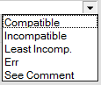

Compatible: No hemolysis or agglutination in the immediate spin or gel phases and is acceptable for transfusion.

When a patient has a clinically significant antibody, all donor red blood cells must be negative for the antigen and no agglutination or hemolysis may be present.

Incompatible: Hemolysis or agglutination in the immediate spin or gel phases and is unacceptable for transfusion unless approval is obtained by the laboratory medical director or on call pathologist. Approval must be documented prior to release of the blood product.

Least Incompatible: If a patient has a positive direct antiglobulin test (DAT), then the crossmatch is interpreted as least incompatible. False negative results may occur in the IAT crossmatch if the patient has a positive DAT.

Least Incompatible transfusions must be approved by the laboratory medical director or on call pathologist. Approval must be documented prior to release of the blood product.

To result a Least Incompatible interpretation the IS or Gel field must include a reaction. If the observed reaction is negative for both phases, then enter (w+) in the Gel field and enter a result comment including the observed reactions.

The following exception window will populate:

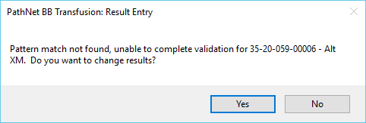

Select the No button and select Yes to Override with the appropriate reason.

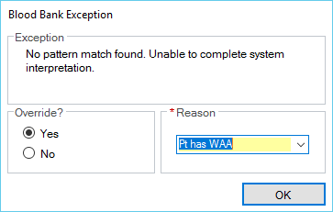

Notify the ordering provider that least incompatible blood products are available.

Err and See Comment should only be used when performing result corrections.

Limitations of Procedure:

Hemolyzed specimens should not be used. However, if there is no alternative due to an emergency situation or a patient that is currently experiencing hemolytic anemia, then run a control in parallel with the IAT gel crossmatch.

Label two MTS Anti-IgG gel card wells. One for the patient plasma and one for a negative donor control.

In the patient plasma well pipette 75 µL of patient plasma.

In the negative donor control well pipette 50 µL of the 0.8% donor red blood cells and 25 µL of MTS Diluent 2.

Compare the color of the patient plasma well with the color of the MTS Anti-IgG gel crossmatch well to determine if there has been an increase in visual hemolysis.

Compare the red blood cell button of the negative donor control well with the size of the cell button in the MTS Anti-IgG gel crossmatch well to determine if donor red blood cells have been lysed.

Enter a blood bank result comment indicating the degree of hemolysis in the specimen and if additional hemolysis was noted using the patient plasma and donor red blood cell controls.

A negative antibody screen does not guarantee that the recipient’s plasma does not have a clinically significant antibody. A negative antibody screen implies that clinically significant antibodies are not detectable with the reagents and methodologies used. A compatible IAT crossmatch does not guarantee expected donor red cell survival.

If an IAT crossmatch unexpectedly results in a positive reaction, then refer to Appendix 17-3 Causes of Positive Pre-transfusion Test Results in the AABB Technical Manual.

If a recipient has an antibody to a clinically significant antibody and antisera is unavailable at the donor center, then the IAT crossmatch must be used to determine compatibility. Approval must be obtained from the laboratory medical director or pathologist and approval must be documented.

Definitions:

Immediate Spin (IS) Crossmatch: Serological method used to determine ABO incompatibility between donor red cells and recipient plasma.

Indirect Antiglobulin Test (IAT) Crossmatch: Procedure that uses the indirect antiglobulin test (IAT), which includes incubation at 37°C and the addition of antihuman globulin to determine the compatibility between donor red cells and recipient plasma. The IAT methodology is utilized when the recipient has been previously or is currently immunized.

Clinically significant red cell antibodies: antibodies frequently associated with hemolytic disease of the fetus and newborn, hemolytic transfusion reactions, or a decreased survival of transfused red cells.
Examples: Anti-D, Anti-C, Anti-E, Anti-c, Anti-e, Anti-K, Anti-Fyª, Anti-Fy^{b}, Anti-Jkª, Anti-Jk^{b}, Anti-S, Anti-s

Clinically insignificant red cell antibodies: antibodies not frequently associated with hemolytic disease of the fetus and newborn, hemolytic transfusion reactions, or a decreased survival of transfused red cells.
Examples: Anti-Leª, Anti-Le^{b}, Anti-M, Anti-N, Anti-P₁, Anti-I, Anti-i

References:

Fung, M.K. (Current Edition). Technical Manual. Bethesda, MD: AABB.

Standards for Blood Banks and Transfusion Services (Current Edition). Bethesda, MD: AABB.

Micro Typing Systems, Inc. (Current Revision). Anti-Human Globulin Anti-IgG (Rabbit) MTS Anti-IgG Card [Manufacturer’s Insert.] Pompano Beach, FL.

Micro Typing Systems, Inc. (Current Revision) Red Blood Cell Diluent MTS Diluent 2. [Manufacturer’s Insert.] Pompano Beach, FL.

Related Documents:

Blood Bank Identification and Collection of Blood Specimen

7540.BB.CC.121 Evaluating Patient Samples and Request Forms

7540.BB.CC.104 Evaluating Requests for Special Products – CMV Negative, Irradiated, or HGB S Negative

7540.BB.CC.142 Selection of Type of Crossmatch

7540.BB.CC.201 Reagent Quality Control- Daily

7540.BB.CC.103 Checking a Patient History

7540.BB.CC.119 Antigen Typing

7540.BB.CC.502 PRBC Requisition

7540.BB.CC.144 Immediate Spin (IS) Crossmatch

7540.BB.CC.101 3%-5% Red Cell Suspension Preparation

7540.BB.CC.100 0.8% Cell Suspension Preparation

7540.BB.CC.106 Reading and Grading Gel Card Reactions

