Dignity Health  
Central Coast Service Area Procedure

|  |  |  |
| --- | --- | --- |
| **Central Coast Service Area North:** | | |
| Santa Maria Campus,  Marian Regional Medical Center | Arroyo Grande Campus,  Marian Regional Medical Center | French Hospital Medical Center |
| **Central Coast Service Area South:** | | |
| St. John’s Pleasant Valley Hospital | St. John’s Regional Medical Center |  |

**SUBJECT**: TEG® 6s Hemostasis System for PlateletMapping ADP & AA   
 **Lab Policy Number: 7500.CG.35c**

# Purpose:

The TEG® 6s Analyzer and the PlateletMapping Cartridge are used to test platelet function. The system records the kinetic changes in a sample of heparinized whole blood as the sample clots. This assay assesses Maximum Aplitude (MA) or clot strength and the reduction in MA due to genetics, antiplatelet therapy, or surgical procedures, and reports it as percentage aggregation or inhibition.

# CLIA Complexity:

Moderate

# Clinical Utility:

The TEG® 6s System is indicated for use with adult patients to assess hemostatic properties specifically platelet function. Hemostasis evaluation using TEG® 6s is commonly used to evaluate hemorrhage or thrombosis conditions in cardiovascular surgery and cardiology procedures.

# Principle:

The Plateletmapping assay consists of ADP and AA platelet agonists together with ActivatorF which measures platelet function using a heparinized blood sample. Thrombin is inhibited by heparin so platelet activation can be measured. Thrombin also converts fibrinogen into fibrin for clot formation, and converts Factor XIII to Factor XIIIa for fibrin cross linking. ActivatorF is used to replace thrombin so that MAActF (Maximum Amplitude, a measure of clot strength) and additional clot strength due to ADP (MAADP) and AA (MAAA) platelet receptor activation can be measured. The HKH reagent (Kaolin and Heparinase) generates test data for the uninhibited MA (MAK). Results from these four reagents are used to calculate the parameters; platelet % Inhibition and % Aggregation for AA and ADP.

# CAlibration

The Teg® 6s does not require routine calibration

# Materials: N/A

|  |  |  |
| --- | --- | --- |
| **Reagents / Media**  Normal and Abnormal Donor blood | **Supplies / Materials**  PlateletMapping ADP & AA cartridges (red box) stored 2-8ºC | **Equipment**  TEG® 6S  Transfer pipettes |

# QUALITY CONROL

## Normal and abnormal donor control checks performed for each new shipment of PlateletMapping cartridges or every 30 days.

### Establish a known normal quality control using blood drawn from a healthy adult (not taking any medication known to affect platelet function and must have previous PlateletMapping values within the established normal range).

#### Run normal quality control the same as a patient sample. Follow steps A-J under IX.

### Establish a known abnormal quality control using blood drawn from an adult with platelet dysfunction (i.e. due to antiplatelet therapy). The abnormal donor must have previous PlateletMapping values within the established abnormal range

#### Run abnormal quality control the same as a patient sample. Follow steps A-J under IX.

### Compare normal and abnormal QC results to established normal reference ranges. Abnormal QC sample results should fall outside and normal QC sample results should fall within the established reference ranges.

##### **PlateletMapping Assay Reference Ranges.**

|  |  |  |  |
| --- | --- | --- | --- |
| ASSAY | MA (mm) | % Inhibition | % Aggregation |
| HKH | 53-68 |  |  |
| ActF | 2-19 |  |  |
| ADP | 45-69 | 0-17 | 83-100 |
| AA | 51-71 | 0-11 | 89-100 |

# Specimen Collection and preparation

## Use a 3.2% sodium citrate vacutainer as a discard tube, followed by two non-gel heparin Vacutainer tubes (> 14.5IU but < 20IU heparin/mL)

## After collection, gently invert tubes 5 times to mix. Do not send samples using Pneumatic Tube system.

## Sample tubes should be used after 30 minute room temperature incubation and within 2 hours of draw.

## **NOTE:** Never check for clots using wooden sticks. Always check for clots visually.

# TEST procedure

## Remove one cartridge per specimen from the refrigerator.

## Tear open the pouch and remove the cartridge. Cartridges must be used within 2 hours after exposure to room temperature.

## From the *Home screen* on the TEG analyzer, touch **new test**

## Select patient ID and enter accession number then select **next**

## Follow prompt on screen by inserting the cartridge into the slot with barcode on left side.

## After the cartridge pretest has completed and the assay is confirmed, touch **next** (or **stop** if incorrect assay is selected)

## On the *Test Information screen*, enter information for the test (optional) and select **next**

## Using a pipette, load blood into the cartridge sample port, filling up to or above the line indicated on the cartridge.

## Select **next** and the results will be displayed as they become available.

## *Remove cartridge* will be displayed when testing is completed. Remove and dispose of the used cartridge.

# INTERPRETATION OF RESULTS

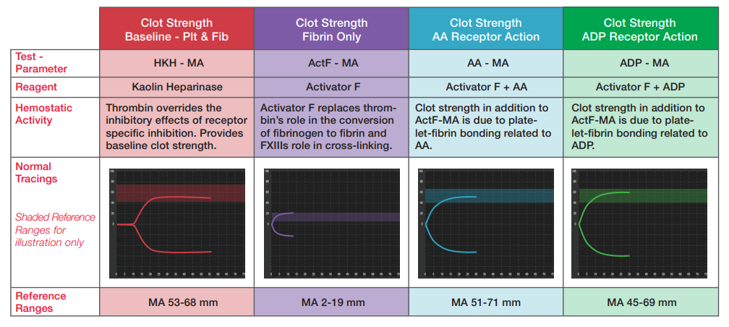

### The plateletMapping assay determines the MA and the reduction in MA due to genetics, surgery, and/or antiplatelet therapy.

### Platelet receptor function is assessed relative to the baseline clot strengther (HKH-MA) and Fibrin only (ActF-MA) clot strength.

### Inhibition is automatically calculated by comparing AA-MA and ADP-MA with that of the baseline platelet and fibrin contribution.

# ReSULTS

## No manual calculations are necessary; results are displayed on the TEG 6s analyzer.

### HKH-MA test result is measured and displayed at the conclusion of the test

### ActF-MA test result is measured and displayed at the conclusion of the test.

### ADP-MA test result is measured and displayed at the conclusion of the test.

### AA-MA test result is measured and displayed at the conclusion of the test.

### % Inhibition for AA and ADP are calculated by the analyzer using Equations based on MA results of the individual assays. Results for both AA and ADP %Inhibition are displayed on analyzer screen at the conclusion of the test.

### INVALID results must be repeated.

## Print the results.

# Reporting results

## In MANUAL MODE of ACCESSION RESULT ENTRY, scan the patient barcode or manually enter the accession number. Enter results.

## Review results and select **Perform**. If necessary, add a Result Comment or Result Note to document collection or processing problems and/or communications with nurses or physicians. Re-enter accession number and select **VERIFY** when compete.

## Record QC results on log.

# Limitations of procedure

## See package insert for list of interfering factors for each assay.

## TEG® 6s analyzer results should be interpreted within the clinical context of the patient’s case. If the results are inconsistent with the patient’s condition, samples should be repeated or additional information should be used.

# References

Mahla E., Suarez T., Bliden K., Rehak E., etal. Patelet Function Measurement-Based Strategy to Reduce Bleeding and Waiting Time in Clopidogrel-Treated Patients Undergoing Coronary Artery Bypass Graft Surgery: The Timing Based on Platelet Function Strategy to Reduce Clopidogrel-Associated Bleeding Related to CABG (TARGET-CABG) Study. Circ Cardiovasc Interv 2012: 5:261-269

TEG® 6s Package Insert. 2019.