Procedure   
Dignity Health Central Coast Service Area

**SUBJECT**: Trinity Biotech G-6-PDH Assay

**ORIGIN**: Hematology

**NUMBER**: 7500.H.53

|  |  |  |
| --- | --- | --- |
| **Applies to:** | | |
| Santa Maria Campus,  Marian Regional Medical Center | Arroyo Grande Campus,  Marian Regional Medical Center | French Hospital Medical Center |
| St. John’s Pleasant Valley Hospital | St. John’s Regional Medical Center | |

# Principle:

To semi-quantitatively determine G-6-PDH deficiency in red blood cells of patients using Trinity Biotech’s modified Beutler fluorescence method. Glucose-6-phosphate is incubated with nicotinamide adenine dinucleotide phosphate (NADP) and then introduced to a blood sample. If the G-6-PDH enzyme is present, the mixture will produce 6-phosphogluconate and NADPH, which is fluorescent under long-wave ultraviolet light. Normal blood samples produce strong fluorescence while deficient samples produce weak or no fluorescence.

G-6-PDH deficiency in red blood cells has been demonstrated to be the basis for certain drug-induced hemolytic anemias. Patients that develop this deficiency are often clinically normal until exposed to one of several oxidant drugs such as anti-malarial drugs, sulfa drugs, ascorbic acid and others.

# Specimen Collection:

|  |  |  |  |  |
| --- | --- | --- | --- | --- |
| Sample Type | Container | Minimum Volume | Storage Temperature | Stability |
| Whole blood | EDTA  Heparin  ACD 9 | 4 mL | Refrigerated  Do not freeze | 1 week |

# Materials:

|  |  |  |
| --- | --- | --- |
| **Reagents / Media**   * TRIZMA Buffer Solution (Trinity Biotech reagent kit) * G-6-PDH Substrate (Trinity Biotech reagent kit) | **Supplies / Materials**   * Filter paper | **Equipment**   * 10 µL pipette * 200 µL pipette * Timer * Long-wave ultraviolet light (320-420 nm) |

# Quality Control:

Samples with normal G-6-PDH, intermediate G-6-PDH and G-6-PDH deficiency should be included with each run to ensure reliable test performance.

## Preparation of Control:

### Add 500 µl dI water to each vial of G-6-PDH control. Allow to stand 5 minutes and then swirl gently. Swirl intermittently until dissolution is complete.

## Preparation of Reagent:

### Add 2.0 ml of TRIZMA Buffer Solution to G-6-PDH Substrate vial. Allow to stand for 1-2 minutes and then mix by inversion.

## Storage and Stability:

### Store unopened control vials in the refrigerator (2-8ºC). Vial labels bear expiration date. After reconstitution, G-6-PDH Control solution is stable for 1 week refrigerated (2-8ºC) or 2 weeks frozen (-20ºC) with a maximum of three freeze-thaw cycles. G-6-PDH control solution should be discarded if turbidity develops.

### Store G-6-PDH Substrate refrigerated (2-8ºC). Reagent label bears expiration date. Store the TRIZMA Buffer Solution at room temperature or refrigerated. Discard if turbidity develops. G-6-PDH Substrate Solution is stable for at least 2 weeks stored frozen, 1 week store refrigerated (2-8ºC), or up to 4 hours at room temperature (18-26ºC).

NOTE: If a dried spot of G-6-PDH Substrate solution exhibits fluorescence when viewed under long-wave ultraviolet light or blood-reagent spots prepared from normal specimens yield dull fluorescence, the reagent may have deteriorated and should be discarded.

# Procedure:

## Into tubes labeled for each control and patient sample, add 200 µl of G-6-PDH Substrate solution.

## Add 10 µl of reconstituted control and mixed patient sample into its respectively labeled tube, immediately mix by swirling, and then promptly transfer a drop of mixture to labeled filter paper. Identify spot of filter paper as “Zero-Time” with each control/patient name.

NOTE: spot sizes should be approximately ½ inch in diameter.

## Place each tube in 37ºC heater block and start timer for 5 minutes.

## Transfer an additional drop of each control and patient tubes to filter paper 5 minutes after “Zero-Time” applications. Label spots with appropriate times and allow all to dry for 15-20 minutes.

## Visually inspect dried spots under long-wave ultraviolet light.

## Record the fluorescent intensity (absent, weak, moderate or strong) of each sample at 0, 5 and 10 minutes.

## NOTES:

### Because of the rapid speed of reaction, “Zero-Time” spots may exhibit traces of fluorescence.

### Fluorescent spots are stable for up to two weeks stored in a plastic bag with desiccant in the refrigerator at 2-8ºC.

# Interpretation of Results:

The test is designed to distinguish normal and intermediate from grossly deficient samples by visually comparing the amount of fluorescence in the 5 minute spots of the sample with that of a normal sample.

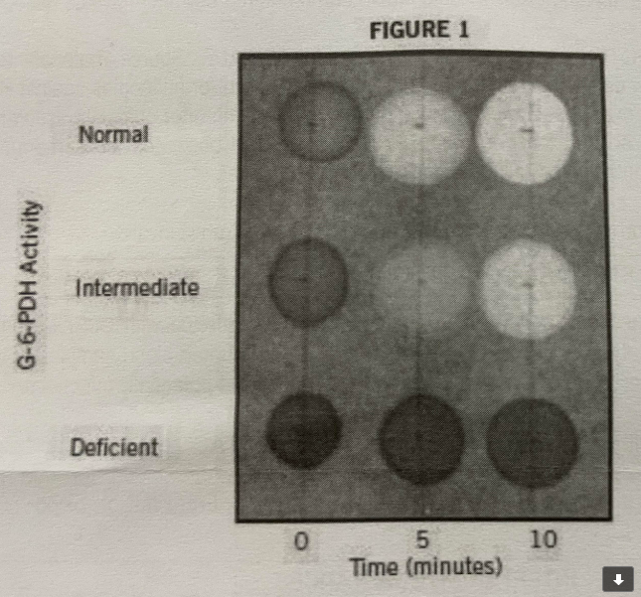

## Normal samples demonstrate moderate to strong fluorescence after 5 minutes and strong fluorescence after 10 minutes.

## Intermediate samples demonstrate weak fluorescence after 5 minutes and moderate fluorescent after 10 minutes.

## Grossly deficient samples will reveal very faint or no fluorescence even after 10 minutes.

# Reporting results

## In MANUAL MODE of ACCESSION RESULT ENTRY, scan the patient barcode or manually enter the accession number. Enter results (Normal, Intermediate, or Deficient) and Kit Lot Number and Expiration.

## Review results and select Perform. If necessary, add a Result Comment or Result Note to document collection or processing problems and/or communications with nurses or physicians. Re-enter accession number and select VERIFY when compete.

## Record the fluorescent intensity (absent, weak, moderate or strong) of each control and patient sample at 0, 5 and 10 minutes on Log.

# Limitation of Procedure:

The test is designed to distinguish normal and intermediate from grossly deficient samples and should not be used to assess the degree of deficiency. It is recommended that samples which have been determined as deficient or intermediate by this procedure be assayed by a quantitative G-6-PDH technique.

# References:

## Trinity Biotech package insert, procedure No. 203, rev. 5/08.