Procedure
Dignity Health Central Coast Service Area

SUBJECT: USE OF CLINITEK ADVANTUS® URINE CHEMISTRY ANALYZER
ORIGIN: Urninalysis
NUMBER: 7500.U.10

Applies to:
☒ Santa Maria Campus,  Marian Regional Medical Center | ☐ Arroyo Grande Campus,  Marian Regional Medical Center | ☐ French Hospital Medical Center
☐ St. John’s Pleasant Valley Hospital | ☐ St. John’s Regional Medical Center

PURPOSE:
Provide guidelines for operating the Clinitek Advantus® analyzer. Urinalysis is commonly used to diagnose a urinary tract or kidney infection, to evaluate causes of kidney failure, to screen for progression of some chronic conditions such as diabetes mellitus and high blood pressure (hypertension). It also may be used in combination with other tests to diagnose some diseases.

Clinical complexity:
Waived

Principle:
The analyzer is a semi-automated reflectance spectrophotometer capable of detection of glucose, bilirubin, ketone, specific gravity, occult blood, pH, protein, urobilinogen, nitrite, and leukocytes in urine samples.

Calibration:
Calibration is performed automatically each time a reagent strip is analyzed.

Specimen Collection:
Sample Type | Container | Minimum Volume | Storage Temperature | Stability
Urine | Sterile Container | 4 mL | Refrigerated  Room Temp | 24 hours  2 hours
Urine | Preservative Tube | 7 mL | 2-25°C | 72 hours

Specimens must be at room temperature and transferred to a properly labeled 13 x100 mL test tube prior to testing.

Materials:
Reagents / Media  - Siements Multistix 10 SG  - Alta Diagnostics, Inc. Positive and Negative Controls | Supplies / Materials  - 16x100mm polystyrene tubes  - BD Urine Preservative Tubes  - Printer tape paper | Equipment  - Clinitek Advantus®

Maintenance

Daily

Turn the analyzer power off

Remove and clean the Push Bar with water and mild detergent

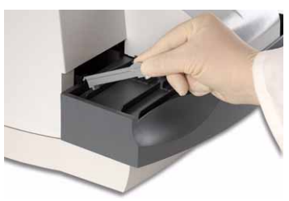

Remove the waste bin liner and discard the used reagent strips. Replace with a new waste bin liner.

Remove and clean the fixed platform with water and mild detergent.

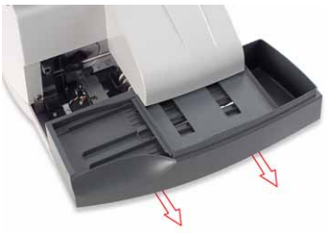

NOTE: When cleaning the platform, avoid wiping the 2 white calibration bars.

Remove and clean the moving table with water and mild detergent.

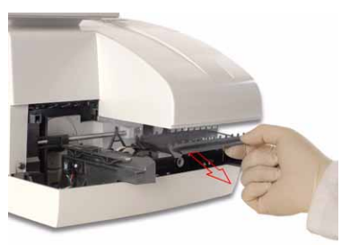

Remove and clean the holddown plate with water and mild detergent.

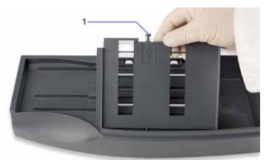

Carefully dry each piece with a paper towel.

Reinstall the moving table, holddown plate, fixed platform, and push bar.

Clean the display screen, with a nonabrasive Kim wipe.

Turn the analyzer power on

As Needed

Refer to Clinitek Advantus Operator’s Guide

Quality control:

Negative and Positive quality controls must be performed once per day of patient testing, when using a new bottle of reagent strips, whenever test results are in doubt and/or to train new operators.

Quality Control procedure:

Bring controls to room temperature

At the Ready/Run screen, select Menu selectQC

Enter the Lot Identification of the controls.

To start test select Enter

Immerse all of the reagent pads on the reagent strip with control material.

Place the reagent strip onto the supports of the strip loading station, with reagent pads facing up. The strip should be placed to the right of and parallel to the push bar.

Repeat steps 2-6 for the next level of control.

Review control results to confirm within range and affix to patient/qc log. If control results fall outside of range refer to Operator’s Guide for possible corrective action.

After controls are run, select Return to Ready/Run

Procedure
- At the Ready/Run screen, select ID
- Enter or barcode the Accession number for the sample to be tested
- Enter or scan the color and clarity
- SelectEnter or scan the Enter code
- Completely immerse all of the reagent pads on a reagent strip in urine sample
- Immediately remove the reagent strip
- While removing the strip, run the edge against the side of the container to remove excess liquid. Do not blot the edge of the strip.

- Place the reagent strip onto the supports of the strip loading station, with reagent pads facing up.

- Repeat steps 1-8 for each specimen
NOTE: When the push bar is the far left of the platform, a new strip can be placed on the loading station.

- SelectPRINT to print a report
- Attach printout to Patient/QC Log

Result Reporting:

The following bolded analytes require a result entry.
Analyte | Reference Range | Reportable Range
Glucose | Negative | Negative  Trace  1+ | 2+  3+
Bilirubin | Negative | Negative  1+ | 2+  3+
Ketone | Negative | Negative  Trace  1+ | 2+  3+
Specific Gravity | 1.001-1.030 | <=1.005  1.010  1.015 | 1.020  1.025  >=1.030
Occult Blood | Negative | Negative  Trace-Lysed  Trace-Intact | 1+  2+  3+
pH |  | 5.0  5.5  6.0  6.5  7.0 | 7.5  8.0  8.5  >=9.0
Urobilinogen | 0.2 EU/dL | 0.2  1.0  2.0 | 4.0  >=8.0
Nitrite | Negative | Negative | Positive
Leukocytes | Negative | Negative  Trace  1+ | 2+  3+
Protein | Negative | Negative  Trace  1+ | 2+  3+
Color |  | Straw  Yellow  Orange  Pink | Red  Green  Blue  Brown
Clarity | Clear | Clear  SL Cloudy  Cloudy | Turbid  Other

A reflex to micorscopic will be triggered based on the following

Protein ≥ 1+

Leukocyte Esterase ≥ Trace

Nitrite positive

RBC ≥ Trace

Limitation of Procedure:

Refer to Multistix 10 SG reagent strip package insert.

Urine should be tested within 2 hours after collection unless in preservative tube. Prolonged testing delay may result in deterioration of some chemical and microscopic components.

Grossly bloody samples should be spun and testing performed on supernatant to control for color interference.

References:

Commission on Laboratory Accreditation, Laboratory Accreditation Program. Urinalysis Checklist for Hematology. College of American Pathologists, Northfield, IL, Edition 2017.

Clinitek AdvantusTM Operator’s Guide

Stransinger, Susan K., Urinalysis and Body Fluids, Sixth Edition, F.A. Davis Publisher, 2014, pages 100-146.

