# Rady Children’s Hospital Laboratory

# Regulated Medical, Universal, and Hazardous Waste Training

# Definitions

# Sharps are devices with sharp points or edges that can puncture or cut skin.

# 

# Needles, lancets, syringes with or without needles

# Glass items – broken or have potential to break – slides, pipettes

# Pipette tips, Blades, razors, scalpels

# Biohazard “Red Bag” Waste (Regulated Medical Waste) is any material

# that may be contaminated with blood, body fluids or other potentially infectious materials, thus posing a significant risk of transmitting infection.

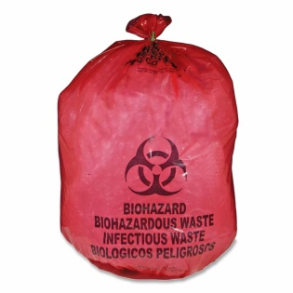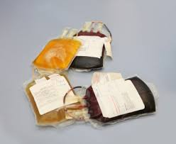 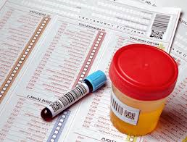

# Items saturated with blood and body fluids

# Blood product bags

# IV tubing containing blood

# Used culture plates

# Specimens for microbiologic culture

# Specimen Containers of blood and body fluids

# Tissues, Fixed and Fresh – Pathology Waste

# Universal Waste is any consumer product containing mercury, lead, cadmium and other substances that are hazardous to human health and the environment. These items cannot be discarded in household trash nor disposed of in landfills.

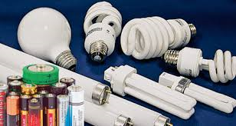 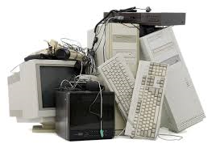

# Batteries

# Florescent lamps

# Mercury thermometers

# Electronics – anything with a cord or battery operated

# Computers, monitors, printers, peripherals

# Hazardous Waste is any material that poses substantial or potential threats to public health or the environment (toxic, reactive, flammable or corrosive).

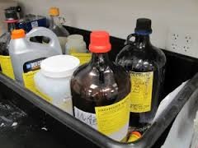 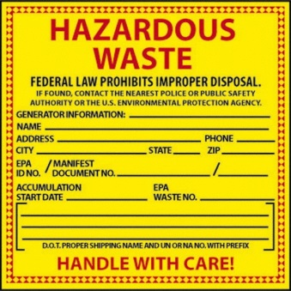

# Gram stain waste

# Xylene waste

# Formalin

# All Other Toxic, Reactive, Flammable, or Corrosive Chemicals

**Policies – Handling, Storage, and Training**

# Sharps Containers

# PPE Must be worn when handling Sharps Containers

# Must be attached to the wall, countertop, or in a floor trolley

# Container is considered full when at ¾ to top. Call EVS when full.

# Lid must be closed when not in use

# Must be labeled with Hospital Name, address and phone number

# Biohazard “Red Bag” Containers

# PPE Must be worn when handling Biohazard containers

# Must be lined with a red hospital-approved plastic liner prior to use

# The Liner must have hospital name, address and phone number

# Must be kept closed when not in use

# When full, call EVS. Liners must be tied or taped closed prior to pick up.

# Container is considered full when at ¾ to top

# Tissues - Fixed and Fresh (Pathology Waste)

# Decant formalin prior to placing tissue in waste container

# Use Double red bags inside Grey container

# Hazardous Waste Containers

# PPE Must be worn when handling Hazardous Waste Containers

# Waste containers must have a yellow Hazardous Waste Label attached

# Information on the Hazardous Waste label must include:

# Hospital name, address and phone number

# Main hazardous contents of the waste

# Start date – date first used – if picked up weekly state “weekly”

# waste collection start date must be less than 180 days

# Characteristics/Hazardous Properties of the waste

# Physical state – liquid, solid, etc.

# Must be kept closed at all times

# Label must be legible at all times – no smears on label

# Waste Containers must be inspected at least weekly for leakage

# New waste must be profiled by a consultant prior to wasting

# Gram Stain Waste Collection Area

# PPE must be worn in the Gram Stain waste collection area

# face shields must be used when wasting into the sink

# Area must be kept clean

# A secondary container must be used under the primary waste container

# Precautions must be taken to prevent gram stain spillage onto the floor

# Collection containers must have a legible yellow hazardous label attached at all times – see requirements for Hazardous Waste label

# Formalin Waste

# Storage and labeling requirements are listed under Hazardous Waste Containers

# Wasted formalin must be recorded and records must be kept for 3 years

# Hazardous Waste Cage Area

# Use funnel and goggles when pouring waste into barrels

# Gram stain is considered contaminated and must be poured into a separately marked barrel in the waste yard

# Barrels in waste cage must be kept closed and sealed at all times

# Never mix incompatible chemical waste

# Waste cage in waste yard must be kept locked when not in use

**Universal Waste – Batteries, Light bulbs, Electronic Items**

* **Must not be placed in regular waste containers. Call EVS for pickup.**
* **EVS collects Universal Waste in the Waste Cage Area**

# Training

# Required for all staff who handle regulated medical, hazardous, and Universal waste

# Required annually

# Must be recorded and signed

# Records must be kept for 3 years