Step | Description: | Key Point / Image / Reason
Note: Team Members will receive emails which can be used to open PolicyTech and go to the Acknowledgement of an updated, revised or to review an AHC Policy, Process of Procedure
1 | Team members will receive an email concerning an update for review in PolicyTech.  The email will be received from donotreply@navexglobal.com | 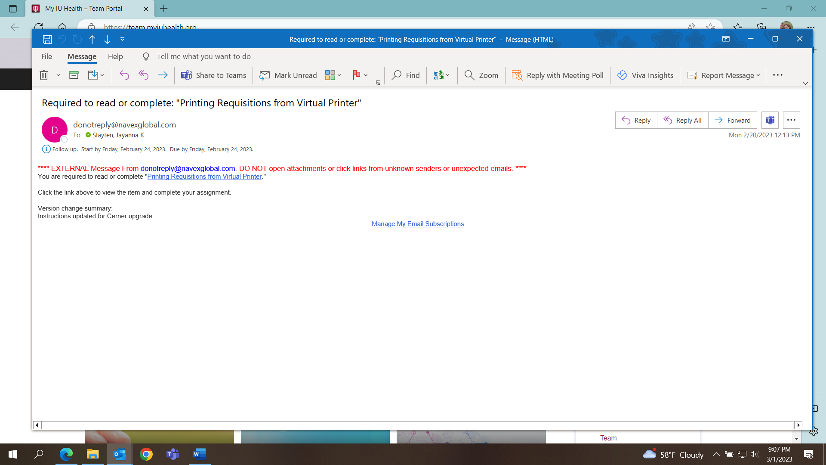
2 | Click on the name of the procedure to link to the policy/procedure/form or job aid | 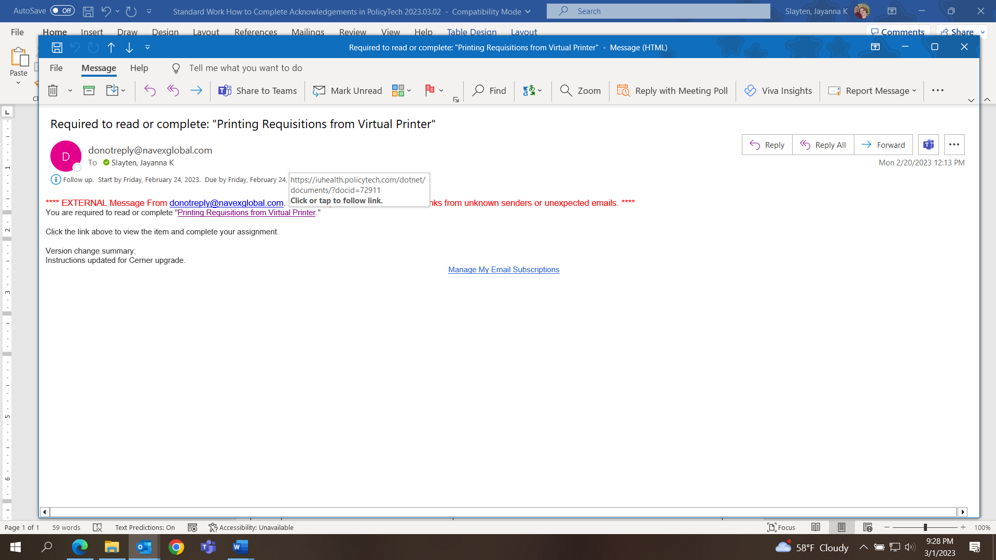
3 | The link will take you to PolicyTech.  Review the Policy/Procedure/Form or Job Aid.  At the top of the page, click on “Mark as Read.” | 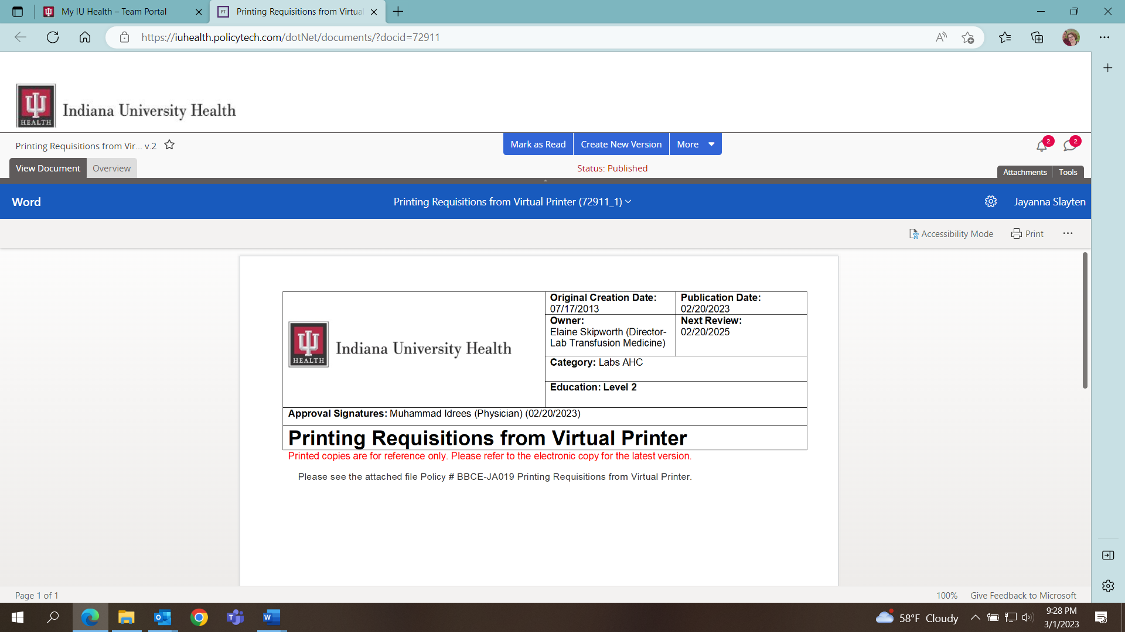
4 | A second box will open.  To complete the acknowledgment in PolicyTech, click on the bloc “Mark as Read.” | 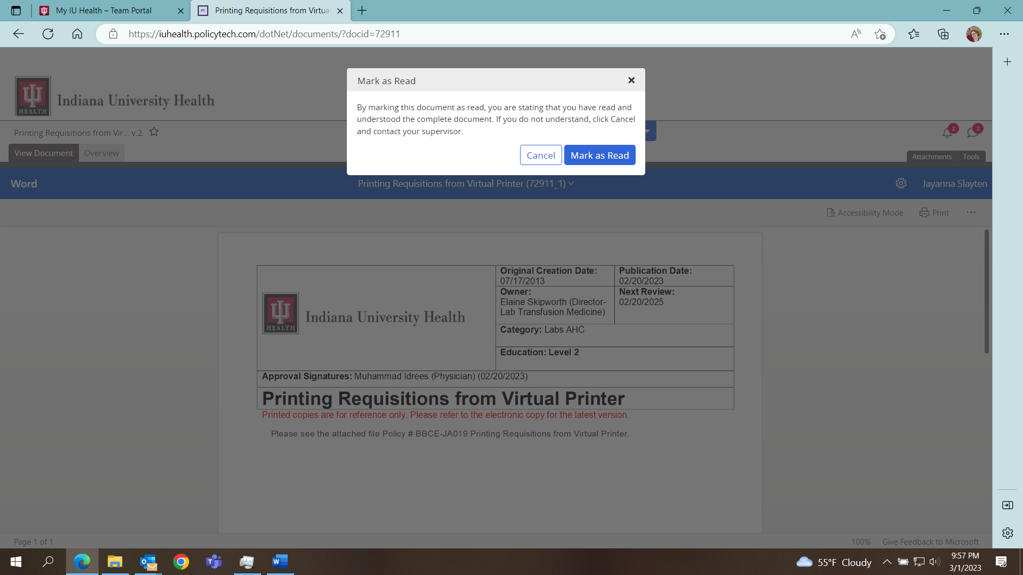
5 | A final box will open, which confirms the acknowledgement is complete.  You may choose to Go To My Tasks for additional actions in PolicyTech, or close. | 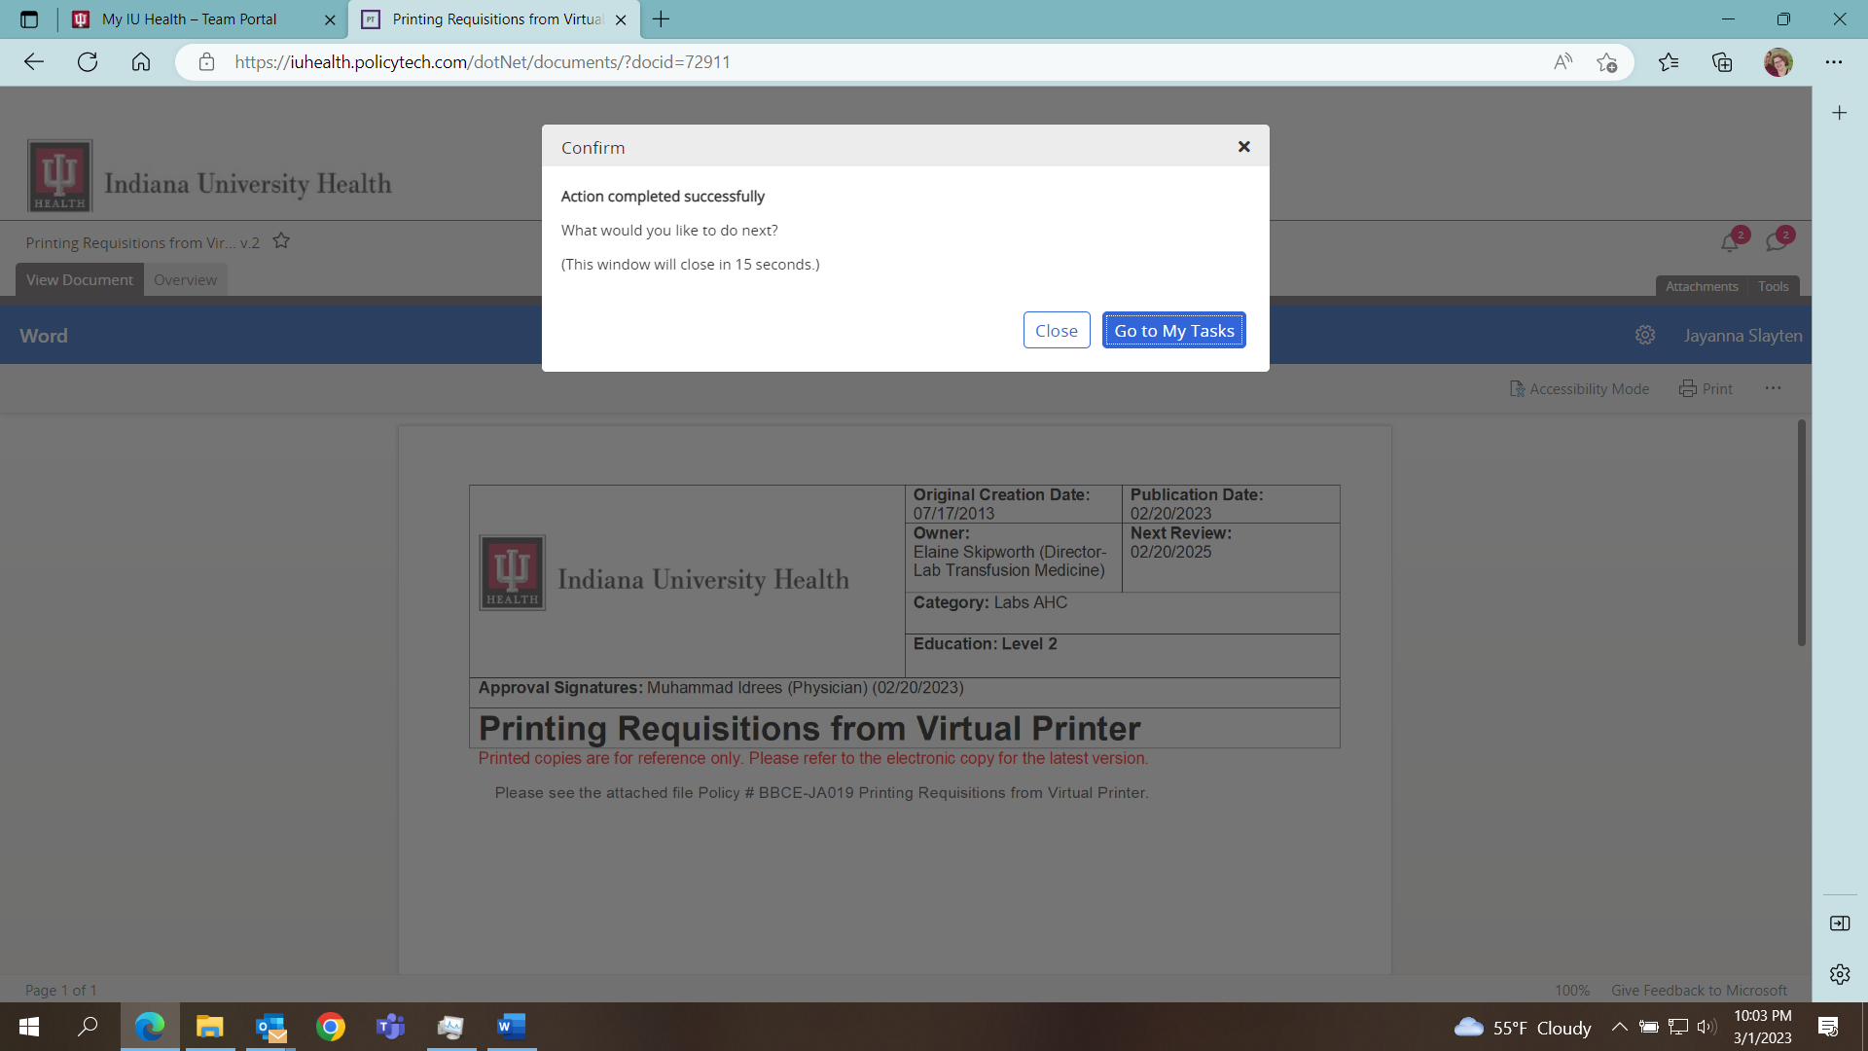
6 | If you don’t go to My Tasks or close, then the screen will timeout. | 