Step | Description: | Key Details
1 | Log into medialab.com  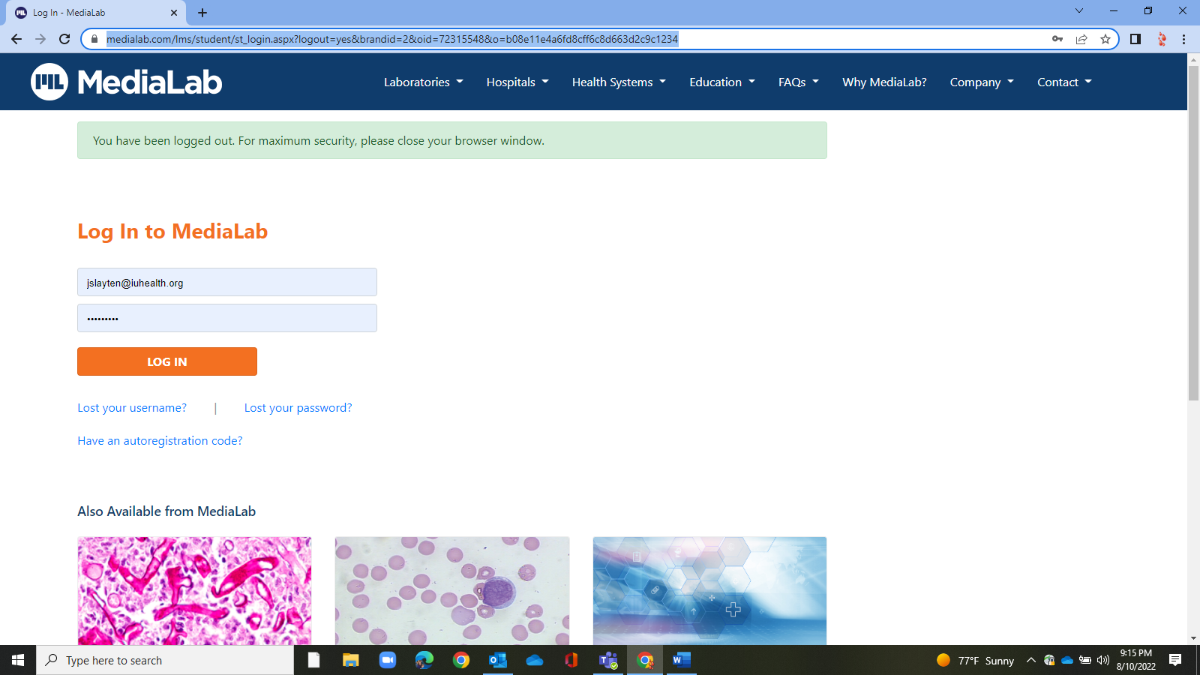 | Log in is set up ahead of time for each BB Team Member.  Log in with your  User name: IUH Email  Password = Set up individually  If you forget your password, then go through the reset feature on this page.
2 | As an observer, you have access to all blood bank competencies for all BB lab professionals. This includes six-month, 12-month and annual.  - This page indicates the competencies which are assigned to each person.  - The “My to Do List and Notifications” at the bottom of the screen will indicate: your assessments due and those assigned to you as an Observer.  Observers have access to  - Assignments Due for Your Users  - Assignments with Competencies that Need Grading  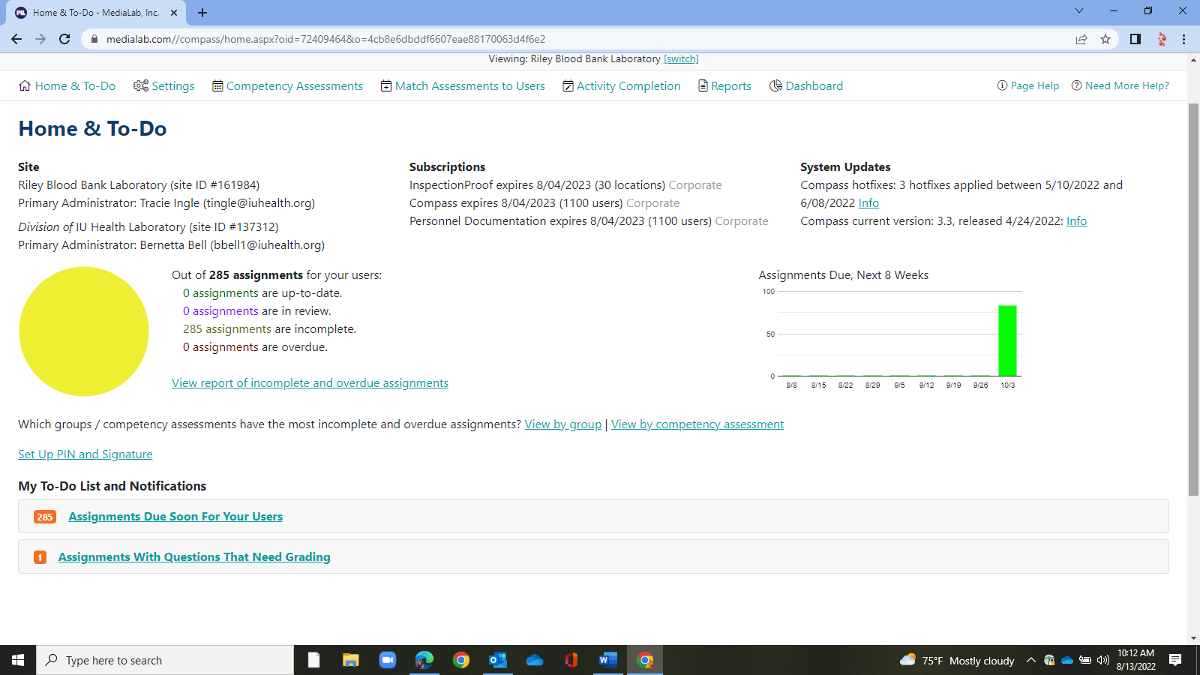 | As an observer, you will receive emails whenever new competencies are assigned or if competencies need graded.  Any of the observers may complete the grading of assignments or the completion of the competencies in MediaLab.
3 | To complete - Assignments with Competencies that Need Grading  This is where we grade a quiz.  If an assignment needs grading it will show below:,  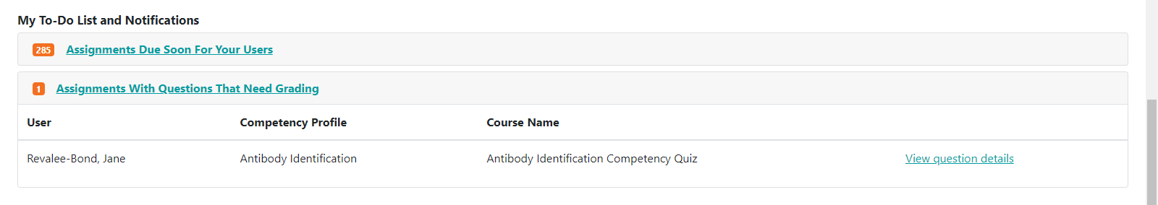  Open the assignment and grade by clicking on View Question Details.  Grade by toggling as Correct or Not Correct on left side of screen.  When all are marked, there is not a “save button, “ but just exit the screen.  As long as all the questions are graded then it will complete the assignment for the lab professional.  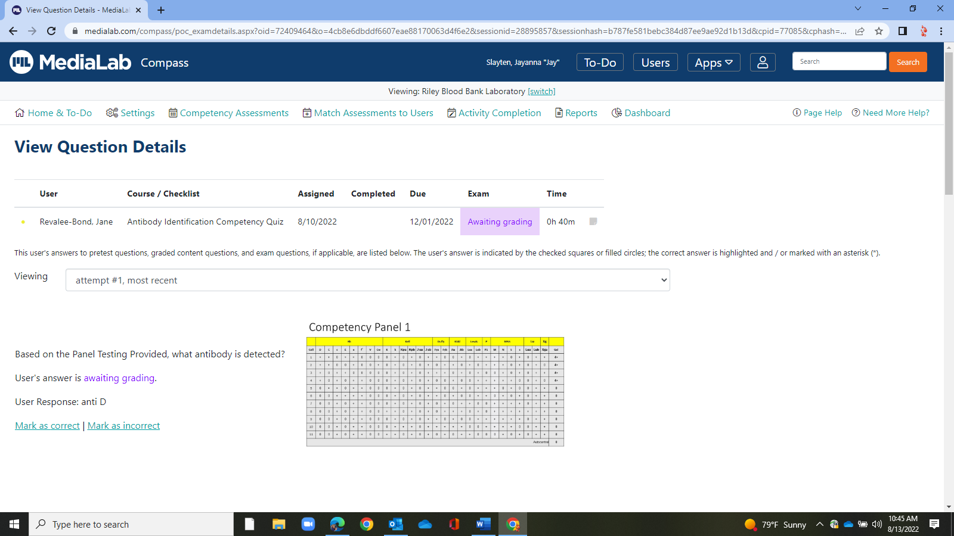 | Any observer may grade any quiz.  If a key is needed, then please contact the BB QA Coordinator for the quiz key.
4 | Completing “Assignments Due Soon for Users”  - Click on Assignments Due Soon for Users  - Click on View Report  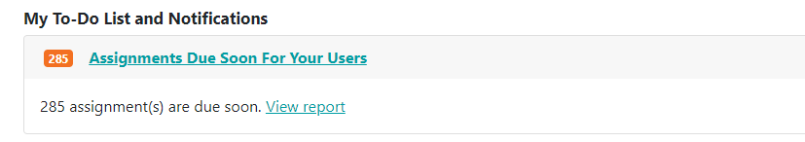  Then click on Details to the right side, to start any of the lab professional’s competencies.  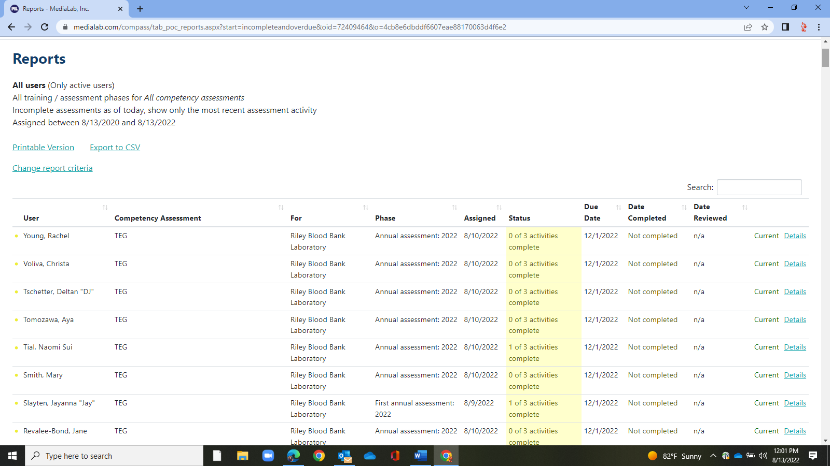  In this screen: The three aspects of the competency being evaluated will expand.  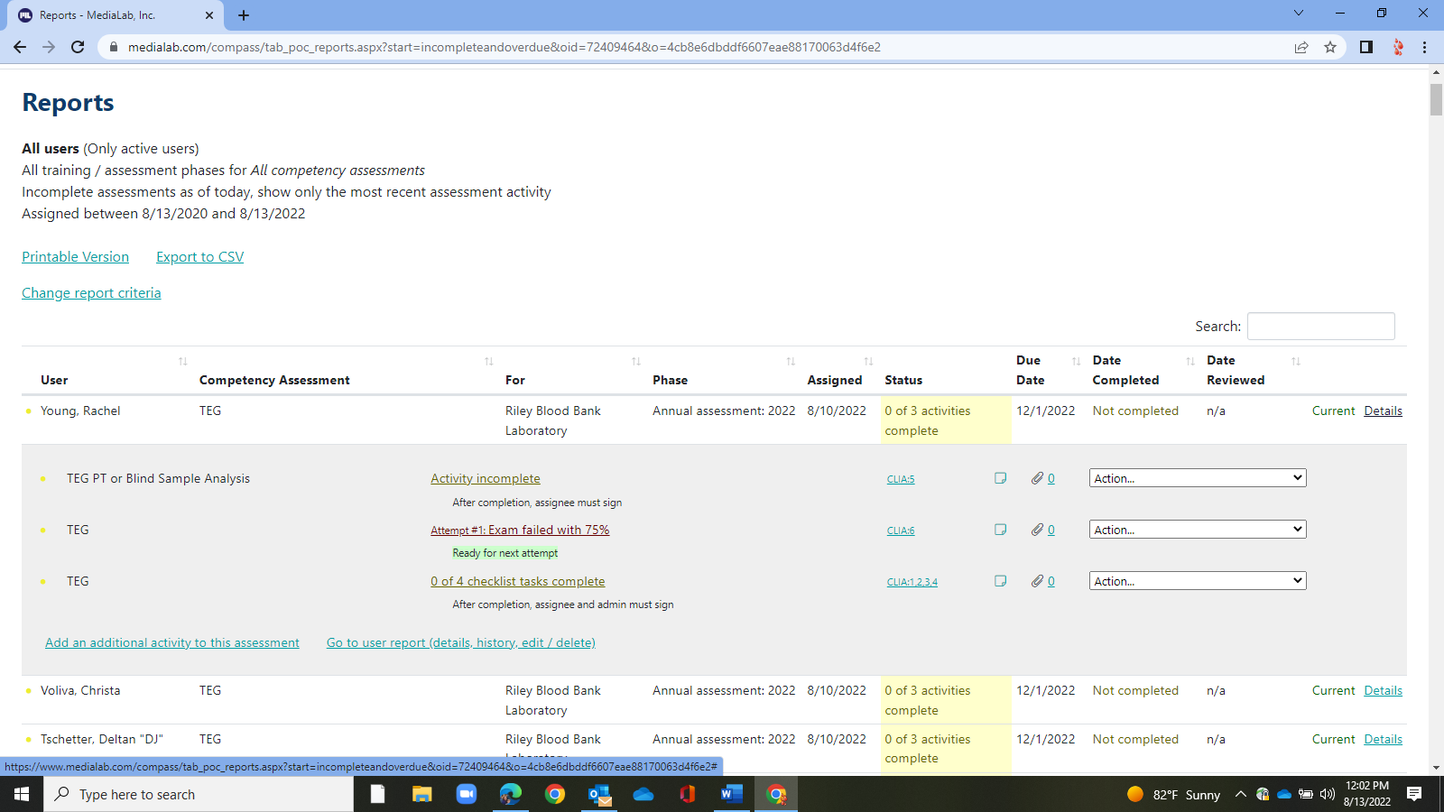  The assigned Blind Sample, Quiz and Checklists can be accessed by clicking in the middle of the screen  Blind Sample Click on Incomplete Assignment – it will take you to the blind  Checklists Click on 0 of 4 checklist tasks complete  it will take you to the checklist  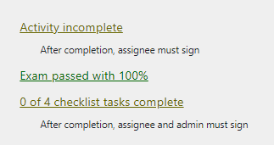  After each task is completed, the observer can come back to each task and use the dropdown on the left for completion documentation and/or to make other annotations on the lab professionals task.  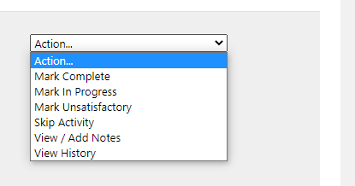 | Only the observer has access to these tasks  All observers can complete any assigned competency in Medialab.
4a | How to complete the Blind Sample  - Follow the instructions on the screen for the completion of Blind Sample  Mark as completed, and document  - For PT testing  An attachment of the PT test result(s) is required to be uploaded into MediaLab.  - For Blind samples  - the observer may include the accession number of the sample tested in the notes section  - (or) the observer uses sample(s) without an accession for the blind sample, then the documentation of the lab professionals testing should be upload into Media Lab with a comment in the notes section describing what is uploaded.  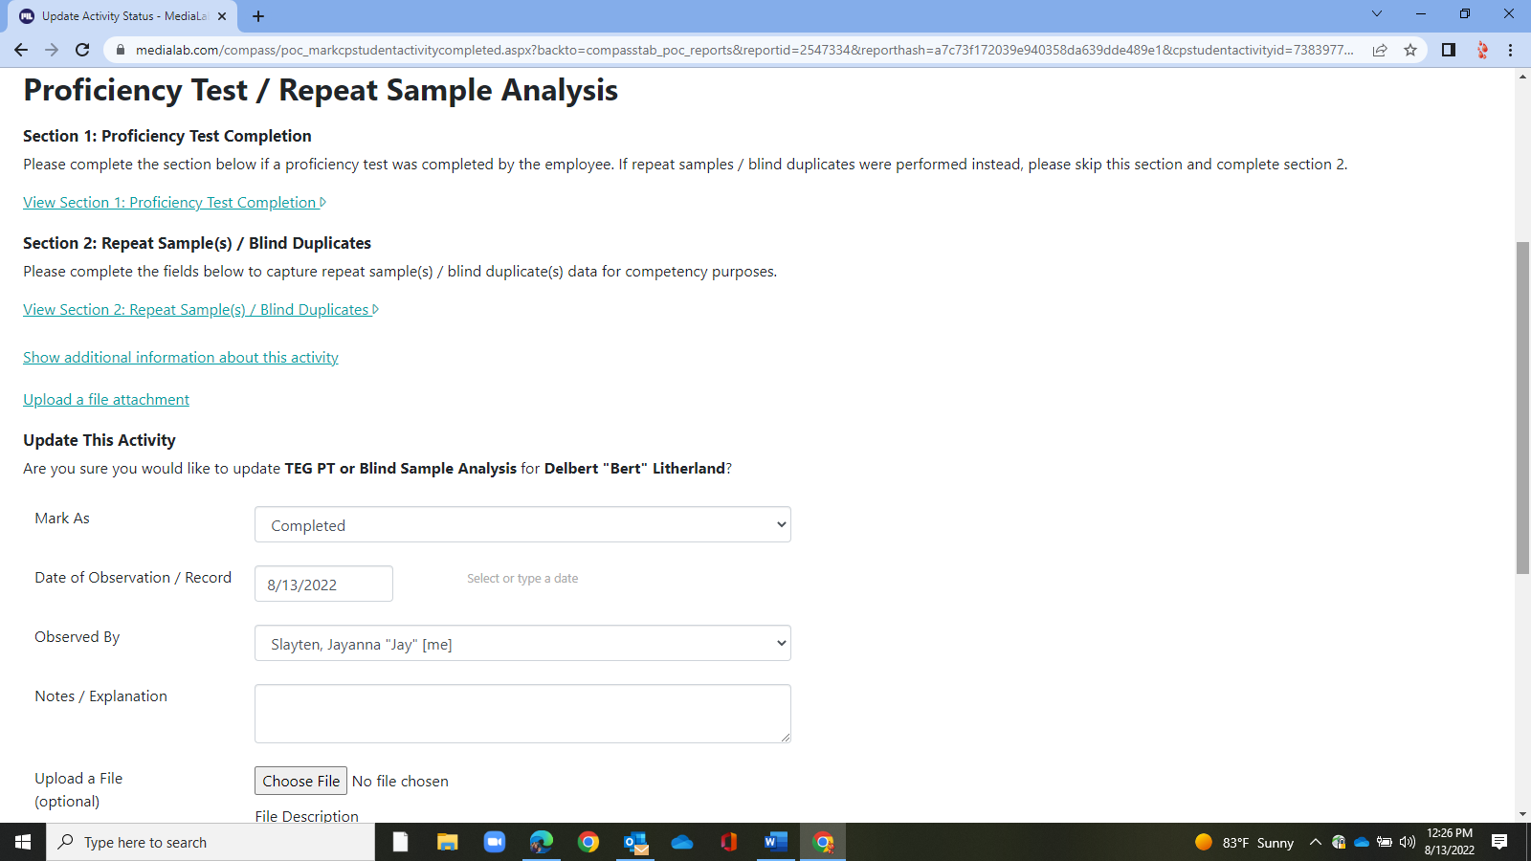 | Documentation of the Blind testing can be completed using the NOTES box for repeat testing, but we would prefer a scan documentation for PT sample testing.  Examples of uploaded documents include: Analyzer print outs, Miscellaneous forms, or Antigrams.
4b | How to complete the Checklist  For each checklist, the observer must answer the task and subtasks.  The Observer answers as  - Yes  - No  - NA  - Add any comments required. A good rule of thumb is if one toggles NA, then add a comment why its marked as NA.  Y = Meets standard and/or expectation  N = Does not meet standard and/or expectation  n/a = Not applicable  Any TASK toggled as NO, YES or NA, will answer all the subtasks.  Any TASK or SUBTASK toggled as NO, will fail the competency.  This will require remediation, and re-assessment.  When all TASKS are complete, and the Save Changes at the bottom is toggled, then the checklist requirement is complete.  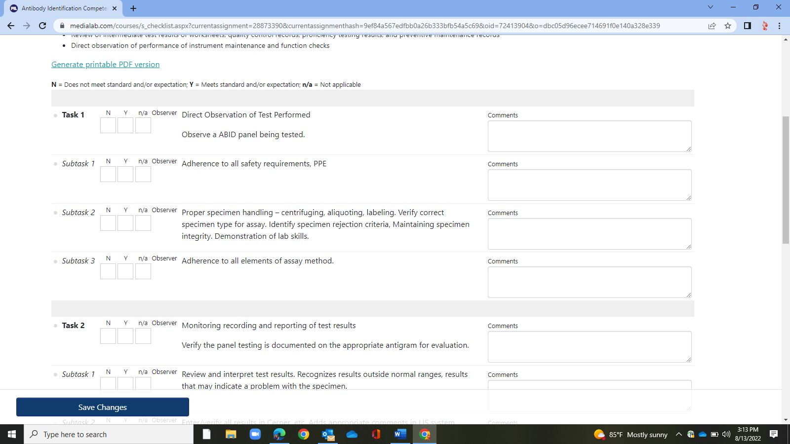 | A checklist may be completed over many days or in one scheduled event.  As long as the Save Changes is clicked at the bottom, then the observer may come back to the task to complete.
5 | Any lab professional who requires remediation and repeat assessment will need to review with the supervisor.  The supervisor should complete the remediation and document in medialab appropriately. | Observers who are not supervisors should communicate with the supervisor of the lab professional for next actions.
6 | Completion of the competency.  When all three  - Blind  - Quiz  - Checklist  Are completed, then the competency is completed for the team member. | As competencies are completed the list of due items continues to be reduced.  For annual assessments, most team members complete their competencies and are done for the year.  New trainees will have their competencies scheduled and based on their start date.

