Step | Description: | Key Point / Image / Reason
Note: TAT (Turn-Around-Time) is monitored as a quality indicator for the service provided by the AHC Blood Bank.
1 | On a routine basis, the TAT report for the AHC Blood Bank is analysed. | The data is monitored by the BB Leadership and BB Quality. This data is reported to the AHC Blood Bank on an on-going basis.
2 | In the lab, when a sample is > 60 min, then the TAT Monitor will turn red. | The monitor is available in all AHC Blood Banks since April 2024.
3 | If a sample TAT turns red, then the testing tech can submit the reason the TAT was > 60 min by accessing the Microsoft Form: AHC Blood Bank Missed TAT Monitoring Form.  - Access the Microsoft TEAMS Page  - Click on Blood Bank TAT Monitoring Form Channel. | 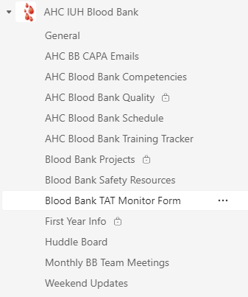
4 | Click on the Files Tab at the top of the TEAMS channel page. | 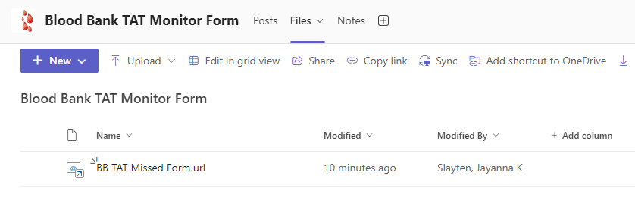
5 | Open the BB TAT Missed Form by clicking the link. | 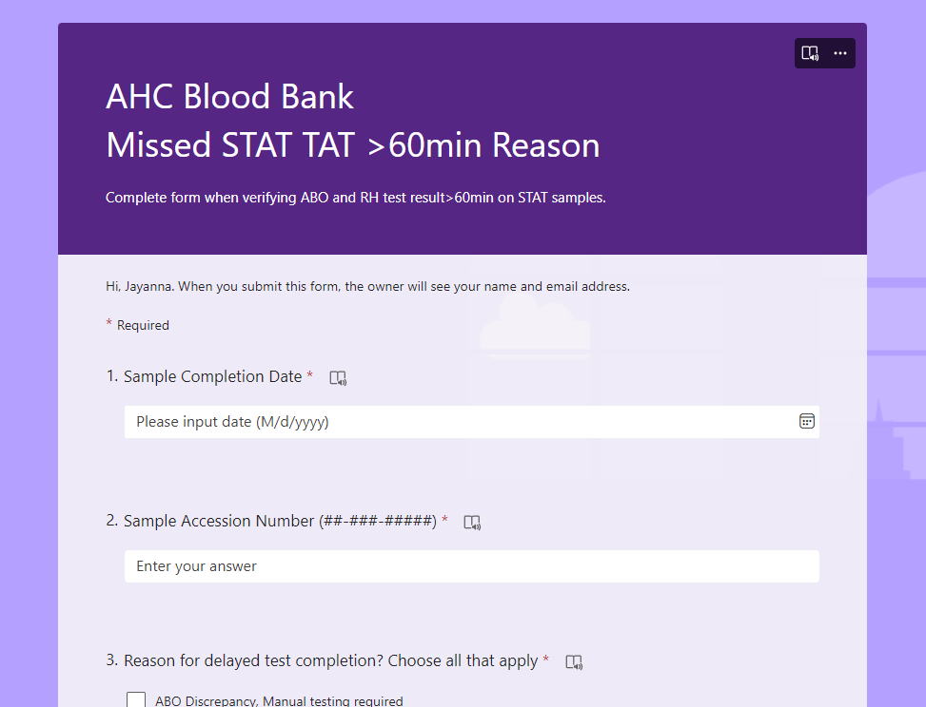
6 | Complete the form and click on SUBMIT.  The | 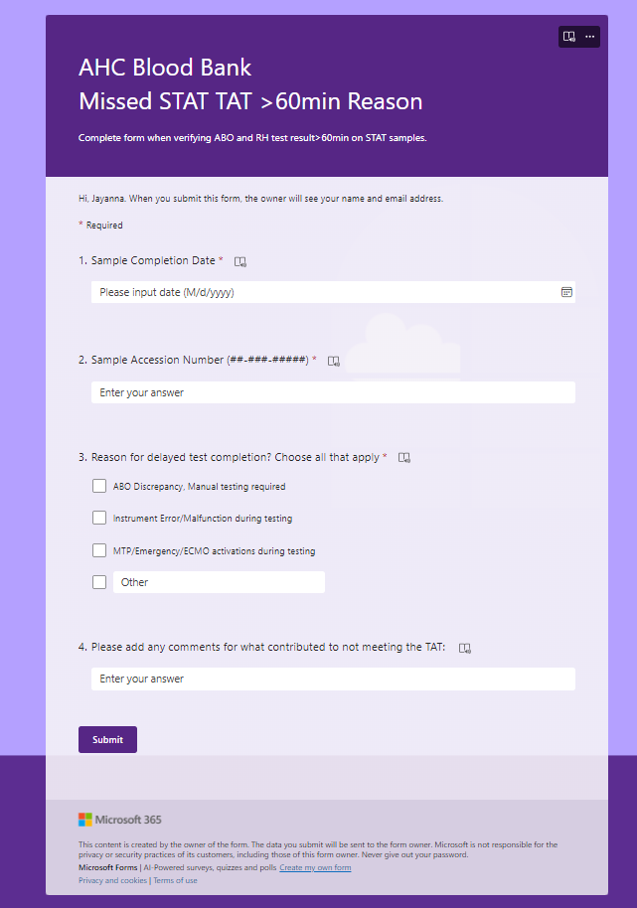
7 | If a team member does not fill out the form, then when completing the daily TAT evaluation, the BB Leadership will forward the form and details to the sample resulting tech. | Link to Form  https://forms.office.com/r/6JWZHqzFaK

