- Log into BludHub
- At Home screen : Select the three lined ICON
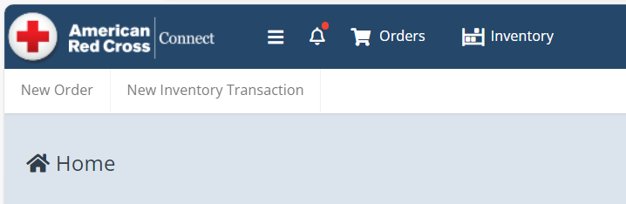
- In the Navigation window that opens: Select“Inventory”
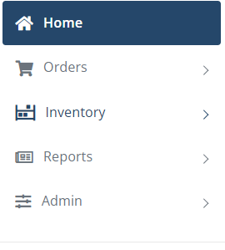
- In the Inventory Drop Down: Select “Pickups”
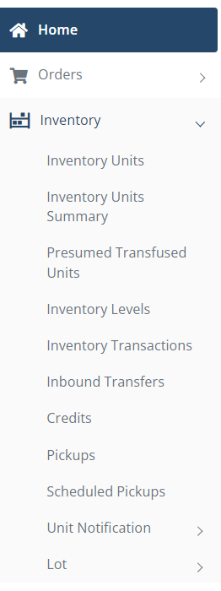
- Select “New Pickup”
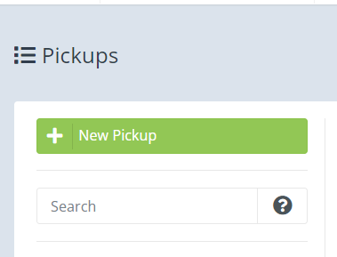
- Select the correct Facility
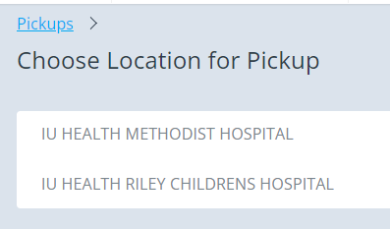
- Complete the Fields on the Form using the drop down options.
- Complete COMMENTS section: Free text details of pick up (example: Empty Boxes)
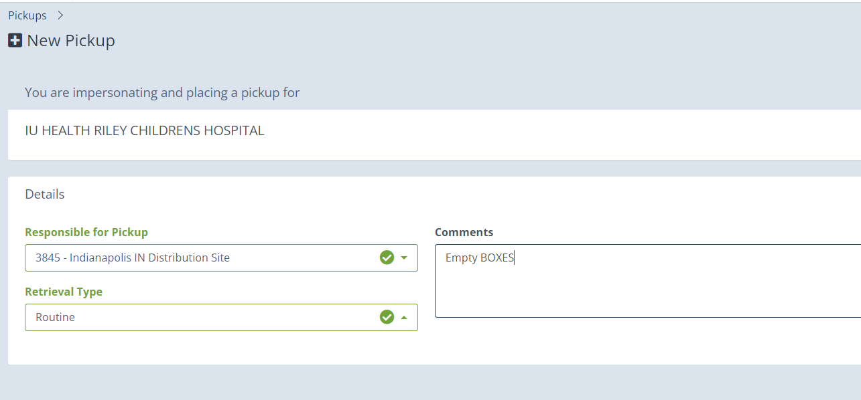
- Select SAVE in bottom right corner.
