Step | Description: | Key Point / Image / Reason
Note:
1 | When assigned for training for Haemonetics, go to Knowledge Center Portal: Log in to the site  Click on Log In in left hand corner. | 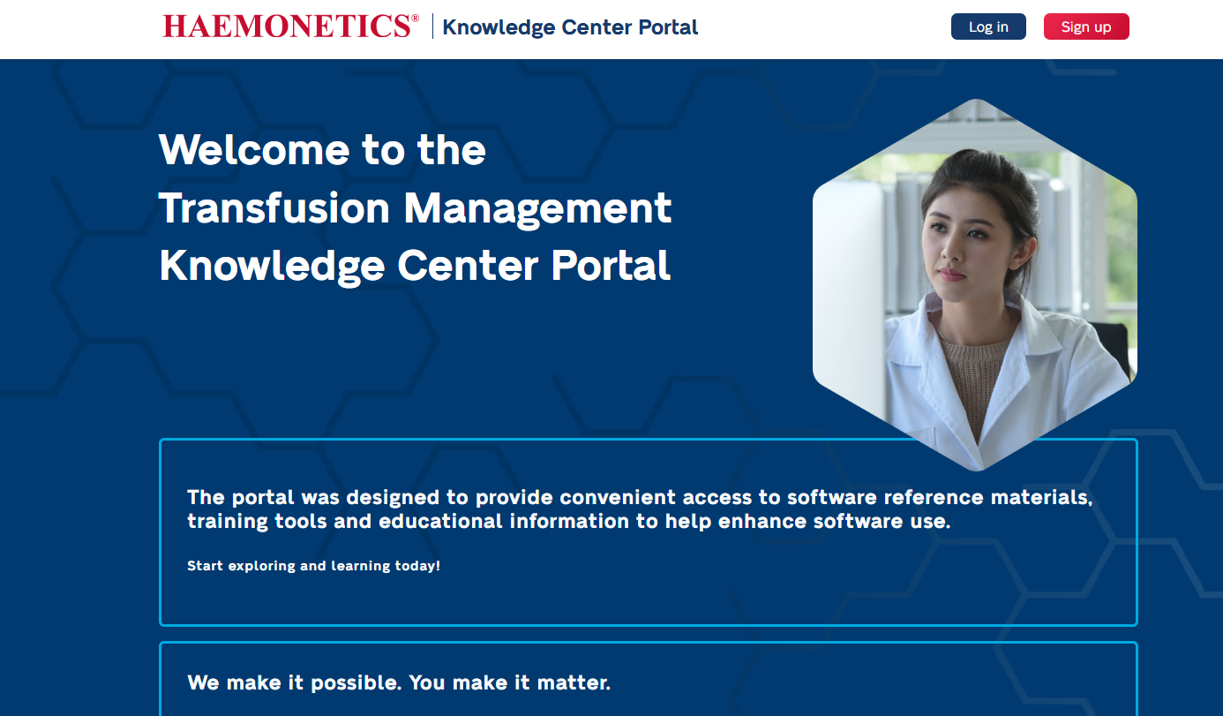
2 | If it’s your first time, then click on sign up now button and create an account.  When you have your username and password set up, then log into the Knowledge Center Portal using your own username and password and click sign in.  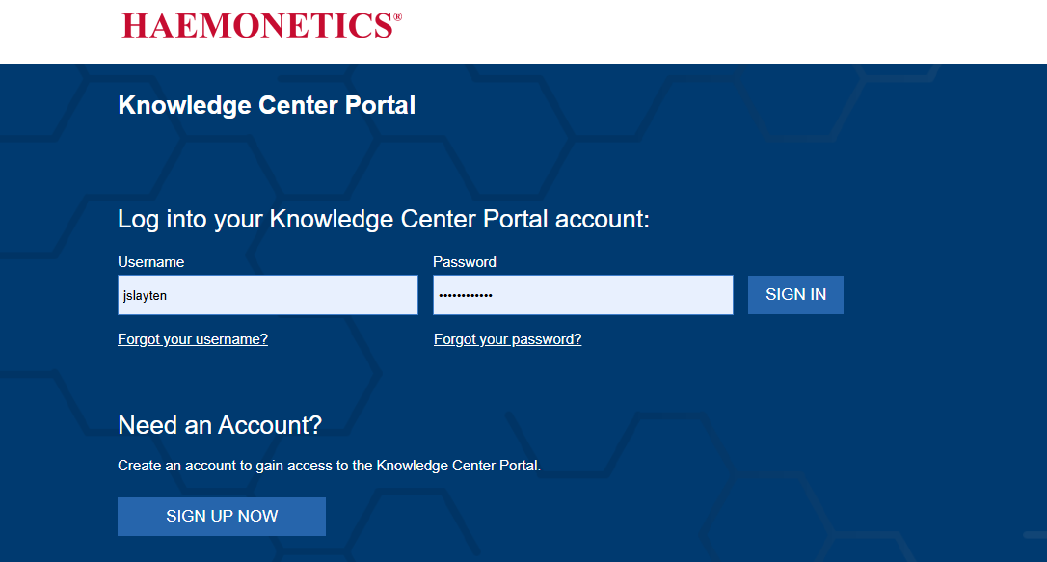  You can make your own username and password; this is not defaulted to your IUH log in. If you forget either your username or password, then go through reset when needed. | 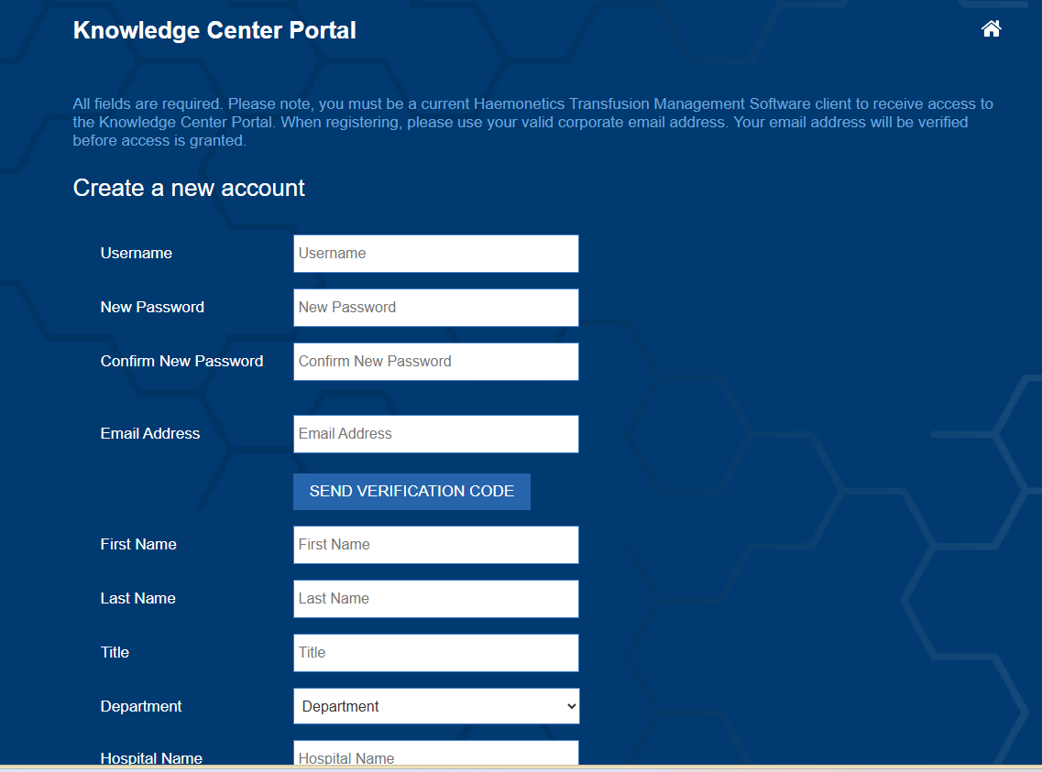
3 | From the welcome page, navigate to the e-learning tab.  Choose BloodTrack  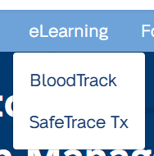  Follow prompt for Module  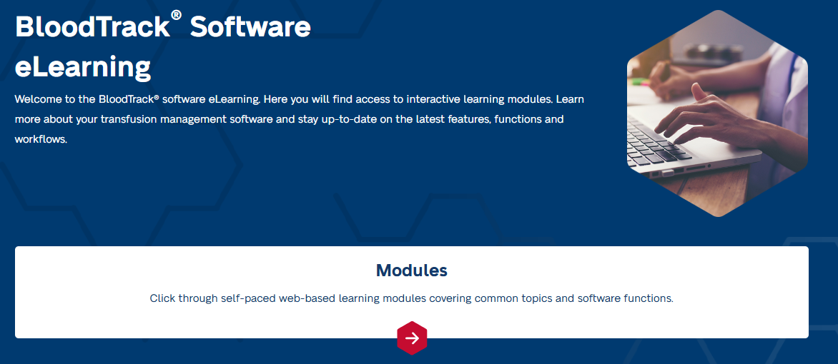  Click on Launch Module  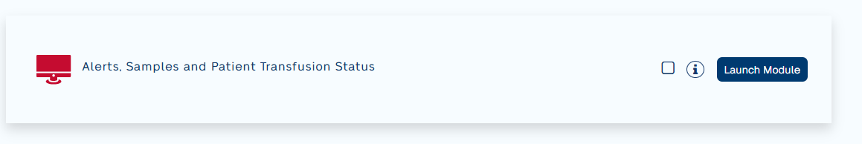 | 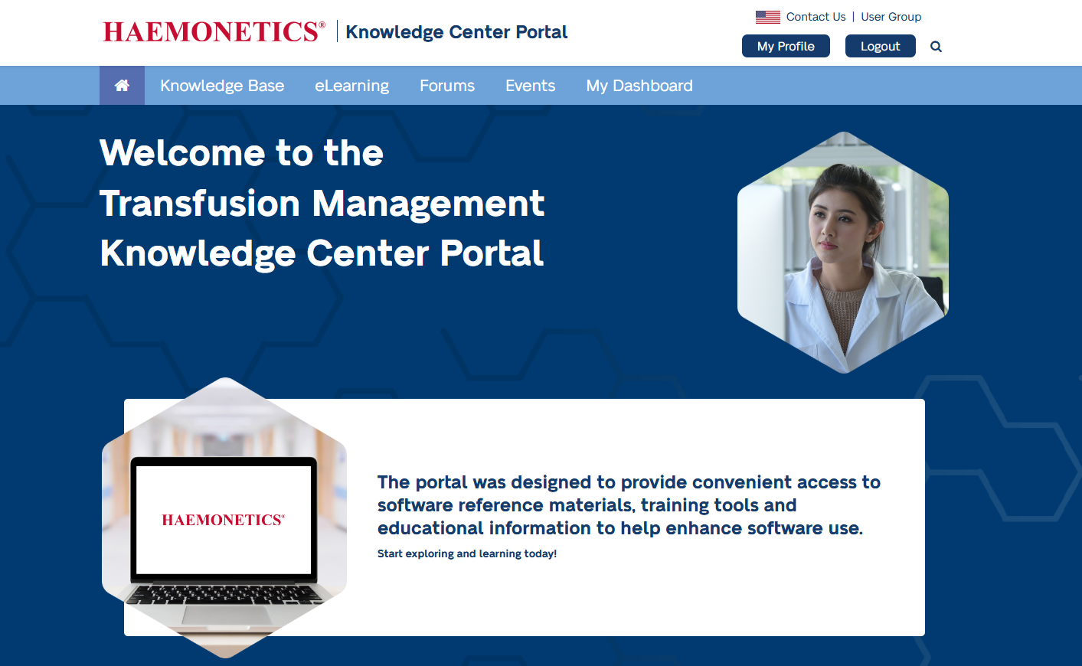
4. | Click on Start Module.  A second window will open for the training. | 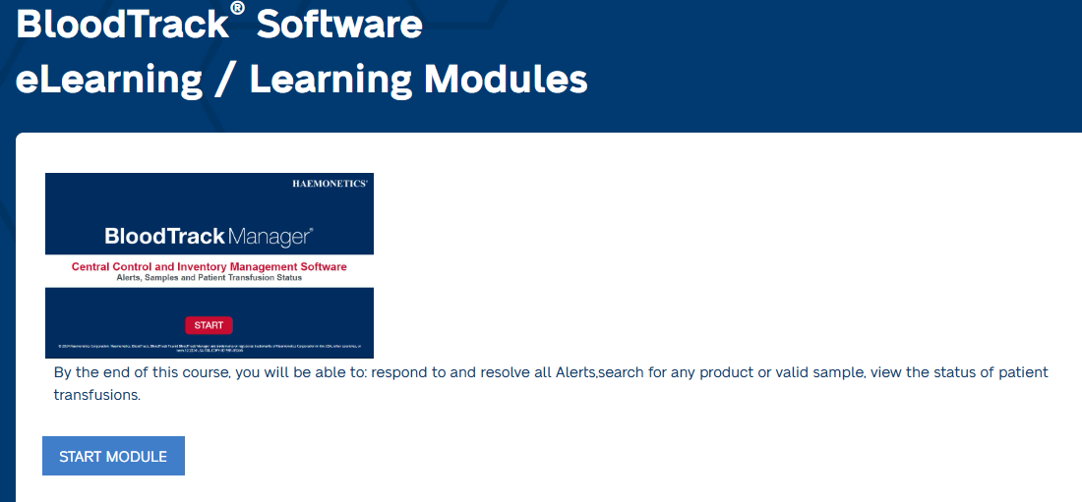
5 | Complete Chapters 1-3  Completed Chapters 4 and 5, but these tasks will not be implemented with this go-live of Blood Track.  When knowledge check is completed, >= 80% then return to home screen.  Estimated time, 10 minutes. | 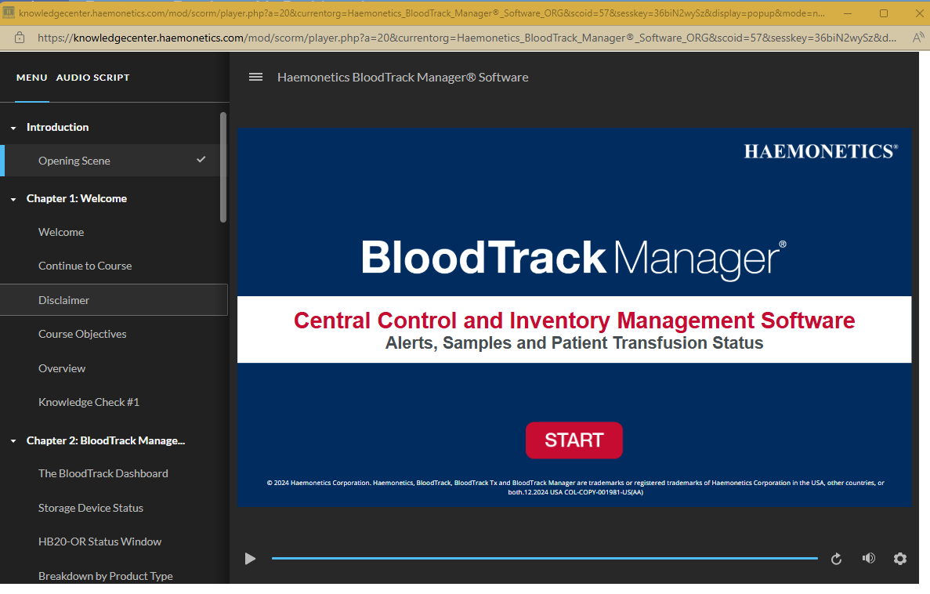
6. | When complete with Knowledge Center, then log into MTS and acknowledge the completion of training to ensure continuing education is assigned to the completion of this training. | MTS  Log In  Complete 2025.03.05 Blood Track Knowledge Center Acknowledgement

