Purpose:
To ensure compliance with regulatory requirements, a new QC profile was added for Diluent 2 use on the Ortho Vision analyzers.

Review of QC Profiles:
The new profile is circled below.
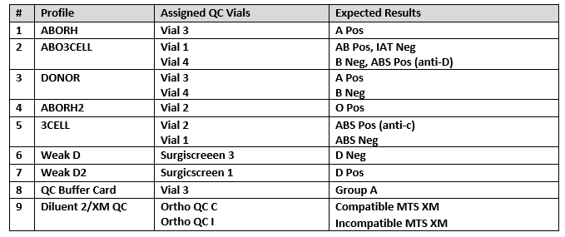

New Designated QC Rack for Diluent 2/XM QC:
Supervisors and team leads will be responsible for preparing the QC rack for this profile.
Blood Bank team members will be responsible for running all QC profiles shown in the table above.
Blood Bank team members will be responsible for loading two QC racks (one containing all 4 tubes of the Ortho Daily QC and one containing the Diluent 2/XM QC tubes).
Please note that the QC rack for Diluent 2/XM QC will be shared between the two analyzers at each site.
