 | 1.0 | PRINCIPLE
 |  | The erythrocyte sedimentation rate (ESR), also called the sed rate, measures the rate of erythrocytes in diluted human plasma. This phenomenon depends on an interrelationship Of variables; such as, the plasma protein composition, the concentration of erythrocytes, and the size/shape of the erythrocytes. The ESR value is determined by measuring the distance from the surface meniscus to the top of the erythrocyte sedimented in a special tube that is placed perpendicular in a rack for one (1) hour.( The numeric value is determined (in millimeters/hr). The clinical value of this procedure is in the diagnosis and monitoring of inflammatory or infectious states.
Usefulness of the ESR
The ESR is not a specific test therefore it is used for screening for certain disease conditions. It can be used to differentiate among diseases with similar symptoms or to monitor the course of an existing disease. For example, early in the course of an uncomplicated viral infection, the ESR is usually normal, but it may rise later with a superimposed bacterial infection. Within the first 24 hours of acute appendicitis, the ESR is not elevated, but in the early stage of acute pelvic inflammatory disease or ruptured ectopic pregnancy, it is elevated. The ESR is elevated in established myocardial infarction but normal in angina pectoris. It is elevated in rheumatic fever, rheumatoid arthritis, and pyogenic arthritis, but not in osteoarthritis. The ESR can be an index to disease severity.

 | 2.0 | PERSONAL PROTECTIVE EQUIPMENT:
Performance of this procedure will expose testing personnel to biohazardous material and possible chemical hazards.

All specimens must be handled as potentially infectious material as outlined in the UUHC universal precautions procedure manual.

The reagent(s) and/or chemical(s) that are used in this assay may be hazardous to your health if handled incorrectly.

More extensive information concerning the safe handling of the reagents and/or chemicals used in this assay, as well as other important safety information, may be obtained by consulting the Material Safety Data Sheet (MSDS). Before performing any part of this assay, the technologist must take any and all precautions and adhere to all prescribed policies.
This procedure may expose you to: | To perform this procedure, you must use:
Bloodborne pathogens | Gloves
Airborne pathogens | Eye/face protection
Hazardous reagents | Laboratory coat
 | Disinfect work area following procedure.UsingSTERIS Germicidal Surface Wipes.
Referencefor spill/Decontamination
MSDS

 | 3.0  SPECIMEN  INFORMATION | Fresh anticoagulated blood collected in EDTA may be used for this procedure.  If the blood is left at room temperature (18 to 25°C) the test must be set up within 2 hours. If anticoagulated blood is refrigerated (kept at 4°C), the test must be set-up within 24 hours, the specimen must come to room temperature before the test is setup.  Hemolyzed specimens cannot be used. Specimens must be examined for the presence of small clots; which would invalidate results  Causes for Rejection:Hemolyzed;clotted specimen:underfilled tube;specimen older than 24 hours;improper labeling;specimen diluted or comtaminated with I.V.fluid.patient specimenwith the presence of cold agglutinins or cryglobins;specimen with plasma removed;specimen received in any anticoagulant other than EDTA;improper labeling;
 | 4.0 | REAGENTS, SUPPLIES AND EQUIPMENT
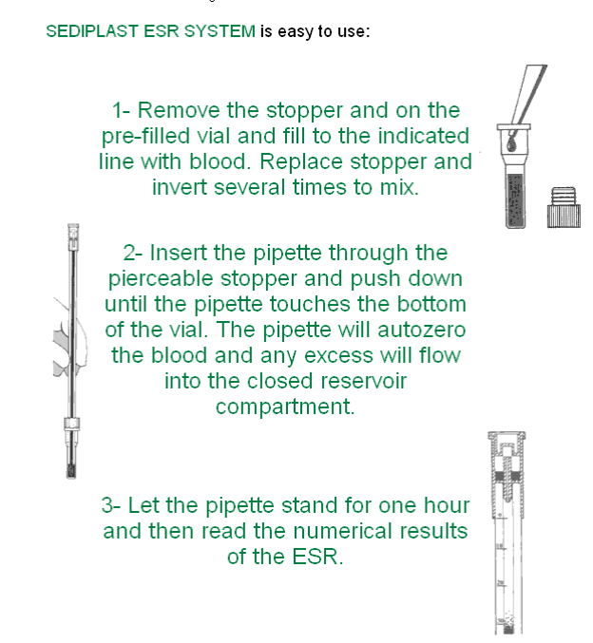
Sediplast System (prefilled with 0.2 ml of 3.8% sodium citrate).

 | QUALITY CONTROL:  5.0 | STRECK ESR-CHEK® 2 controls are used daily when tests are performed.(8a-4:30p,4p-12mn &12mn-8am) Two levels of controls are included, normal and abnormal high. These controls are set up like patient samples and read at 1 hour. Control ranges are displayed on the monthly QC log.If controls are unacceptable,please repeat and document corrective action.
 | 6.0 | PROCEDURE
- Collect whole blood anticoagulated with EDTA.
- Premix blood specimen for 5 minutes on rotating mixer.
- Label the puncture ready vial with the patient’s name,last four of ss# and specimen#.
- Remove cap from the puncture ready vial and add well mixed blood up to the line (see illustration).
- Replace cap and invert 8 times making sure the blood and diluent mix well.
- Carefully insert the Westergren tube into plungeable vial cap of blood/diluent mixture twisting as you push the tube down.Allow the excess blood to flow into the resivior compartment.
- Place the tube in the Westergren rack to a vertical position and leave undisturbed for exactly 1 hour.(the rack with level surface).
- Set timer for 1 hour.
- After 1 hour has passed, read the distance in millimeters from the bottom of the plasma meniscus to the top of the sedimented erythrocytes. Do not include the buffy coat in this measurement. (The buffy coat is the layer of white cells and platelets at the interface of red cells and plasma. It is usually negligible, but may be noticeable in cases of leukocytosis or thrombocytosis.)
NOTE: The autozero Westergren tube must completely touch the bottom of the Sedivial to insure proper results.
10.Read the numerical result of the erythrocytes sedimentation in millimeters.
 | 7.0 | NORMAL VALUES
Normal values
Adult male 0-15 mm/hr
Adult female 0-20 mm/hr

RECORDS REQUIRED AND RETENTION:
Patient test results will be retained for a minimum of 2 years.
 | 8.0 | PROCEDURE SOURCES OF ERROR:
- Because the ESR depends on the ability of erythrocytes to form rouleaux conditions in which rouleaux formation is inhibited, such as sickle cell anemia, HbSC, and spherocytosis, may be accompanied by normal sedimentation rates (i.e. the ESR will not be as elevated as expected for the degree of anemia in these specimens).

- Age of specimen leaving the specimen for more than 2 hours at room temperature will cause erythrocytes to become spherical and inhibit rouleaux formation:

- Overanticoagulation causes lower values. Incorrect ratio of blood to diluent Bubbles in the Westergren tube

- Even slight tilting of the tube increases the ESR. Tilting of the Westergren tube (accelerates the fall of the erythrocytes; an angle of even 3 degrees from vertical can accelerate sedimentation by as much as 30%)

- If area of RBC-plasrna separation is hazy, read the level where the full RBC density is apparent.

- Marked changes in room temperature will increase (in high temperatures) or decrease (in low temperatures) the ESR.

- The presence of anemia invalidates the ESR as a tool to detect rouleaux (as an indication of some disease process).

- contaminate with IV fluid. Patient with presence of cold agglutinins or cryoglobins, specimen received with plasma removed.

- Vibration such as from a nearby centrifuge will cause a false ESR.
ESR is considered a non-specific indicator of tissue damage, and it is increased
In a number of disorders. Some of the more significant conditions are
listed in the table of Excepted ESR in in various conditions.

Factors affecting the ESR
Increase | Decrease
Rouleaux formation | Microcytes
Elevated fibrinogen | Sickle cells
Excess immunoglobulin | Spherocytes

 | 9.0 | Biological factors affecting the ESR  1. Plasma factors  Increased plasma concentration of fibrinogen, along with immunoglobulin, will result in rouleaux formation and an increased ESR. It can therefore be expected that disease states that are characterized by hyperfibrinogenemia or elevated immunoglobulin levels will result in an increased ESR.  2. RBC factors  When rouleaux formation cannot occur, owing to the shape or size of the RBC, a decreased or low ESR is expected. This is observed with sickle cells and spherocytes. The ESR is of little diagnostic value in severe anemia or in hematologic states evidenced by poikilocytosis.  CONDITION COMMENTS  ESR Increased  Inflammatory conditions associated with elevated plasma protiens,in  particular,fibrinogen and alpha and beta gloubins.  Acute and chronic infections  Rheumatic fever  Rheumatoid arthritis  Myocardial infarction  Nephrosis  Tuberculosis  Multiple rnyeloma  Waldenstrorn’ s macroglobulinemia  Subacute bacterial endocarditis  Hepatitis  Menstruation  Pregnancy After the third month  Decreased ESR  Spherocytes When large numbers present in peripheral blood .  Sickle cells  Sickle cell anemia  Hemoglobin CC disease  Hereditary spherocytosis
 | 10.0 | CLINICAL APPLICATIONS:  The ESR directly proportional to the weight of cell aggregate and inversely  proportional to surface area. Microcytes sediment more slowly than macrocytes. Erythrocytes with abnormal or irregular shape, such as, sickle cells or spherocytes hinder rouleaux formation and lower the ESR. Removal of fibrinogen by defibrination also produces a decreased ESR.  The Westergren method is preferred by NCCLS standards because of its simplicity and greater distance of sedimentation measured in the longer Westergren tube. The straight tube is 30 cm long, 2.5 mm in internal diameter, and calibrated in millimeters from 0-200. Approximately 1 mL of blood is required. The method it replaces is called the Wintrobe method
 | 11.REFERENCES | 1.Clinical Hematology: Principles, Procedures, Correlations; Cheryl Lotspeich-  Steininger, E. Anne Stiene-Martin,John A. Koepke  2. Sediplast Westergren ESR System Package Insert  3.Streck ESR-CHEX Package Insert.

PROCEDURE HISTORY PAGE

DATE | PROCEDURE NUMBER  VERSION | CHANGES:  MAJOR/MINOR  ANNUAL REVIEW COMMENT | CHANGES BY:  SIGNATURE/DATE | APPROVED BY:  SIGNATURE/DATE
 |  | If blood is refrigerated,it must be tested within 24 hrs.The specimen must be brought to room temperature.

