PPMP Providers --- Please Read Concerning Clue Cell Identification

Dear Providers:

Only about 30% of the SHS providers who perform Wet Mount testing are correctly identifying a Clue Cell on the Point of Care competency and proficiency testing images. Please review the information below:

Bacteria cover these urine epithelial cells so that the cell borders are not visible-these are Clue Cells. Clue cells are rough, “hairy” looking with a “fur coat” look or a 2 day beard growth. The cell borders are not distinct.

NOTE: Folding or touching epithelial cells do not make it a clue cell. Look for bacteria around the periphery of the cell.

Internal cellular elements of normal epithelial cells can be confused. Look at the cell border to be sure.

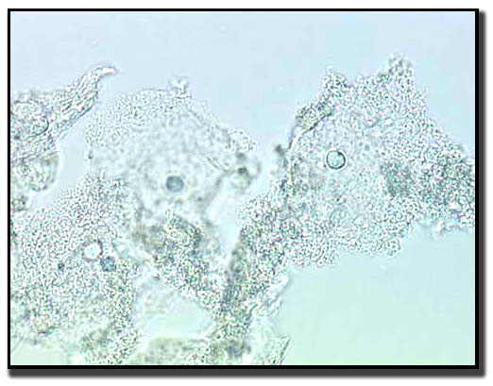 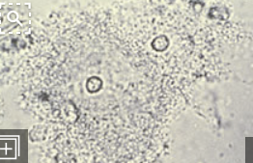

**Clue cells-epithelial cell borders are obscured by bacteria. Clue cells-close up**

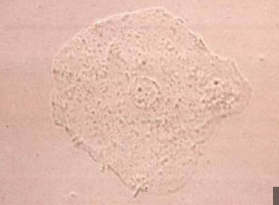 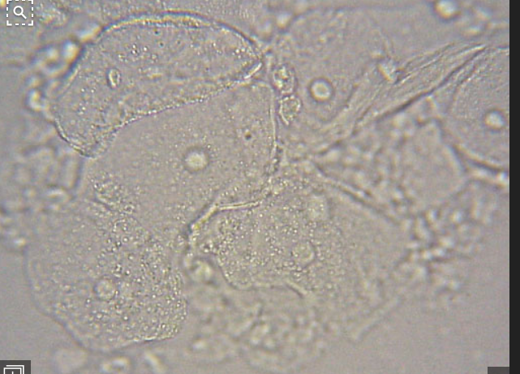

**Not a clue cell-cell edges are defined Not a clue cell-cell edges are defined**