PPMP Providers --- Please Read Concerning Clue Cell Identification

Dear Providers:

Only about 30% of the SHS providers who perform Wet Mount testing are correctly identifying a Clue Cell on the Point of Care competency and proficiency testing images. Please review the information below:

Bacteria covering these urine epithelial cells makes them Clue Cells. The epithelial cells are “hairy” looking or a “fur coat”. The cell membrane borders are not distinct.

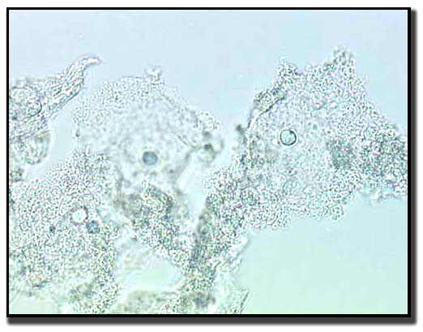

**These are clue cells.**

NOTE: Folding or touching epithelial cells do not make it a clue cell. Look for bacteria around the periphery of the cell.

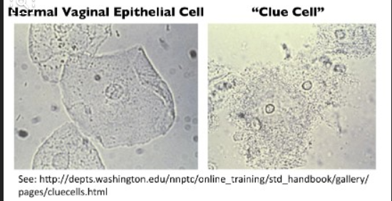

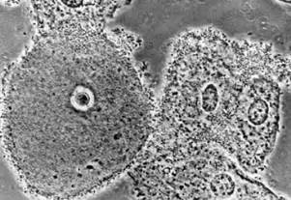

**Rough cell membranes. These are clue cells.**

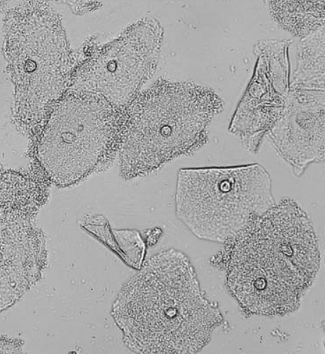

**Normal epithelial. Note the clear cell borders. Intracellular granules are normal.**

**Clue cells-rough, with the bacteria coating the cell membrane.**