
WI Aurora SL South Shore
September Lab Meeting Agenda
September 2019
Reminder – these minutes are confidential and should not be shared outside of our laboratory!
Presenters: Allison
Participants:
 | Alexandrea Rodriguez |  | Christine Manlick-Ludorf |  | Emily Pirkle
 | Allison Smatlak |  | Christopher Wells |  | Joshua Guros |  | Sandra Peplinski
 | Amir Toghraee |  | Collin Mah |  | Kathleen Ballenger |  | Santana Estrada
 | Apeksha Patel |  | Connie Ochs |  | Ligia Torres Sanchez |  | Timothy Brown
 | Blandine Nzolameso |  | David Cole |  | Margaret Rydeski |  | Timothy McRae
 | Allison Engan |  | Dorota Kuehni |  | Maribel Coughlin
Invited Guests:

 | Agenda Item | Discussion | Action/Decision | Responsible Person(s)
 | Welcome & Congratulations! | Welcome New Team Members:  Brooklyn – Sept 23  Anniversaries:  Emily – Sept 4  Birthdays:  Margaret – Sept 3  Emily – Sept 12  Chris M – Sept 14 |  |  | Allison
 | Reflection |  | - “The pessimist complains about the wind; the optimist expects it to change; the realist adjusts the sails.”
 | Safety Story |  |  |  | Allison
 | August Minutes | Any questions or outstanding items? | It is strongly recommended that you read minutes for additions and things you may have missed! |  | Allison
 | Advocate Aurora Items | 2020 benefits  Flu vaccine | Check your home mailing address for a benefit packet about the upcoming 2020 changes  If you require a flu vaccine exemption – you must have this in by September 13  Flu vaccines will be 9/30 -10/25. They are mandatory! Schedule is posted by the tech/phleb schedule |  | Allison
6. | ASLSS Items | President  Benefit expo  Ordering supplies | Effective October 1st, Jessica Bauer will no longer be president at South Shore. Our new president, Marie, will share responsibility between St. Luke’s and South Shore. You should not see much impact day to day. Please reach out with any questions.  Will take place at South Shore in the auditorium on Thursday, 9/26 from 10-2. Bring questions, not a formal presentation  Any ideas how to improve how we order supplies? Please bring them to me! |  | Allison
7. | Recognition |  | THANK YOU TO EVERYONE FOR YOUR HELP WITH THE CAP INSPECTION!!!  WITHOUT YOUR HELP AND TEAMWORK, IT WOULD NOT HAVE BEEN SO SUCCESSFUL!!  South Shore is still leading the way with utilizing Kudos Connection in the system – have you done yours yet? |  | Allison
8. | ACL Items | BEAKER  CAP | As we continue our journey toward a single patient record across Advocate Aurora Health, we are very excited that ACL Laboratories will be part of this unified Epic platform. This integration increases safety, quality and service throughout the system. This single platform will streamline workflows and improve interoperability by providing one centralized location for our patient records. EPIC BEAKER GO LIVE IS FEBRUARY 1ST, 2020!  Timeline:  - Credentialing Trainers – September 23, 2019 – November 4, 2019  - Trainers take courses from ACL Principal Trainers to become credentialed trainers, so they can then train super users and end users on the new system.  - Super User Training – November 11-25, 2019  - Super Users are trained and prepared to lead their peers through the transition. Super Users will serve as support personnel for end users as they go through training and Go-Live. Super Users are an extension of the project team in the field and play a vital role in the success of our implementation.  - End User Training – December 2, 2019 – January 20, 2020 (WI) | April 20, 2020 – June 12, 2020 (IL)  - End users must be trained on the system and learn how they will perform their daily tasks in Epic Beaker. Playground access, where end users can practice what they’ve learned in training, is covered during training. Epic logins are also given once users complete their training.  - Support Planning  - Go-live support planning for the February 1, 2020 implementation will begin. Included in the planning will be Logistics for Call Center Support and staffing for the IT/Operational Command Centers needed to ensure a successful go-live.  - Go-Live Readiness Assessments (GLRA)  - GLRAs will be conducted at the 90, 60 and 30-day marks before go-live. GLRAs review readiness and identifies risks, plans for resolution of issues, and provides a platform to communicates concerns before go-live.  - Technical Dress Rehearsal (TDR)  - During Technical Dress Rehearsal, all the technical aspects of the system are tested as if they were live. Do workstations work properly? Can users login? Can they print? Do business continuity devices work? It’s an opportunity for the technical teams to identify any issues in a live simulation prior to go-live.  - Workflow Dress Rehearsal (WDR)  - Workflow Dress Rehearsal is a true dress rehearsal of the way specimens flow through the lab system. It’s an opportunity to find flaws in the workflows and correct them prior to go-live.  Is OVER!! We are now working on our deficiency responses which are due middle of October  Summary of our deficiencies:  -Transfusion:  -Blood warmer temperature QC documentation (nursing)  -Blood administration policy (system nursing)  -Blood cooler validation (system)  -Hematology:  -Urobilinogen ranges between policy and report do not match (system)  -No explanation on IRIS validation exceptions (challenge)  -POC:  -MD missing competency  -Chemistry:  -No carryover studies done following major maintenance (system challenge) |  | Allison
9. | TATm | Heme-  Coag-  Chem-  Specimen processing-  Transfusion | Oncology CBC TAT is <18 minutes.  Coag rollover data is complete – actual rollover will occur in late October  Siemens local training class in October – if interested, please see me.  LDH >200 should be repeated to determine if results are acceptable  pH adjustment for urine drug screens – if pH is <4, adjust pH to 5-8, but append text code “PH4” to the result. This translates to: pH,=4, presence of adulterant suspected.  No update on legal alcohols yet. All exposures must have accompanying paperwork |  | Allison
10. | Policies of the Month | READ YOUR POLICIES! |  |  | Allison
11. | Quality – IP Morning Results Completion Time | >88% morning IP results before 730am | August at 94%  Year to date = 87%!! So close to the goal of 88%!  Keep it up! It is amazing to see the progress. |  | Allison
12. | Quality – Blood Culture Contamination | % Contamination  Goal <2.3% | August data:  Lab: 1.0%  Nonlab: 0%  There was a significant increase for lab drawn blood cultures – please remember hand hygiene and protocol  Goal met. |  | Allison
13. | Quality – Patient ID Errors | PID errors in June =  Goal is <25 DPM for 2019. | ZERO PID errors for August AND YTD!! AMAZING |  | Allison
14. | Quality – Corrected Results | Corrected Results in June  Goal is <160 DPM for 2019. | ZERO corrected reports for August– 5 months without!! Target is <160.. we are at 114 =GREEN!! |  | Allison
15. | Quality – Proficiency Testing | 2019 – PE Goals based on sites performance of >99% | We are at 99.3% - great |  | Allison
16. | Quality – Specimen Acceptability | Goal is >99.4% for 2019. | August was at 99.80% . YTD = 99.66% |  | Allison
17. | Quality – ABN Compliance (watchlist) | Lab Collected ABN rate is 0%. Goal is 84.0% for 2019. | August was at 100%, and our YTD is at 81.9% |  | Allison
18. | Learning | MTS | Please continue to work on 2019 MTS modules as workload allows. Team members must score 100% on all competencies.  There have been annual competencies assigned for phlebotomy -due in October |  | Allison
19. | IT – Data Base Trackers |  |  |  | Allison
20. | Open Positions  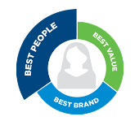 | - FTE phleb (Milo’s position)  1.0 FTE 2nd shift Phleb | Recruiting –  Filled with Brooklyn H – starts 9/23  Any suggestions on staffing? Still remains a low score for engagement |  | Allison
21 | Opportunities | Leadership opportunities. | Vacant director positions are posted online: Sinai, South Shore, St. Luke’s and Sheboygan |  | Allison
22. | Safety | Verges for August | - Delay in PTT draw for a heparin patient – was a critical result  - No 24-hour urine containers available  - VANCO trough not drawn at the correct time  - Urine brought to the lab with an unscrewed cap  - Miscommunication – nursing thought that a K value of >2.8 was a critical result |  | Allison
23. | Phlebotomy Focus |  | As noted above HAND HYGIENE audits were completed using administrative staff and secret shoppers. Corrective Action plans have been identified and are ongoing.  We have averaged around 75% compliance – the goal is 100% Please be mindful about proper gel in/out always  If you are noticed as noncompliant, just in time feedback will be required. |  | Allison
24. | Tech Talk |  |  |  | Allison
25. | Engagement survey |  | Engagement Poll scores for ASLSS were concerning – The survey is OPEN from September 16-October 7  A few reminders for the engagement survey:  -Your direct supervisor applies to Allison only  -Senior leadership at South Shore includes: Ania, Jessica Bauer, etc  -Senior leadership at ACL includes: Barb Bigler, Mick Runnoe (was here for a site visit), etc  -The survey is about the year as a whole, it is easy to take the survey on a day that you are particularly upset, however, this is a good chance for feedback that you would like to see changed  Thank for the suggestion on the whiteboard for a suggestion box! For the next few weeks, it will also act as the engagement box. There will be themes of the week, and you are encouraged and welcome to place your suggestions, thoughts, tips, ideas in the box.  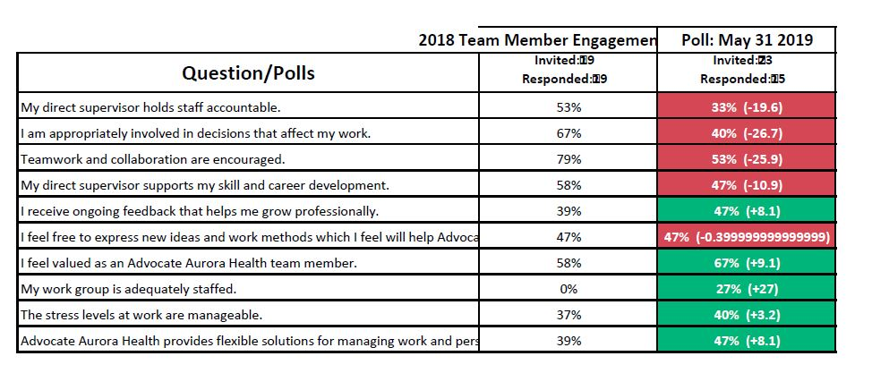  Goal for the engagement survey participation is >87% - we are at 59%! Thank you to everyone who has provided feedback so far! |  | Allison
26. | Annual performance |  | Reminder:  Your 2019 performance evaluation is based on three things:  - Job responsibilities (25%) – how well do you do you fulfill your responsibilities  - Goals (25%) – these are located in your current performance document for reference, most include metrics  - Behaviors (50%) – there are six of them – how well do you exhibit these: Collaborate, communicate effectively, ensure accountability, exhibit courage, foster resilience and value differences |  | Allison
27. | Diversity & Inclusion |  | https://www.youtube.com/watch?v=2g88Ju6nkcg |  | Allison

