Table of Contents

Entering a Gram Stain in to Beaker 2
Gram Stain Review – With Telepathology/Photograph Review 5
Gram Stain Review – When Telepathology/Photograph Review Cannot be Performed 7
Entering a KOH Preparation 10
Work up of a Blood Culture – Organisms Seen 13
Work up of a Blood Culture – No Organisms Seen 19
Entering a Reject Sputum Gram Stain in to Beaker 23

Entering a Gram Stain in to Beaker

- Click on Result Entry.
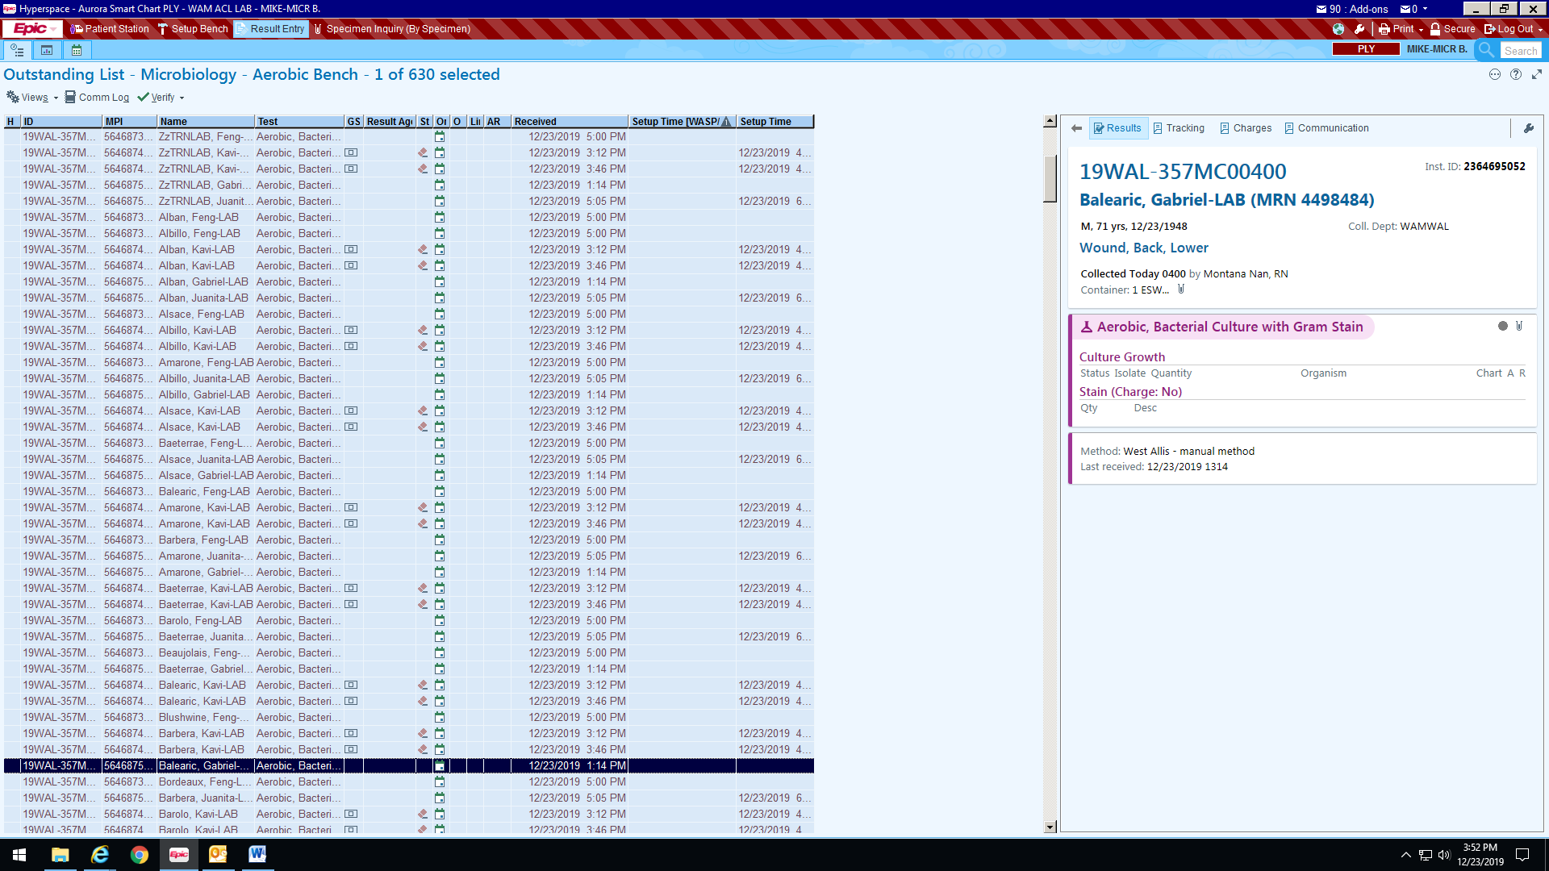
- Scan Specimen ID from Gram stain. There is a QR code on the label for the Gram stain.
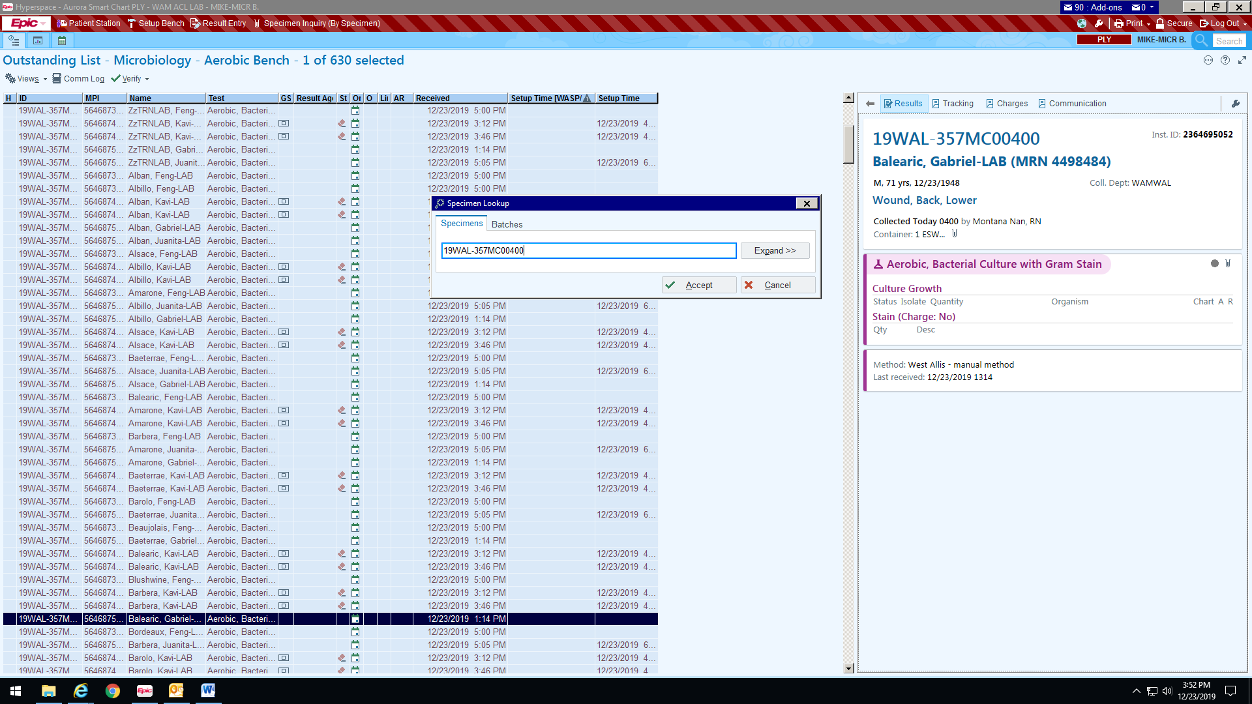

- Click on Edit

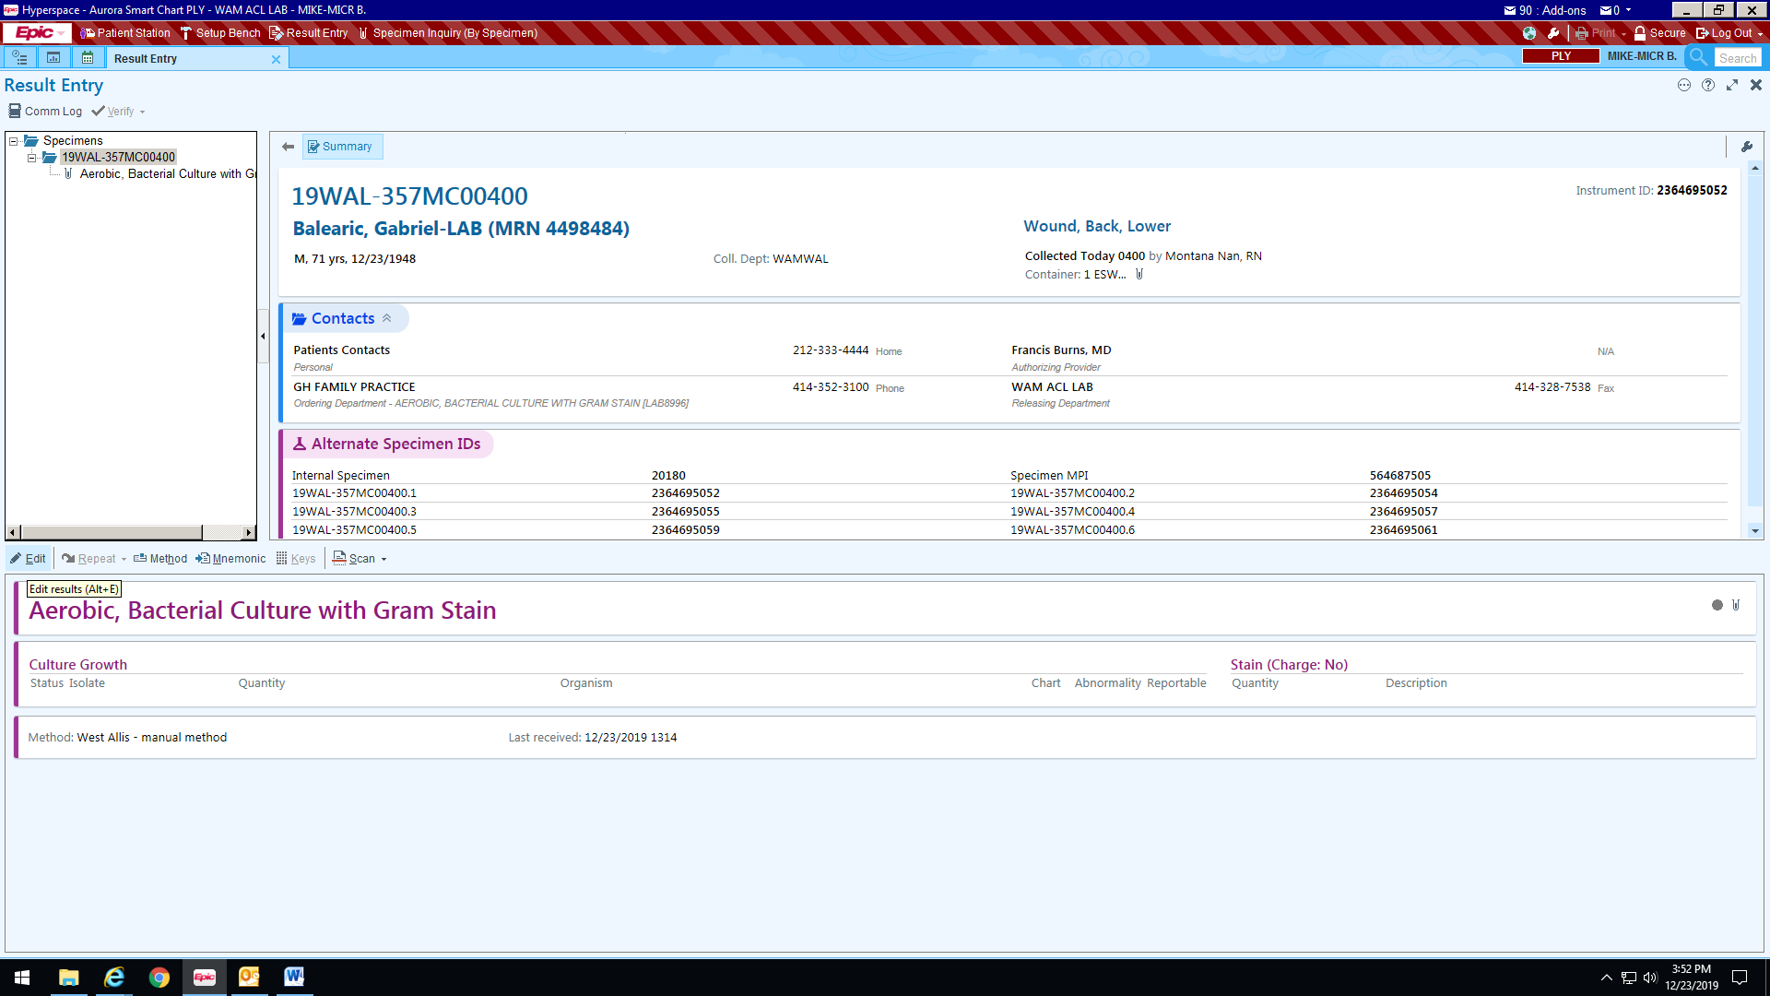
- Click on Stain Tab

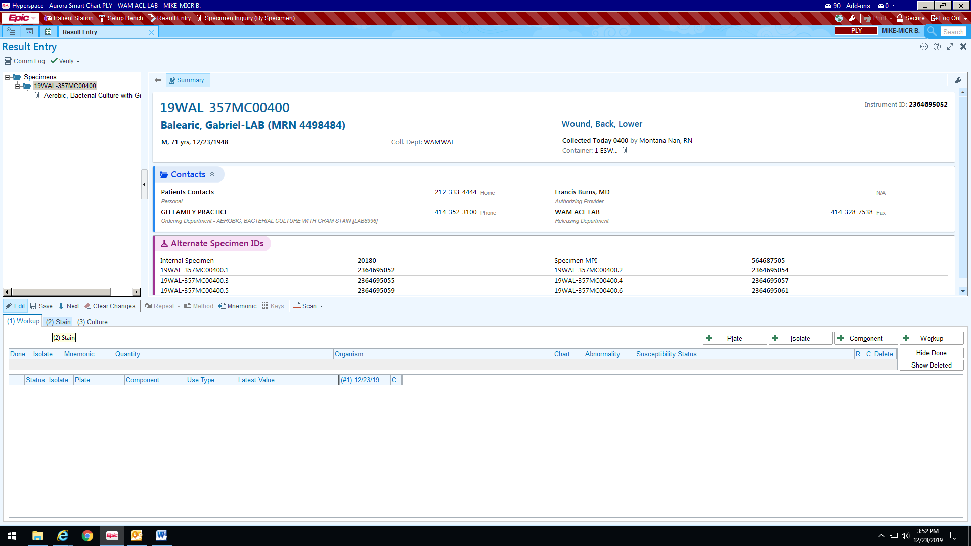

- Enter your result by using the magnifying glass or typing.

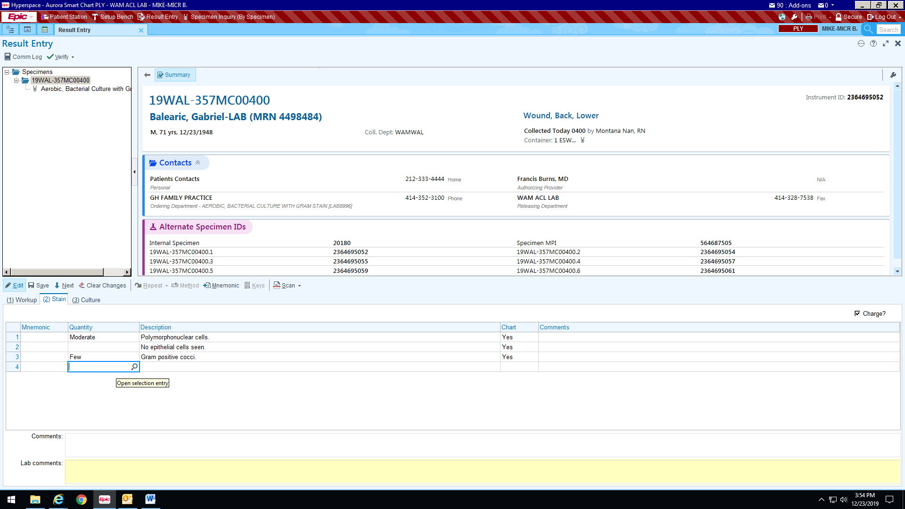

Gram Stain Review – With Telepathology/Photograph Review

(If Central Microbiology makes a final determination based on telepathology/photograph review to enter Gram stain results.)
Note: If a final determination cannot be made by Central Microbiology via telepathology/photograph review based on quality of sample or limited information available, follow the reporting format on Page 7.
- Enter Gram stain results under Stain tab.

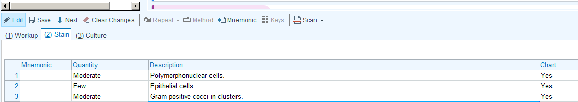

- Enter comment “Gram stain reviewed remotely by ACL Central” (REMOTE).

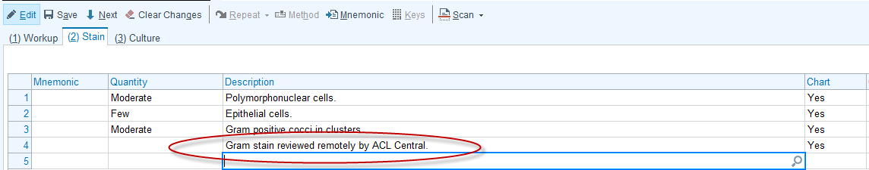

- If call documentation is required (e.g. critical result), click on the Comm Log.
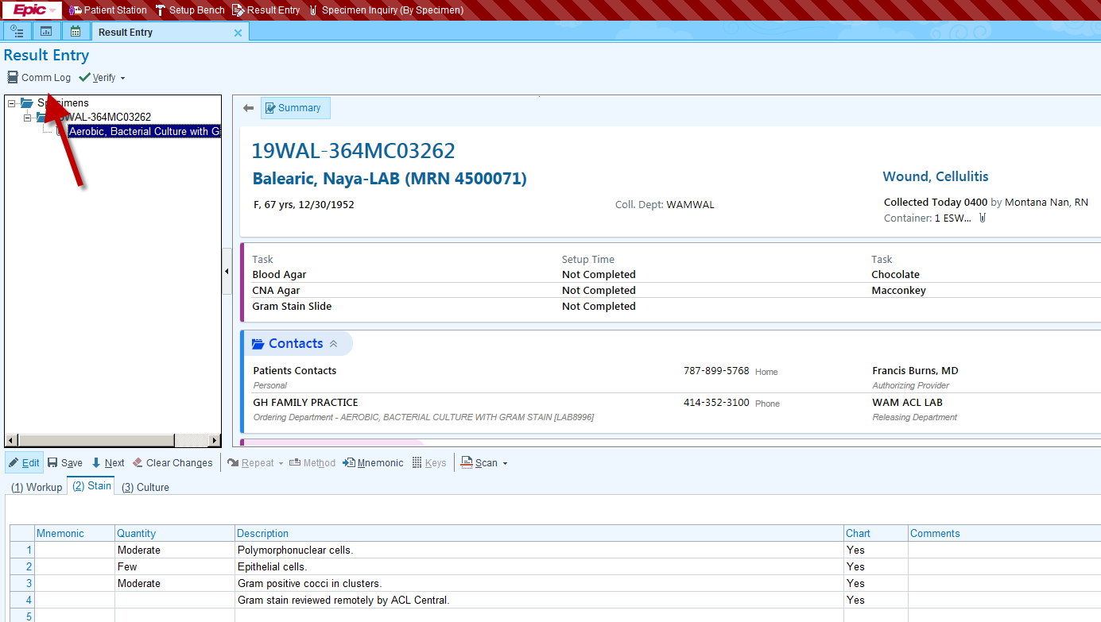
- To change the purpose for the phone call to the appropriate category (e.g. critical result, Other, etc.), click the magnifying glass in the Topic field.

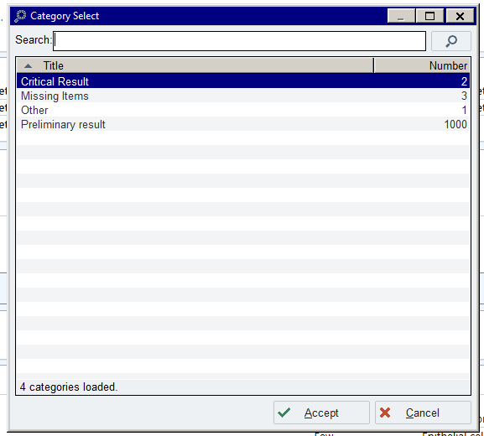
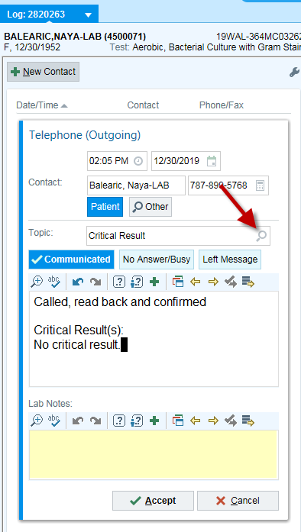
- Put who you called in your call documentation. The system will automatically document who is making the phone call. Hit Accept.

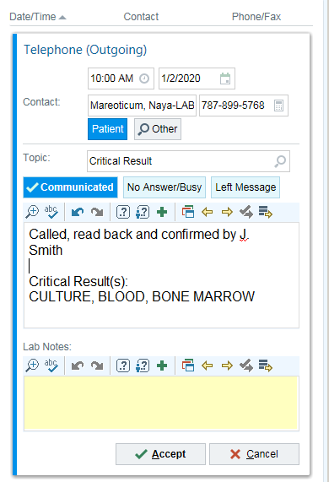

- Prelim Verify Results.

Gram Stain Review – When Telepathology/Photograph Review Cannot be Performed

Note: If a final determination cannot be made by Central Microbiology via telepathology/photograph review based on quality of sample, limited information available, or equipment malfunction - follow the reporting format below.

- Enter Gram stain results under Stain tab.

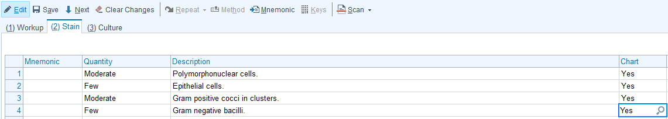

- Enter comment “Preliminary Report to be Reviewed by ACL Central” (MCPRE).

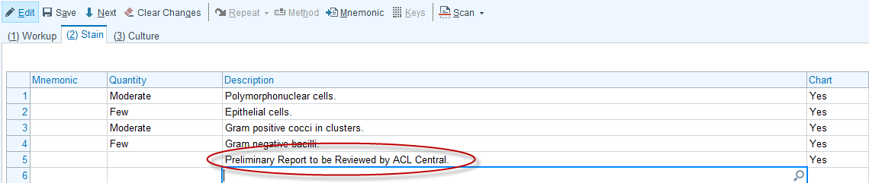

- If call documentation is required (e.g. critical result), click on the Comm Log.

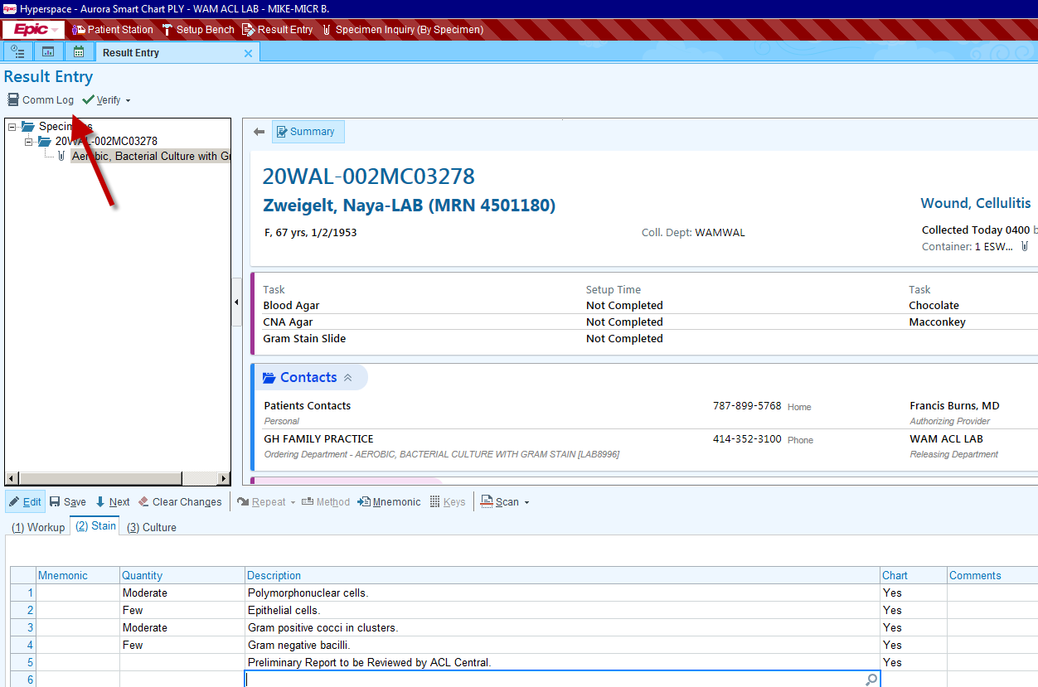
- To change the purpose for the phone call to the appropriate category (e.g. critical result, Other, etc.), click the magnifying glass in the Topic field.

- Enter your call documentation as to who was called. The system will log who made the phone call. Hit Accept.

- Prelim Verify Results.

- When ACL Central receives the smear for review, it will be indicated whether the review agrees or disagrees with the original assessment.

  - If the review is in agreement, the comment “Gram stain confirmed by ACL Central” will be entered.

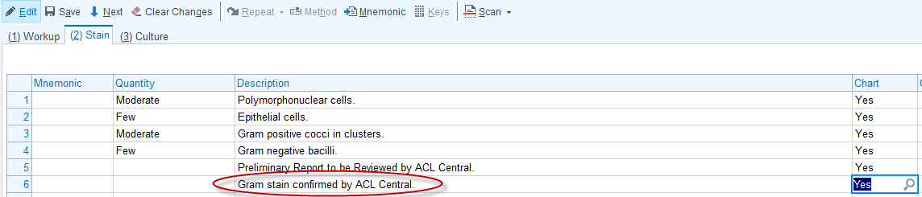

  - If the review is in disagreement, the comment “Upon Review by ACL Central” will be entered with the ammended results following the GRAM STAIN REVIEW BY CENTRAL MICROBIOLOGY procedure.

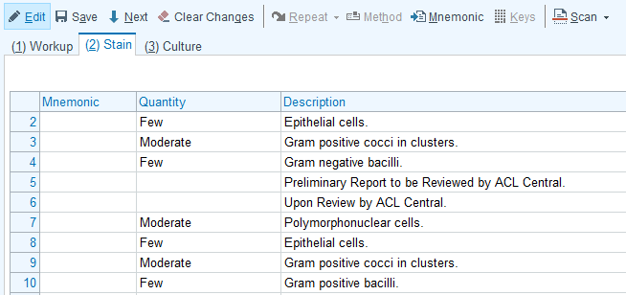

Entering a KOH Preparation

- Go to Result Entry and scan Specimen ID.
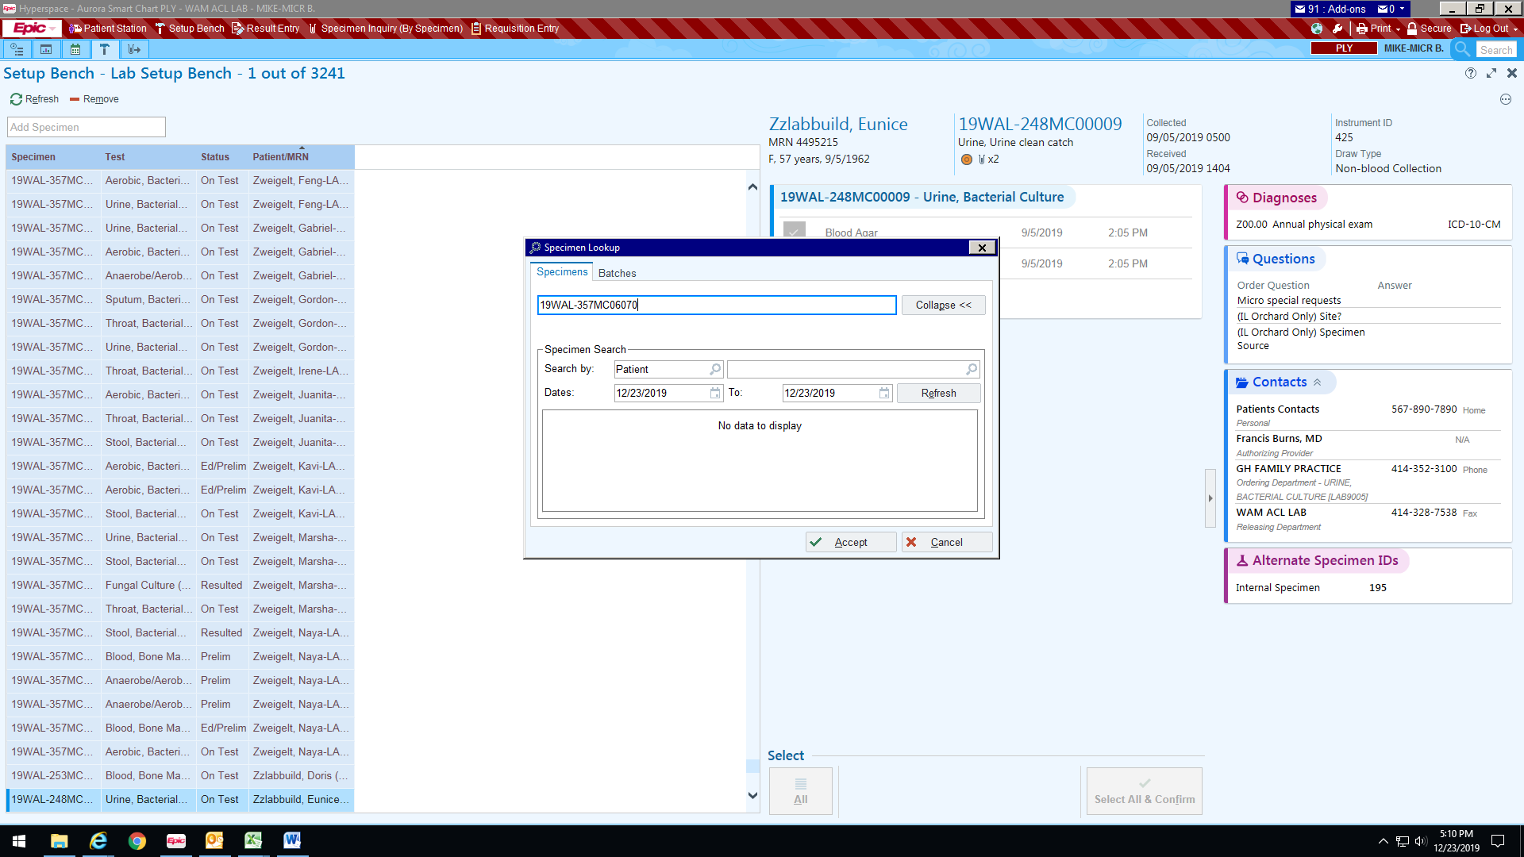
- Click on Edit for the KOH
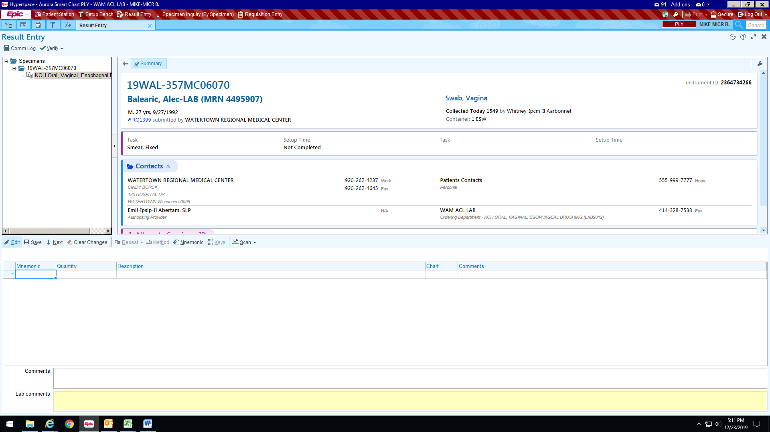
- Enter into the description the result. For this example it was entered as No Fungal Elements Seen.
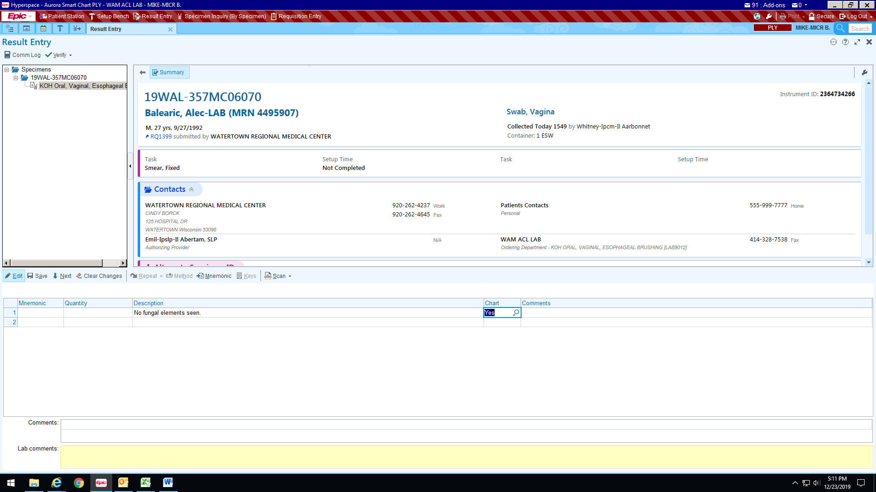
- Click on Final Verify.
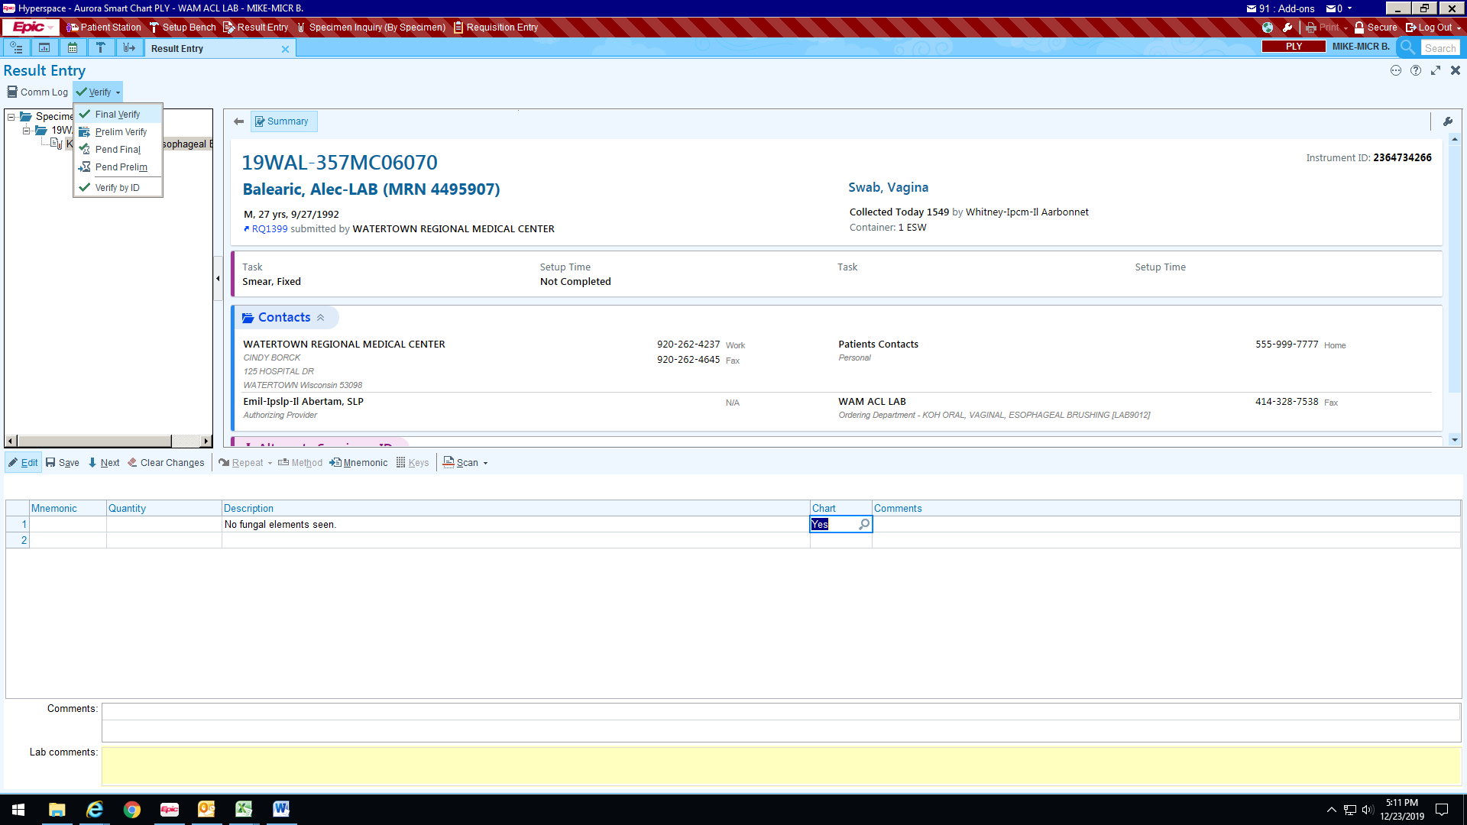

- Verify your results and hit Confirm Final.
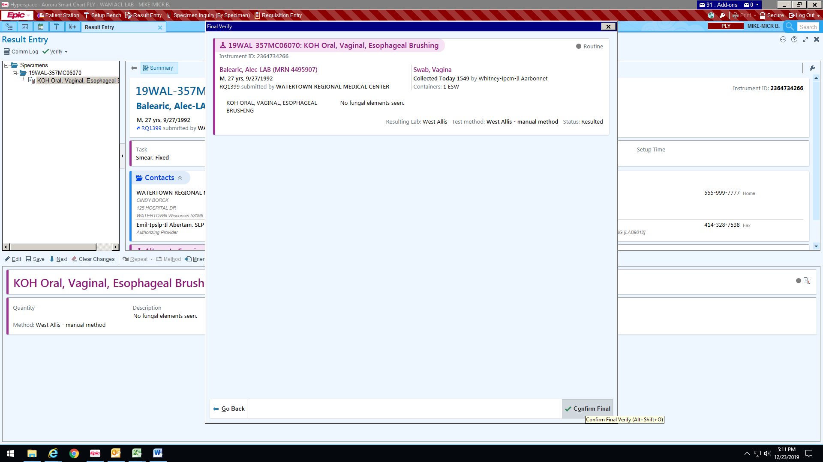

Work up of a Blood Culture – Organisms Seen

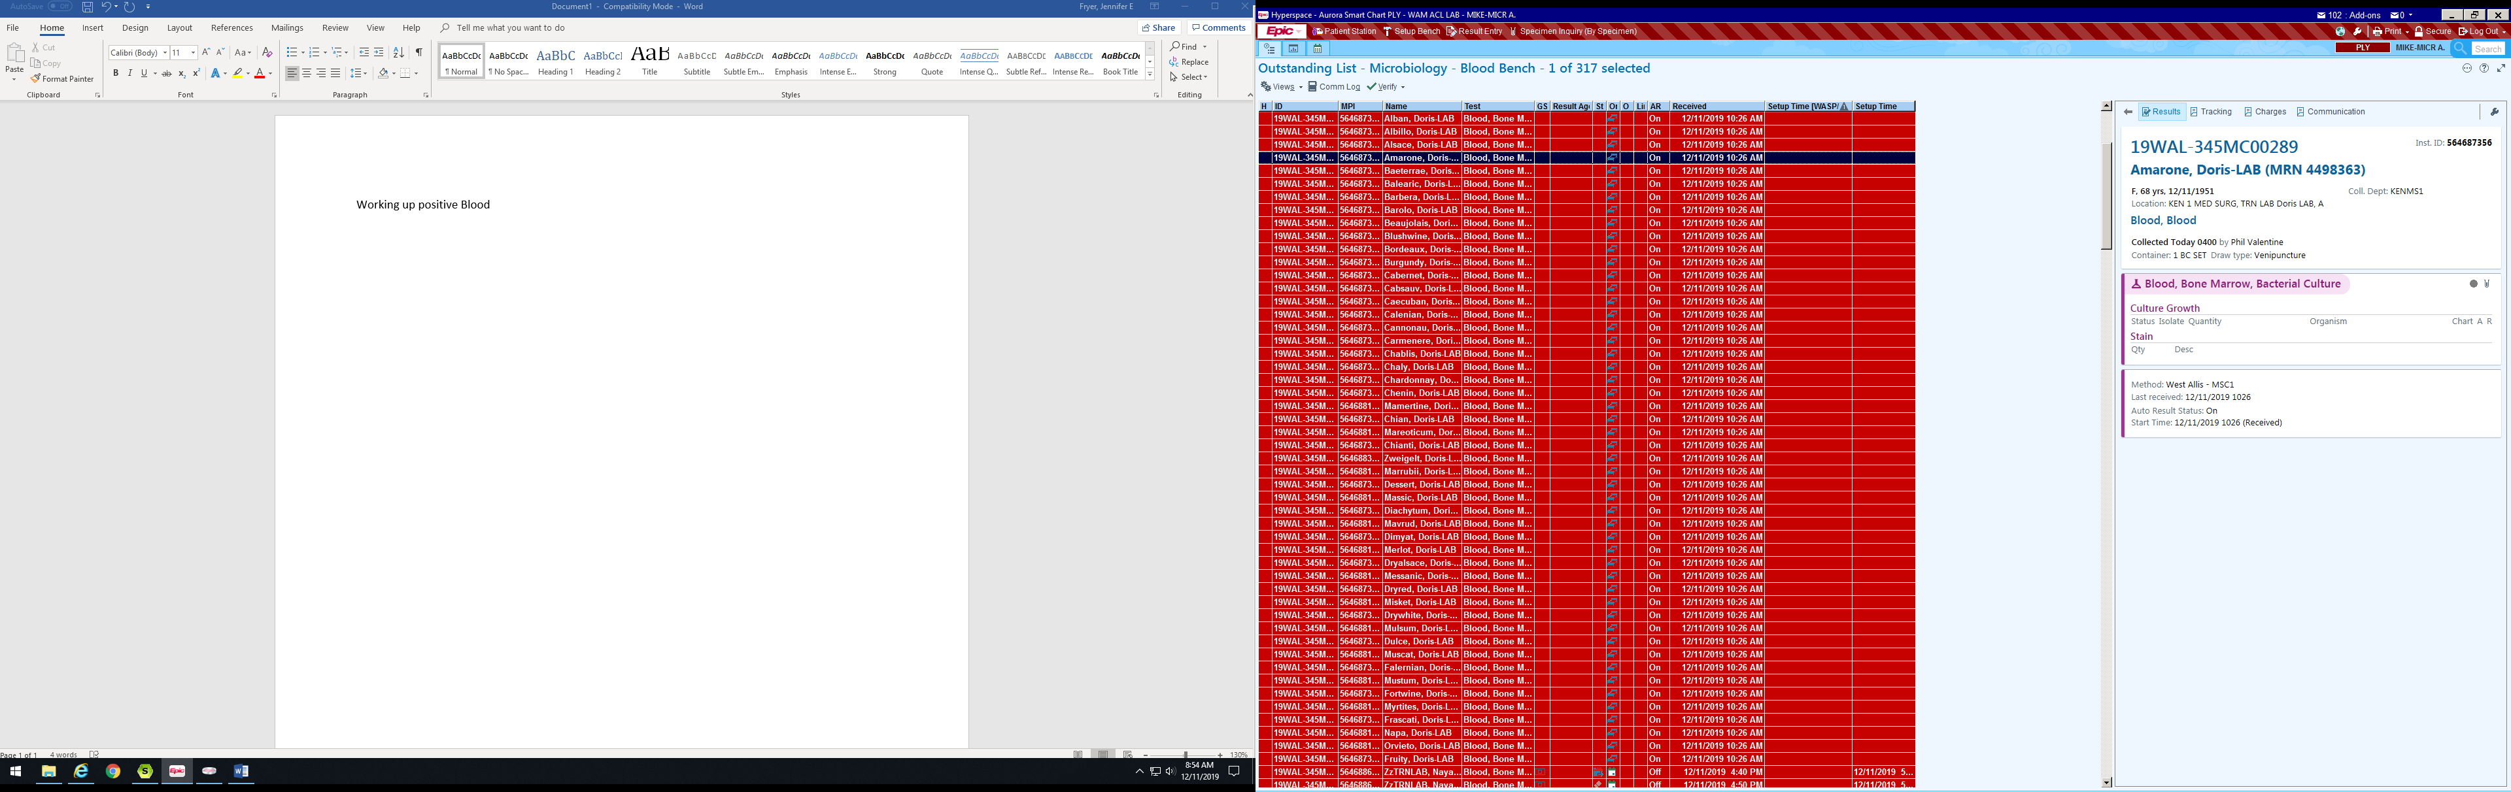
- Open Result Entry

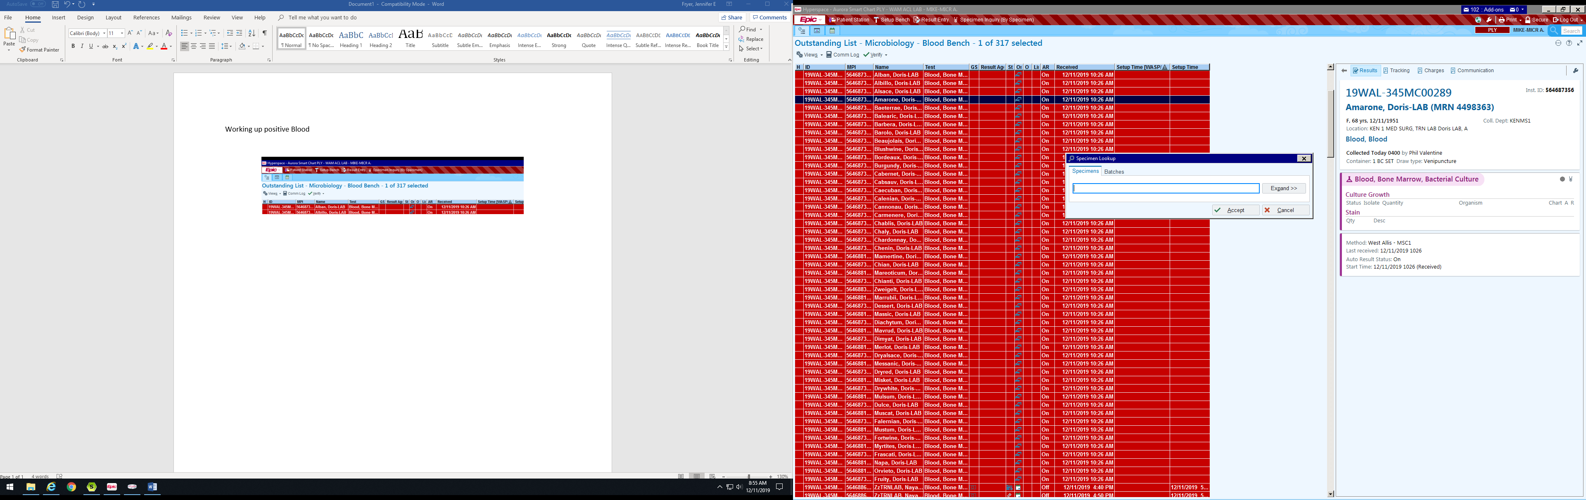
- Scan Accession

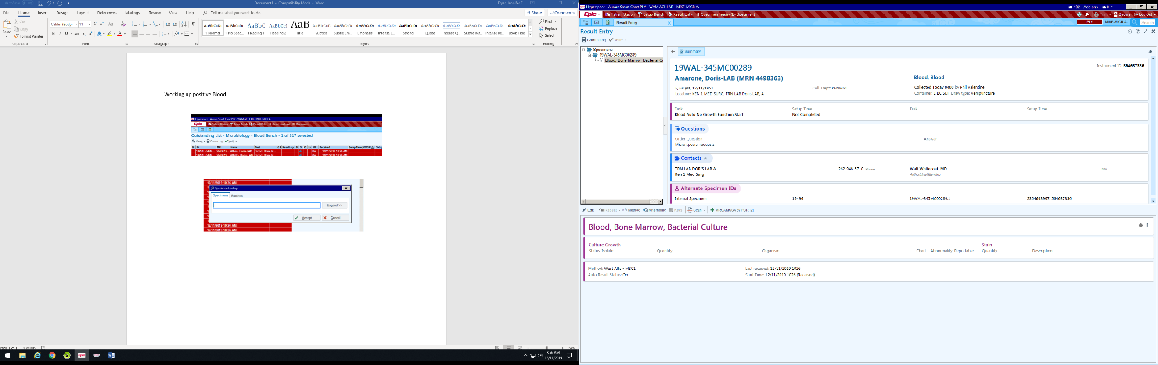
- Click Edit

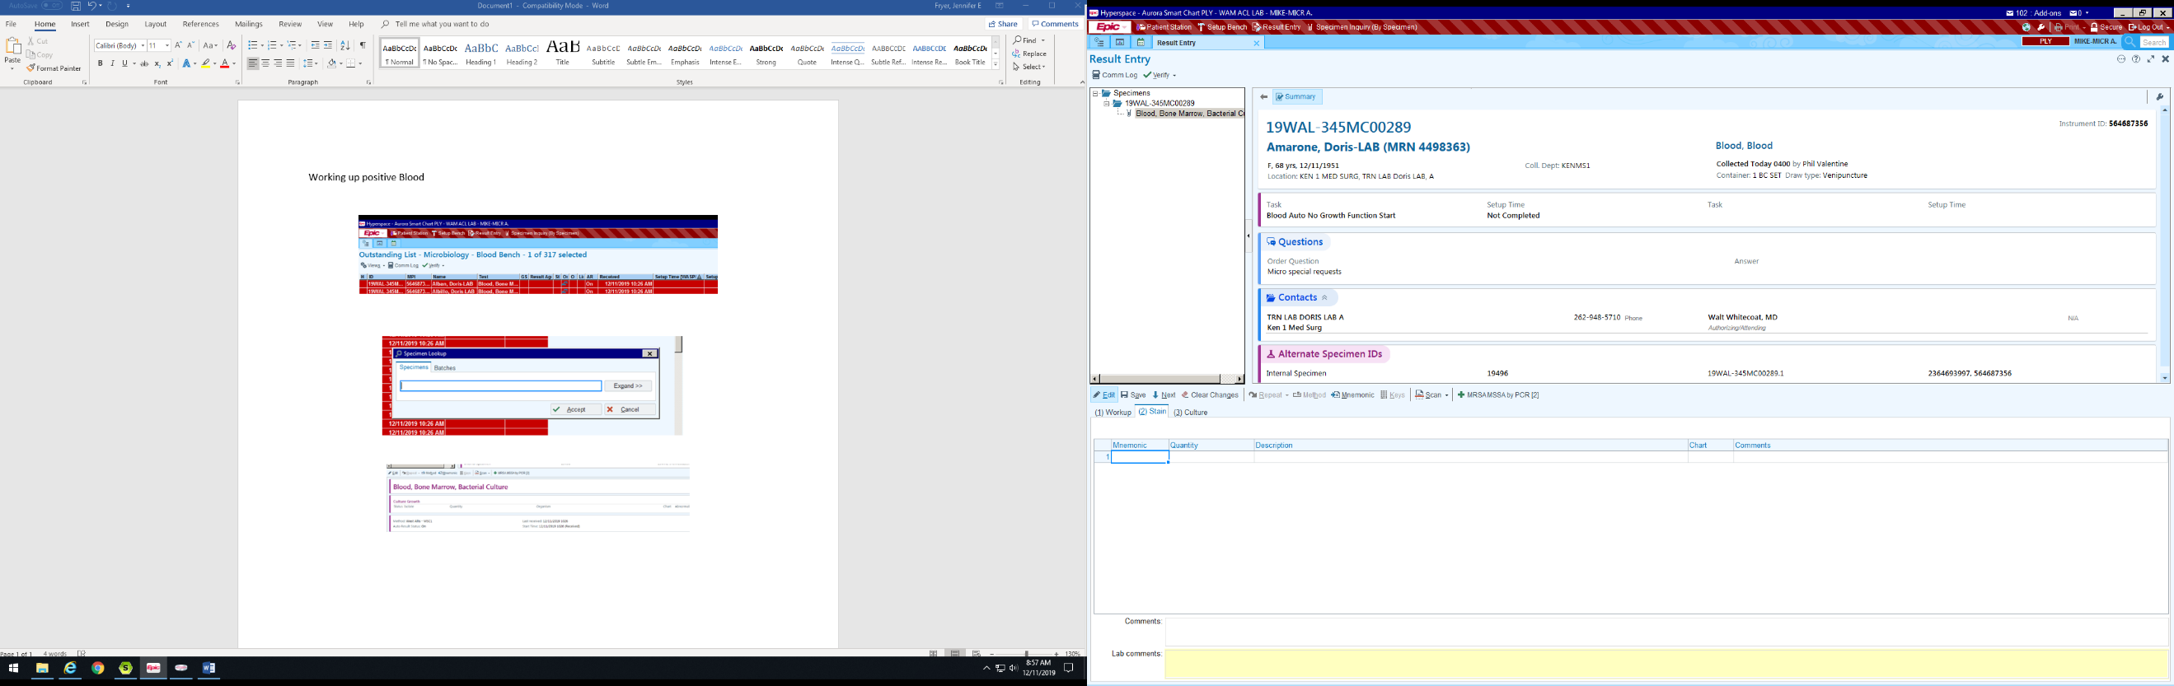
- Click the “Stain” Tab

- Enter Gram stain result. Click the magnifying glass for a list of options or begin to type result and click tab. Many codes are built similar to AML (GPCICL = Gram positive cocci in clusters)

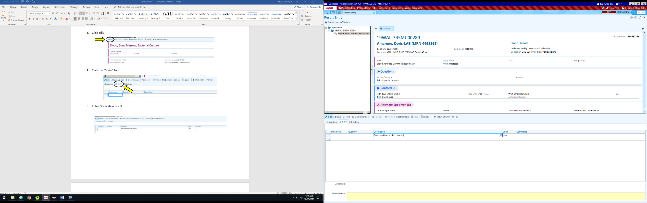
- Click in comment field

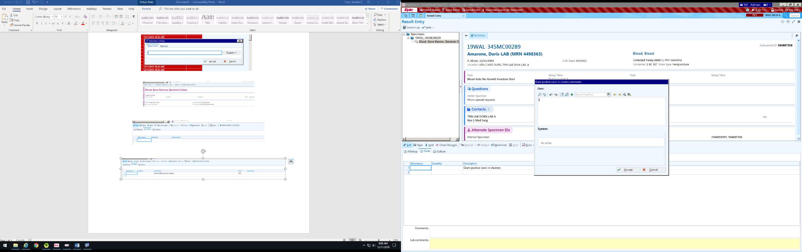
- A window will pop up to add in your comment codes i.e IAB, IANB, and IBB. Click Insert SmartText box and begin to search for code.

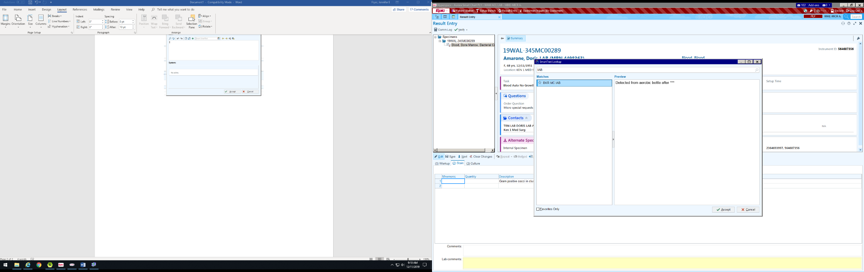
- Once correct code is found hit Accept.

Bottle Type | Look up | Beaker Comment Code
Aerobic Bottle | IAB | BKR MC IAB
Anaerobe Bottle | IANB | BKR MC IANB
Aerobic/Anaerobic Bottle | IBB | BKR MC IBB

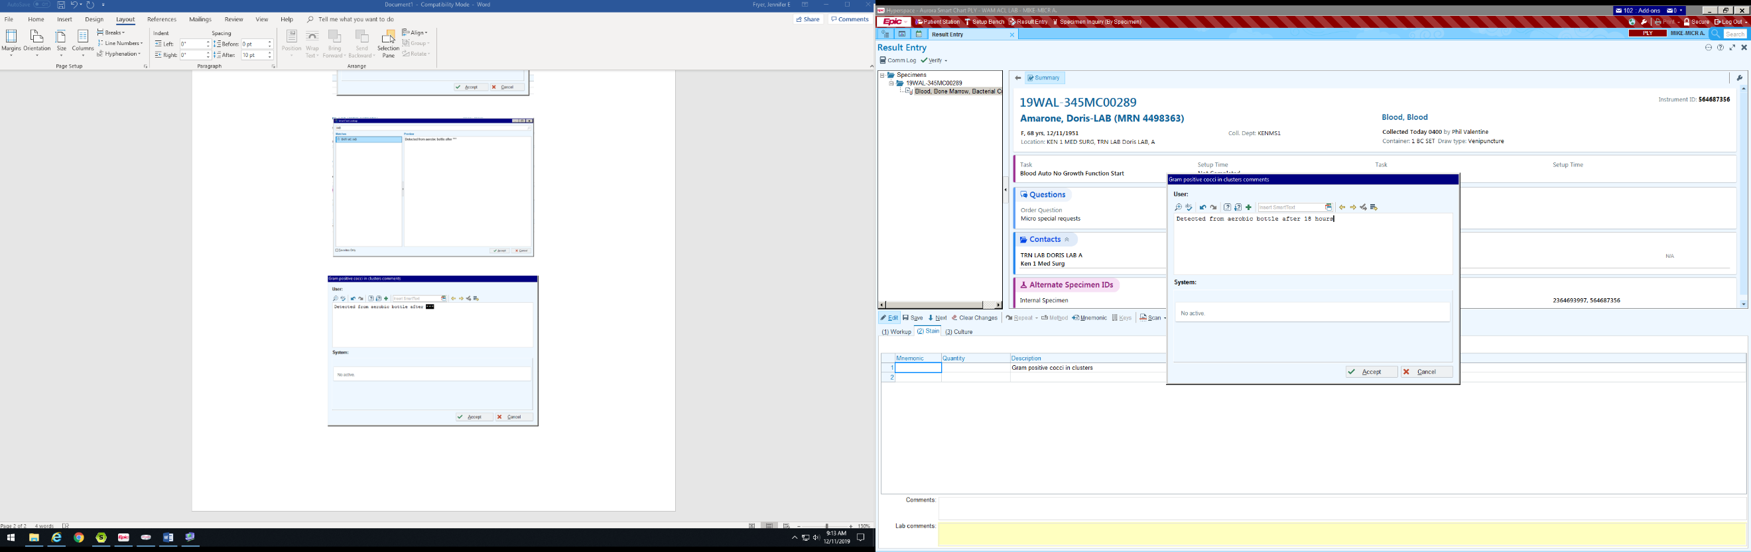
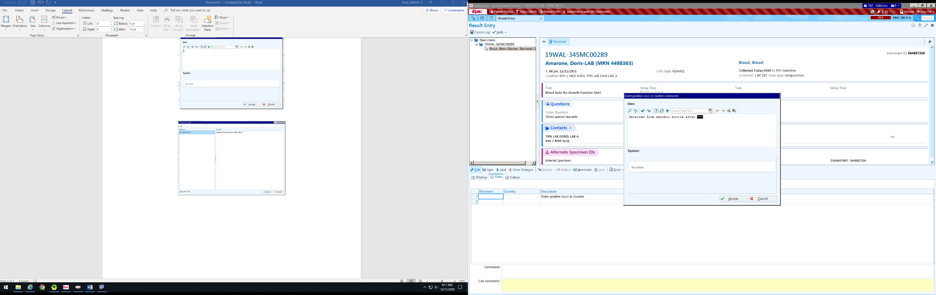
- After hitting Accept the comment will appear in the box below. Hit F2 to highlight the starred areas. (The starred areas always mean the comment needs to be completed). In this case after hitting F2, type how many hours positive. Then click Accept.

- Now the comment appears in the comment section. No need to Alert this (like in AML) as it is done automatically.

- From here click on the “Workup” Tab
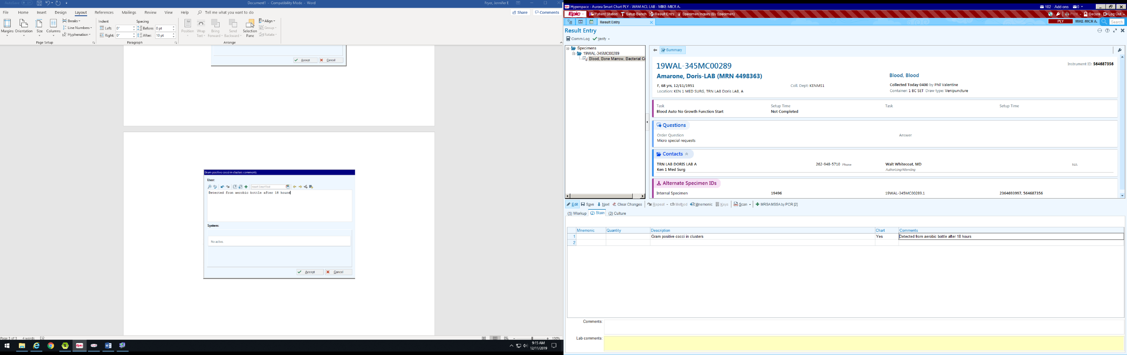

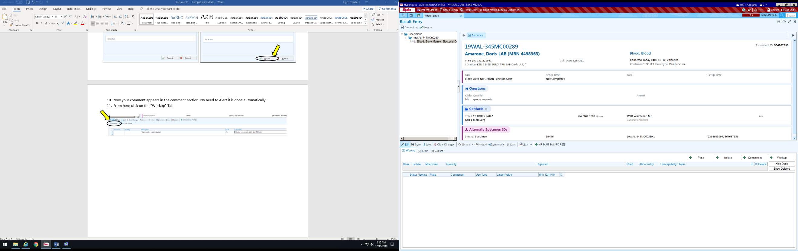
- Click “Isolate” to add an Isolate

- All the decision trees will appear. Click the “RRL Central” tree.

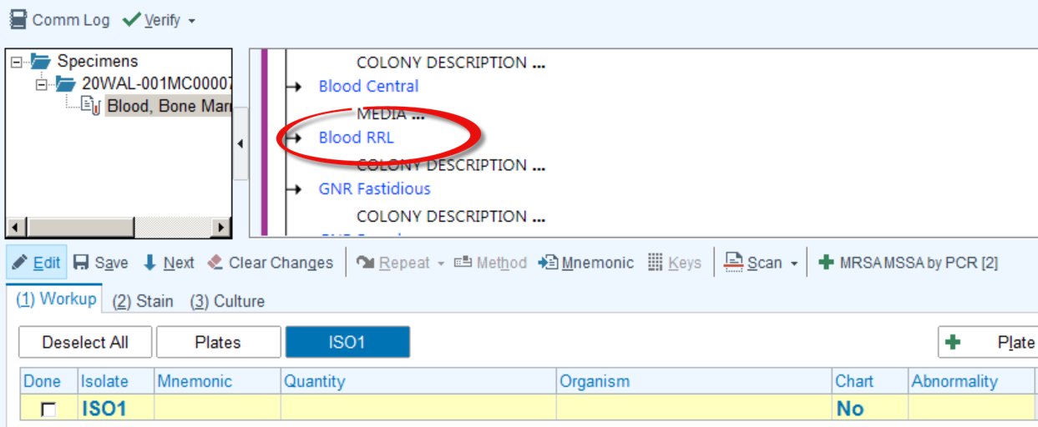

- For Colony Description, select “Positive”.

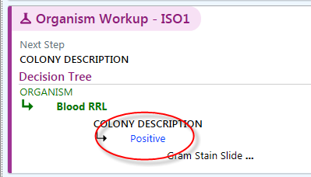

- The next option is Gram stain result.

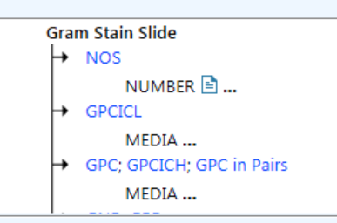

- The next option is bottle type.
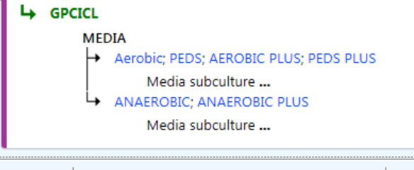
- The next option just click on what components will be subbed.

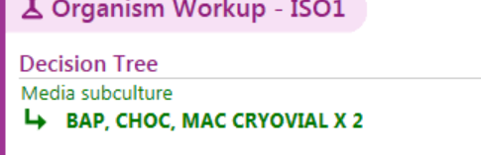

- At this point, the Decision Tree is complete. The organism line should be yellow/blank with “no” in the CHART section

- In the Culture Growth below you’ll have to change the culture result if the Gram stain was positive for bacteria/yeast/fungi from “No Growth…” to “Culture reincubated. No further information available.” You will find this result by clicking on the magnifying glass.

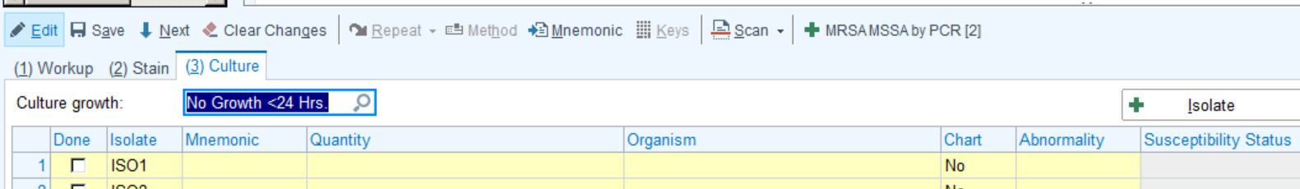

- To reprint labels for the culture and subs, select the following:

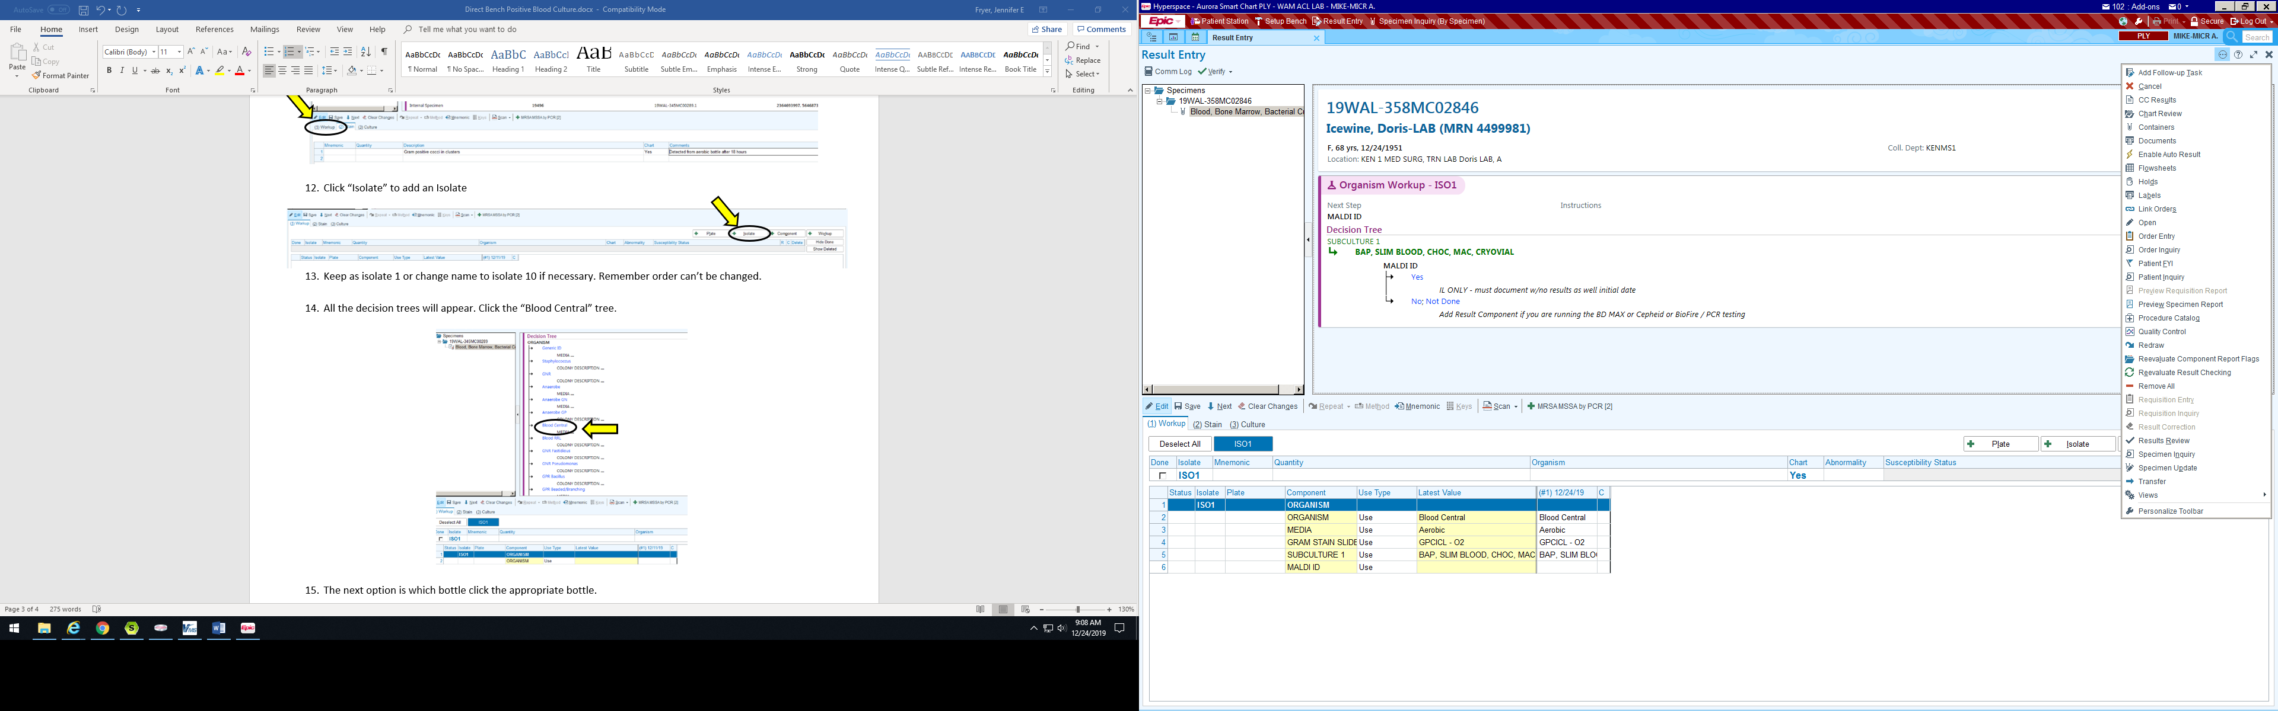

- Ensure the Call Documentation is entered into the Comm Log.

- The Decision tree and culture workup is complete. Prelim Verify Results.

Work up of a Blood Culture – No Organisms Seen

- Open Result Entry

- Scan Accession

- Click Edit

- If the Grams stain result is No Organisms Seen, DO NOT enter anything in section (2) Stain & (3) Culture. Go straight to (1) Workup where the decision trees are located, and enter your tasks.

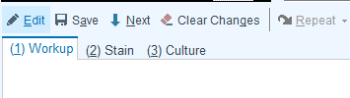
X
X

- Choose the Blood – RRL tree

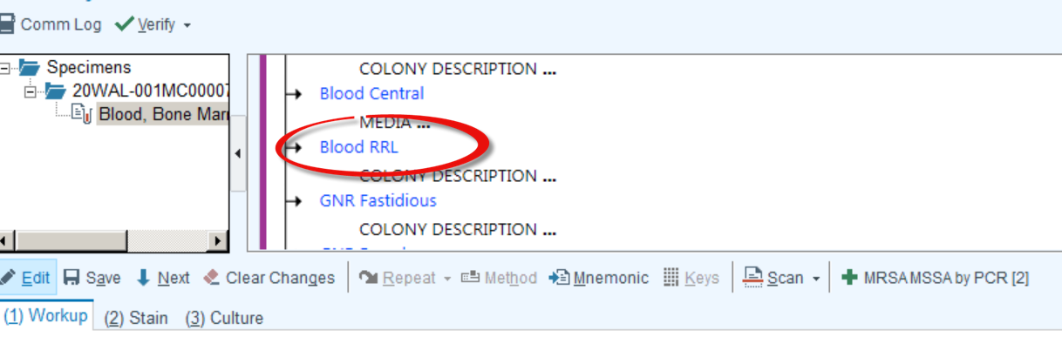

- For the Colony Description, select “Positive”.

- Select NOS – for No Organisms Seen

- Choose if it was the 1st time NOS or 2nd time NOS. A pop up message will appear to remind us if it’s the first time to reload the bottle. You’ll only send the plates and slides to Central.

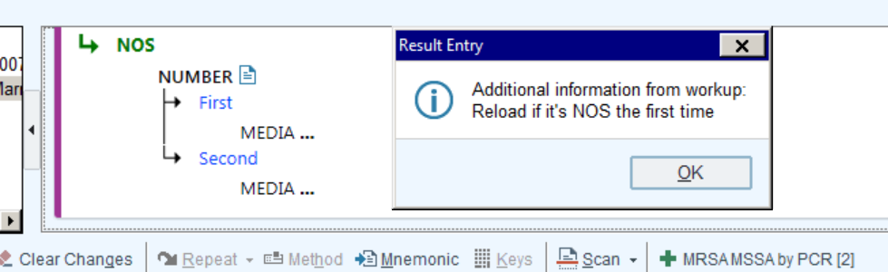

- Choose the bottle type and media that that NOS should be plated on.

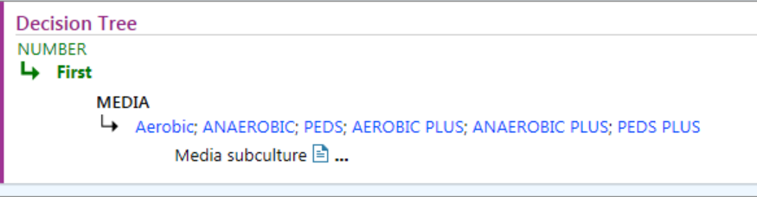
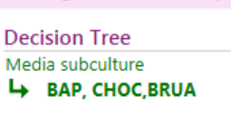

- If it’s the 2nd NOS you will get a message to send plates, bottle, and extra slide to central. You will still have to make sure the auto no growth is on and Beaker updating it automatically.

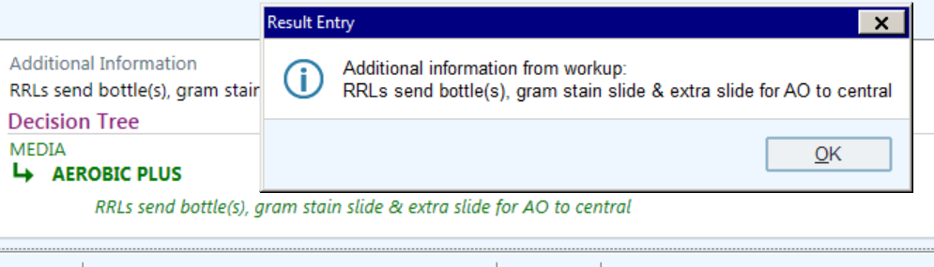

- To reprint labels for the culture and subs, select the following:

- The Decision tree and culture workup is complete. Prelim Verify results.

Entering a Reject Sputum Gram Stain in to Beaker

- Click on Result Entry.

- Scan Specimen ID from Gram stain. There is a QR code on the label for the Gram stain.

- Click on Edit

- Click on Stain Tab

- Enter results by using the magnifying glass or typing the code BSPT.

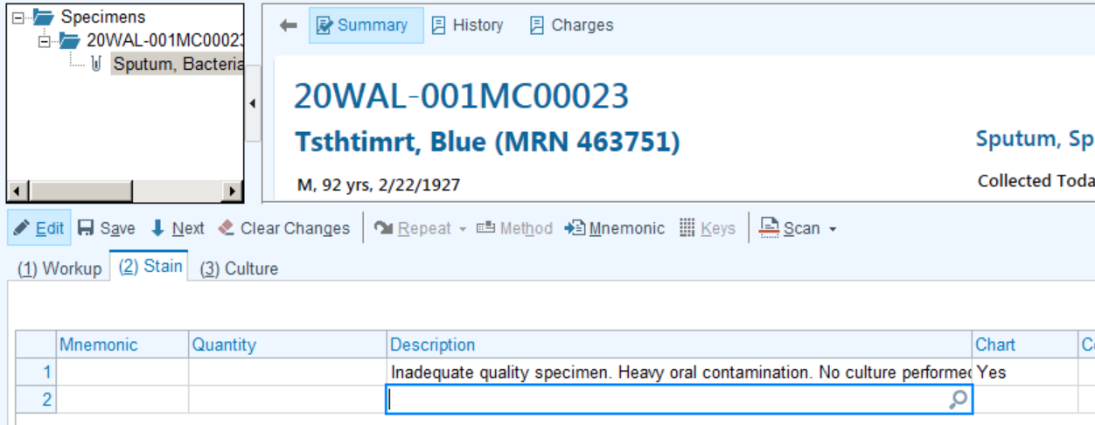

- Enter “Culture not performed” in the Culture Result Field #3 below. By using the magnifying glass you can locate the result and select it.

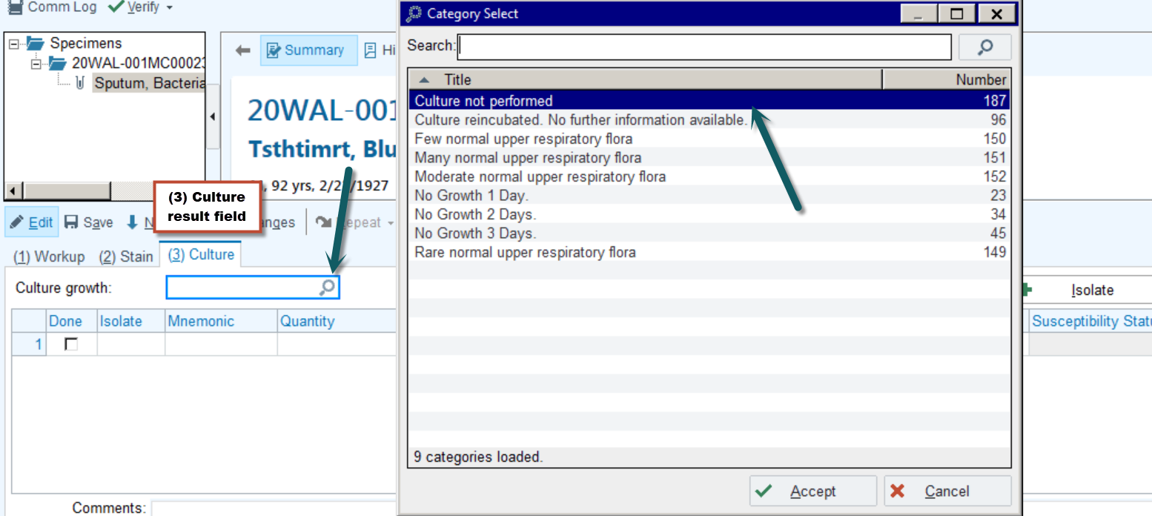

- Call documentation is required click on the Comm Log.

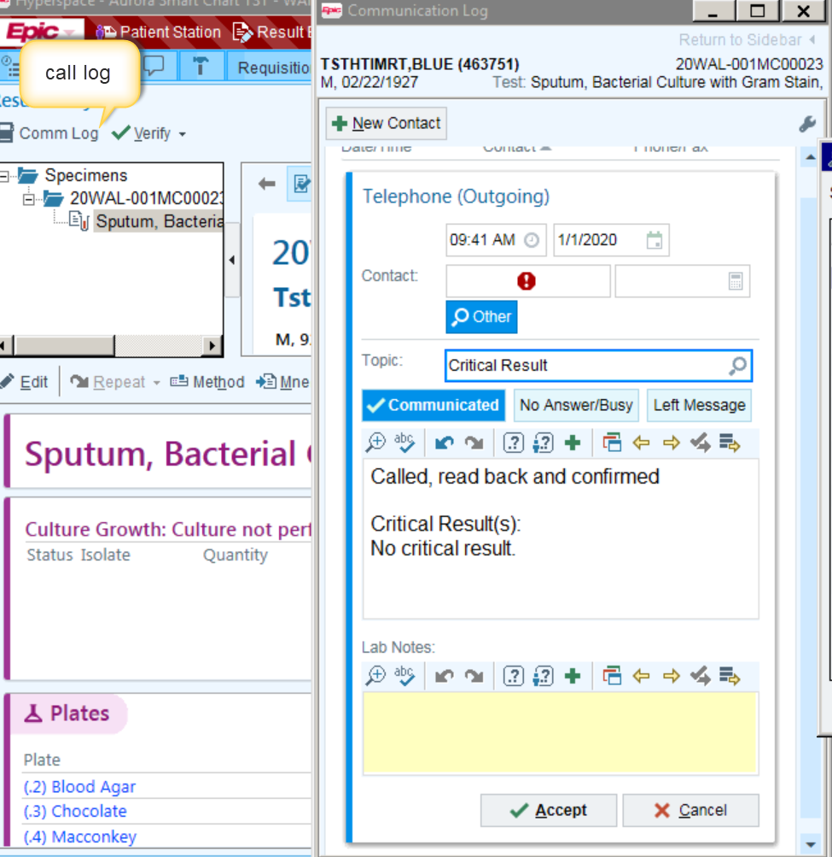

- Once you have the Comm log opened click on the topic box circled in red below and topics will appear. Choose the “Sputum Rejects” topic.

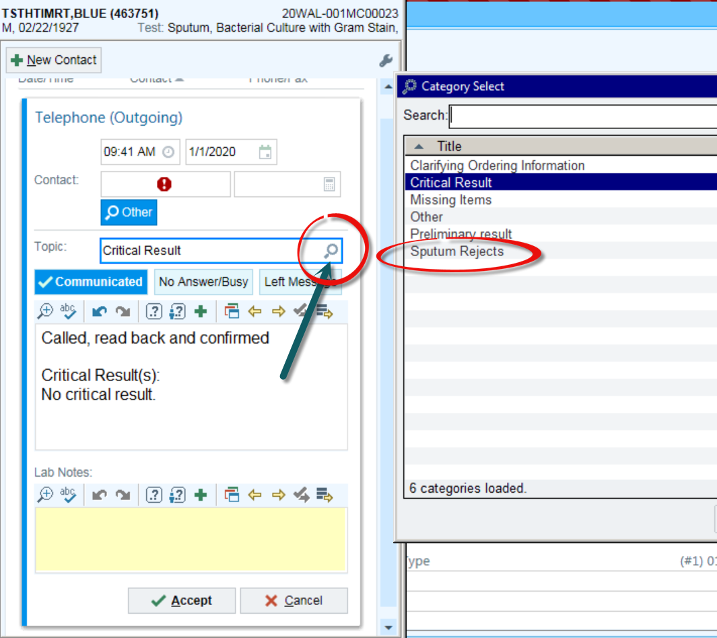

- Once you have selected the correct topic, enter who you had notified. That is the only documentation required. The system will date/time stamp and add your name as the person that called.

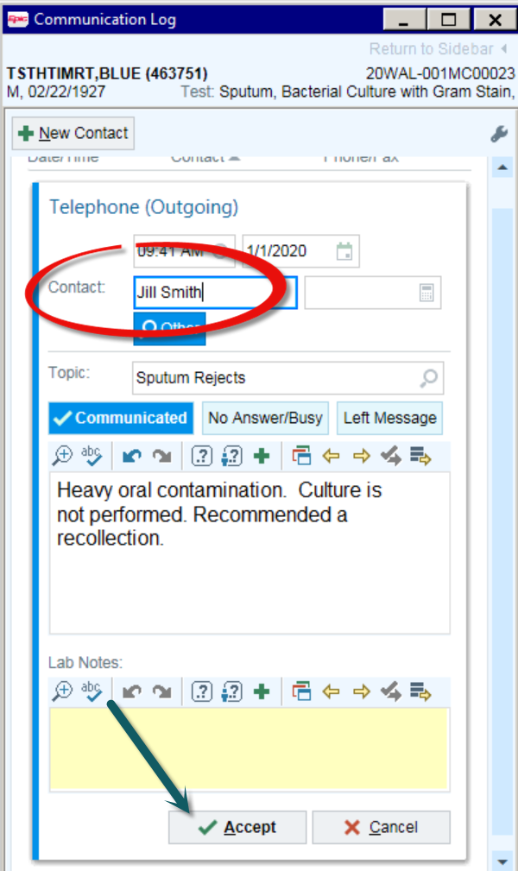

- Final verify your results by going to the top of the page by the Comm Log and click on Final Verify.

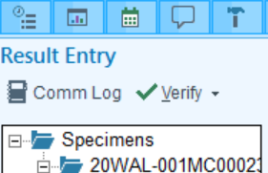
- This is what the report will look like.

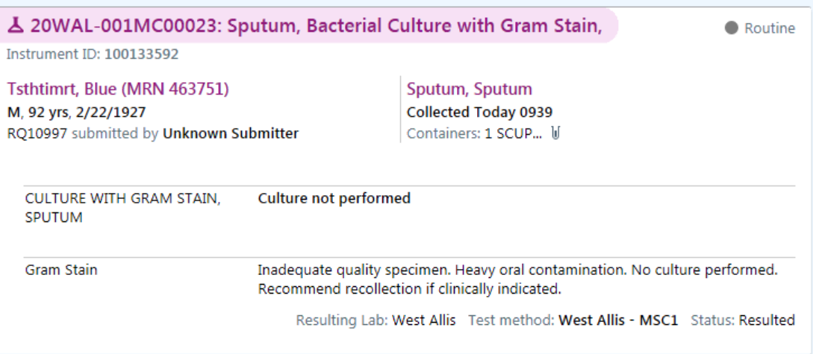

- Must credit the culture portion of the test by going into specimen inquire (by patient)

- Find the Charges page and remove the culture 87070 (CPT) Culture, Aerobic charge noted below.

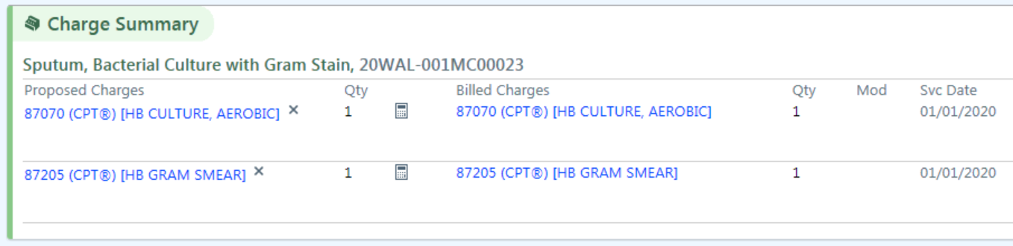

- Click on the “x” for the CPT code charge we are removing and a box w/reasoning will appear. Select Credit and “Yes” w/the green check mark. A comment is not necessary.

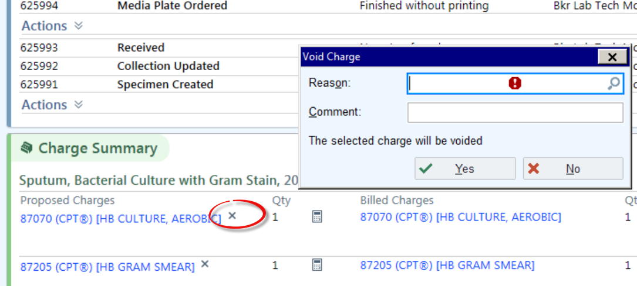
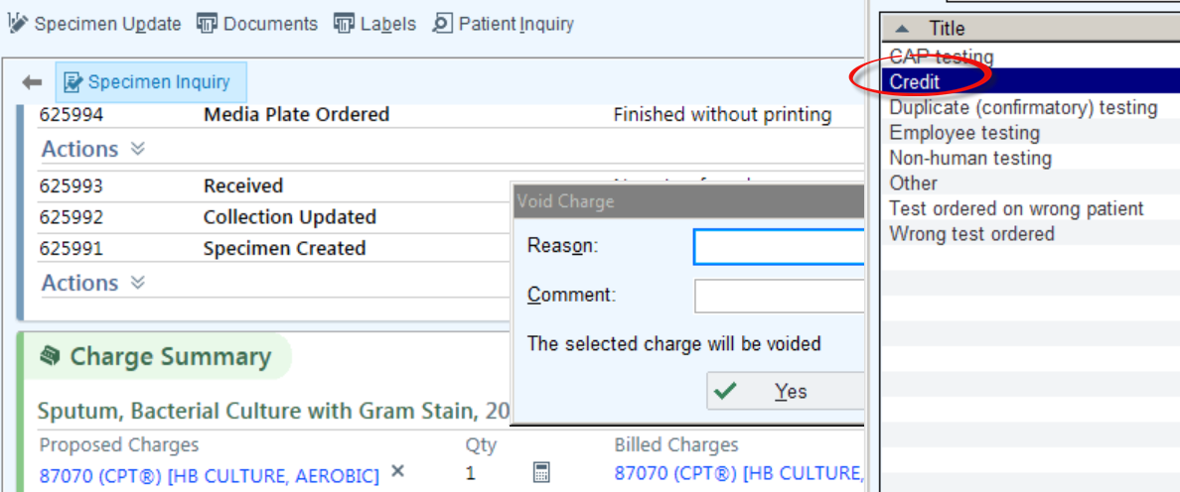
- If the charges were successfully removed it should look like this:

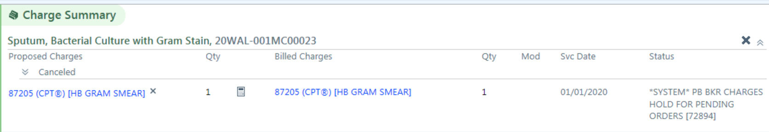

- Call documentation in the chart will appear like this:

