**INCIDENT RESPONSE PLAN**

1. **Introduction**

Tarrant County is exposed to many hazards, all of which have the potential for disrupting County operations, causing damage and creating casualties. Each department of Tarrant County is responsible for protecting citizens and employees from the hazards associated with natural disasters, technological accidents, criminal acts, etc. These responsibilities include providing for the safety of County personnel, preserving facilities and equipment, protecting the public from on-site incidents that affect the health and safety of the community, and contributing to overall community emergency preparedness.

Some of the hazards which might affect the County include, but are not limited to, natural disasters such as extreme cold/heat, fires, flood/water related incidents and severe storms, including tornadoes, lightning and hail. Technological disasters include hazardous materials accidents and power/telephone outages. Other hazards may include bomb threats, vandalism, civil unrest, terrorism and medical emergencies.

This incident response plan was prepared and implemented to meet the requirements set forth according to 29 CFR Part 1910.120, OSHA’s Hazardous Waste Operations and Emergency Response Standards.

Drills or exercises must be conducted annually to test and evaluate the effectiveness of the Incident Response Plan. The plan must be reviewed and revised, as necessary, annually, after any drill or exercise and after any incident. Drills and exercises must be documented to include how the drill or exercise tested and evaluated the plan, any problems that were identified and corrective actions(s) taken, and the names of registered entity personnel participants.

Training for all laboratory personnel on the Incident Response Plan (IRP) will occur on an annual basis. New employees will receive IRP training immediately after hire. Personnel must receive annual updates or additional training when procedural or policy changes occur. Visitors entering the laboratory with DOJ security risk assessment approvals who will be working in the BSL-3 laboratory (Rooms 1714 and 1714A) and BT Suite areas (Rooms 1715-1718) will receive training on the Incident Response Plan before working in those areas, when procedural or policy changes occur, and annually thereafter.

1. **Chain of Authority/Recall List**

A. The Public Health Department Director, or their designee, will evaluate building situations. Based on this evaluation, the Director will coordinate the decision-making process with appropriate first responder agencies to determine if evacuation of the building is necessary. In the temporary absence of the Director, the Deputy Director will coordinate all decisions. The Deputy Director will attempt to contact the Director but will **not** delay making the decision to evacuate if doing so might jeopardize employee safety.

1. An updated contact list, titled “Notification Contacts and Phone Numbers”, including mobile telephone numbers and pager numbers, is located in Appendix A of this Plan.
2. In the event of an emergency, various levels of notification will need to be made. During business hours in life-threatening situations, immediate notifications will be made via alarm and overhead paging system. For after hours and threatening situations, a call-down tree will be initiated. Notifications will be made at various levels depending on the situation. The Public Health Director will determine the level of notification needed.
   1. **Level 1 Notification:**

Public Health Director *will notify*

* Deputy Director
* Health Authority
* Senior Public Information Officer
* Associate Director, Clinical Services
* Associate Director, Disease Control and Prevention
* Associate Director, Family Health Services
* Associate Director, Health Protection and Response
* Fiscal Services Manager
  1. **Level 2 Notification:**

Public Health Director *will notify*

* Deputy Director
  + - Health Authority
    - Senior Public Information Officer
    - Fiscal Services Manager
    - Associate Director, Clinical Services *will notify*

Division Manager, Adult Health Services

Division Manager, Preventive Medicine Clinic

Division Manager, Tuberculosis Elimination

Division Manager, Breast Cervical Cancer Control Program

Division Manager, Vaccine Distribution

* Associate Director, Disease Control and Prevention *will notify*

Division Manager, North Texas Regional Laboratory

Division Manager, Epidemiology and Health Information

Division Manager, Health Informatics; Public Health Information Technology Team

Division Manager, Tarrant County Information Registry

* Associate Director, Family Health Services *will notify*

Division Manager, WIC

Division Manager, Chronic Disease Prevention

Division Manager, Nurse-Family Partnership (NFP)

Division Manager, Perinatal Hepatitis B Program

Division Manager, Fetal Infant Mortality Registry & Child Fatality Review Team

Division Manager, 17P Program

* Associate Director, Health Protection and Response *will notify*

Division Manager, Public Health Preparedness

Division Manager, Environmental Health Promotion

* 1. **Level 3 Notification:**

Public Health Director *will notify*

* Deputy Director
  + - Health Authority
    - Senior Public Information Officer
    - Fiscal Services Manager
    - Associate Director, Clinical Services *will notify*

Division Manager, Adult Health Services

Division Manager, Preventive Medicine Clinic

Division Manager, Tuberculosis Elimination

Division Manager, Breast Cervical Cancer Control Program

Division Manager, Vaccine Distribution

* Associate Director, Disease Control and Prevention *will notify*

Division Manager, North Texas Regional Laboratory

Division Manager, North Texas Regional Laboratory *will notify*

* + Laboratory Response Coordinator
  + Clinical Laboratory Operations and Quality Coordinator
  + Consumer Microbiology Laboratory Operations and Quality Coordinator
  + Laboratory Technology Coordinator

Division Manager, Epidemiology and Health Information

Division Manager, Health Informatics; Public Health Information Technology Team

Division Manager, Tarrant County Information Registry

* Associate Director, Family Health Services *will notify*

Division Manager, WIC

Division Manager, Chronic Disease Prevention

Division Manager, Nurse-Family Partnership (NFP)

Division Manager, Perinatal Hepatitis B Program

Division Manager, Fetal Infant Mortality Registry & Child Fatality Review Team

Division Manager, 17P Program

* Associate Director, Health Protection and Response *will notify*

Division Manager, Public Health Preparedness

Division Manager, Environmental Health Promotion

**4.** **Level 4 Notification:**

A Level 4 notification will follow the same protocol for Level 3 notification. Each Division will develop a protocol to notify all employees within the division.

During normal business hours, office telephone numbers should be dialed first. If there is no answer at the office number, cell phone numbers should be dialed next. After normal business hours, home phone numbers should be dialed first. If there is no answer at the home phone number, cell or alternate phone numbers should be dialed next.

During heightened threat levels, the Public Health Director, Deputy Director, Associate Directors, Health Authority, Epidemiology Division Manager, Laboratory Division Manager, Information Technology Manager and Preparedness RN Coordinator will carry 800 MhZ radios to maintain communications in the event telephone and cellular networks are unavailable.

1. **General Information**
   1. **Building Description**
2. Tarrant County Public Health Department is located at 1101 S. Main Street, Fort Worth, Texas, 76104. The building is two stories tall and constructed of brick/glass.
3. Fire alarm pull stations and extinguishers are located strategically throughout the laboratory.
4. A safety kit shall be kept in each suite occupied by laboratory employees. The supervisor or most senior staff member in the suite shall determine the location for storage and perform routine safety checks (coordinated twice annually by the safety team). This responsibility can be delegated to the safety officer identified in each suite. The supervisor/senior staff member will ensure that the other employees in the suite are aware of the location. Employees are encouraged to keep emergency and safety supplies at their individual workstations.
5. Emergency shutoff for electricity and CO2 are located in the laboratory hallway outside of suite 1715 on both sides of the hallway. Emergency shutoff for the emergency back-up generator is located in the primary electrical room in the emergency generator service panel.
6. Laboratory emergency exits are located on the North and South sides of the building in the laboratory area and exits through the building are located on the East side. All exits are marked with lighted signs.
7. Evacuation maps are located at the end of this procedure.
   1. **Training**
8. Fire/Emergency drills will be conducted as directed by the Department Director/Supervisor and should be conducted at least annually to ensure that all employees are aware of evacuation routes and actions to be taken in emergencies.
9. Ensure that all employees are aware of emergency procedures.
10. Include training in emergency procedures during new employee orientation.
11. Specialized training will be offered to safety officers as necessary to prepare them to assist in an emergency.
12. Drill Preparations
13. Employees are required to participate in Emergency Drills in order to familiarize themselves with the building evacuation procedures and stairwell exits. The designated safety officers will play pivotal roles in these drills just as they will do in actual events. Any special considerations or exclusions from participation in drills must be pre-approved by both the departmental supervisor and the appropriate safety officer. All departments and all personnel are required to participate in drills. Safety is First! Do not take any unnecessary risks when participating in drills.
14. The safety officer will circulate a memo throughout the area detailing the evacuation plan. This plan must be readily available to all employees as well as visitors and guests in county facilities.
15. The safety officer will maintain a roster of division personnel listing the names of all persons assigned in the area. The roster will be carried to the gathering points outside in order to account for all employees.
16. The applicable Fort Worth Fire Department will be informed of the drill.
17. Drills will be scheduled at a time during which all employees have arrived for work. For the drill to be effective, the employees should not be aware of the date or time.
18. The safety officer for each area should put the evacuation plan into action. All alternates and aids for the physically challenged should assume their positions.
19. The Department Director/Supervisor will assist in supervising the drills. During an actual fire, this person may be coordinating with the Fire Department.
20. Occupants should leave the building via the nearest stairwell or exit and follow their exit plan to the gathering point area specified in the building evacuation plan. Occupants should remain aware of wind direction and should gather in an area upwind of the impacted building.
21. After the fire drill is concluded, input from safety officers and alternates will determine the overall effectiveness of the drill.
    1. **Emergency Responders**

Planning and coordination with local emergency responders must be maintained by the Laboratory Manager (Responsible Official) and/or the Laboratory Response Coordinator (Alternate Responsible Official). The connection to first responders is through Emergency Management Coordinators (EMCs) or Police/Fire Chiefs at each agency or municipality.

1. The Laboratory Response Coordinator will maintain a current list of local first responders and municipalities. Updated lists can be obtained from:
   1. Tarrant County Public Health’s Emergency Preparedness Supervisor in the Bioterrorism and Emergency Preparedness Section. The Emergency Preparedness Supervisor regularly coordinates with local emergency responders for fire drills at Tarrant County Public Health.
   2. Emergency Management Coordinator in the Tarrant County Administrator’s Office.
2. Examples of planning and coordinating with local emergency responders include, but are not limited to:
   1. Emergency Responder Training classes presented by the Laboratory Response Coordinator or Emergency Preparedness Supervisor.
   2. Laboratory tours and education on possible hazards that could be encountered in the event of an emergency response at the North Texas Regional Laboratory.
   3. Planned drills or exercises. These can be conducted in coordination with the Emergency Preparedness Supervisor.
   4. The Laboratory Response Coordinator maintains a relationship with the Weapons of Mass Destruction (WMD) Coordinator for the Dallas Field Office of the Federal Bureau of Investigation (FBI). The Dallas WMD Coordinator is the liaison between local emergency responders for delivery of unknown environmental samples to NTRL to be tested for agents of bioterrorism.
3. Interactions when planning and coordinating with emergency responders will be documented. Examples include, but are not limited to:
   1. Training sign in sheets and/or certificates of attendance for classes.
   2. Documentation of site visits and lab tours.
   3. Email communications related to coordination and/or planning.
   4. After-action reports for drills or exercises and/or reporting of test results.
4. **Safety Guidelines**
   1. **Fire**

1. The fire alarm will sound on the overhead paging system and will trigger strobe lights to flash. **If you hear the fire alarm,** evacuate the building and report to your evacuation point for accountability. When the fire alarm sounds, always assume the danger is real and evacuate the building.

2. **If you see a fire, activate the fire alarm immediately and call 9-1-1** on a telephone out of the immediate danger area.

3. All employees should know the location of the nearest fire extinguisher and should be trained in the use of the equipment. A Tarrant County employee may attempt to control small fires ONLY if the employee is familiar with types of fires and extinguishers and there is no immediate danger to themselves or others. NEVER use water on electrical or grease fires.

4. Emergency procedures.

1. Evacuate the floor when you are notified there is a fire in the building using the stairs, if necessary.

b. Go to the nearest exit.

c. **Do Not** use elevators under ANY circumstances.

d. Ensure fire doors are closed. Close all windows and the last one exiting the room should close the door. Do **not** lock door or windows.

e. Before opening closed doors, feel the door to see if it is hot. If the door is hot, do not open it, find another exit.

f. Do not enter smoke filled stairwells.

g. If trapped in a smoke-filled area, stay near the floor; cover your mouth and nose with a damp towel if possible.

h. Direct responding fire personnel to the fire scene; provide keys for any locked areas.

i. Report to your evacuation point for roll-call.

j. Once an evacuation is complete, no employee may reenter the building until allowed to do so by the Fire Department Incident Commander.

k. See Appendix E and G for evacuation routes.

l. If stairwells are blocked by fire or smoke, return to your office and:

1) Close the door.

2) Call the Fire Department (9-1-1) and give your location.

3) Place towels, clothes, etc. around the doors to prevent smoke from entering.

4) Place a wet towel or cloth over your mouth and nose and stay low to the floor.

5) Do not break any windows except as a last resort as this will only provide oxygen for the fire.

m. Make sure all employees are aware of the designated staging area outside the building. See Appendix F – Evacuation Rally Points.

n. It is possible that Fire Department personnel may be utilizing the stairwells to access the location of the fire. Always stay against the wall when going down a stairwell. If there is smoke, you can guide yourself down by following the wall.

o. STAY CALM AND ALERT! DO NOT RUN! If a stairwell becomes impassable, cross the floor to another stairwell and continue down. Only proceed to a higher floor if ordered to do so by Fire Department personnel or a Sheriff’s Deputy.

* 1. **Explosions**

1. **If you see an explosion**, **dial 9-1-1** on a telephone out of the immediate danger area. Evacuate the building immediately and proceed to your assigned evacuation point.

2. Emergency procedures:

a. Take shelter under a hard, sturdy surface to shield yourself from falling debris during the initial explosion.

b. After the initial explosion, go to the nearest exit.

c. Be aware of fire and other potential hazards.

d. **Do Not** use elevators under any circumstances.

e. Exit the building immediately following evacuation procedures.

f. If stairwells or evacuation routes are blocked by debris, seek an alternate route.

**C. Severe Weather**

Each facility normally occupied by County personnel should have a radio, a weather alert radio, or a television in each area. Whenever severe weather threatens Tarrant County, supervisory personnel should listen to the weather alert radio (162.550 MHz) or WBAP (820 kHz) or watch a local news station, or the local cable weather channel which includes the same audio as the weather alert radio.

Remember that a **Watch** means conditions are favorable for the event, such as a tornado, flooding or a severe thunderstorm to occur. A **Warning** means that the event, such as a tornado, has been confirmed to have occurred in the area.

The safety officer or alternate has the authority to notify all personnel of watches and warnings. If there is a **watch**, the safety officer (or designee) will notify the other safety officers and division managers in each area. The division manager or safety officer is responsible for notifying staff and clients if necessary. **Warnings** shall be announced so that all can be made aware. If a warning is announced, take appropriate actions listed below.

**1. Tornado**

a. If a tornado WATCH has been issued, continue to monitor weather reports and prepare to take shelter. If a tornado WARNING is issued for Tarrant County, **take shelter immediately.** The shelter area in the laboratory at the Main Street building is the stat lab (room 1707). At the Arlington lab, take shelter in the WIC area. If customers or clients are present in the lobby, they should be escorted to the shelter area by a lab employee and signed in when it is safe to do so.

b. If working outdoors, seek shelter in a permanent building or low-lying area using your hands to shield your head.

c. If in a vehicle, evacuate the vehicle and seek shelter in a permanent building or low-lying area. Never seek shelter under an overpass.

d. If in the building, move to your designated shelter point. ***Do not remain on second floor, move to ground floor.***

e. Avoid rooms with a large roof expanse, and stay away from windows.

f. Stay in shelter point until the “all clear” has been given.

g. After the tornado has passed, check for potential hazards: avoid power lines and fallen debris.

**2. Flooding**

1. Should flooding occur within the building, essential records and equipment should be moved to protected areas. Do so **ONLY** if there is no risk of personal injury.

b. If roads or entrances to the facility are flooded, contact Tarrant County Facilities Management at 817-884-2878 during business hours. After hours contact 817-994-5727.

c. If you are in a vehicle DO NOT drive into water. As little as 18 inches of water can displace a vehicle.

**3. Severe Thunderstorms**

Severe thunderstorms may produce high winds and hail which may cause damage to County property or facilities. Lightning may also occur.

**a. Lightning**

1. Emergency procedures:

a) When a thunderstorm threatens, seek shelter in a permanent building.

b) Do not stand underneath a natural lightning rod such as an isolated tree.

c) Avoid projecting above the surrounding landscape.

d) Get out of and away from open water.

e) Get away from tractors and other metal farm equipment.

f) Get off and away from motorcycles and bicycles.

g) Stay away from wire fences, rails and other metallic paths, which could carry lightning to you from some distance away.

h) Avoid standing in small isolated structures in open areas.

i) In wooded areas, seek shelter in a low area under a thick growth of small trees. In open areas, go to a low place such as a ravine or valley, but be alert for flash floods.

j) If you are in an open field and feel your hair stand on end, drop to your knees and bend forward putting your hands on your knees. Do not lie flat on the ground.

1. **High Winds and Hail**

1) Emergency procedures:

a) If outdoors, seek shelter in a permanent building.

b) Stay away from windows.

c) If the facility is damaged, notify Tarrant County Facilities Management at 817-884-2878 . Facilities Management will repair the damage or, if after hours, will make emergency repairs to secure the facility and complete permanent repairs during regular business hours. If the damage is extensive and requires the use of an outside vendor for repairs, Facilities will direct the department on how to proceed.

d) A Department representative, with assistance from facilities, shall remain at the facility until broken windows, doors, etc., which may compromise the facility’s security are repaired.

**D. Winter Storms**

In the event of inclement weather resulting in the closing of Tarrant County facilities or other alterations in work plans, employees will be alerted through the following sources:

WBAP Radio (820 AM)

KSCS Radio (96.3 FM)

KRLD Radio (1080 AM)

KXAS Channel 5 Television (beginning at 6:00 a.m.)

Tarrant County Web Site - [www.tarrantcounty.com](http://www.tarrantcounty.com)

1. Take caution driving on icy roads.

2. If you must go outside, several layers of lightweight clothing will keep you warmer than a single heavy coat. Gloves (or mittens) and a hat will prevent loss of body heat. Cover your mouth to protect your lungs.

3. Understand the hazards of wind chill, which combines the cooling effect of wind and cold temperatures on exposed skin.

4. As the wind increases, heat is carried away from a person's body at an accelerated rate, driving down the body temperature.

5. Walk carefully on snowy, icy, sidewalks.

**E. Hazardous Materials Spills or Accidents**

Hazardous materials are substances that may be flammable, combustible, explosive, toxic, noxious, corrosive, oxidizable, an irritant or radioactive. A hazardous material spill or release can pose a risk to life, health or property. An incident can result in the evacuation of a few people, a section of a facility or an entire neighborhood.

Facility supervisors should ensure that extreme care is taken in the use of hazardous materials in all processes, production stages, storage and shipment. They should also be aware of their use in neighboring facilities. Personnel should be advised of the risks associated with handling hazardous materials and receive training in how to protect themselves.

The two types of hazardous or toxic spills addressed here are: (1) Large volume spills, and (2) Small but containable spills. Large volume spills pose a greater risk and require professional assistance from trained emergency responders. Smaller toxic spills can be readily managed and contained by staff without endangering themselves or others. The manager or supervisor will evaluate the level of response necessary for the spill. The actions are as follows.

**Large volume hazardous spills:**

1. Dial 9-1-1 to report any release or spill of hazardous materials. If you receive a suspicious item of mail (letter, package, etc.) follow the handling and reporting guidelines in Appendix C.

2. In case of imminent danger and emergency response personnel have not yet arrived, the authorized person must decide the appropriate action. If evacuation is ordered, use the evacuation procedures developed for fires.

3. The Fire Department bears primary responsibility for rescue of personnel and for containment and neutralization of hazardous materials spills to the extent possible.

4. Clean up and disposal of hazardous materials will be accomplished as directed by the Fire Department Incident Commander.

**Small volume hazardous spills:**

1. In laboratories or clinics where employees have been trained in decontamination procedures and have the necessary equipment to begin decontamination, they may do so prior to the arrival of the Fire Department. All other departments and facilities should wait for the Fire Department before beginning decontamination.

2. Lab personnel will utilize chemical spill kits to contain and clean up small toxic chemical spills. Personnel are to follow the kit directions and laboratory procedures for containment and clean up of chemical spills as directed by their supervisor.

3. Clinical personnel will follow safety procedures as directed by their supervisor for the containment and clean up of biohazardous materials such as body fluids and sharps instruments. Proper PPE will be utilized as needed (gloves, N-95 masks, and gowns). Sharps instruments (needles and syringes) will be properly disposed of in approved sharps containers.

4. Housekeeping staff are also available to assist with the clean up of spills on floors and surfaces as needed.

**F. Terrorism**

Acts of terrorism are usually unpredictable and difficult to plan for. Facility supervisors and employees should stay alert to the possibility of terrorism, including bioterrorism, especially during times of increased international or social tension. Refer as needed to Section E - Hazardous Materials Spills or Accidents above for response to hazardous substances as well as to the guidelines for handling suspicious mail items in Appendix C. If an act of terrorism is occurring at the facility, such as the introduction of a harmful substance or the taking of hostages, call 9-1-1 immediately.

In the event an act of terrorism occurs, you will be notified of the proper action to take by your immediate supervisor. If there is no immediate danger, shelter in place and await instructions. Employees should remove themselves from the source of harm as best they can. Do not try to overpower an armed terrorist. If taken hostage, do not antagonize the hostage takers.

**Types of Terrorism:**

**1. Biologicals/Toxins**

**a. Laboratory Response to a Biological Attack or Other Disease Outbreak**

1) The Bioterrorism Response and Emerging Agents (BREA) Section is a member of the Centers for Disease Control and Prevention’s (CDC) Laboratory Response Network (LRN) and follows all policies and procedures as designated by that entity. The BREA Section performs all environmental testing of samples submitted by law enforcement/HAZMAT agencies as well as clinical samples submitted by Sentinel Laboratories, Epidemiology, and Environmental Health Services. All technical areas of the public health laboratory are overseen by a staff of degreed personnel who are certified for high complexity testing. Laboratory personnel performing testing and contributing to laboratory operations are microbiologists, lab assistants, and administrative staff.

2) There will be microbiologists trained to perform approved LRN protocols from CDC for the majority of the Category A agents and several from Category B. These personnel will be the primary response team and are on call to provide 24/7 response capacity.

3) If necessary, testing will be suspended in other areas of the laboratory and microbiologists, as well as additional laboratory staff, will be pulled in to perform additional essential tasks (i.e., paperwork, gram stains, etc.). These assignments will vary depending on the scope of the emergency. These microbiologists are considered surge capacity.

4) Once the testing of human clinical specimens and/or environmental samples is complete and the samples cannot be ruled out as possible agents of bioterrorism, follow the notification procedure as described in the *Notification and Results Reporting Procedure for the Bioterrorism Response Laboratory* located in the *Laboratory Operations Procedures/Policies for the Bioterrorism Section* manual.

5) Follow all instructions given by the Centers for Disease Control and Prevention (CDC) and the Texas Department of State Health Services (DSHS).

6) As soon as the notification process is complete, BT personnel should begin to prepare for increased numbers of specimens and samples that may possibly be submitted for testing.

7) Heightened security awareness should be stressed to all laboratory employees.

8) Additional actions may be required such as record keeping for timesheets and staff overtime that will need to be reported to the business office. An After Action Report should be prepared at the conclusion of the event (bioterrorist attack, pandemic, or other public health threat) to identify any problems encountered and corrective actions needed, as well as processes that went well.

9) Follow the guidelines set forth in the Surge Capacity Procedure of the *Laboratory Operations Procedures/Policies for the Bioterrorism Section* manual.

**b. Types of Biological Agents and Toxins**

Biological Agents and Toxins include infectious agents of humans, plants, and animals, as well as the toxins that may be produced by microbes and by genetic material potentially hazardous by itself or when introduced into a suitable vector. Biological agents and toxins may exist as purified and concentrated cultures but may also be present in a variety of materials such as body fluids, tissues, soil samples, etc. The agents of biowarfare are primarily those that can be easily transmitted by the airborne route, survive desiccation, and cause serious illness. The specific biological agents and toxins stored/utilized within the BSL-3 area (rooms 1714 & 1714A) and stored in the BT Suite area (room 1715 only) may be found below. Information concerning the specific hazards associated with all registered select agents and toxins as well as the appropriate actions to contain the agents and toxins may be found in the “Infectious Agents Material Safety Data Sheets” manual located in rooms 1714 and 1715 and in Appendix L – Hazardous Characteristics of Select Agents & Pathogens.

1) *Bacillus anthracis*

Agent Specific Information:

Large Gram-positive bacillus that forms non-pigmented colonies; colonies are dry with “ground glass” surface, slightly convex with irregular edges.

Biosafety Level:

Level 2- clinical specimens

Level 3- bacterial cultures

Storage Condition and Location:

-80°C, RM 1715

Select Agent Status:

*Bacillus anthracis* (Pasteur strain) - CDC BC3132. **SELECT AGENT; REQUIRES CDC/APHIS SAP FORM 2.** Positive control strain for the following *B. anthracis* ID test: gamma-phage lysis. Concentration: spore suspension of 2x10E8 colony-forming units per ml. ATCC 4229.

**2) *Yersinia pestis***

Agent Specific Information:

Plump Gram-negative rod which may exhibit bipolar staining. Colonies appear gray-white to slightly yellow opaque raised, irregular “fried egg” appearance.

Biosafety Level:

Level 2- clinical specimens

Level 3- bacterial cultures

Storage Condition and Location:

-20 to -80°C, RM 1715

Select Agent Status:

Y. pestis avirulent positive strain A1122 is not a select agent. A1122 is equivalent to ATCC 11953.

**3) *Francisella tularensis***

Agent Specific Information:

Faintly staining very tiny Gram-negative coccobacillus. Colonies appear a gray-white to bluish-gray with entire bordered and smooth, flat surface.

Biosafety Level:

**\*\*\* HIGHLY INFECTIOUS\*\*\***

Level 2- clinical specimens

Level 3- bacterial cultures

Storage Condition and Location:

-20 to -80°C, RM 1715

Select Agent Status:

*F. tularensis* LVS attenuated positive control strain is not a select agent. **REQUIRES USDA PERMIT.** LVS is equivalent to ATCC 29684.

**4) *Brucella spp.***

Agent Specific Information:

Faintly staining Gram-negative coccobacillus, appears like “fine sand”. Colonies appear pinpoint, smooth, with an entire border and translucent.

Biosafety Level:

**\*\*\* HIGHLY INFECTIOUS\*\*\***

Level 2- clinical specimens

Level 3- bacterial cultures

Storage Condition and Location:

-20 to -80°C, RM 1715

Select Agent Status:

*Brucella abortus* (Strain 19) – positive growth control for phage strain. Is not a select agent. **REQUIRES USDA PERMIT.** ATCC27565

*Brucella abortus* (Strain RB51) – positive growth control CO2 enhanced strain. Is not a select agent. **REQUIRES USDA PERMIT.**

*Brucella suis* (Strain 1330) - CDC BC3170. **SELECT AGENT; REQUIRES CDC/APHIS SAP FORM 2.** Live stock culture of *B. suis* used as a positive growth control. ATCC 23444.

*Brucella melitensis* (Strain M16)- CDC BC3171. **SELECT AGENT; REQUIRES CDC/APHIS SAP FORM 2.** Live stock culture of *B. melitensis* used as a positive growth control, ATCC 23456.

**5) Ricin toxin (*Ricinus communis* toxin)**

Agent Specific Information:

Poison that can be made from waste left over from processing castor beans. Can be in the form of a powder, a mist, or a pellet, or it can be dissolved in water or weak acid.

Biosafety Level:

Minimum BSL-2 facilities and BSL-3 practices

Storage Condition and Location:

2-8°C, RM 1714

Select Agent Status:

Ricin toxin, A chain, obtained from Vector Laboratories is not subject to regulation as a Select Toxin since the aggregate amount does not exceed 100 milligrams.

**6) *Burkholderia mallei***

Agent Specific Information:

*Burkholderia mallei* is a Gram-negative non-motile coccobacillus or slightly curved rod with rounded ends. *B. mallei* can appear singly, in pairs end-to-end, or parallel bundles. Colonies appear as smooth, gray, translucent at 48 hrs on SBA.

Biosafety Level:

**\*\* HIGHLY INFECTIOUS\*\***

Level 3- bacterial cultures & clinical specimens

Storage Condition and Location:

Tier 1 SELECT AGENT – no longer in entity’s possession

Select Agent Status:

*Burkholderia mallei:* **SELECT AGENT; REQUIRES CDC/APHIS SAP FORM 2.**

**7) *Burkholderia pseudomallei***

Agent Specific Information:

*Burkholderia pseudomallei* is a motile Gram-negative aerobic bacillus. Colonies vary from smooth to wrinkled; on SBA the colonies are smooth and creamy at 24 hrs but may become dry and wrinkled at 48-72 hrs.

Biosafety Level:

**\*\* HIGHLY INFECTIOUS\*\***

Level 3- bacterial cultures & clinical specimens

Storage Condition and Location:

Tier 1 SELECT AGENT – no longer in entity’s possession

Select Agent Status:

*Burkholderia pseudomallei:* **SELECT AGENT; REQUIRES CDC/APHIS SAP FORM 2.**

**8) *Coxiella burnetii***

Agent Specific Information

Q fever is a zoonotic disease caused by *Coxiella burnetii,* a species of bacteria that is distributed globally.  Many human infections are unapparent. *Coxiella burnetii* is a highly infectious agent that is rather resistant to heat and drying. It can become airborne and inhaled by humans. A single *C. burnetii* organism may cause disease in a susceptible person.  This agent could be developed for use in biological warfare and is considered a potential terrorist threat.

Biosafety Level:

Level 2- Clinical specimens

Level 3- Bacterial Isolates

Storage Condition and Location:

No isolates at this lab for control use or otherwise.

Select Agent Status:

*Coxiella burnetii* isolates are currently not in laboratory use. **Coxiella burnetii is listed as a select agent. REQUIRES CDC/APHIS SAP FORM 2.** Real-time PCR is used for detection and presumptive identification.

**9) H5 Avian Influenza Virus**

Agent Specific Information:

An influenza A virus subtype that occurs mainly in birds. A few cases of human-to-human spread of H5N1 have occurred.

Biosafety Level:

Level 3 – Clinical specimens

Storage Condition and Location:

-80oC, RM 1715

Select Agent Status:

Inactivated, noninfectious positive control, vaccine candidate virus, generated by reverse genetics. Contains human cell material (for RNase P). This control is not a Select Agent.

**c. Handling of Biological Agents and Toxins in Emergency/Disaster Situations**

In the event of severe weather or disaster situations such as hurricanes, tornadoes, flooding, etc., where the integrity of the security of Biological Agents and Toxins (i.e., Select Agents and Toxins) is compromised, actions must be taken to either transfer the agents/toxins to another registered entity within the Laboratory Response Network (LRN) or destroy the agents/toxins.

**1) Security**

In instances where the structural integrity of the building itself has been compromised, the county-contracted security force will patrol the perimeter of the building and provide security. In instances where the county-contracted security force cannot fulfill this requirement, the City of Fort Worth Police/Fire Department will respond. For instances where long-term security is needed, the determination for provision of security will be made by Tarrant County Administration.

**2) Transfer of Agents/Toxins**

If security and safety of the agents/toxins is compromised, the agents/toxins must either be transferred to another registered entity or destroyed. The transfer of agents/toxins must be approved by the Centers for Disease Control and Prevention (CDC) Select Agent Program and subsequent faxing of *Form 2 – Report of Transfer of Select Agents and Toxins*. This form and subsequent information may be found online at <http://www.selectagents.gov> using the forms tab located at the top of the page. The material must be shipped to the registered entity only after an approval authorization number has been received from CDC. Select agents and toxins must be packaged, labeled, and shipped in accordance with all federal regulations. (See *Policy For Biological/Chemical/ Radiological Specimens For Submission, Transport, Transfer, and Handling,* located in the *Laboratory Operations Procedures/Policies for the Bioterrorism Section* manual.)

The registered entities that Tarrant County Public Health, North Texas Regional Laboratory may ship biological agents and toxins to are Dallas County Health and Human Services, Dallas, Texas; Public Health Laboratory of East Texas, Tyler, Texas; and Texas Department of State Health Services, Bureau of Laboratories, Austin, Texas. The contact names and phone numbers may be found in *Appendix A - Notification Contacts and Phone Numbers*.

**3) Destruction of Agents/Toxins**

In a situation where transfer of biological agents and toxins is not feasible, the agents and toxins must be destroyed. This may be accomplished by steam sterilization (autoclaving) or chemical sterilization, in instances where autoclaves are not available. This may be done by flooding the agent/toxin for 20 to 30 minutes with a 1:10 solution of 5.25% - 6.15% hypochlorite. CDC must be notified when the destruction of Select Agents/Toxins has occurred.

**d. Theft, Loss or Release of Biological Agents or Toxins**

1) If any select agents or toxins are unaccounted for during inventory or at any other time and discovered by an individual with access approval from the HHS Secretary or Administrator, that individual will immediately report their findings to the Responsible Official and Alternate Responsible Official(s).

2) Additionally, any release of a select agent, including a spill or splash, outside of primary containment (e.g. biosafety cabinet), must be immediately reported to the Responsible Official and Alternate Responsible Official(s) and is reportable via *APHIS/CDC Form 3*.

3) Once it is determined that the agent(s) are indeed lost, stolen, released, or misused, the appropriate agencies will be notified.

a) Texas Department of State Health Services (DSHS)

b) Centers for Disease Control and Prevention (CDC)

c) Department of Health and Human Services (DHHS) **and/or** the United States Department of Agriculture (USDA).

d) The notification must be reported to the HHS Secretary by either telephone, facsimile, or e-mail in accordance with 42 CFR Part 73.21.

e) The Centers for Disease Control and Prevention (CDC) Select Agent Program must be notified using *APHIS/CDC Form 3 –* Incident Notification and Reporting (Theft, Loss or Release). This form and subsequent information may be found online at <http://www.selectagents.gov> using the forms tab located at the top of the page. The appropriate law enforcement agencies will be notified pending direction from CDC.

4) Inventory will be reconciled on a monthly basis and recorded on the appropriate select agent inventory log sheet. Any agent(s) unaccounted for will be immediately reported to the Responsible Official and Alternate Responsible Official(s). Once it is determined that the agent(s) are indeed lost, stolen, or released, the appropriate agencies will be notified. (See Section IV. F.1.d.2.)

5) Any discrepancies discovered during an inventory check, such as typographical errors on the inventory sheets, typographical errors on the agent labels, or various other typographical-related errors or other inventory discrepancies not involving the loss, theft or release of any agents will be immediately reported to the Responsible Official and Alternate Responsible Official(s). Corrections to that month’s inventory sheet will be made with an explanation describing the discrepancy.

6) A complete inventory audit of all affected select agents and toxins in long-term storage must be conducted when any of the following occur:

a) Physical relocation of a collection or inventory of select agents or toxins for those select agents or toxins in the collection or inventory.

b) Upon the departure or arrival of a principal investigator for those select agents and toxins under the control of that principal investigator.

c) In the event of a theft or loss of a select agent or toxin, all select agents and toxins under the control of that principal investigator.

7) Any breaches in security measures will be immediately reported to the Responsible Official and Alternate Responsible Official(s). Decisions will be made at that time as to whether law enforcement agencies will be notified depending on the severity and type of the security breach.

a) Any breaches in information security would be immediately reported to the Responsible Official, Alternate Responsible Official(s), and to Tarrant County IT Operations Security (O/S). The laboratory would then follow all instructions from O/S. After completing an assessment of the scope and severity of an incident, the Responsible Official and Alternate Responsible Official(s), in conjunction with the IT Operations/Security Office will determine the appropriate next steps and make the required notifications, if needed. (See Section IV. F.1.d.2.)

b) For more information regarding security breaches, refer to the *Laboratory Security Policies/Procedures* plan located in the *Laboratory Operations Procedures/Policies for the Bioterrorism Section*  manual.

**e. Hazards Associated with Biological Agents and Toxins**

**1) Hazards**

The hazards associated with the biological agents and toxins specified above are accidental percutaneous exposures, mucous membrane exposures, or respiratory exposures to infectious aerosols.

**2) Primary barriers**

Primary barriers to prevent exposures or release of infectious materials are the utilization of biological safety cabinets (BSCs) and personal protective equipment (PPE) inside specified areas. The BSC is the principal device used to provide containment of infectious splashes or aerosols generated by many microbiological procedures. Open-front Class I and Class II BSCs are primary barriers that offer significant levels of protection to laboratory personnel and to the environment when used with good microbiological techniques. PPE to be used inside the BSL-3 area include wrap-around gowns, double gloves, and N95 protective face masks. These may be found on the shelves in the hallway outside of the BT suite and in the BSL-3 ante-room. If there is potential for the generation of aerosols, the use of PAPRs (Powered Air Purifying Respirators) are required. These PAPRs provide high level protection and consist of a fully enclosed hood with a face shield, PAPR assembly, and filtering device. The helmets may be found on the shelves in room 1716 and the hoods are in the hallway outside the BT suite. Protective coveralls and shoe covers must be worn and may also be found on the shelves in the hallway outside of the BT suite and the BSL-3 ante-room. Safety showers and eyewash fountains are located in the BSL-3 ante-room, just outside the BSL-3 ante-room in the hallway, and outside the STAT lab. Fire extinguishers are located just outside the BSL-3 ante-room in the hallway, in the milk and dairy lab, just outside of the STAT lab, outside the conference room, and in the lab waiting area.

**3) Secondary barriers**

Secondary barriers include controlled access to the laboratory and ventilation requirements that minimize the release of infectious aerosols from the laboratory. During certain emergency response procedures, such as fire or evacuation, all work with select agents or toxins shall be immediately suspended, the sash on the biological safety cabinet (BSC) in the BSL-3 area closed, PPE removed and disposed of properly, both doors leading into and out of this area shall be closed, and employees should either shelter in place or report to their respective evacuation points, depending on the situation. Once the all clear command has been given, employees should either resume work or return select agents to storage, as appropriate.

**4) Responding agencies**

The appropriate agencies that would respond to emergencies, such as the local fire department and HAZMAT, have been alerted to the hazards that could be encountered during an emergency response procedure.

Appropriate Biosafety Level (BSL) Working Conditions for each Threat Agent/Toxin:

|  |  |  |
| --- | --- | --- |
| **Agent/Toxin** | **BSL** | **Laboratory Risk** |
| *B. anthracis* | 2/3 | medium |
| *Y. pestis* | 2/3 | medium |
| *F. tularensis* | 2/3 | high |
| *Brucella spp.* | 2/3 | high |
| Smallpox | 4 | high |
| *Burkholderia spp.* | 3 | high |
| Ricin toxin | 2/3 | high |
| *Coxiella burnetii* | 2/3 | medium |
| H5 Avian Influenza | 3 | high |

**f. Decontamination/disinfection of areas containing biological agents and toxins**

**General decontamination information:**

1. **PPE**

Laboratory coats and gloves must always be utilized when cleaning up a spill. Eye and respiratory protection are required if there is any potential for generation of aerosols and/or chemical fumes.

**2) Routine decontamination of *laboratory work surfaces*, NO suspect agent:**

a) Work surfaces should be wiped down both prior to and after use.

b) Decontaminate work surfaces with a 1:10 solution of 5.25% - 6.15% hypochlorite solution (5250-6150 mg/L) made fresh daily or Bleach Germicidal Cleaner disinfectant.

**3) Decontamination of *laboratory work surfaces* WITH suspect agent:**

a) If decontaminating surfaces with toxins and/or spores, decontaminate with a 1:10 solution of 5.25% - 6.15% hypochlorite solution (5250-6150 mg/L) made fresh daily or Bleach Germicidal Cleaner disinfectant.

b) After allowing to air dry, surfaces may be wiped down with RNase Away.

c) Dispose of all adsorbent towels/material into autoclave containers/bags for sterilization (60 min, 121o C, 15 psi, slow exhaust).

**4) Decontamination of *spills* WITH suspect agent:**

a) Immediately alert co-workers within close proximity.

b) Remove gloves and boot covers. Don new PPE (gloves and boot covers)

c) Gather spill kit and hang spill signs located in spill kit.

d) Establish spill parameter.

e) Soak towels located in spill kit with a 1:10 solution of 5.25% - 6.15% hypochlorite, or EPA registered equivalent (Bleach Germicidal Cleaner disinfectant).

f) Working outside-in, cover spill with towels.

g) Allow for appropriate contact time. For biological agents, the contact time should be 20-30 minutes, for toxins, 30 minutes. At lower temperatures and/or with significant quantities of organic matter, the contact time may need to be increased (e.g., up to 60 min with 1:10 hypochlorite).

h) Working outside-in, pick up towels using tongs, also located in spill kit.

i) Dispose of contaminated towels and waste in biohazard bags/boxes to be autoclaved.

j) Mop spill area with a 1:10 solution of 5.25% - 6.15% hypochlorite, or EPA registered equivalent (Bleach Germicidal Cleaner disinfectant).

k) Remove gloves and boot covers. Don new PPE.

l) Log and report incident. All releases/exposures to select agents or toxins should be immediately reported to CDC by submission of APHIS/CDC Form 3 – Incident Notification and Reporting (Theft, Loss or Release). This form may be found online at <http://www.selectagents.gov> using the forms tab located near the top of the page.

**5) Gross decontamination of BSL-3**

a) If gross contamination of the BSL-3 lab area should occur, vapor phase hydrogen peroxide decontamination must be performed. This is done by using the CURIS Core VHP System. Refer to BTP-105 *Operation of the CURIS Core Decontamination System* for instructions.

**6) Decontamination of supplies/waste**

a) Contaminated items such as pipettes, needles, loops, and microscope slides should be immersed in decontamination solution until autoclaving.

b) Disposable, microbiological and non-corrosive chemical wastes are decontaminated by autoclaving (60 min, 121o C, 15 psi, slow exhaust) in closed containers/biohazard bags, then labeled properly and disposed of per laboratory safety policies.

**7) Decontamination of equipment:**

a) Follow published guidelines for decontamination of equipment.

b) Equipment must be decontaminated before repair, maintenance, or removal from the laboratory.

**g. Emergencies inside the BSL-3 area**

Exiting the BSL-3 in an EMERGENCY situation:

1. **Non-Life-Threatening Emergency**
2. Examples include minor medical emergencies such as a needlestick injury, HVAC failure or malfunction, bomb threat or power failure.
3. Alert co-workers and notify supervisor if possible. Important phone numbers are posted near the phone.
4. Secure select agents.
5. Exit expeditiously, discarding PPE into receptacle as you leave the anteroom.
6. Wash hands.
7. Notify supervisor and RO/ARO.
8. Seek first aid or request assistance by dialing 9-1-1 for first responders.
9. Log and report the incident.
10. **Life-threatening medical emergency**
11. Examples include major medical emergencies such as heart attack or unconscious individual.
12. Immediately notify a SRA cleared individual for emergency response assistance or dial 9-1-1.
13. Assist or remove the injured technician from the BSL-3 lab into the anteroom. Tools for evacuation assistance are located in the anteroom and include the fire blanket and Outside Doffing Kit.
14. When evacuating in a life-threatening situation, you do not need to remove PPE before exiting the laboratory.
15. If possible, decontaminate the injured technician and yourself in the anteroom.
16. If possible, remove the PPE from the injured individual and yourself. Use scissors if necessary and discard into receptacle.
17. If doffing must occur outside either the anteroom or the building, take the Outside Doffing Kit upon exit.
18. Remove the injured individual to the anteroom or just outside of the exit and wait for first responders to arrive.
19. Doff normally and discard PPE into biohazardous waste bag from Outside Doffing Kit. All discarded material will be autoclaved before disposal.
20. Use soap and water or hand sanitizer to wash hands after doffing.
21. Notify appropriate staff.
22. If a spill occurred, hang spill signs at the spill perimeter to notify others not to enter.
23. If the exit route was contaminated, PPE from the hallway will be donned and area VHP decontamination will be used prior to returning the area to service.
24. If a spill has occurred in the BSL-3 lab, standard cleanup procedures will be followed prior to returning the area to service.
25. Log the incident.
26. **Life-threatening emergency**
27. Examples include man-made events such as building security breached by a car crash, seeing fire or smoke, smelling a gas leak or smoke.
28. Immediately exit the BSL-3 suite and take the Outside Doffing Kit.
29. When evacuating in a life-threatening situation, you do not need to remove PPE before exiting the laboratory.
30. Proceed to designated gathering area near the flagpole. Take extra care to segregate yourself from the rest of the laboratory personnel.
31. Doff normally and discard PPE into biohazardous waste bag from Outside Doffing Kit. All discarded material will be autoclaved before disposal.
32. Use soap and water or hand sanitizer to wash hands after doffing.
33. If a spill occurred, hang spill signs at the spill perimeter to notify others not to enter.
34. If the exit route was contaminated, PPE from the hallway will be donned and area VHP decontamination will be used prior to returning the area to service.
35. If a spill has occurred in the BSL-3 lab, standard cleanup procedures will be followed prior to returning the area to service.
36. Notify the appropriate staff that you have exited the building.
37. Log the incident.
38. **Shelter in place emergency**
39. Examples include tornados and severe weather.
40. Exit expeditiously, discarding PPE into receptacle as you leave the anteroom.
41. Wash hands.
42. Immediately exit the BSL-3 and proceed to the designated lab shelter area.
43. Wait here until the all clear has been given.

**2. Chemicals/Radiologicals**

For laboratory response procedures regarding chemical or radiological terrorism, refer to the *Policy for Biological/Chemical/Radiological Specimens for Submission, Transport, Transfer and Handling* located in the *Laboratory Operations Procedures/Policies for the Bioterrorism Section* manual.

**3. Sabotage**

Sabotage may occur at any facility, but the types of target for sabotage can usually be predicted. The saboteur will usually look for a target that is critical, vulnerable, and accessible. In general, sabotage may be prevented by reducing target accessibility and vulnerability, allowing only authorized access to the potential target and conducting continuing education for employees on prevention of sabotage.

**4. Bomb Threats**

Bomb threats are the form of terrorism which departments will most likely encounter. Experience shows that over 95 percent of all written or telephoned bomb threats are hoaxes, but there is always a chance that a threat may be authentic. Appropriate action should be taken in each case to provide for the safety of employees, the public and property.

a. If the threat is by telephone, try to get all the information possible on the person or group making the threat and the size and location of the bomb. A questionnaire kept near telephones and used to gather all the necessary information may be the single most important resource in dealing with bomb threats. Appendix B is an example. Don’t hesitate to ask for their name and address; it is not as unlikely that a caller will give this information as you may think.

b. Dial 9-1-1. Give the information recorded on the questionnaire to responding personnel.

c. Turn off two-way radios.

d. The Tarrant County Public Health Department Director will need to coordinate the decision-making process whether to evacuate the facility. In the absence of the Public Health Director, the Associate Director will have the same authority. Use the same procedures for alerting and evacuating the building as developed for fires.

e. Follow all Police/ Fire Department instructions.

f. With the Bomb Squad’s assistance, employees familiar with the area should search for unfamiliar briefcases, packages, bags, boxes, or other objects. Do not touch or attempt to move any object which appears suspicious. If a suspicious object is found, evacuate the immediate area.

**G. Civil Unrest**

During periods of increased tensions, employees should be alert to the possibility of civil unrest. If violence should erupt near the facility, follow these emergency procedures.

* 1. Secure doors.
  2. Dial 9-1-1.
  3. Keep everyone away from windows until the facility is secured by law enforcement.

**H. Vandalism (minor damage to County facilities or property)**

1. To report the incident 9-1-1 if it is an emergency situation.

2. Contact the Facilities Management department – 817-884-2878 during business hours and817-994-5727 or 817-925-6217 – after hours.

3. The Facilities Management department will repair the damage or, if after hours, will make emergency repairs to secure the facility and complete permanent repairs during regular business hours. If the damage is extensive and requires the use of an outside vendor for repairs, the Facilities Management department will direct the department on how to proceed.

**I. Utility Outages**

1. In the case of an electrical outage, turn off air conditioners and any other equipment that draws a large amount of current. Turn off computers to prevent damage from a power surge.

2. Utilize flashlights and spare batteries at the facility.

3. Contact the Department Director/Supervisor to determine if the facility will need to be closed. The Department Director/Supervisor Designee or the Facilities Management department will contact the utility company to ensure that the problem has been reported and to determine how long the outage is expected to last. The numbers for the utility companies are:

Electric - TXU: 1-800-233-2133

Phone - AT&T: 1-800-286-8313

* 1. In the case of a telephone outage, cellular telephones may be used to notify AT&T of the problem or to determine how long the outage is expected to last.

1. **Hostile Intruder**
2. If you can do so safely, **dial 9-1-1 immediately and then notify security.**
3. Security will issue the following alert over the public address system: *“Attention all employees, initiate lock-down in your area.”*
4. Assume that the intruder is dangerous and possibly armed.
5. DO NOT try to be a hero.
6. DO NOT move about the building. Immediately go to the designated Safe Areas within the laboratory and lock the doors. The Laboratory Safe Area list is attached to each employee’s phone. Turn out lights and turn off or silence all electronic devices. Remain calm, quiet and out of site until security or a police officer gives the “all clear”.
7. DO NOT engage the intruder in conversation.

**K. Medical Emergencies**

1. Serious illness or injury of an employee or member of the public:

a. Dial 9-1-1 and give the following information:

* Self-identification.
* Location and address.
* Location of patient.
* Type of injury or symptoms of illness, if known.
* If more than one victim, the number affected.

b. Notify the Department Director/Supervisor.

c. If the injury is work related, notify the Department Director/Supervisor.

d. Unless trained in CPR or first aid, do not attempt to give aid. Departments are encouraged to purchase a plastic one-way valve resuscitation kit for administering CPR.

e. If the victim is an employee, the department or division head should notify the next of kin.

f. Designate a person to meet medical responders at the door and direct them to the scene.

g. If the injury is the result of criminal activity or potential negligence, designate a different person to isolate the witnesses.

h. Supervisors are to refer to the Risk Management Policy & Procedures manual for reporting all injuries and accidents involving employees and/or clients.

**V. Special Considerations for Persons with Disabilities**

Additional information on emergency planning for persons with disabilities to supplement these suggestions may be obtained from the Emergency Management Office.

A. Persons with disabilities should be stationed as near to exits as possible.

B. Employees should take note of all persons with disabilities, including visitors and guests, and take measures to ensure their safety in the event of an incident.

C. The Department Director/Supervisor or safety officer in each area should develop a “buddy system” to ensure that persons with disabilities are alerted to emergencies and have assistance in evacuations. Designate alternates to serve in the absence of the regularly assigned “buddy”.

D. Identify safe areas where those with disabilities may be moved to if it is impossible to evacuate.

E. Ensure that employees are aware that it would take several well-trained workers to move a wheel-chair user down a stairwell. Equipment has been developed to facilitate a safe evacuation downstairs, and has been purchased and installed. All Safety Officers and alternates have been trained in the use of this device.

F. All employees in the area should be familiar with the evacuation plan to ensure evacuation proceeds quickly and safely.

G. Considerations for the Visually Impaired

1. Visually impaired visitors unfamiliar with the facility will need assistance and should be included in the plan.

2. The safety officer in each area should work with visually impaired employees to travel and study escape routes in advance and in detail.

3. When assisting a person who is blind or visually impaired, allow them to take your right elbow and have them walk a half-step behind you. Alert them when you will be going through doorways and when you are coming to ascending or descending stairs. Pause at the first step and let the person know that you are going up a set of stairs or that you are going down a set of stairs.

4. Molding, tape, or tactile material along the exit can serve as directional “feelers” to the nearest exit.

H. Considerations for the Hearing Impaired

The alarm system is equipped with strobe light indicators to alarm those who are hearing impaired. The safety officer or designee shall make special considerations to warn those who are hearing impaired.

**VI. Communicating with the Media**

In order to protect and enhance Tarrant County’s credibility and to communicate effectively with the media, the Department Director/Supervisor should consider the following suggestions:

A. Employees should refer all questions from the media to their Department Director or to the Tarrant County Public Health Department Information Officer.

B. Employees should be aware that reporters are under constant deadlines, but no deadline is so important that it’s worth making an inaccurate statement.

C. Employees should be aware that media reporters often frame their questions to bring out the emotion or conflict in a story.

D. Never provide your “personal” or “off the record” opinion, even when prompted.

**Tarrant County Public Information Officers can be contacted at the following numbers:**

Tarrant County Public Health issues: 817-321-5306 during and after business hours

All Tarrant County issues: 817-884-2535 – during business hours

**VII. Community Safety and Preparedness**

**POLICY**

**Tarrant County Public Health Department employees should ensure their safety in the event of an emergency, should maintain open channels of communication, and, if safe to do so, should be prepared because of their unique skills and training, to respond to the threat or emergency.**

**PROCEDURES**

A community emergency means a major and/or large-scale emergency situation, including natural disasters, acts of terrorism or aggression, or other situations that require mass mobilization and response.

Any emergencies that should occur will be reviewed by the Risk Management Committee and emergency response actions will be critiqued. If deemed necessary, corrective actions will be implemented and follow-up will occur within a specified time frame agreed upon by the Committee.

Communication is always a critical component of preparedness, especially because emergencies can happen unexpectedly at any time of the day or night.

**Therefore, employees should:**

* Keep their supervisor informed of how to be reached outside normal business hours. At a minimum, employees should provide their supervisors with a current telephone number at their home or, if there is no home telephone, at a nearby location where a message can easily be transmitted to the employee.
* All employees should keep their County ID badges with them to facilitate access to emergency locations. If employees are called after hours and asked to report to a special location in response to the emergency, they must wear their badges.
* Employees with assigned County pagers should activate them whenever there is notice of an impending emergency or whenever their supervisors request in advance that they do so.
* When employees are aware of an occurring or impending emergency, they should attempt to contact their immediate supervisor for information.
* Employees should report to their work site **unless** they have reason to believe that an emergency is occurring at or near the work site that is severe enough to potentially cause harm to themselves. In such situations, the employee should continue attempting to make contact with the supervisor and also attempt to contact a colleague for information.
* Employees should also monitor events on local television, radio, internet and other available means of receiving information.

**Supervisors should:**

* Distribute a contact list to their employees at least annually and have all employees check and update the information.
* Supervisors should maintain an extra copy of the contact list in a location accessible after business hours, along with maintaining a copy at their usual worksite(s).
* Supervisors should test the accuracy of their communication systems with employees at least annually. This test should include calling the immediate subordinates and requesting that these subordinates, in turn, call their subordinates (if applicable).
* In the event of a community emergency in which employee safety is potentially threatened or in which the mobilization of employees to assist is called for, supervisors should activate the communication system.

**Once at the work site during a community emergency, this policy and procedure is superseded by other procedures in this manual, along with other applicable policies and procedures, and specific instructions from their supervisors.**

**VIII. Safety Officers**

A. Public Health Director will appoint a Safety Officer (and alternate) to coordinate all aspects of the safety program. Duties will include, but not be limited to:

1. Work with safety officers in all areas regarding fire safety, severe weather, hazardous materials spills, and bioterrorism.

2. Ensure safety officers obtain appropriate training to perform their duties.

3. Work with the Risk Management Committee and other appropriate groups to evaluate and correct hazards as encountered.

B. The Safety Officer shall coordinate the formation of a safety team. This safety team will consist of safety officers and alternates identified in each suite.

1. A safety officer will be identified in each area who will be responsible for alerting employees and clients and ensuring proper evacuation procedures are followed. The safety officer will possess a radio for emergency communications and safety vest for identification.

2. Each safety officer shall have an alternate. The alternate safety officer shall be familiar with all the duties and will assume the safety officer duties in the absence of the primary officer.

3. Safety officers and alternates will be provided with training to provide basic assistance to persons in their area in an emergency. Safety officers will provide assistance to those with special needs. Anyone requiring special assistance in an emergency should inform the safety officer of those needs for documentation.

**IX. References**

1. *Tarrant County Public Health Building Safety Plan;* Rev 6/05/2009; pages 1-37
2. 29 CFR Part 1910.120, *Hazardous Waste Operations and Emergency Response Standards*; United States Department of Labor, Occupational Safety and Health Administration; [www.osha.gov](http://www.osha.gov)

C. *Biosafety in Microbiological and Biomedical Laboratories* *(BMBL), 6th Edition;* June 2020

<https://www.cdc.gov/labs/pdf/CDC-BiosafetyMicrobiologicalBiomedicalLaboratories-2020-P.pdf>

**Appendix A**

**Notification Contacts & Phone Numbers**

**Bioterrorism Response:**

**Erin Taylor – BT Laboratory Response Coordinator (TCPH), Alternate Responsible Official**

Office: (817) 321-4755

Cell: (972) 978-9742

**Texas Department of Health - Austin:**

Erin Swaney – Team Lead BT Microbiologist

Office: (512) 776-7185

Cell: (512) 689-5537 - Available 24 hours a day, 7 days a week

Dr. Grace Kubin - State Laboratory Director

Office: (512) 458-7570

Cell: (512) 634-6737

**Dallas County Health and Human Services, Dallas, TX:**

24/7: (972) 342-5605

**Public Health Laboratory of East Texas, Tyler, TX:**

24/7: (903) 312-3537

**Federal Bureau of Investigation:**

Chris Ford – FBI Weapons of Mass Destruction Coordinator (Dallas)

Office: (972) 559-5104

Cell: (214) 608-4059

Dallas FBI Field Office

Office: (972) 559-5000

**Centers for Disease Control & Prevention:**

CDC Emergency Duty Officer – Available 24 hours a day, 7 days a week

Office: (770) 488-7100

**Tarrant County Public Health:**

**Dr. Brian Byrd –Director of Public Health/Health Authority (effective 7/1/2024)**

Office: (817) 321-5300

**Dr. Catherine Colquitt – Medical Director**

Office: (817) 321-4816

Cell: (817) 205-8402

**Angela Hagy – Deputy Director**

Office: (817) 321-5309

Cell: (817) 475-0406

**Talmage Holmes – Associate Director, Disease Control and Prevention**

Office: (817) 321-5333

Cell: (501) 350-6234

**Rune-Par Nilsson – Laboratory Manager, Responsible Official**

Office: (817) 321-4757

Cell: (210) 422-3786

**Nancy Turnage – Lab Operations & QA Coordinator, Biosafety Officer**

Office: (817) 321-4758

Cell: (817) 723-7311

**Russell Jones – Epidemiology Manager**

Office: (817) 321-5333

Cell: (817) 944-1696

**Security:**

**Building Security:**

(817) 321-4703

**Fort Worth Police Department:**

(817) 335-4222 (non-emergency)

**Tarrant County Offices:**

**Emergency Management Office: Personnel Department: Facilities Management:**

817-884-1473 817-884-1188 817-884-1080

**Risk Management Office: County Administrator:**

817-884-2640 817-884-1732

Ja

**Appendix B**

**Bomb Threats**

(Keep this information near your telephone)

**Questions to ask:**

1. When is the bomb going to explode?

2. Where is it right now?

3. What does it look like?

4. What kind of bomb is it?

5. What will cause it to explode?

6. Did you place the bomb?

7. Why?

8. What is your address?

9. What is your name?

**Exact wording of the threat:**

**Caller’s voice: Background Sounds:**

____Calm ____Nasal ____Street Noises ____Factory Machinery

____Angry ____Stutter ____Crockery ____Animal Noises

____Excited ____Lisp ____Voices ____Clear

____Slow ____Raspy ____PA System ____Static

____Rapid ____Deep ____Music ____Local

____Soft ____Ragged ____House Noises ____Long Distance

____Loud ____Clearing Throat ____ Motor ____Booth

____Laughter ____Deep Breathing ____Office Machinery ____Other: _________

____Crying ____Cracking Voice

____Normal ____Disguised **Threat Language:**

____Distinct ____Accent ____Well Spoken (Educated) ____Incoherent

____Slurred ____Familiar ____Foul ____Taped

____Whispered ____Irrational ____Message read by

threat maker

If voice is familiar, who did it sound like?

_________________________________

Remarks:

**Appendix C**

**Tarrant County Public Health Department**

***Recommended Guidelines for Handling Suspicious Letters or Packages***

**Some characteristics of suspicious letters or packages**

* It is open or has been opened
* The unopened letter or package appears to be empty
* Powdery substance felt through or appearing in the package or envelope
* Oily stains, discoloration, strange odor or crystallization on wrapper
* Mailed from a foreign country
* Excessive postage
* Shows a city or state in the postmark that does not match the return address
* Excessive weight, rigid, or bulky
* Lopsided or uneven envelope
* Protruding wires or aluminum foil
* Excessive binding, masking tape, string, etc.
* Visual markings that are distracting
* Poorly typed or handwritten addresses
* Incorrect title with name or title only but no name
* Common words are misspelled
* No return address
* Marked with restrictive endorsement such as “Personal” or “Confidential” or marked “Special Delivery”
* Bears a threatening message
* Makes ticking sounds

**Steps for handling suspicious opened or unopened letters or packages:**

1. Do not shake or empty the contents.

2. Do not carry the package or envelope, show it to others or allow others to examine it.

3. Put the package or envelope down on a stable surface; do not sniff, touch, taste, or look closely at it or at any contents which may have spilled.

4. **If the content spills, do not try to clean up any powder.** Cover the spilled contents immediately with anything (clothing, paper, trash can) and do not remove covering.

5. **If content is aerosolized** or a small explosion occurs, turn off all local fans or ventilation units in the area. Shut down all air handling systems in the building.

6. Alert others in the area about the suspicious package or envelope. Leave the area, close any doors, and take actions to prevent others from entering the area.

7. Wash your hands with soap and water to prevent spreading potentially infectious material to face or skin. Seek additional instructions for exposed or potentially exposed persons.

8. Report the incident to the laboratory director / laboratory supervisor, security officer, or law enforcement official.

9. Remove heavily contaminated clothing as soon as possible. Place it in a plastic bag or other container that can be sealed. Give bag or clothing to emergency responders.

10. Shower with soap and water as soon as possible. Do not use bleach or disinfectants on skin.

11. Make a list of all the people in the room or area where the suspicious letter or package was recognized or opened, in the event that follow up is needed. Give the list to both the local public health authorities and law enforcement officials.

**Appendix D**

**Tarrant County**

**Inclement Weather/Emergency Close Down**

**I. Purpose**

In anticipation of future critical needs to close down County facilities for whatever reason (severe weather, hazardous working conditions, construction convenience, etc.), the Commissioners Court has formulated a policy to provide for orderly close down under such critical conditions as may develop in a manner that is fair to all employees and to the public which is served.

**II. Policy**

In the absence of an official closure notice from appropriate departmental personnel or through the media, the County is defined as open for business as usual.

If the County is to be closed, official notice will be made through the designated media outlets: WBAP Radio (820 AM), KSCS (96 FM) and KRLD Radio (1080 AM) beginning at 5:30 a.m. and KXAS Channel 5 Television beginning at 6:00 a.m.

**III. Administration**

The County Judge shall trigger the process of closure after considering the nature of the close down need. The Judge may consult the Commissioners on the need, each of who may act as a central decision-making source for their respective sub-courthouses in the event that a unique localized condition warrants such action in the outlying areas.

**IV. Applicability**

Official notice of the closure of County facilities applies to all non-critical personnel.

**V. Payroll/Compensation**

Employees whose jobs require their presence despite or because of emergency conditions will be allowed compensation time in the usual manner as workloads permit and subject to department head special approval.

Employees who individually decide not to report on a day that the County is otherwise open for business, must notify their department that they will be absent in the manner required by the department. The employee shall be reported as absent for payroll purposes. The department head shall make the final decision as to the nature of the absence (personal leave, comp time, etc.)

**Appendix E Laboratory Floor Plan**

**Evacuation Route**

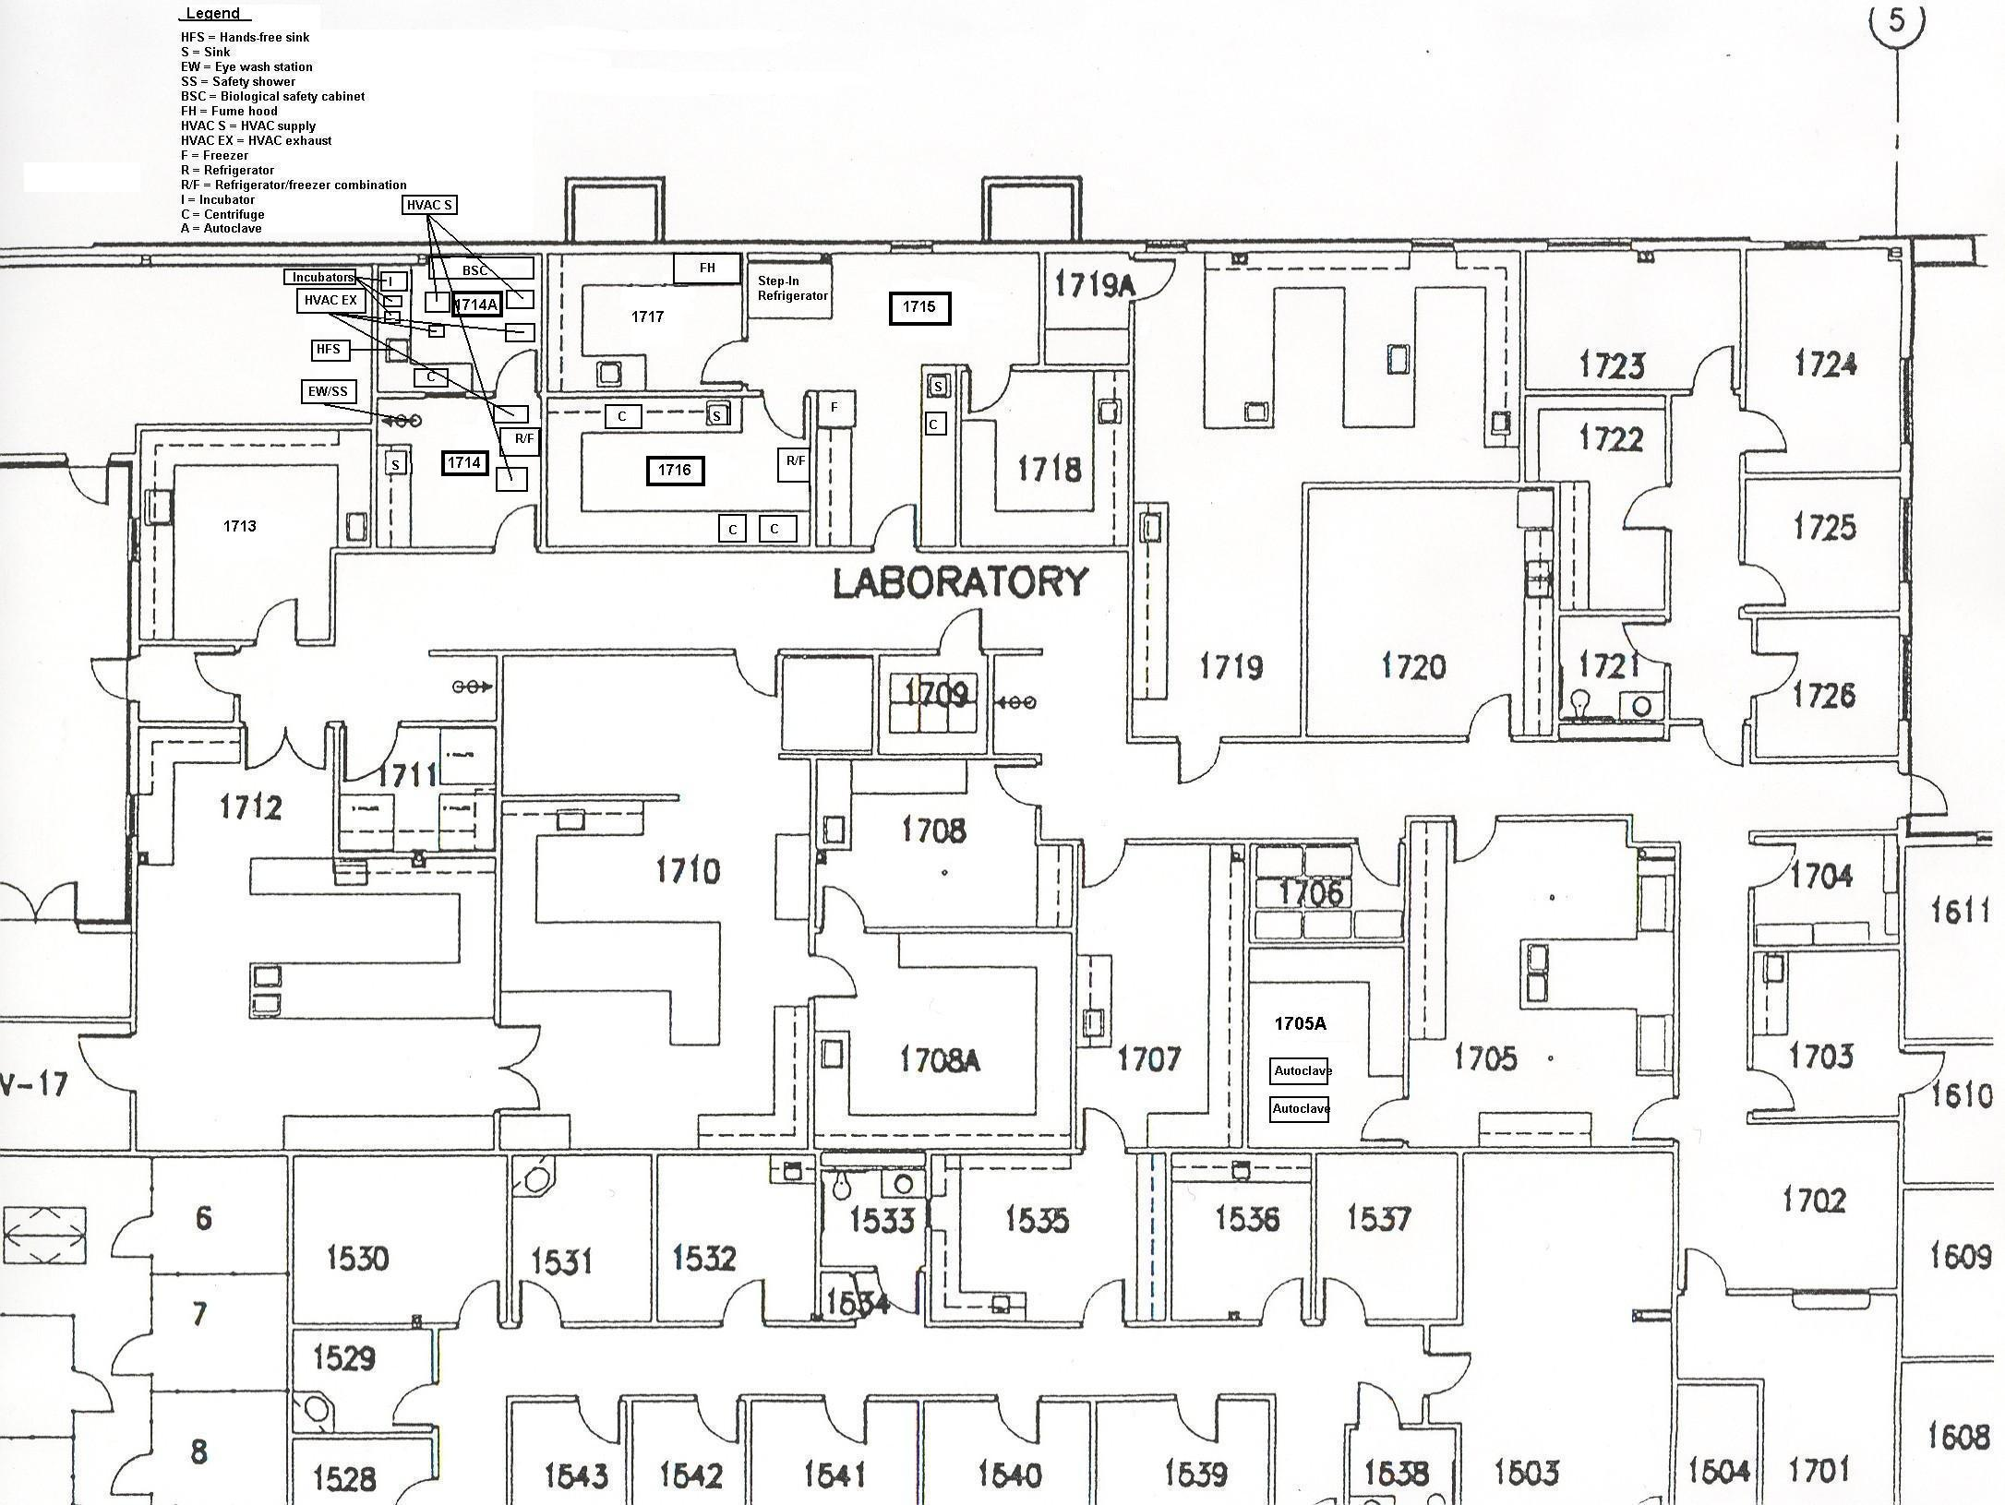

**Appendix F**

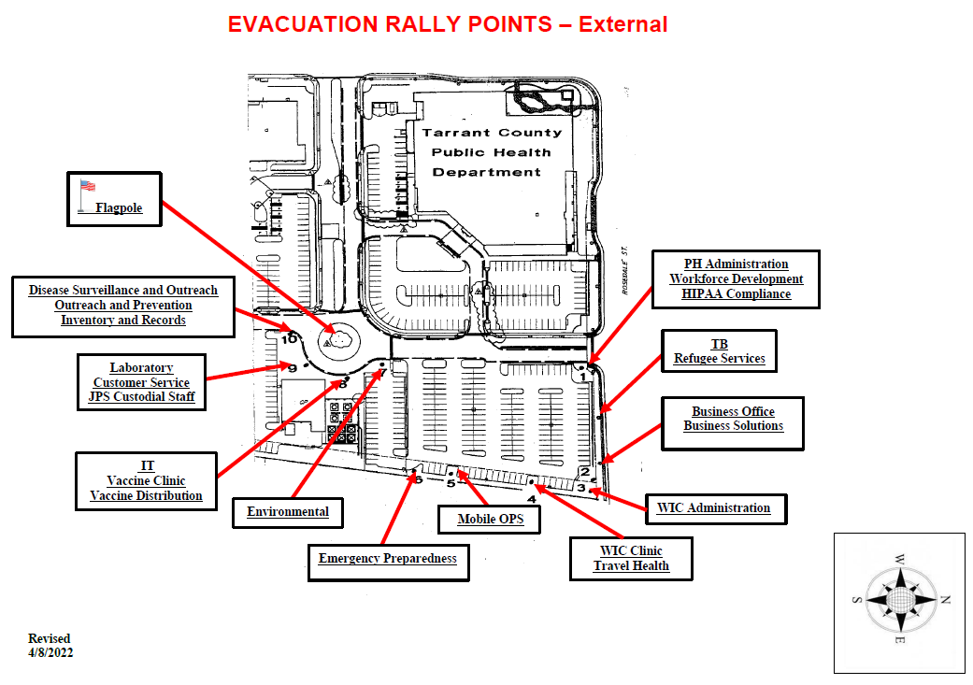

Conference Room Guests

Business Offices and PH Informatics

Environmental Health, WIC Clinic

Adult Health Services, TB, Central Storage, PMC

Administration

Epidemiology

HIV Administration and Planning Council, Preparedness

Travel Health Services, IT,

Vaccine Distribution

Laboratory, Customer Service, and BCCCP

WIC Administration

**Appendix G**

Storm Shelter Points and Evacuation Routes – First Floor

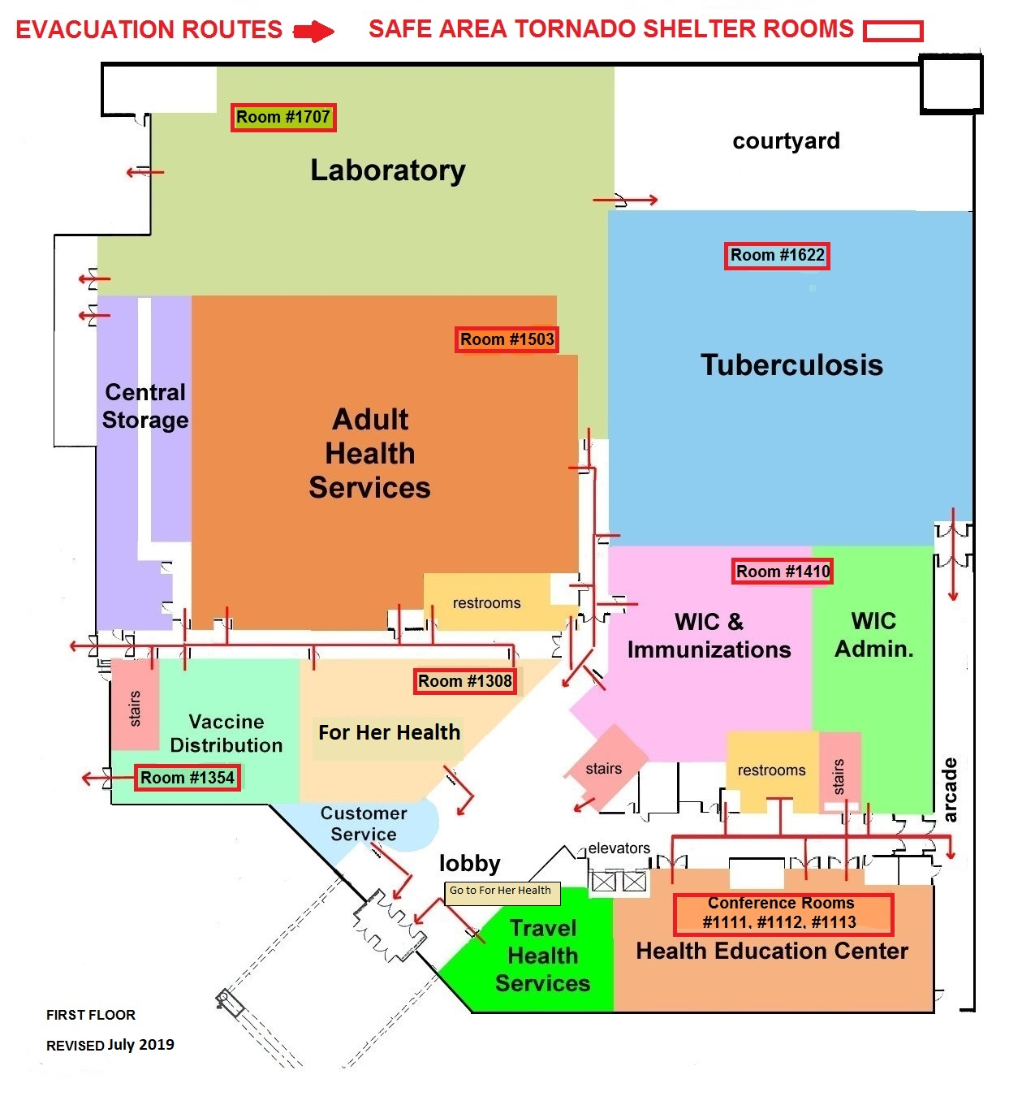

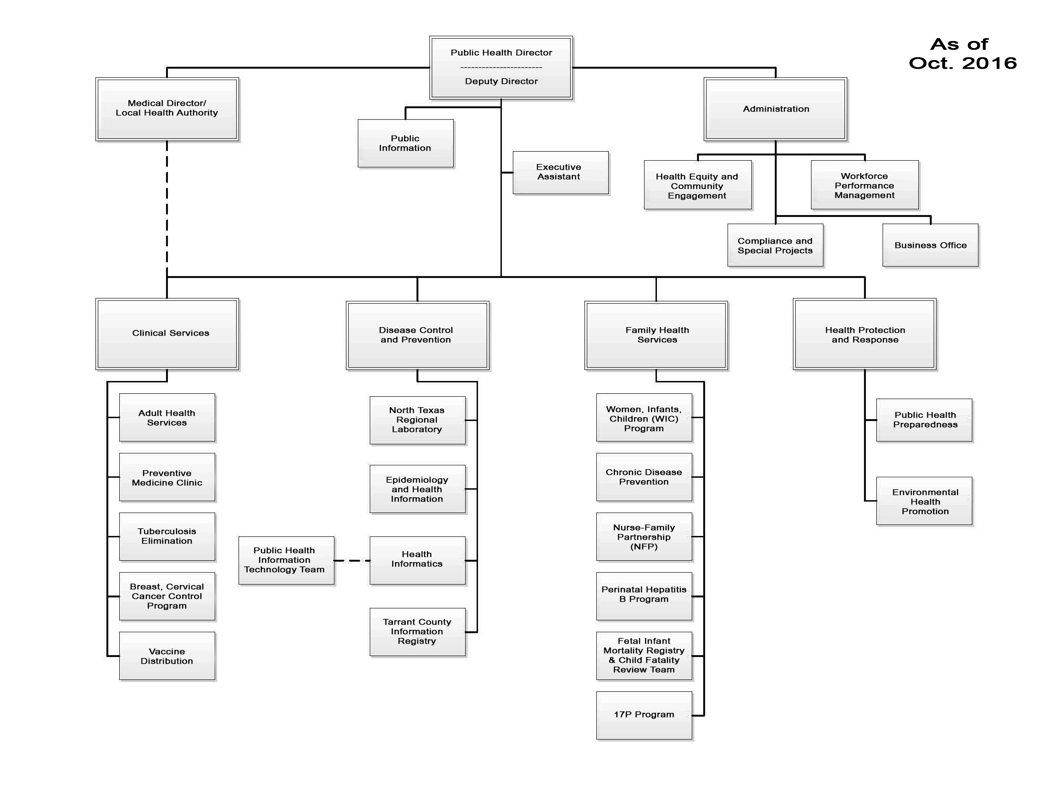Tarrant County Public Health Organizational Chart

**Appendix H**

**North Texas Regional Laboratory Organizational Chart (Rev 2/2020)**

**Appendix I (page 1)**

**North Texas Regional Laboratory Organizational Chart**

**Appendix I (page 2)**

**Staff roles and responsibilities for the laboratory organizational chart are described below. All these positions have as part of their job description the following duty: “Responds as needed in the event of a bioterrorism event or any public health threat.”**

**Laboratory Manager**

Responsible for the overall direction, planning, coordination and evaluation of laboratory services. Regularly assesses customer needs and ensures quality services are provided by the laboratory sections. Communicates with federal, state, and local officials regarding effective surveillance strategies and diagnosis of various health threats.

**Administrative Assistant IV**

Tracks a variety of complex budgets including State Grants. Assists the Laboratory Manager with personnel management and administrative tasks; authorizes and tracks all division requisitions and expenditures from County and State funds; supervises revenue collection and generate reports; participates in customer service and customer relations activities; and supervises support staff.

**Laboratory Response Coordinator, Bioterrorism Response Section**

Coordinates the overall laboratory preparedness and response to biological threat agents within Tarrant County and thirty-two additional counties in the North Texas Region. Facilitates a competent, well trained laboratory workforce to handle, process, and rule-out bioterrorism agents within the jurisdiction.

**Clinical Section Operations & Quality Coordinator**

Supervises and coordinates clinical laboratory staff activities and operations. Serves as quality manager and oversees laboratory testing, analysis, reporting and quality control/quality assurance procedures. Provides responsible staff assistance to assigned senior management personnel.

**Consumer Microbiology Section Operations & Quality Coordinator**

Supervises and coordinates consumer microbiology laboratory staff activities and operations. Serves as quality manager and oversees laboratory testing, analysis, reporting and quality control/quality assurance procedures. Provides responsible staff assistance to assigned senior management personnel.

**Laboratory Technology Coordinator**

Administers the technical aspects of the Laboratory Information Management System (LIMS) within the Tarrant County Public Health, NTRL. Ensures accurate and efficient capturing and reporting of laboratory data in compliance with various regulatory agencies, acts as the SME on all things related to the LIMS and is responsible for administering the daily operation of the LIMS.

**Microbiologist II**

Provides various laboratory services for all customers of the NTRL and assists the responsible laboratory coordinator in supervision and quality assurance activities for their area of responsibility. Areas of testing include consumer microbiology and chemistry, clinical microbiology, clinical chemistry, immunology, virology, parasitology, and molecular biology.

**Microbiologist I**

Provides various laboratory services for all customers of the NTRL. Areas of testing include consumer microbiology and chemistry, clinical microbiology, clinical chemistry, immunology, virology, parasitology, and molecular biology.

**Laboratory Assistant II**

Provides team leadership for support services to the consumer microbiology, clinical, and bioterrorism response and emerging agents (BREA) sections of the Tarrant County Public Health/North Texas Regional Laboratory.

**Laboratory Assistant I**

Provides support services to the consumer microbiology, clinical, and bioterrorism response and emerging agents (BREA) sections of the Tarrant County Public Health/North Texas Regional Laboratory.

Texas Laboratory Response Network Revised 12.21.22

**Appendix J**

|  |  |  |  |  |  |  |  |  |  |
| --- | --- | --- | --- | --- | --- | --- | --- | --- | --- |
| **LRN** | **Name** | **Position** | **Office Phone** | **24/7 Contact** | **Fax** | **Email** | **Mailing Address** | **Physical Address** | **Website URL** |
| Texas DSHS | Rahsaan Drumgoole | EP Manager | 512-776-6171 | 512-634-6727 | 512-776-7431 | [Rahsaan.Drumgoole@dshs.texas.gov](mailto:Rahsaan.Drumgoole@dshs.texas.gov) | MC 1947 PO Box 149347 Austin, TX 78714-9347 | 1100 W. 49th Street  Austin, TX 78756 | <http://www.dshs.state.tx.us/lab/epr.shtm> |
| Erin Swaney | BT Team Lead | 512-776-7185 | 512-634-6728 | [Erin.Swaney@dshs.texas.gov](mailto:Erin.Swaney@dshs.texas.gov%20%20) |
| Ashley Cordero | Biothreat Team | BT Lab Main  512-776-3781 | 512-689-5537 | [Ashley.Cordero@dshs.texas.gov](mailto:Ashley.Cordero@dshs.texas.gov) |
| Mark Mergen | Biothreat Team | [Mark.Mergen@dshs.texas.gov](mailto:Mark.Mergen@dshs.texas.gov) |
| Miguel Marquez | Biothreat Team | [Miguel.Marquez@dshs.texas.gov](mailto:Miguel.Marquez@dshs.texas.gov) |
| David Davila | Biothreat Team | [David.Davila@dshs.texas.gov](mailto:David.Davila@dshs.texas.gov) |
| Andrea Saldana | Biothreat Team | [Andrea.Saldana@dshs.texas.gov](mailto:Andrea.Saldana@dshs.texas.gov) |
| Jocelyn Hover--Jeansonne | CT Team Lead | 512-776-3486 | 512-634-9945 | [Jocelyn.Hover-Jeansonne@dshs.texas.gov](mailto:Jocelyn.Hover-Jeansonne@dshs.texas.gov) |
| Kendra Mueller | CT Team | CT Lab Main  512-776-7270 | [Kendra.Mueller@dshs.texas.gov](mailto:Kendra.Mueller@dshs.texas.gov) |
| Keyori Moore | CT Team | [Keyori.Moore@dshs.texas.gov](mailto:Keyori.Moore@dshs.texas.gov) |
| City of El Paso Department of Public Health Laboratory Annex | Ben-Bani, Semone | Lab Manager | 915-212-0438 |  | 915-212-0439 | [Ben-banism@elpasotexas.gov](mailto:Ben-banism@elpasotexas.gov) | 9566 Railroad Drive El Paso, TX 79924 | 9566 Railroad Drive El Paso, TX 79924 | <http://home.elpasotexas.gov/health/laboratory.php> |
| Martha Rubi Gasca | MLS/RO | 915-212-2763 | 915-216-6410 | [GascaMR@elpasotexas.gov](mailto:GascaMR@elpasotexas.gov) |
| Ana Garibay | MLS/ARO | 915-212-2766 |  | [GaribayAX@elpasotexas.gov](mailto:GaribayAX@elpasotexas.gov) |
| Dallas County Health and Human Services | **Luke Short** | Lab Director | 214-819-6375 | 214-673-4087 | Fax  214-819-2896  BT Lab Main  214-819-1935 | [luke.short@dallascounty.org](mailto:luke.short@dallascounty.org) | 2377 N Stemmons Freeway Ste 022, Basement Dallas, TX 75207 |  | [www.dallascounty.org](http://www.dallascounty.org/) |
| **Joey Stringer** | General Laboratory Supervisor and RO | 972-692-2762 |  | [Joey.Stringer@dallascounty.org](mailto:Joey.Stringer@dallascounty.org) |
| Alexandra Lansing | Bioterrorism  LRN Supervisor | (972) 692-2708 |  | [alexandra.lansing@dallascounty.org](mailto:alexandra.lansing@dallascounty.org) |
| Agnes Marfo | BT microbiologist | (972) 692-2761 |  | [Agnes.Marfo@dallascounty.org](mailto:Agnes.Marfo@dallascounty.org) |
| Kayle Cirrincione | Biosafety Officer | (972) 692-2704 |  | [kayle.cirrincione@dallascounty.org](mailto:kayle.cirrincione@dallascounty.org) |
| **Diana Esquivel** | Microbiologist | 972-692-2704 |  | [Diana.esquivel@dallascounty.org](mailto:Diana.esquivel@dallascounty.org) |
| **Randall Busse** | Microbiologist | 972-692-2764 |  | Randall.busse@dallascounty.org |
| Public Health Laboratory of East Texas  (Tyler) | Janine Yost | Microbiologist Manager | 903-877-5071 | 903-714-6579 | 903-877-5259 | [janine.yost@uthct.edu](mailto:janine.yost@uthct.edu) | 11937 US Highway 271N Tyler, Texas 75708 | 11949 US Highway 271N Building 558  Tyler Texas 75708 | 903-312-3537 |
| Hannah Allie | Microbiologist | 903-877-5071 | 903-275-9131 | [hannah.allie@uthct.edu](mailto:hannah.allie@uthct.edu) |
| Maria Olalde | Microbiologist | 903-877-5071 | 903-740-4415 | [maria.olalde@uthct.edu](mailto:maria.olalde@uthct.edu) |
| TIEHH Bioterrorism Response Laboratory  (Lubbock) | Dr. Steve Presley | Laboratory Director | 806-885-0236 | 806-549-1942 | 806-885-1075 | [steve.presley@ttu.edu](mailto:steve.presley@ttu.edu) | TIEHH  PO Box 41163  Lubbock, TX 79409-1163 | 1207 Gilbert Dr.  Lubbock, TX 79416 | <http://www.tiehh.ttu.edu/Pages/default.aspx>  24/7 #  806-885-0235  806-252-3652 (Lubbock LRN) |
| Sierra Malaeb | Microbiologist | 806-620-1167 |  | [Sierra.malaeb@ttu.edu](mailto:Sierra.malaeb@ttu.edu) |
| Dr. Cynthia Reinoso Webb | BT Response Coordinator | 806-834-7009 | 718-974-2875 | [Cynthia.reinoso@ttu.edu](mailto:Cynthia.reinoso@ttu.edu) |

|  |  |  |  |  |  |  |  |  |  |
| --- | --- | --- | --- | --- | --- | --- | --- | --- | --- |
| **LRN** | **Name** | **Position** | **Office Phone** | **24/7 Contact** | **Fax** | **Email** | **Mailing Address** | **Physical Address** | **Website URL** |
| Tarrant County Public Health, North Texas Regional Lab | Erin Taylor | BT Lab Response Coordinator | 817-321-4755 | 817-353-2020 | 817-321-4790 | [eltaylor@tarrantcounty.com](mailto:eltaylor@tarrantcounty.com) | 1101 South Main Street  Fort Worth, TX, 76104 |  | [www.tarrantcounty.com](http://www.tarrantcounty.com) |
| Rune-Par Nilsson (RP) | Laboratory Manager | 817-321-4757 | 210-422-3786 | [rinilsson@tarrantcounty.com](mailto:rinilsson@tarrantcounty.com) |
| Lindsey Raimond | BT Section Supervisor | 817-321-4770 |  | [LMRaimond@tarrantcounty.com](mailto:LMRaimond@tarrantcounty.com) |
| Lucy Lenguyen | BT Microbiologist | 817-321-4765 |  | [LXLenguyen@TarrantCounty.com](mailto:LXLenguyen@TarrantCounty.com) |
| Vacant | BT Microbiologist | 817-321-4783 |  |  |
| Houston Health Dept. | Meilan Bielby | Laboratory Clinical Manager | 832-393-3956 | 832-260-6723 | 832-393-3983 | [Meilan.bielby@houstontx.gov](mailto:Meilan.bielby@houstontx.gov) | 2250 Holcombe Blvd.  Houston, TX 77030 |  | [www.houstontx.gov](http://www.houstontx.gov/) |
| Ricardo Quijano | Laboratory Supervisor | 832-393-3926 | 713-471-6376 |  | [Ricardo.Quijano@houstontx.gov](mailto:Ricardo.Quijano@houstontx.gov) |
| Gustina Gonzales | Micro III | 832-393-3974 | N/A | 832-393-3983 | [Gustina.Gonzales@houstontx.gov](mailto:Gustina.Gonzales@houstontx.gov) |
| Mingzhong Zheng | Micro IV | 832.393.3959 | 713-805-6673 | 832-393-3982 | [Mingzhong.zheng@houstontx.gov](mailto:Mingzhong.zheng@houstontx.gov) |
| Linda Galicia | Micro III | 832-393-3959 (Lab phone) | 832-262-2873 | 832-393-3982 | [Lindsey.templeton@houstontx.gov](mailto:Lindsey.templeton@houstontx.gov) |
| Raven Foster | Biosafety officer | 832.393.3973 | 281-540-8164 | 832.393.3992 | [raven.foster@houstontx.gov](mailto:raven.foster@houstontx.gov) |
| Corpus Christi Nueces County Public Health District | Valerie Requenez | BT Coordinator | 361-826-7214 | 361-533-3500 | 361-826-7217 | [valerier@cctexas.com](mailto:valerier@cctexas.com) | 1702 Horne Rd Corpus Christi TX 78416 |  |  |
| Dante Gonzalez PhD | Public Health Assistant Director | 361-826-7203 | 361-244-5508 | 361-826-7217 | [DanteG@cctexas.com](mailto:DanteG@cctexas.com) |
| Angela Flores-Ledesma | Laboratory Manager | 361-826-7218 | 361-585-9280 | 361-826-7217 | [AngelaF@cctexas.com](mailto:AngelaF@cctexas.com) |
| Raymond Martinez | Micro I | 361-826-1331 | 210-887-7529 | 361-826-7217 | [RaymondM@cctexas.com](mailto:RaymondM@cctexas.com) |
| Texas Department of State Health Services - South Texas Laboratory | Kristina Zamora | Team Lead / BT Coor./ARO | 956-364-8369 | 512-694-9306 | 956-412-8794 | [kristina.zamora@dshs.texas.gov](mailto:kristina.zamora@dshs.texas.gov) | 1301 S. Rangerville Road  Harlingen, TX 78552 |  | <http://www.dshs.state.tx.us/Layouts/ContentPage.aspx?PageID=34563&id=34352&terms=south+Texas> |
| Aurora Martinez | Lab Branch Manager/RO | 956-364-8748 | 512-634-6738 | 956-412-8794 | [aurora.martinez@dshs.texas.gov](mailto:aurora.martinez@dshs.texas.gov) |
| Michelle Chavez | Molecular Biologist II | 956-364-8756 | 956-521-2968 | 956-412-8794 | [Michelle.chavez1@dshs.texas.gov](mailto:Michelle.chavez1@dshs.texas.gov) |
| Thelma Cano | Micro II | 956-364-8756 | N/A | 956-412-8794 | [Thelma.cano@dshs.texas.gov](mailto:Thelma.cano@dshs.texas.gov) |
| San Antonio Metropolitan Health District LRN Laboratory | Mark Wade | Lab Services Director | 210-207-8747 | 210-387-9387 | 210-207-0867 | [mark.wade@sanantonio.gov](mailto:mark.wade@sanantonio.gov) | 2509 Kennedy Circle, Building 125, B-level  San Antonio, TX 78235 | Same | <http://www.sanantonio.gov/health> |
| Brandon Guin | LRN Laboratory Coordinator | 210-207-5883 | 210-551-5464 | [brandon.guin@sanantonio.gov](mailto:brandon.guin@sanantonio.gov) |
| Alexis Anderson | Laboratory Scientist II | 210-207-0841 | 210-218-1385 | [Alexis.anderson@sanantonio.gov](mailto:Alexis.anderson@sanantonio.gov) |

|  |  |  |  |  |  |  |  |  |  |
| --- | --- | --- | --- | --- | --- | --- | --- | --- | --- |
|  | Wayne Beaumier | Laboratory Scientist II | 210-207-0843 | 832-721-2035 |  | [wayne.beaumier@sanantonio.gov](mailto:wayne.beaumier@sanantonio.gov) |  |  |  |

**Appendix J**



**Appendix K**

Current as of January 2023

Red = 24/7 testing

**Appendix L**

**Hazardous Characteristics of Select Agents & Pathogens**

