Identified as a Category ___
Task as defined by the
U.S Department of Labor.
Adopted: 5/26/2009 |  | Approved by:
Reviewed/Revised |  | Medical Director Date
Reviewed/Revised |  | Proofread by:
Reviewed/Revised |  | Technical Director Date
Reviewed/Revised |  | Prepared by: Date
Reviewed/Revised
Reviewed/Revised
Supersedes: bhGL9resultedit 3/3/2006 Page 1 of 4

bhGL9resultedit

Procedure: Editing Accepted Results (Non-Microbiology)

Responsibility: Result Entry Technical Staff

Purpose: Correct a result, notify the clinician of the correction, and ensure the corrected result is displayed prominently. The correction must be performed to replace the original result. Appending a comment to note the value of the new result is not acceptable.
Three steps: Notification, Replacement, and Documentation

Steps (Notification)
- The Physician, Physician's Office or Nursing Unit must be immediately notified of the corrected result.
- The technician performing the data correction is responsible to call the appropriate area of care to alert the clinician of the change.
- This notification will be documented with the result.

Steps (Sunquest – to replace the result)
- To ensure that an incorrect result is replaced.
- Function [MEM] or [OEM]
- [MEM] always use worksheet mode.
- Results have already been accepted so you must use M-Accn.# at the accession number entry prompt.
- You must enter the corrected result as if you were “typing over” the original value. DO NOT USE THE HYPEHN TO APPEND THE CORRECTED RESULT.
- Enter the correct numeric value or appropriate coded comment (e.g. WRONG to note RESULTS DO NOT BELONG TO THIS PATIENT ) DO NOT USE THE HYPEHN TO APPEND THE CORRECTED RESULT. –see example A,B

Example A

The initial CL value = 100 was incorrect, the correct value = 110.

From step 6: enter 110 for the CL value = 110
Note: 1. The Sunquest correction statement is automatically invoked
2. The anion gap will get recalculated based on the new CL value

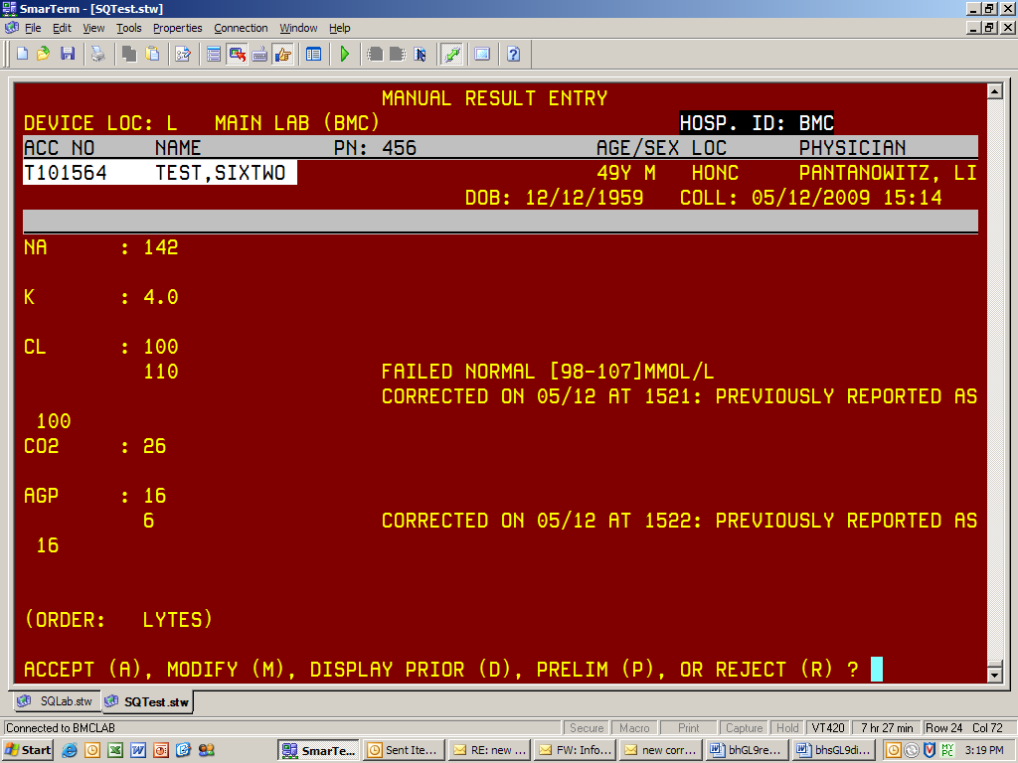

Example B

A Glucose value of 256 was reported and you become aware that specimen does not belong to the patient.

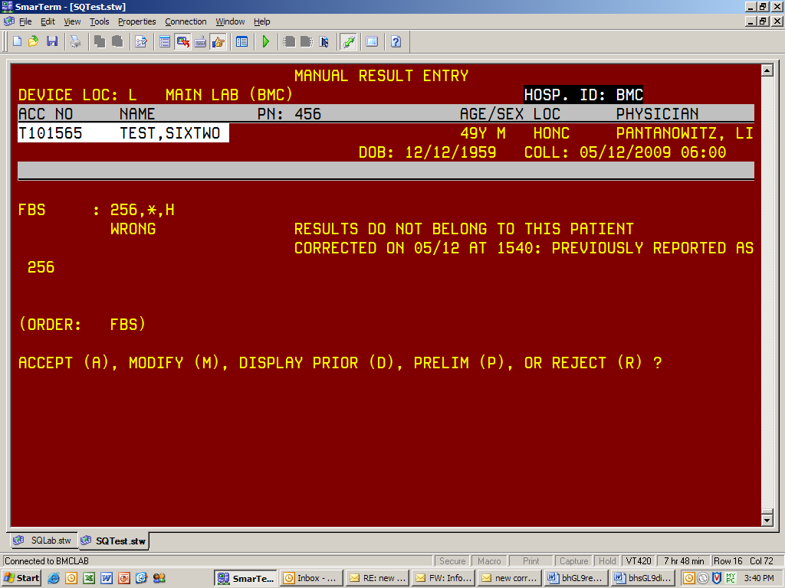

Steps (Sunquest – documenting the action)
- To ensure proper documentation.
- Function [MEM] or [OEM]
- [MEM] always use worksheet mode.
- Results have already been accepted so you must use M-Accn.# at the accession number entry prompt.
- APPEND THE DOCUMENTATION FOR THE CORRECTED RESULT.
- Follow standard “appending a free text comment” procedure (the hyphen, semicolon (-;)).
- Enter in who was notified, when notified, and by whom
- See example C.

Example C

