**Hopi Health Care Center**

**Polacca, AZ**

**Laboratory Department**

|  |  |  |  |
| --- | --- | --- | --- |
| **Title: Manual Dipstick Urinalysis Procedure** | | | |
| **Responsible Person: Kendrick Fritz, Supervisory Medical Technologist** | | | |
| **Standards/Regulations: DC.02.01.01, WT.01.01.01, WT.04.01.01, and WT.05.01.01** | | | |
| **Distribution: Laboratory Staff** | | | |
| **Original Effective Date:**  05/04 | **Reviewed/Revised:**  12/2015 | **Review Interval:**  Annual | **Due for Review:**  12/2016 |
| **HHCC Website: Chapter: Departmental Policies and Procedures**  **Folder: Laboratory Policy & Procedure** | | | |

**PURPOSE**

To establish policy & procedures for performing manual urine dipstick testing as a source to utilize as a backup in event the urinalysis analyzer is unavailable.

**SUMMARY AND INTENDED USE**

Siemens Reagent Strips are for professional use in point of care and centralized laboratory locations. The strips are intended for use in at-risk patient groups to assist diagnosis in the following areas:

* kidney function
* urinary tract infections
* carbohydrate metabolism (e.g. diabetes mellitus)
* liver function

The strips also measure physical characteristics, including acid-base balance and urine concentration. Test results can be used along with other diagnostic information to rule out certain disease states and to determine if microscopic analysis is needed.

The tests on the reagent strips when read visually is designated as CLIA Waived.

**SPECIMEN COLLECTION**

Patient Preparation

1. Female preparation for a Clean Catch Urine specimen
   1. Separate the folds of the urinary opening.
   2. Using a towelette wipe one side of the inner fold with a downward stroke.
   3. With another towelette wipe the other inner fold with a downward stroke.
   4. Using the last towelette wipe the center area with a downward stroke.
2. Male preparation for a Clean Catch Urine specimen

a. Clean the head of the penis with a towelette. If not circumcised, pull the foreskin back when urinating into the container.

1. After the above procedures are performed, collect the urine in a properly labeled container by midstream method.

a. Begin by voiding the urine in the toilet.

b. Move the container into the "midstream" to interrupt flowing urine.

c. Fill only half of the container with urine.

4. The specimen of choice for analysis is a clean catch collection of the first morning urine specimen.

1. Random, supra-pubic, catheterized, and midstream specimens are also acceptable for testing.
2. Urine must be collected in a clean screw cap container.

**SPECIMEN PRESERVATION**

1. If the specimen cannot be tested within two hours after collection, it may be refrigerated for up to 24 hours after collection.
2. It is especially important to use fresh urine to obtain optimal results when testing for bilirubin and urobilinogen, these compounds are unstable when exposed to room temperature and light.

**STORAGE & HANDLING**

1. All unused strips must remain in the original bottle. Transfer to any other container may cause reagent strips to deteriorate and become unreactive.
2. Test strips must be stored at room temperature (15-30°C).
3. **Do not remove strip from the bottle until immediately before it is to be used for testing. Replace cap immediately and tightly after removing reagent strip.**
4. Do not touch test areas of the reagent strip
5. Work areas and specimen containers should be free of detergents and other contaminating substances.
6. Do not use the strips after their expiration date.
7. Do not remove desiccant from the bottle.

**QUALITY CONTROL**

1. Two levels of external quality control need to be tested, negative and positive.
   1. KOVA-Trol I – Positive Control.
   2. KOVA-Trol III – Negative Control.
2. Compare QC results to the Kova-Trol Control Results Package Insert.
3. The performance of the reagent strips **MUST** be confirmed by testing with Negative and Positive urine QC material when a new bottle is first opened and each new lot number.
4. Thereafter, QC must be performed **weekly.**
5. Water should NOT be used as a negative control.
6. Corrective action must be taken if the QC results are unacceptable, do not test patient specimens. Repeat QC tests until you have acceptable results.
7. Corrective action must be documented on the QC sheet

**PROCEDURE (Must be followed exactly to achieve reliable test results)**

1. Follow hospital policy for the proper identification of the patient to be tested and proper specimen labeling. (Specimen accession labels contain the first and last name of the patient, medical record number, date of birth, date and time of specimen collection).
2. Mix urine sample well before testing.
3. Remove one strip from the Multistix 10 SG bottle and recap immediately.
4. Completely immerse strip in fresh urine. (Remove immediately to avoid dissolving out reagent).
5. Start timing.
6. While removing, run the strip edge against the rim of the urine container to remove excess urine.
7. Hold the strip in horizontal position to prevent possible mixing of chemicals from adjacent reagent areas.
8. Visually read test results carefully at the times specified (starting with the shortest time), in a good light (such as fluorescent lighting) and with the test area held near the appropriate Color Blocks on the bottle label.
9. Proper read time is critical for optimal results. Read as follows and match carefully:
10. Glucose and Bilirubin pad read at 30 seconds after dipping.
11. Ketone pad read at 40 seconds.
12. Specific gravity pad read at 45 seconds.
13. Blood, pH, Protein, Urobilinogen, and Nitrite pad read at 60 seconds.
14. Leukocytes pad read at 2 minutes.
15. Do not read any test pad after 2 minutes. Color changes that occur after 2 minutes are of no diagnostic value.
16. Avoid laying the strip directly on the Color Chart, as this will result in the urine soiling the chart.

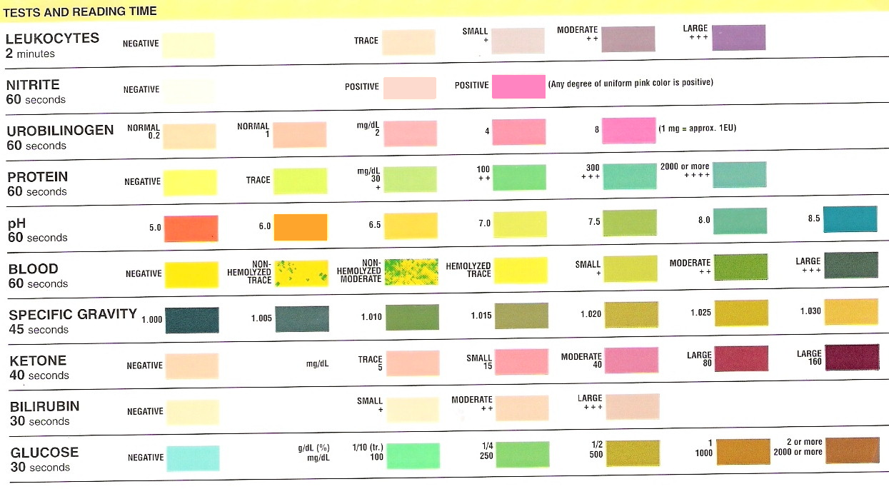

**REFERENCE RANGES**

* 1. Leukocytes: Negative
  2. Nitrate: Negative
  3. Urobilinogen: 0.2 – 1.0 mg/dL
  4. Protein: Negative
  5. pH: 4.6 – 8.0
  6. Blood: Negative
  7. Specific Gravity: 1.001 – 1.035
  8. Ketone: Negative
  9. Bilirubin: Negative
  10. Glucose: Negative

**DOCUMENTATION OF RESULTS**

Manual dipstick results must be documented along with the initials of personnel performing the test and the date the test was performed. A functional audit trail must be maintained that allows retrieval of results.

1. Document all results for patient/medical record number and accession number on proper forms(logs, T-sheets, etc.)
2. Completely document date test was performed and initials of staff performing test.
3. Results should be entered into RPMS lab package.

**LIMITATION OF PROCEDURE**

1. Substances that cause abnormal urine color may affect the readability of the test pads on urinalysis reagent strips. Substances include, visible levels of blood or bilirubin, drugs containing dye (e.g. Pyridium, Azo Gantrisin, Azo Gantanol), and antibiotic such as Macrodantin and Furadantin, or riboflavin. The intense color development may cause false positive results.
2. Discoloration or darkening of the test pads may indicate deterioration. If test results are questionable or inconsistent with expected findings, confirm the test strip is within the expiration date, check performance against external quality control, and/or retest with fresh test strips.
3. Contamination of the urine specimen with skin cleansers containing chlorhexidine may affect protein (and to a lesser extent specific gravity and bilirubin) test results.
4. Protein: A visibly bloody urine may cause falsely elevated results.
5. Blood: Capoten may reduce the sensitivity. Certain oxidizing contaminants and microbial peroxidase may produce false positive results.
6. Leukocytes: Elevated glucose concentrations, presence of cephalexin, cephalothin, or high concentrations of oxalic acid may cause decreased test results. High levels of tetracycline may cause a false negative reaction. Vaginal discharge may cause positive results.
7. Nitrite: Pink spots or pink edges should not be interpreted as positive result. A negative result does not rule out significant bacteriuria. False negative results may occur with shortened bladder incubation of the urine.
8. Glucose: Ketone bodies reduce the sensitivity of the test; moderately high ketone levels (40 mg/dL) may cause false negatives for specimens containing small amounts of glucose (75-125 mg/dL).
9. Ketone: False Trace result may occur with highly pigmented urine specimens or those containing large amounts of levodopa metabolites.
10. pH: Bacterial growth by certain organisms in a specimen may cause a marked alkaline shift (pH > 8.0), usually because of urea conversion to ammonia.
11. Specific Gravity: Highly buffered alkaline urines may cause low readings, the presence of moderate quantities of protein (100-750 mg/dL) may cause elevated readings.
12. Bilirubin: Indican may interfere with the interpretation of a negative or positive reading. Metabolites of Lodine may cause false positive or atypical results. Atypical colors may indicate that bilirubin-derived bile pigments are present in the urine sample and may be masking the bilirubin reaction.
13. Urobilinogen: May react with interfering substances known to react with Ehrlich’s reagent, such as ρ-aminosalicylic acid and sulfonamides. The presence of formalin may cause a false negative result.

**REFERENCE**

1. Siemens Package Insert, Siemens Healthcare Diagnostics Inc., Rev. 2/11.
2. Clinical and Laboratory Standards Institute (CLSI; formerly NCCLS). Urinalysis and Collection, Transportation, and Preservation of Urine Specimens; Approved Guideline – Second Edition. Vol. 21. No. 19. Document GP-16A2. Wayne, PA 2001.

**This Policy & Procedure was originated, reviewed and approved by the following:**

______________________________________________________________________________

Kendrick Fritz, Laboratory Supervisor Date

______________________________________________________________________________

Noelle E. Blue Arm, M.D., Medical Laboratory Director Date